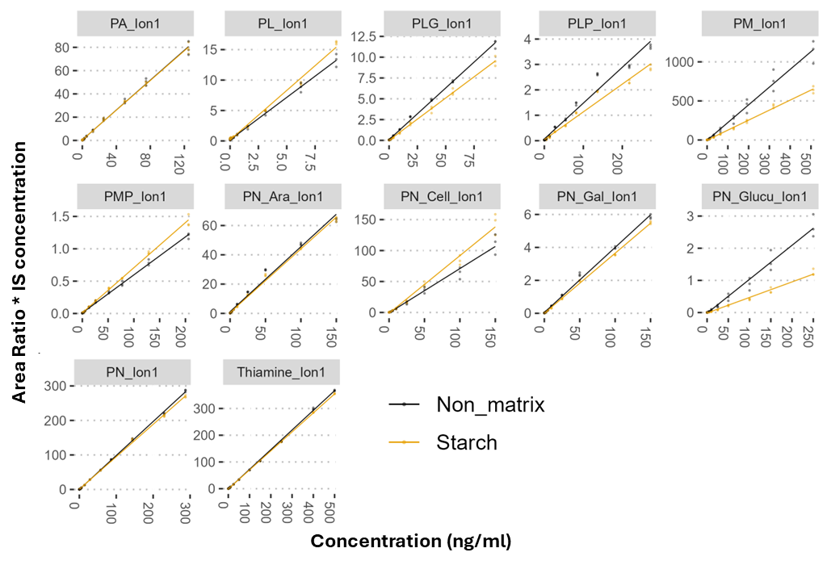
Additional file 2. Calibration curves illustrating the relationship between vitamin concentration (ng/ml) and Area-ratio* internal standard (IS) concentration. Area-ratio = Area of analyte peak/ Area of IS peak. Lines indicate relationships by linear regression with line gradient equalling response factor (Rf). Calibration curves made without a matrix are shown in black, whilst those in a starch matrix are shown in yellow. Each concentration was measured in triplicate with each of the three samples measured on three separate days.

