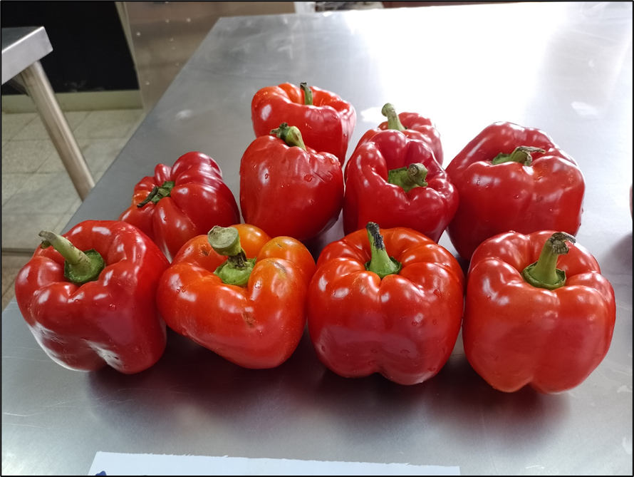
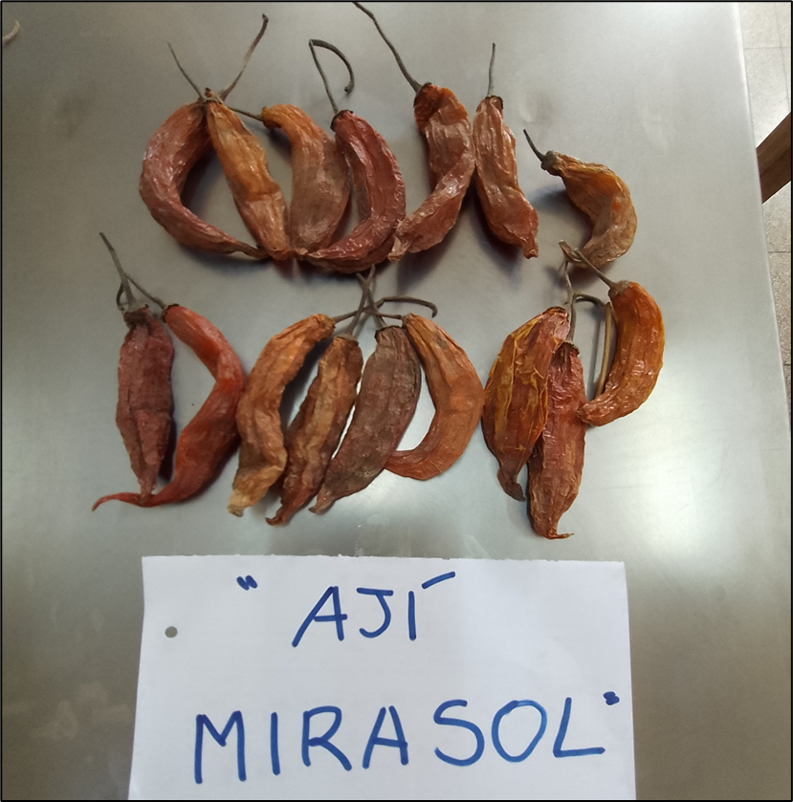
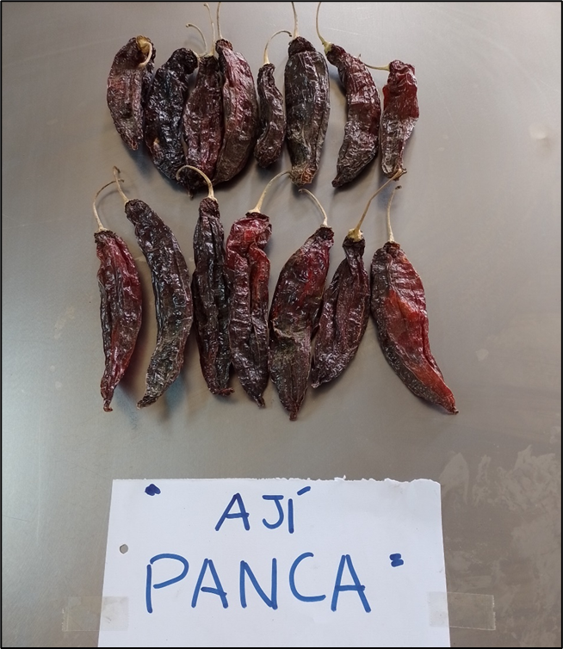
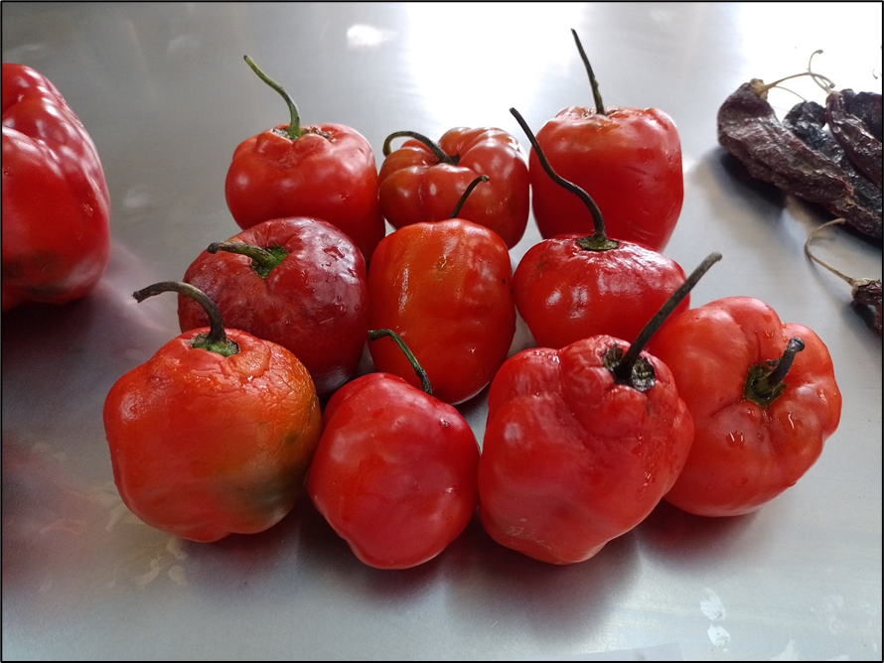
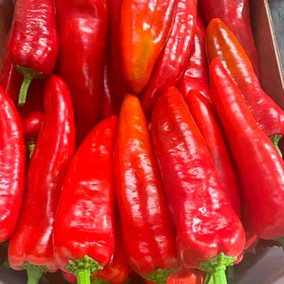
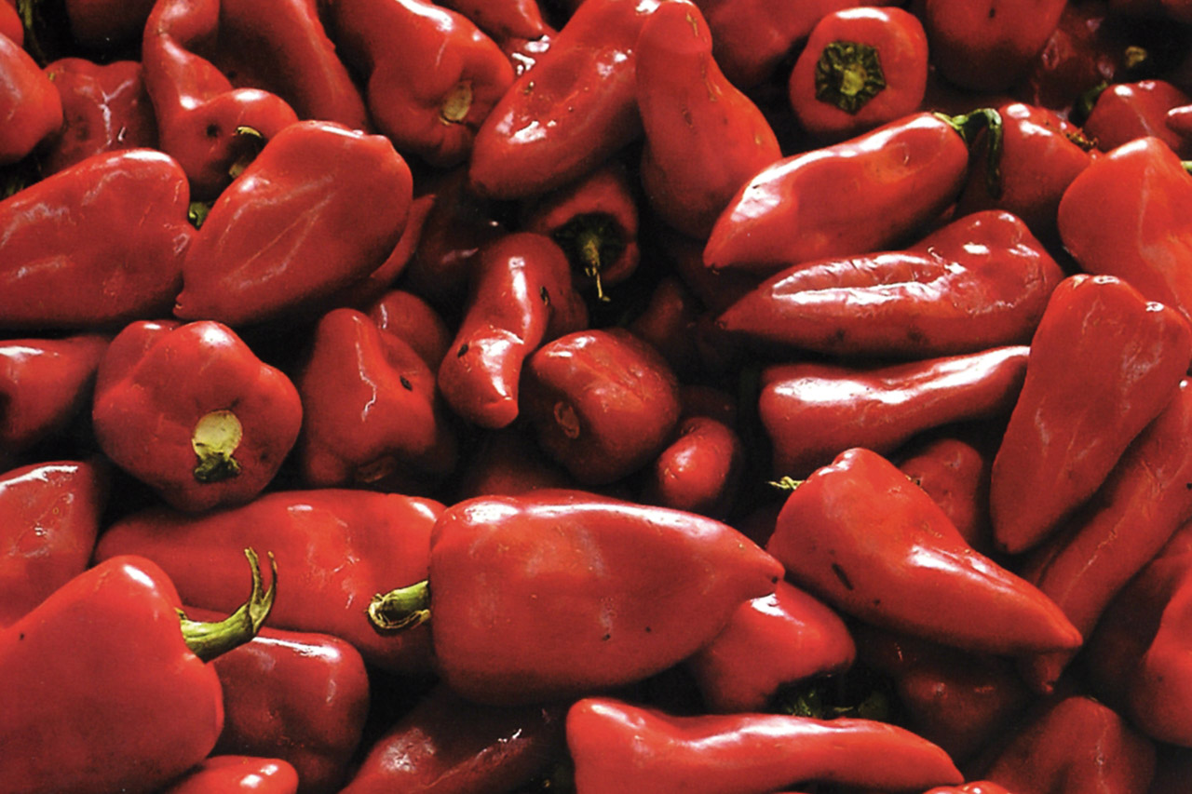
California
Piquillo
Kapia
Mirasol
Panca
Rocoto
Capsicum annuum
Capsicum baccatum
Capsicum chinense
Capsicum pubescens

Supplementary Fig. 1A). Fruits of three varieties of C. annuum (California, Kapia, Piquillo), one variety of C. baccatum (Mirasol), one variety of C. chinense (Panca), and one variety of C. pubescens (Rocoto).

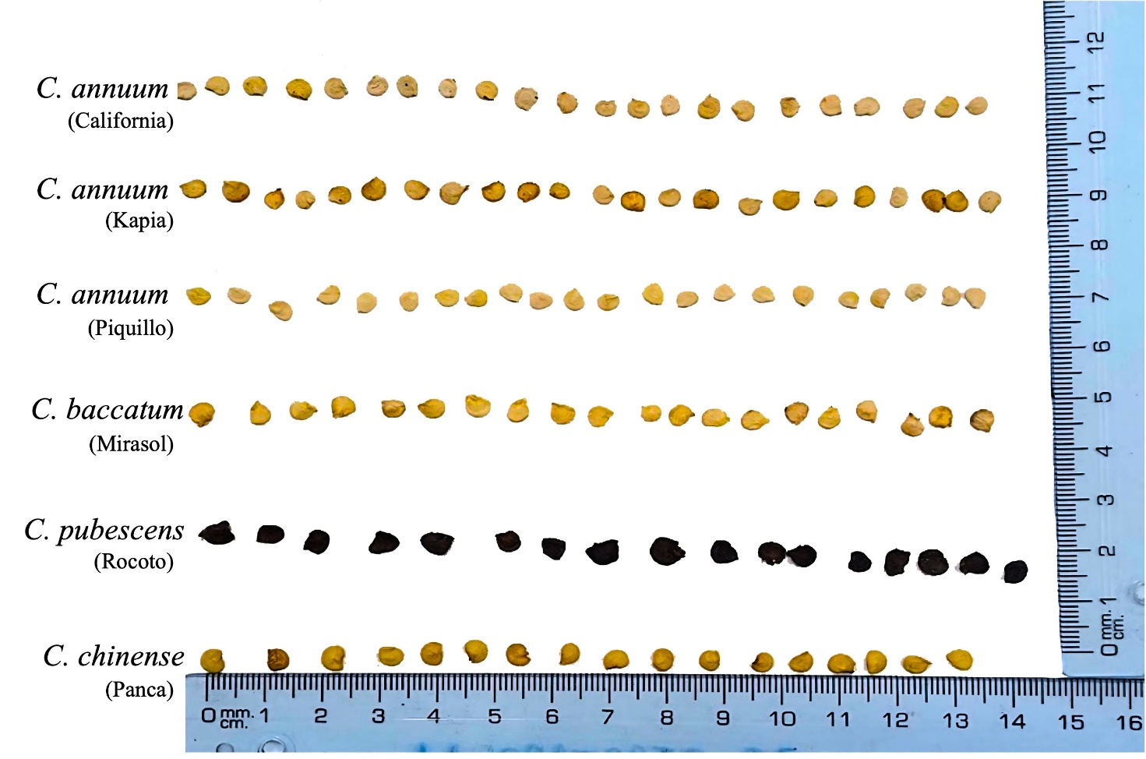
Supplementary Fig. 1B). Seeds of three varieties of C. annuum (California, Kapia, Piquillo), one variety of C. baccatum (Mirasol), one variety of C. pubescens (Rocoto) and one variety of C. chinense (Panca).

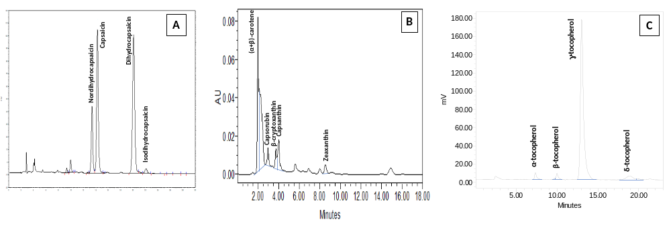

Supplementary Fig. 2. HPLC profile of capsaicinoids (A), carotenoids (B), and tocols (C) of oils extracted from Capsicum samples.

Supplementary Table 1. Nutritional and health-related indices.
Index | Equation
α-Linolenic acid/linoleic acid ratio (ALA/LA) | $$\frac{C18:3 ω3}{C18:2 ω6}$$
Index of desirable fatty acids (DFA) | $$C18:0+ ΣMUFA+ ΣPUFA$$
Sum of hypercholesterolemic fatty acids (OFA) | C14:0 + C16:0
Hypocholesterolemic/hypercholesterolemic ratio (HH) | $$\frac{C18:1 ω9+C18:2 ω6+C20:4 ω6+C18:3 ω3+C20:5 ω3+C22:5 ω3+ C22:6 ω3}{(C14:0+C16:0)}$$
Index of atherogenicity (AI) | $$\frac{C12:0+\left(4 ×C14:0\right)+C16:0}{ΣMUFA+ΣPUFA}$$
Index of thrombogenicity (TI) | $$\frac{C14:0+C16:0+C18:0}{0.5 x ΣMUFA+0.5 x Σ\left(ω6\right)PUFA+3x Σ(ω3)PUFA+(\frac{Σω3 PUFA}{Σω6 PUFA})}$$
Oleic desaturation ratio (ODR) | $$100 x \frac{C18:2+C18:3}{C18:1+C18:2+C18:3}$$
Linoleic desaturation ratio (LDR) | $$100 x \frac{C18:3}{C18:2+C18:3}$$
Saturation fat index (S/P) | $$\frac{C14:0+C16:0+C18:0}{ΣMUFA+ΣPUFA}$$
Oleic acid/(ALA + LA) | $$\frac{C18:1}{(C18:2+C18:3)}$$

Supplementary Table 2. Linear correlation coefficients of the characteristics tested on the different Capsicum oils (n = 6).

 | L* | a* | b* | SFA | MUFA | PUFA | SV | Capsaic | Scoville | Tocols | Carot | IR | Density | Acidity | PV | p-An | Totox | INTOX | K₂₃₂ | K₂₆₈ | OSI 140
a* | -0.74
b* | 0.87* | -0.60
SFA | -0.26 | -0.24 | 0.06
MUFA | 0.39 | -0.17 | 0.32 | -0.23
PUFA | 0.07 | 0.32 | -0.21 | -0.88* | -0.25
SV | -0.34 | -0.10 | -0.05 | 0.94** | 0.03 | -0.95**
Capsaic | -0.02 | 0.32 | -0.15 | -0.64 | -0.57 | 0.91** | -0.82*
Scoville | -0.04 | 0.32 | -0.17 | -0.62 | -0.60 | 0.90** | -0.80 | 1.00***
Tocols | -0.32 | -0.03 | -0.10 | 0.78 | -0.62 | -0.47 | 0.64 | -0.20 | -0.18
Carot | -0.88* | 0.81* | -0.76 | 0.17 | -0.05 | -0.14 | 0.38 | -0.19 | -0.17 | 0.23
IR | -0.36 | 0.50 | -0.27 | 0.05 | -0.68 | 0.28 | -0.04 | 0.45 | 0.46 | 0.63 | 0.38
Density | -0.42 | 0.62 | -0.39 | -0.10 | -0.59 | 0.39 | -0.14 | 0.49 | 0.49 | 0.49 | 0.47 | 0.98***
Acidity | 0.02 | 0.05 | 0.50 | 0.64 | -0.07 | -0.61 | 0.59 | -0.35 | -0.34 | 0.48 | 0.04 | 0.18 | 0.03
PV | -0.19 | -0.03 | 0.26 | 0.89* | -0.05 | -0.86* | 0.88* | -0.62 | -0.61 | 0.62 | 0.21 | 0.06 | -0.08 | 0.90*
p-An | 0.18 | 0.22 | -0.06 | -0.80 | -0.36 | 0.97*** | -0.92** | 0.94** | 0.93** | -0.31 | -0.26 | 0.41 | 0.47 | -0.48 | -0.78
TOTOX | 0.17 | 0.24 | -0.04 | -0.76 | -0.40 | 0.95** | -0.90* | 0.95** | 0.94** | -0.26 | -0.25 | 0.46 | 0.51 | -0.41 | -0.72 | 1.00***
INTOX | 0.18 | 0.23 | -0.06 | -0.79 | -0.37 | 0.97** | -0.92** | 0.95** | 0.94** | -0.30 | -0.26 | 0.42 | 0.48 | -0.47 | -0.76 | 1.00*** | 1.00***
K₂₃₂ | 0.30 | 0.06 | 0.52 | -0.17 | -0.40 | 0.37 | -0.40 | 0.61 | 0.61 | -0.02 | -0.45 | 0.27 | 0.17 | 0.44 | 0.06 | 0.49 | 0.55 | 0.50
K₂₆₈ | -0.34 | 0.28 | -0.10 | 0.34 | -0.91** | 0.11 | 0.10 | 0.47 | 0.49 | 0.69 | 0.10 | 0.77 | 0.65 | 0.43 | 0.32 | 0.25 | 0.32 | 0.27 | 0.58
OSI 140 | -0.62 | 0.22 | -0.24 | 0.86* | -0.52 | -0.61 | 0.79 | -0.30 | -0.27 | 0.79 | 0.45 | 0.35 | 0.23 | 0.64 | 0.82* | -0.55 | -0.50 | -0.54 | 0.02 | 0.64
Shelf-life | -0.34 | 0.35 | 0.04 | 0.53 | -0.63 | -0.22 | 0.40 | 0.11 | 0.12 | 0.79 | 0.28 | 0.76 | 0.64 | 0.74 | 0.64 | -0.07 | 0.01 | -0.05 | 0.46 | 0.88* | 0.76

SFA: saturated fatty acids; MUFA: monosaturated fatty acids; PUFA: polyunsaturated fatty acids; SV: saponification value; Capsaic: capsaicinoids content; Carot: carotenoids content; IR: refraction index; PV: peroxide value; p-An: p-anisidine value; TOTOX: total oxidation; INTOX: integral oxidation; OSI 140: oxidation stability index at 140 °C. * = p≤0.05; ** = p≤0.01; *** p≤0.001

