Supporting Information file

Simulation experiment data
The purpose of this supplementary experiment is to evaluate the influence of different missing value mechanisms on the performance of the MLE algorithms considered in the main text. In the main simulation experiments, missing values in GNSS coordinate time series were generated randomly. However, missing values in real data may occur in different patterns, including randomly scattered gaps, continuous data interruptions and combinations of both. Therefore, this supplementary experiment was designed to test whether the conclusions obtained in the main text remain valid under different missing value patterns.
Three missing value patterns were considered: random, block and mixed. The random pattern represents randomly scattered missing values, which may occur due to sporadic data loss or observation failures in short term. The block pattern represents continuous missing segments, which are commonly associated with receiver failures, equipment maintenance. The mixed pattern combines randomly scattered missing values and continuous missing segments and is intended to approximate more realistic GNSS coordinate time series.
The complete simulated GNSS coordinate time series used in this supplementary experiment were taken from the complete series of Group 3 in the main text. Each complete GNSS coordinate time series contains 5000 observations. The background noise model is WN+PL, where the true fraction parameter of the PL component is κ = 0.5, the true spectral index of the PL noise is α = −1.4 and the true standard deviation of the driving white noise is σ = 1.5.
Table S1 Information on simulation experiment data of different missing value patterns.
Dataset | Missing value pattern | Percentage of missing values (%) | Noise model | κ | α | σ | Monte-Carlo runs
R10 | Random | 10 | WN+PL | 0.5 | -1.4 | 1.5 | 300
B10 | Block | 10 | WN+PL | 0.5 | -1.4 | 1.5 | 300
M10 | Mixed | 10 | WN+PL | 0.5 | -1.4 | 1.5 | 300
R30 | Random | 30 | WN+PL | 0.5 | -1.4 | 1.5 | 300
B30 | Block | 30 | WN+PL | 0.5 | -1.4 | 1.5 | 300
M30 | Mixed | 30 | WN+PL | 0.5 | -1.4 | 1.5 | 300
R50 | Random | 50 | WN+PL | 0.5 | -1.4 | 1.5 | 300
B50 | Block | 50 | WN+PL | 0.5 | -1.4 | 1.5 | 300
M50 | Mixed | 50 | WN+PL | 0.5 | -1.4 | 1.5 | 300

Based on the same complete simulated data realizations, three types of incomplete datasets were generated. For the block pattern, the missing values were divided into three continuous missing segments. For the random pattern, the missing positions were generated randomly over the time span. For the mixed pattern, 50% of the missing values were generated as three continuous missing segments while the remaining 50% were generated randomly. Missing percentages of 10%, 30% and 50% were considered for each missing value pattern. For each dataset, 300 Monte-Carlo realizations were used. The detailed settings of the datasets are summarized in Table S1 and examples of the three missing value patterns are shown in Fig. S1.
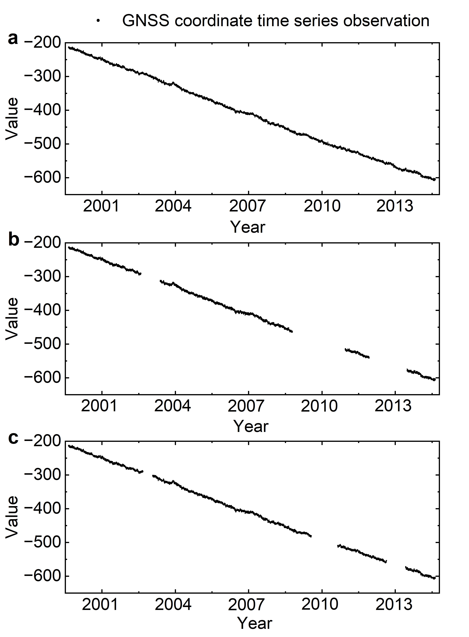
Fig. S1 Schematic diagram of simulated GNSS coordinate time series with different missing value patterns. a represents the case of random pattern. b represents the case of block pattern. c represents the case of mixed pattern.

Results and Analysis
Fig. S2 shows the estimated noise model parameters obtained by different MLE algorithms under the three missing value patterns. Overall, the relative performance of the different algorithms is consistent with the results obtained from the simulation experiments in main text. The Modified First-Differenced MLE (WN+PL), Normal MLE (WN+PLApprox) and Normal MLE (WN+GGM) show relatively stable noise parameter estimates under different missing value patterns.
In contrast, Normal MLE (WN+PL) and Standard First-Differenced MLE (WN+PL) exhibit stronger sensitivity to the missing value patterns, especially under random pattern. In these cases, the estimated noise parameters show larger deviations from the true values and larger dispersions. This behavior is particularly evident when the missing percentage increases. The results indicate that the spatial distribution of missing values in GNSS coordinate time series can influence the stability of noise model parameter estimation, rather than the percentage of missing values alone.
Fig. S2 The results of estimated noise parameters of the PL noise model for simulated GNSS coordinate time series in different dataset using different MLE algorithms. The black solid line represents the true value. a shows the results for κ in PL+WN. b shows the results for α in PL. c shows the results for σ in PL+WN.
The behavior of the Standard First-Differenced MLE algorithm is consistent with the mechanism discussed in the main text. When missing values are randomly scattered, the first-differencing operation breaks more adjacent observation pairs and causes additional loss of valid differenced observations. By contrast, when missing values are concentrated in continuous blocks, fewer separated gap boundaries are introduced and the loss of adjacent differenced observations is less severe. Therefore, the Standard First-Differenced MLE algorithm is more strongly affected by randomly distributed missing values than by block type missing segments.
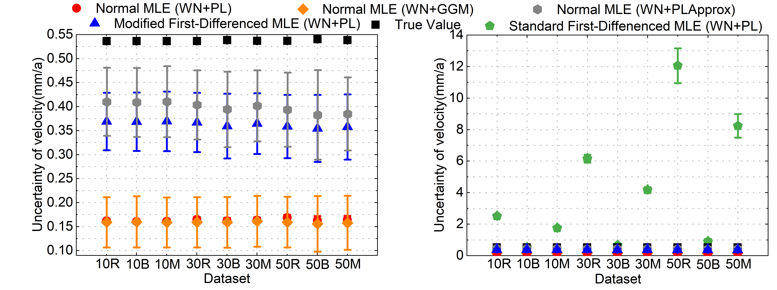
Fig. S3 Velocity uncertainty estimation results of simulated GNSS coordinate time series using different MLE algorithms.
Fig. S3 presents the velocity uncertainty estimates obtained by the different MLE algorithms. Compared with the noise model parameter estimates, the influence of the missing value pattern on velocity uncertainty is mainly observed for the Standard First-Differenced MLE (WN+PL). Its velocity uncertainty estimates vary substantially among different missing value patterns, especially when the missing values are more randomly distributed.
In contrast, the Modified First-Differenced MLE (WN+PL) remains stable under the three missing value patterns. This result supports the practical significance of the proposed information-preserving first-differenced MLE algorithms. By avoiding the additional loss of valid differenced information caused by missing values in GNSS coordinate time series, the proposed algorithms provide more robust noise model parameter and velocity uncertainty estimates under more complex and realistic missing value mechanisms.

