 |  | 

Project ELeVATE

Item Scoring Guide – Standard Based Assessments

Table of Contents

General Remarks
FAQ
Standard Based Test
K-5 Energy
K5-E_01 Pool
K5-E_04 Slide
K5-E_06 Bowling
K5-E_08 E-Motor
Middle School Energy
MS-E_05 Carpooling
MS-E_08 Space Jump
MS-E_10 BBQ
MS-E_11 Bumper cars
MS-E_13 Repelling magnets
MS-E_15 Air Hockey

General Remarks

- For each task a Rubric shows how different elements of performance in DCI (Disciplinary Core Idea) and CCC (Cross Cutting Concepts) combined with different elements of a Practice form different levels on which the PE (Performance Expectation) or LP (Learning Performance) can be met.

- A general description of the levels of performance is given in bold print in each box.

- The levels of performance are interconnected, as the general descriptions detail. For example, in a “CER” task students have to support their claim with evidence. Thus, an answer without a claim cannot receive a score for evidence.

- If a student scores a 0 on the Design or Claim (first row in the rubric), they can only score a 0 on the subsequent rows (Justification, Evidence, Reasoning, etc.)

- Bullet points separate different possible answers on the same level of performance.

- Student responses in italics are provided as examples.

- For each rubric there are two detailed examples below (left: IQWST student; right: transfer student)

Elements of Practice / Elements of DCI+CCC | Levels of Performance
Elements of Practice / Elements of DCI+CCC | 0 | 1 | 2
Design | Students don’t / incorrectly describe how they combine and connect materials to build a device that converts energy from one form to another.  - incorrect or no statement about how the solution powers Susan’s light bulb. | Based on scientific ideas students incompletely describe how they combine and connect materials to build a device that converts energy from one form to another.  - Statement / picture that describes a correct combination of materials for a solution to power Susan’s light bulb.  Use the wires and the hand cranked generator. | Based on scientific ideas students describe how they combine and connect materials to build a device that converts energy from one form to another.  - Statement / picture that describes a correct way of combining and connecting the materials for a solution to power Susan’s light bulb.  You could attach the wires to the hand cranked generator, then wrap the other end of the wires around the threads (ridges) of the light bulb (so that the lightbulb conducts energy), and attach a magnet to the ceiling and another to the lightbulb. So the mechanical energy of you cranking the generator would turn into electric energy to power the light bulb.
Justification | Students don’t / incorrectly bring in scientific principles (DCI / CCC) to justify their design and explicitly connect to the design.  - incorrect or no statement about how energy is involved in the solution powering Susan’s light bulb. | Students incompletely bring in scientific principles (DCI / CCC) to justify their design and explicitly connect to the design.  - Statement that describes which source of energy is used to power Susan’s light bulb.  OR  - Statement that describes that the solution generates electric energy to power Susan’s light bulb.  Cranking the generator generates electric energy. | Students bring in scientific principles (DCI / CCC) to justify their design and explicitly connect to their designed device.  - Statement that describes which form of energy the solution converts into electric energy to power Susan’s light bulb.  You could attach the wires to the hand cranked generator, then wrap the other end of the wires around the threads (ridges) of the light bulb (so that the lightbulb conducts energy), and attach a magnet to the ceiling and another to the lightbulb. So the mechanical energy of you cranking the generator would turn into electric energy to power the light bulb.

- If a student answer is not covered by the bullet points refer back to the general description and try to assign a score on this basis.

- Additional information not relevant to the question is ignored.

- Additional information relevant to the question but not required by the rubric is ignored.

- When in doubt about what the student meant, do not score in favor of the student!

- Spelling or grammatical mistakes are not considered.

- Students don’t have to use technical language, e.g. they can say that “in a collision energy moves from one object to another” instead of talking about a transfer of energy.
However, if they decide to use technical language they have to apply it correctly.

Special Codes:

-99 | missing (no text or any kind of markings)
-97 | Task was not reached (statement that says “not enough time”, “didn’t reach this”, “not finished” etc.)
-96 | illegible
-95 | off-topic / irrelevant

Student Response | Scoring Template
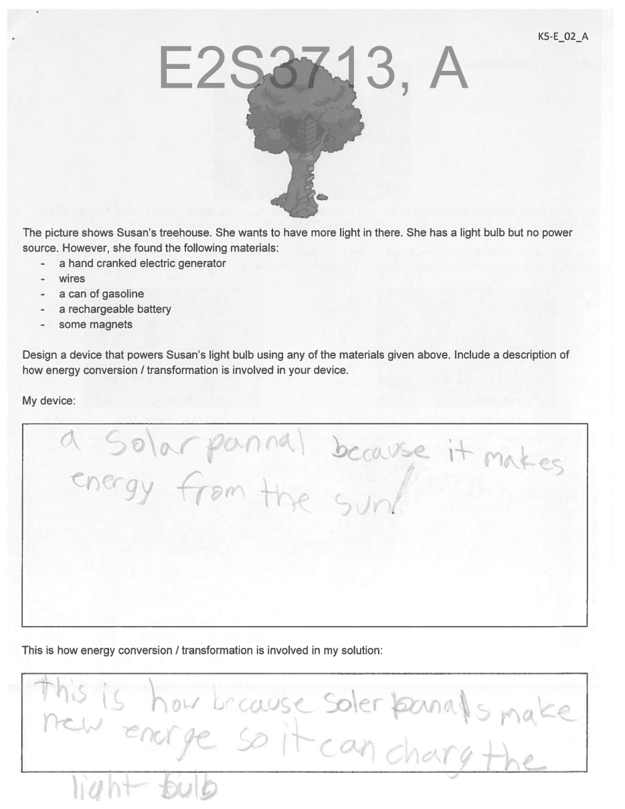 | The top row (A, B, C, D, E) refer to the column headings in the excel scoring template  Using the student response example to the left, we see the student code corresponds to the “Code” in the third row of the Scoring Template  - E2S3713 on the student response corresponds to “Code” on the Scoring template  Next to the student code on the student response example is the letter “A.” This tells us that we would use columns B and C to record our score as indicated by the “X’s” in the table above.  There will be a letter (A, B, C, D, E, or F) next to the student code on the student response. This letter will tell you which column to use in the excel scoring template.  - A, B, C use columns B and C  - D, E, F use columns D and E | Each response will have at least two scores. The number of scores will be shown in each rubric as a separate row.  - Des = Design Score  - Just = Justification Score  - Pre = Prediction Score  - C = Claim Score  - E = Evidence Score  - R = Reasoning Score  - Pro = Problem Score  - Sol = Solution Score  - Graph = Graph Score  - Inv = Investigation Score  - Prop = Property Score  - CoV = Control of Variables Score  - Mod = specify variable/ components Score  - Rel = Relationship Score  - Ident = Identification Score  - Expl = Explanation Score
  A | B | C | D | E
  Code | A/C_K5-E_02_Des | A/C_K5-E_02_Just | D/F_K5-E_02_Des | D/F_K5-E_02_Just
  E2S3255
  E2S3713 | XXXXX | XXXXX
  E2S9898

FAQ

Transfers of energy or transformations of energy?
- Many of the phenomena in the tasks can be analyzed through a lens of energy transfers or energy transformations. As long as the answer is scientifically appropriate, it does not matter which lens (energy transfers or energy transformations) students use.

What about those statements such as “Correct” or “+A” on some of the sheets?
- Those are markings from the teachers which do not reflect how we score the tasks - ignore them.

What counts as evidence?
- Evidence always has to refer to the data/picture/story in the task. Reference to personal or other experience does not count as evidence.

Can a student score evidence or reasoning without a claim?
- Claim, Evidence, Reasoning: To be able to receive credit for evidence, a student has to receive at least a partial credit for the claim. To be able to receive credit for reasoning, a student has at least to score a partial credit for claim and evidence.

Does the order of claim, evidence, reasoning matter? Do student labels like “claim” etc. matter?
- Claim, Evidence, Reasoning: If students specify which part of their answer is “claim”, “evidence”, and “reasoning”, we ignore this. For example evidence presented in the “claim” part is counted and does not diminish the “claim”. The order of Claim, Evidence, and Reasoning does not matter. Always take the answer as a whole into account.

In the rubric it says “the faster someone moves, the more energy he has”. Does the vice versa formulation also count?
- Relations in the rubric such as “The faster Anna moves, the more energy she has” are also considered if the students puts down a vice versa formulation (the slower Anna moves, the less energy she has)

Can models include text? What kind of models are you looking for?
- Models can be put down in various forms. They do not have to match the examples. Models can also be specified in writing, e.g. as the speed of the solar car increases, energy is transferred to it from the sun via light.

What about those models with boxes and arrows?
- Models: Some students learn to use an Energy Transfer Model (ETM). Such a model looks like this: Systems are represented as boxes with the system’s name in them.
Processes going on in the systems are represented in brackets in the system boxes. An arrow between the systems represents a transfer of energy in the direction the arrow is pointing.

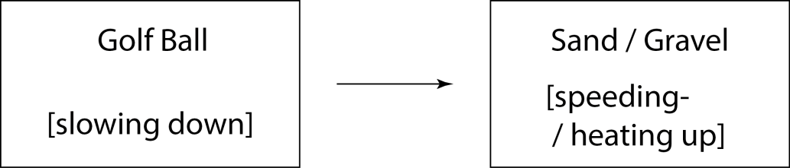

Standard Based Test

Middle School Energy

MS-E_05 Carpooling

PE: Construct and interpret graphical displays of data to describe the relationships of kinetic energy to the mass of an object and to the speed of an object.

Elements of Practice / Elements of DCI+CCC | Levels of Performance
Elements of Practice / Elements of DCI+CCC | 0 | 1 | 2
Identified Relationship | Students don't / incorrectly articulate a statement that relates given phenomenon / situation to a scientific idea (DCI / CCC).  - Incorrect or no statement about how the kinetic energy of an object is related to the mass of that object | Students incompletely articulate a statement that relates given phenomenon / situation to a scientific idea (DCI / CCC).  - Student states that if the mass of an object increases, its kinetic energy increases  The more mass, the more kinetic energy. | Students articulate a statement that relates given phenomenon / situation to a scientific idea (DCI / CCC).  - Student states that if the mass of an object increases, its kinetic energy increases proportionally (student don’t have to use the word proportionally but can say something like kinetic energy and mass increase in the same way)  When the mass of an object increases, the kinetic energy increases proportionally.
Justification | Students don't / incorrectly identify and describe the relevant given data to provide evidence that supports their claim.  - Incorrect or no reference to the mass of the car and respective kinetic energy.  The more passengers there are, the less kinetic energy because the more people in the car, the more gas is needed. | Students incompletely identify and describe the relevant given data to provide evidence that supports their claim.  - Students discuss that the kinetic energy (measured by the gasoline consumption) increases with the mass of the car (measured by the amount of passengers).  The data in the graph demonstrates that mass and kinetic energy have a relationship because when the number of passengers increases, the more kinetic energy is needed. This is shown with the variable gasoline. | Students identify and describe the relevant given data to provide evidence that supports their claim.  - Students discuss that the kinetic energy of an object is proportional to its mass by identifying that when the mass of the car (measured by the amount of passengers) increases, the kinetic energy (measured by the gasoline consumption) is growing in the same way.  The graph shows, that when the mass of the car (measured by the amount of passengers) increases, the kinetic energy of the car (measured by the gasoline needed to speed it up) increases proportionally.
 | 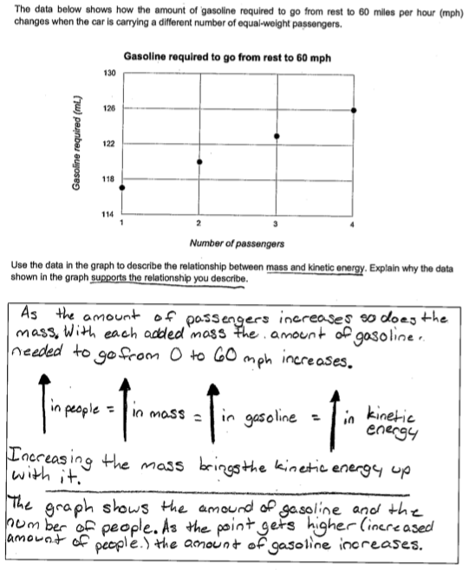 | 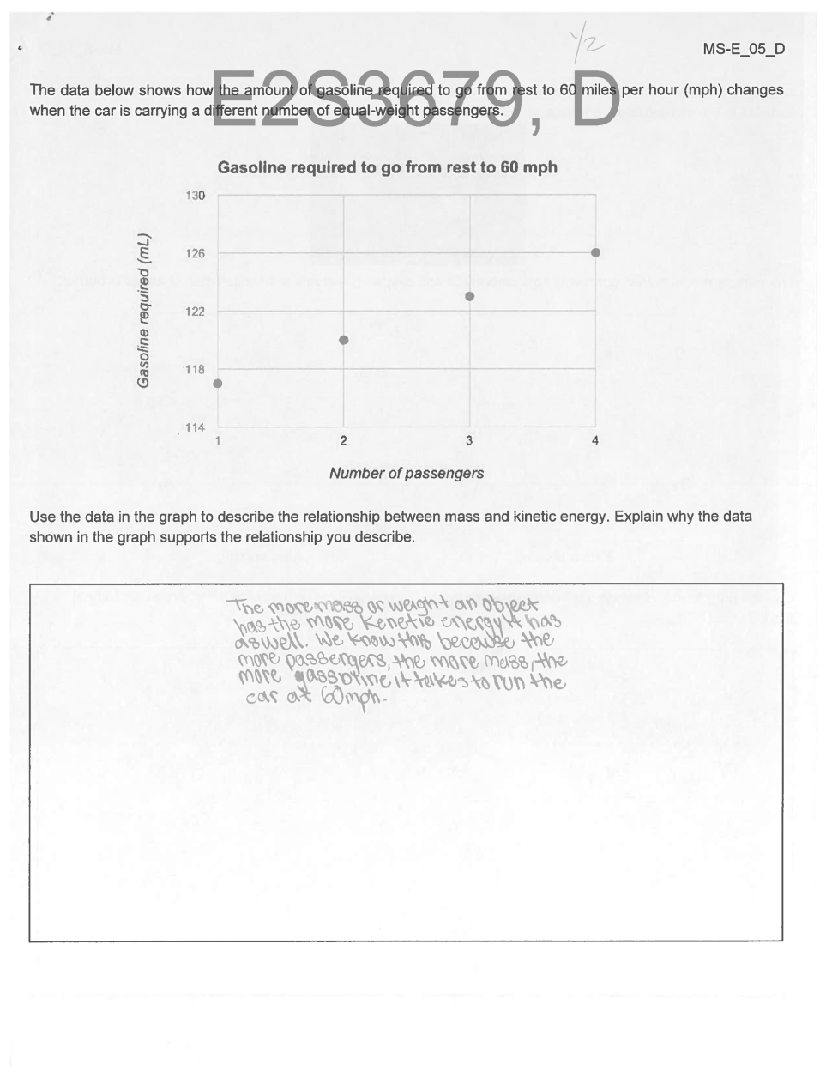
Identified relationship | Partial credit (1): Relationship between mass and kinetic energy established, but no reference to proportionality. | Partial credit (1): “Correct relationship identified (more mass = more kinetic energy) However, no explicit reference to proportionality.
Justification | No Credit (1): Gasoline consumption is lined to kinetic energy and mass of the car is related to number of passengers. | Partial credit (1): More passengers mean more mass which means more gasoline (as a measure of energy) is consumed. However, no explicit reference to proportionality.

MS-E_08 Space Jump

LP: LP-1: Develop a model that describes the relationship between the (gravitational) potential energy of a system of two objects, the speed of the objects, and the distance between them.

Elements of Practice / Elements of DCI+CCC | Levels of Performance
Elements of Practice / Elements of DCI+CCC | 0 | 1 | 2
Specify components / variables | Students don't / incorrectly provide a model that depicts relevant components.  The student does not provide a model that includes representations of the Earth and Felix Baumgartner.  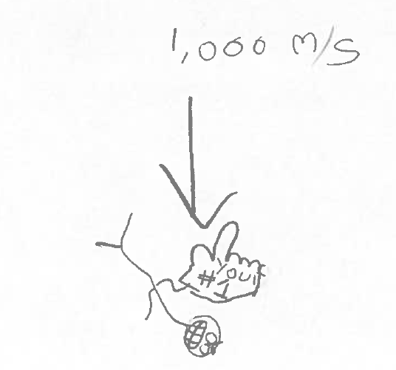 | Students incompletely provide a model that depicts relevant components (DCI / CCC components).  The student provides a model of the situation that includes representations of Felix Baumgartner and the Earth and  - The gravitational energy between the two  OR  - Felix Baumgartner’s speed  (A “gravitational field” system counts as a representation of earth. Gravitational energy can be represented as an arrow in an ETM) (“high”, “height” etc. count as references to the Earth)  Felix Baumgartner gets his kinetic energy from the gravitational energy he has when he is very high up.  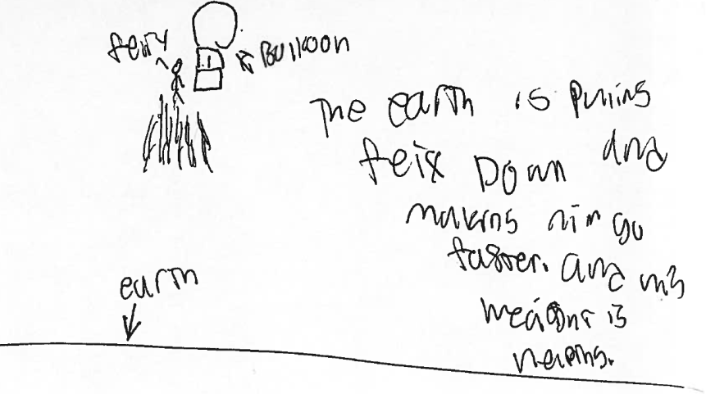 | Students provide a model that depicts relevant components (DCI / CCC components).  The student provides a model that includes a representation of Felix Baumgartner, the Earth, the gravitational energy between the two, and Felix Baumgartner’s speed.  (A “Felix/Earth gravitational field” system counts as a representation of earth. Gravitational energy can be represented as an arrow in an ETM) (“high”, “height” etc. count as references to the Earth)  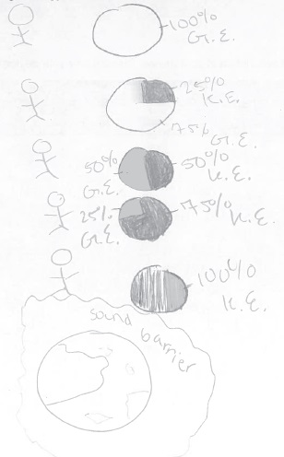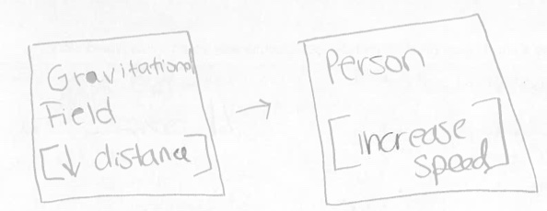
Relationship between components | Students don’t provide a model that depicts relevant relationships between components (DCI / CCC components).  In the model, the student does not depict that the decrease in potential energy between the Earth and Felix Baumgartner leads to an increase in his speed. | Students incompletely provide a model that depicts relevant relationships between components (DCI / CCC components).  In the model, the student depicts  - the decrease in potential energy between the Earth and Felix Baumgartner. (The decrease in potential energy can be depicted as a transfer from a Earth/Felix gravitational field system or a gravitational field system)  OR  - The increase in his speed. | Students provide a model that depicts relevant relationships between components (DCI / CCC components).  In the model, the student depicts that the decrease in potential energy between the Earth and Felix Baumgartner leads to an increase in his speed.  (The decrease in potential energy can be depicted as a transfer from a earth / Felix gravitational field system or a gravitational field system )  Felix traveled so fast without an engine because as he is falling he is losing gravitational energy and its being converted into kinetic energy. This is why Felix was travelling so fast without an engine.

 | 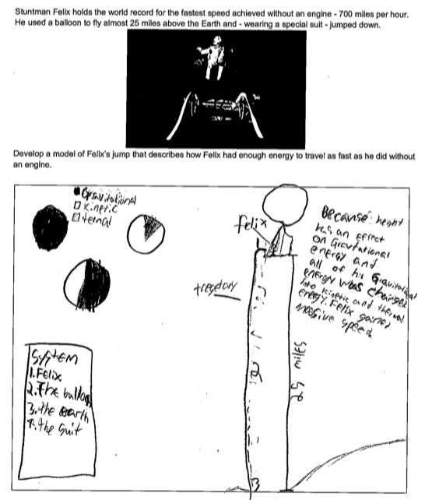 | 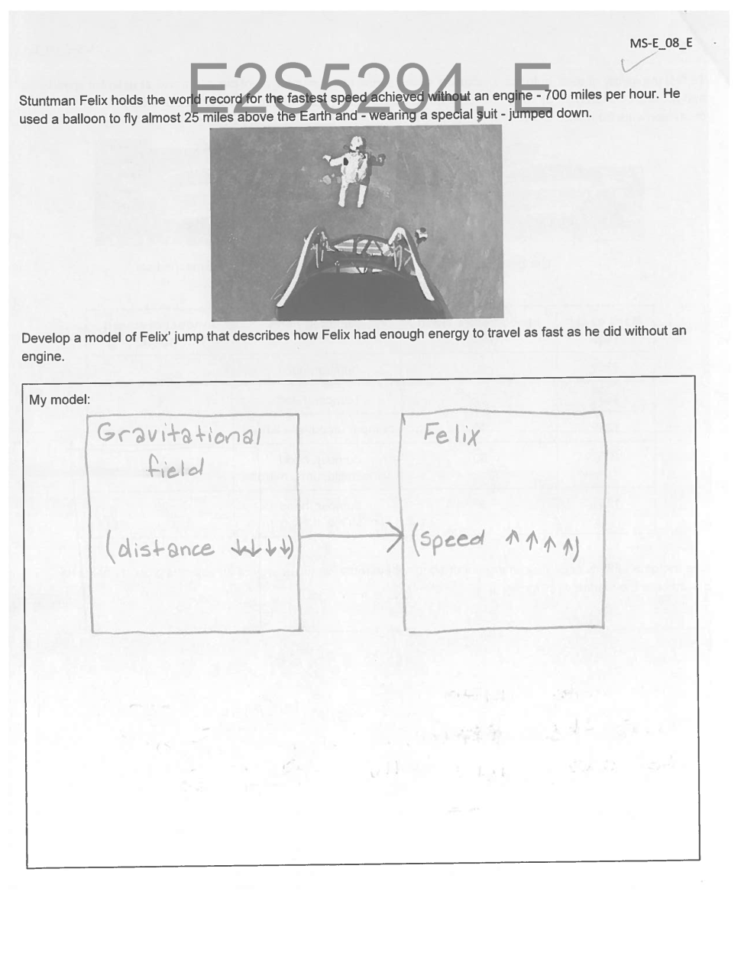
Specify components / variables | Full credit (2): The model includes a representation of Felix, the Earth, the gravitational energy (pie chart) and a reference to his speed (“gain massive speed”) | Partial credit (1): The model includes representations of Felix Baumgartner, the Earth, (gravitational field) the gravitational energy between the two (arrow), and Felix Baumgartner’s speed. However, the model shows a “gravitational field” instead of a “Felix/Earth gravitational field”.
A Relationship between components | Full credit (2): In the pie charts, gravitational energy decreases and kinetic energy increases which in the text is linked to an increase in his speed. | Full credit (2): An increase of Felix’s speed and a decrease of the energy in the gravitational field system are depicted.

MS-E_10 BBQ

LP: LP-5 Develop a model that describes how the energy of a system of particles changes when the particles undergo a chemical reaction.

Elements of Practice / Elements of DCI+CCC | Levels of Performance
Elements of Practice / Elements of DCI+CCC | 0 | 1 | 2
Relationship between components | Students don't / incorrectly describe the relevant changes in the relationships between model components (DCI / CCC).  - Students don’t describe that the distance between oxygen and carbon particles has changed (that they have rearranged). | Students incompletely describe the relevant changes in the relationships between model components (DCI / CCC).  - Students describe that the distance between oxygen and carbon particles has changed (that they have rearranged / changed etc.). | Students describe the relevant changes in the relationships between model components (DCI / CCC).  - Students describe that the distance between oxygen and carbon particles has decreased.
Explanation | Students don’t explain how the change in relationship they identified explain the phenomenon.  - Students don’t connect particle rearrangement with energy release / temperature increase. | Students incompletely explain how the change in relationship they identified explain the phenomenon.  - When the distance between particles changes / they rearrange, temperature can increase. | Students explain how the change in relationship they identified explain the phenomenon.  - When the distance between particles changes / they rearrange, energy can be released and heat up things
 | 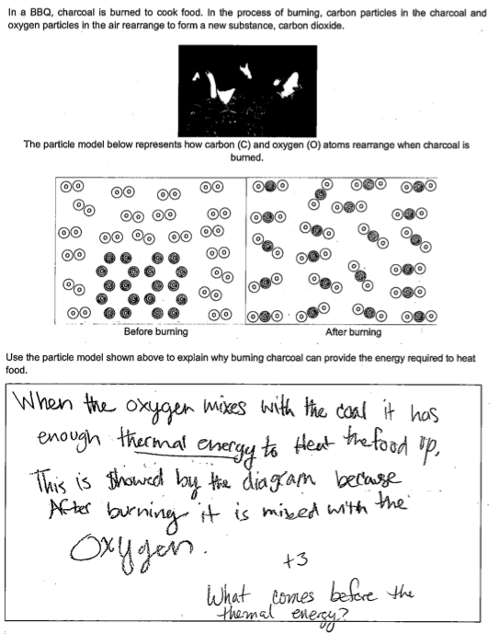 | 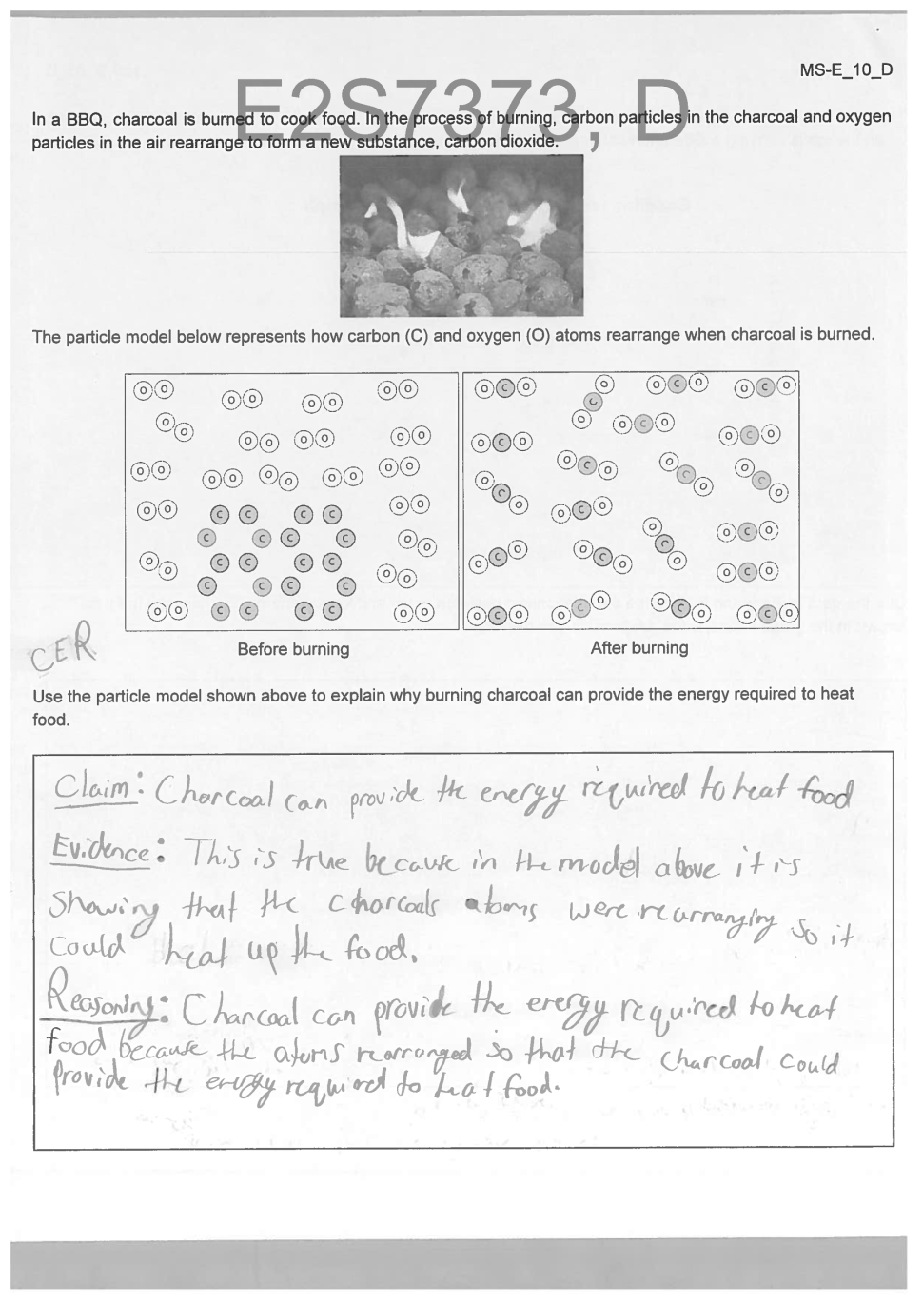
Relationship between components | Partial credit (1): “This is showed by the diagram because after burning it is mixed with the oxygen.” Reference to change to rearrangement of carbon / oxygen particles. | Partial credit (1): Reference that the particles rearranged. However, no reference to change in distance.
Explanation | Partial credit (1): “When the oxygen mixes with the coal it has enough thermal energy to heat the food up.” Rearrangement of particles is related to an increase in temperature. | Full credit (2): Particle rearrangement is linked to release of energy and temperature increase.

MS-E_11 Bumper cars

LP: LP-5a: Construct an explanation to support the claim that, when objects collide or otherwise come into contact, kinetic energy of one object is transferred to other objects.

Elements of Practice / Elements of DCI+CCC | Levels of Performance
Elements of Practice / Elements of DCI+CCC | 0 | 1 | 2
Evidence | Students don't / incorrectly identify and describe the relevant given data to provide evidence that supports the claim.  - Incorrect or no statement that before the collision Anna’s car moves at high speed, and Donnie’s car is at rest. The cars collide. After the collision Donnie’s car moves at high speed and Anna’s car moves at a slower speed. | Students incompletely identify and describe the relevant given data to provide evidence that supports the claim.  - Statement that after the collision Donnie’s car sped up.  OR  - Statement that after the collision Anna’s car slowed down.  Donnie’s car moves back because it didn’t have energy being transferred to it then Anna’s car hit Donnie’s and a force acted on it pushing it back and energy was transferred to Donnie’s cart from Anna’s | Students identify and describe the relevant given data to provide evidence that supports the claim.  - Statement that before the collision Anna’s car moves at high speed, and Donnie’s car is at rest. The cars collide. After the collision Donnie’s car moves at high speed and Anna’s car moves at a slower speed.  Donnie’s Car speeds up after the collision because during the collision Anna’s car gives its energy to Donnie’s. This is shown by Donnie’s car increasing speed and Anna’s car decreasing speed.2
Reasoning | Students don't / incorrectly connect a scientific principle (DCI / CCC) to link their evidence from the data provided in the item with the claim.  - Incorrect or no statement that during collision, the decreasing of the speed of Anna’s car indicated the decreasing of its energy, while the other car, which is originally at rest, began to move indicated that its energy increased. Therefore we can claim that energy of Anna’s car was transferred to Donnie’s car.  Donnie’s car got Anna’s car energy. Anna got Donnie’s energy. So that is why Anna comes to a halt. | Students incompletely connect a scientific principle (DCI / CCC) to link their evidence from the data provided in the item with the claim.  - During the collision Donnie’s car sped up which indicates that energy was transferred to it. Since it collided with Anna’s car, the energy was transferred from Anna’s car.  Donnie’s car moves back because it didn’t have energy being transferred to it then Anna’s car hit Donnie’s and a force acted on it pushing it back and energy was transferred to Donnie’s cart from Anna’s | Students connect a scientific principle (DCI / CCC) to link their evidence from the data provided in the item with the claim.  - During collision, the decreasing of the speed of Anna’s car indicated the decreasing of its energy, while the other car, which is originally at rest, began to move indicated that its energy increased. Therefore we can claim that energy of Anna’s car was transferred to Donnie’s car.

 | 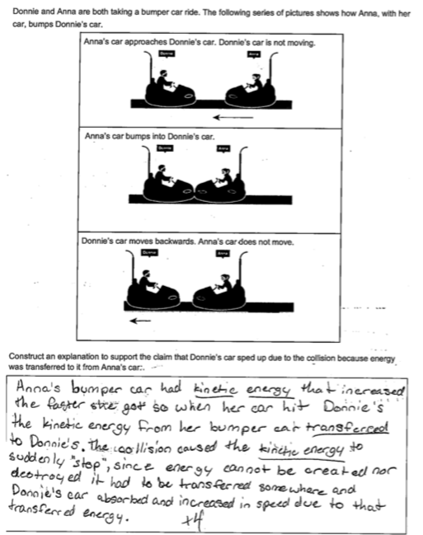 | 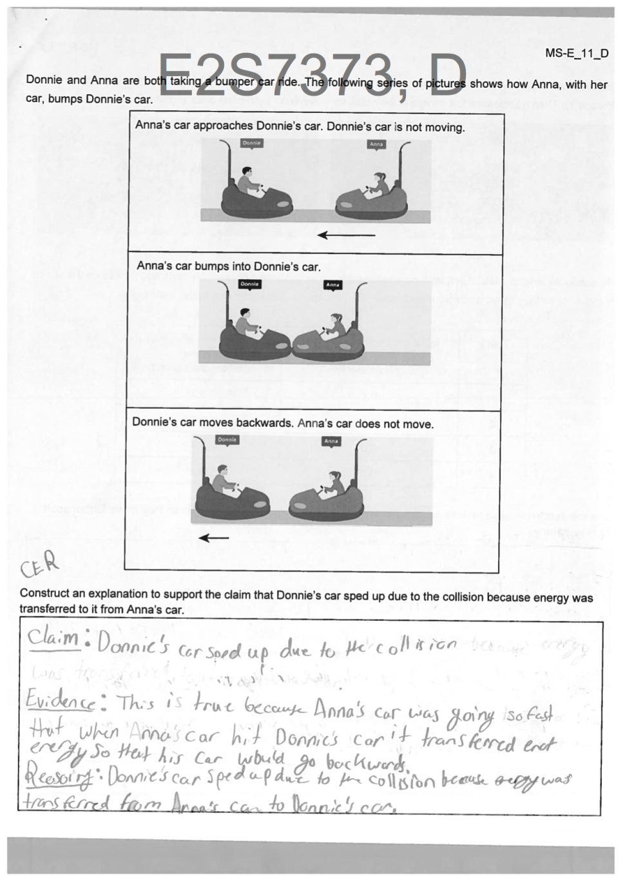
Evidence | Partial credit (1): “The collison caused […] Donnie’s car […] increased in speed.” Statement that after the collision Donnie’s car sped up. | Partial credit (1): Statement that after the collision, Donnie’s car sped up. No reference to the speed of Anna’s car.
Reasoning | Partial credit (1): “It [energy] had to be transferred somewhere and Donnie’s car absorbed and increased in speed due to that energy transfer.” Statement that relates the increase in speed and energy of Donnie’s car to an energy transfer from Anna’s car. | Partial credit (1): Statement that during the collision Donnie’s car sped up which indicates that energy was transferred to it. The energy was transferred from Anna’s car. However, no reference to the changes in speed of both cars.

MS-E_13 Repelling magnets

LP: LP-3: Analyze data in order to identify the relation between changes in the potential energy of a system of two charges and the change of the distance between them.

Elements of Practice / Elements of DCI+CCC | Levels of Performance
Elements of Practice / Elements of DCI+CCC | 0 | 1 | 2
Analysis of Data | Using data, students don’t / incorrectly articulate a statement that identifies a relation between two variables (DCI / CCC).  - Incorrect or no statement about how speed of a cart is related to the distance between the carts. | Using data, students incompletely articulate a statement that identifies a relation between two variables (DCI / CCC).  - Student only interprets one variable, i.e. states that the speed increases / decreases  OR  - that the distance increases / decreases.  The greater the distance between them, the slower the reaction, so the less potential energy. | Using data, students articulate a statement that identifies a relation between two variables (DCI / CCC).  - Student states that if the speed of the cart increases, the distance between the carts decreases (and vice versa).
Data Evaluation | Students don’t / incorrectly evaluate their analyzed data, linking it to the investigation.  - Incorrect or no statement that that links a change in speed to an energy transfer. That energy is transferred from the potential energy between the two magnets. | Students incompletely evaluate their analyzed data, linking it to the investigation.  - Student statement that links a change in speed to an energy transfer from the potential energy between the two magnets.  OR  - An increase in speed goes together with a decrease in potential energy (and vice versa). | Students evaluate their analyzed data, linking it to the investigation.  - Student statement links a change in speed to an energy transfer or transformation. Energy is transferred from the field between the two magnets and the cart  OR  - magnetic potential energy is transformed into kinetic energy.  As the magnets are held close together and the magnetic fields get closer together and the potential energy increases. When you let go the push drives them away making one of the carts increase in speed. As the kinetic energy (speed) increases the potential energy decreases.
Identification of Relationship | Students don't / incorrectly use their analysis of the data to identify the relation between changes in the potential energy of a system of two charges and the change of the distance between them.  - Incorrect or no reference to the relation between potential energy of a system of two magnets and the distance between them. | Students incompletely use their evaluation of the data to identify the relation between changes in the potential energy of a system of two charges and the change of the distance between them.  - Students identify that when the distances between two magnets changes, the potential energy of that system changes. | Students use their evaluation of the data to identify the relation between changes in the potential energy of a system of two charges and the change of the distance between them.  - Drawing on the increase in kinetic energy of the carts, students identify that when the distances between two magnets decreases, the potential energy of that system increases.  The greater the distance between them, the slower the reaction, so the less potential energy
 | 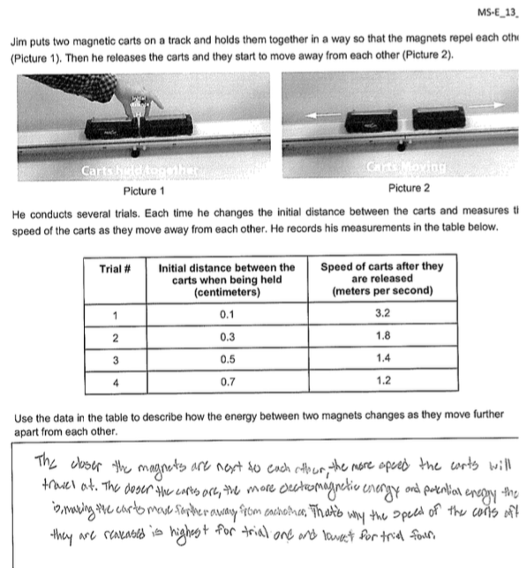 | 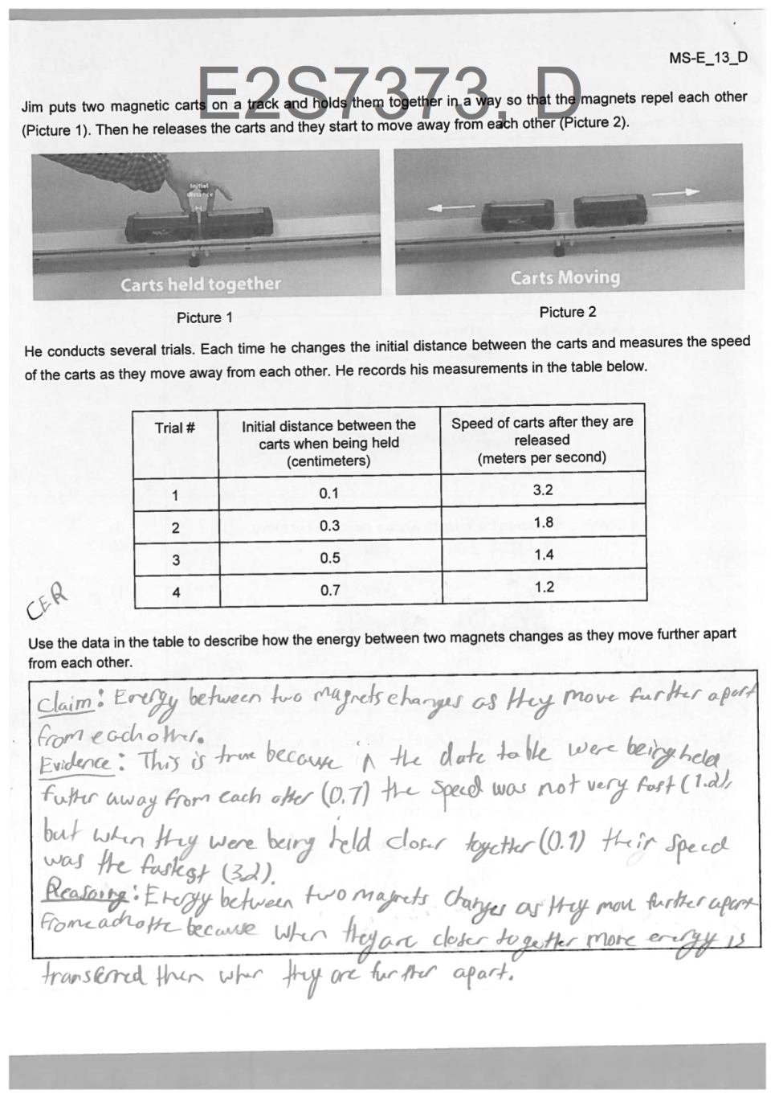
Analysis of Data | Full credit (2): Statement connects the increase in speed with a decrease in distance of the magnets. | Full credit (2): Statement connects the increase in speed with a decrease in distance.
Data Evaluation | Partial credit (1): The change in speed is connected to potential energy. | Partial credit (1): The statement links a decrease in distance between the magnets with an increase of energy that is transferred from them. (This increase in energy that is transferred from them can only be connected to the increase in speed.)
Identification of Relationship | Full credit (2): “The closer the carts are, the more potential energy here is.” Relates decreasing distance between the magnets to increasing potential energy. | Partial credit (1): Statement connects a change in distance between the magnets with a change in energy between them.

MS-E_15 Air Hockey

LP: LP-5b: Analyze and interpret data to support the claim that, when objects collide or otherwise come into contact with each other, kinetic energy of one object is transferred to other objects.

Elements of Practice / Elements of DCI+CCC | Levels of Performance
Elements of Practice / Elements of DCI+CCC | 0 | 1 | 2
Evidence | Students don't / incorrectly identify and describe the relevant given data to provide evidence that supports the claim.  - Incorrect or no reference to the speed of the pucks after the collisions. | Students incompletely identify and describe the relevant given data to provide evidence that supports the claim.  - Reference to data that the speed of Julia’s puck decreased after the collisions.  OR  - Reference to data that the speed of Phillip's puck increased after the collisions. | Students identify and describe the relevant given data to provide evidence that supports the claim.  - Reference to data that the speed of Julia’s puck decreased after the collisions.  AND  - Reference to data that the speed of Phillip’s puck increased after the collisions.
Reasoning | Students don't / incorrectly connect a scientific principle (DCI / CCC) to link their evidence from the data provided in the item with the claim.  - Incorrect or no statement that since the speed of the pucks changes during the collision, energy is transferred during the collision. | Students incompletely connect a scientific principle (DCI / CCC) to link their evidence from the data provided in the item with the claim.  - Since the speed of the pucks changes during the collision, energy is transferred during the collision.  In the first collision, Julia’s puck is going 2 m/s but slows down after the collision because her puck transferred its energy to Philip’s puck, cause Philip’s puck to go faster. This happens with each collision, just with different speeds. | Students connect a scientific principle (DCI / CCC) to link their evidence from the data provided in the item with the claim.  - Statement that since speed is an indicator of an object’s energy a decrease/increase in speed in connected to a decrease/increase in kinetic energy. Since the speed of one puck increases in the collision while the other slows down, energy is transferred from the faster to the slower puck.  Energy is transferred from the fast puck to the slow one because each time the fast puck decreases by a number the slow puck increases by that much and we know that when something is decreasing, energy is being transferred from it and when something increases the energy is being transferred to it.
 | 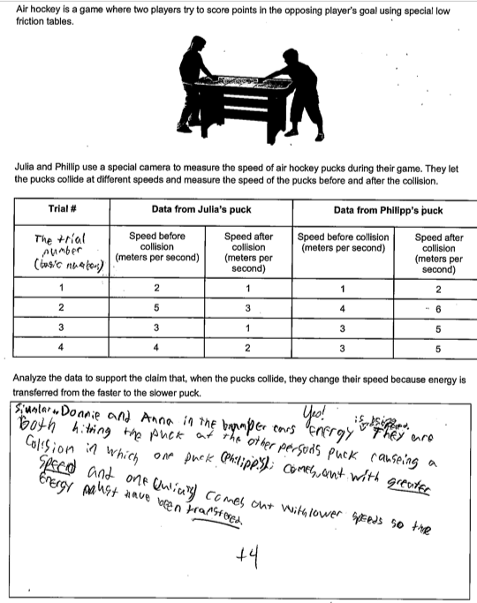 | 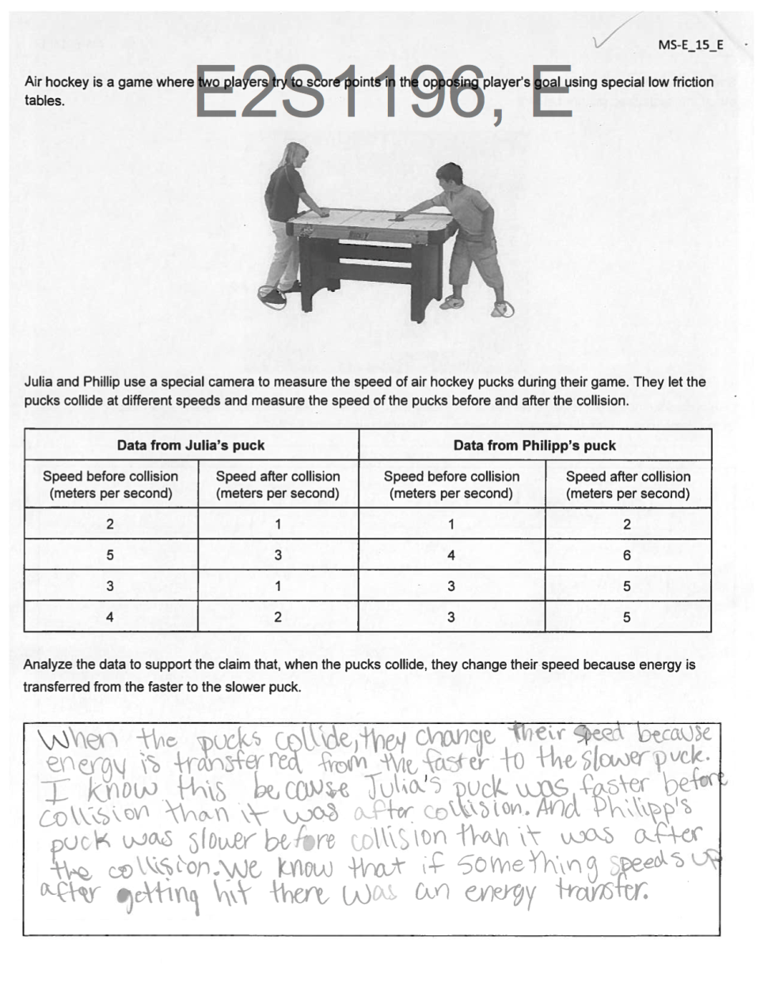
Evidence | Full credit (2): Reference to the changes in speed of Julia’s and Phillip’s pucks. | Full credit (2): Reference to data that the pucks decreased / increased in speed after collisions.
Reasoning | Partial credit (1): “[…] causing a collision in which one puck comes out with greater speed and one comes out which lower speed so the energy must have been transferred.” Statement that when the pucks collide they change their speed because energy was transferred. | Partial credit (1): “We know that if something speeds up after getting hit, there was an energy transfer”. However, for full credit a reference to something slowing down after a collision is missing.

