Additional file 1. Supplementary Materials
Supplementary Material A. Teacher and student protocols

Teacher protocol - High school 3D plant modeling

The Project

The Education Research and Outreach Lab at the Donald Danforth Plant Science Center (DDPSC) offers opportunities to high school students to promote science education. This project addresses the disconnect between science, design, and technology. It explores how high school students can benefit from innovative learning experiences in plant science that integrate these disciplines while allowing them to gain the interest and skills needed for future STEM careers.

This project offers direct learning opportunities for high school students based on the innovative use of technologies such as virtual and augmented reality (AVR), that inspire creative learning, provide critical thinking and problem-solving benefits, support concepts of innovation and creativity, and allow students to connect to real-life situations impacting STEM career paths. Through the AVR experiences, students will work in collaborative teams to create 3D models of plant objects. In doing so, they will be able to establish a connection between science, technology, and design. Teams will consist of self-identified science, technophile, and art students to generate the awareness that design and technology are a part of science, and that science is a part of design and technology. A STEAM (science, technology, engineering, art, and math) approach will be applied in which students’ projects are focused not only on the final product but also on the artistic creative process. Strategic partnerships with scientists from the DDPSC and the zSpace AVR company will support the development of students’ projects through training and mentoring. Students will have the opportunity to interact with researchers and present their projects at public and scientific events. Students will be trained in the use of AVR technologies and 3D design. This project will generate AVR plant science content that will be available to educators and students around the globe through zSpace. These experiences will be implemented, tested, and evaluated through the Plant and Agriculture Virtual Reality Learning Laboratory (PAVRLL) at the DDPSC. This learning experience will also contribute to the PAVRLL efforts to increase student awareness and improve knowledge about plants. Beyond plant-based content assessments, we will assess if these enriching experiences improve student attitudes towards STEAM subjects and interests in STEM careers.

Objectives
The overall and long-term goal of this project is to promote the connection between science, technology, and design among high school students while providing direct learning opportunities that will guide them in choosing their future career paths. The STEAM goal will be accomplished through four major objectives:
- Science: Inspire interest in STEM careers among students and provide them with skills for a future STEM career.
- Science: Foster knowledge and appreciation of plant science among high school students.
- Design: Integrate art and design into STEM plant science education (STEAM).
- Technology: Apply AVR technology to advance plant science education through the use of novel tools and methodologies.

Learning outcomes
Students who participate in this project are expected to be able to:
- Use AVR technology and its applications to create 3D plant models, thereby building useful technological skills for potential future STEM career paths.
- Identify and describe plant content and increase awareness of plants.
- Recognize the importance of art and design within STEM and appreciate science opportunities within art and design.
- Recognize the opportunities available for a future career in STEAM fields.
- Acknowledge the benefit of collaboration among peers, teachers, and scientists.

Education science and art standards
Below are the Next Generation Science Standards and the National Core Art Standards that apply to this project and that are expected to be used as a framework for the learning outcomes.

Next Generation Science Standards
Performance Expectations | Disciplinary Core Ideas
Life Science
HS-LS1 From Molecules to Organisms: Structures and Processes
HS-LS1-5. Use a model to illustrate how photosynthesis transforms light energy into stored chemical energy. | LS1.C: Organization for Matter and Energy Flow in Organisms
HS-LS2 Ecosystems: Interactions, Energy, and Dynamics
HS-LS2-4. Use mathematical representations to support claims for the cycling of matter and flow of energy among organisms in an ecosystem. | LS2.B: Cycles of Matter and Energy Transfer in Ecosystems
HS-LS2-5. Develop a model to illustrate the role of photosynthesis and cellular respiration in the cycling of carbon among the biosphere, atmosphere, hydrosphere, and geosphere. | LS2.A: Interdependent Relationships in Ecosystems
HS-LS4 Biological Evolution: Unity and Diversity
HS-LS4-4. Construct an explanation based on evidence for how natural selection leads to adaptation of populations. | LS4.C: Adaptation
Engineering, technology, and applications of science
HS-ETS1-3. Evaluate a solution to a complex real-world problem based on prioritized criteria and trade-offs that account for a range of constraints, including cost, safety, reliability, and aesthetics as well as possible social, cultural, and environmental impacts.
HS-ETS1-2. Design a solution to a complex real-world problem by breaking it down into smaller, more manageable problems that can be solved through engineering. | ETS1.B: Developing Possible Solutions
 | ETS1.C: Optimizing the Design Solution

National Core Arts Standards
Artistic Process | Anchor Standard #
Creating | Conceiving and developing new artistic ideas and work  AS#1. Generate and conceptualize artistic ideas and work  AS#2. Organize and develop artistic ideas and work  AS#3. Refine and complete artistic work
Presenting | Presenting (visual arts): Interpreting and sharing artistic work  AS#4. Select, analyze, and interpret artistic work for presentation  AS#5. Develop and refine artistic techniques and work for presentation  AS#6. Convey meaning through the presentation of artistic work
Responding | Understanding and evaluating how the arts convey meaning  AS#7. Perceive and analyze artistic work  AS#8. Interpret intent and meaning in artistic work  AS#9. Apply criteria to evaluate artistic work
Connecting | Relating artistic ideas and work with personal meaning and external context  AS#10. Synthesize and relate knowledge and personal experiences to make art  AS#11. Relate artistic ideas and works with societal, cultural and historical context to deepen understanding

Materials
Provided by the DDPSC | Provided by the schools
8 zSpace AIOs with 8 3D and 16 2D glasses | Proper area and sturdy surfaces to display the zSpaces
5 Oculus Quest | Continuous electrical source
Manuals and protocols | Care and safe use of the zSpaces
Cleaning supplies | Cleaning of the equipment to prevent infectious diseases

How to implement the project with your students

Overall project activities for teachers

- Guide your students to work in teams of self-identified science, technophile, and art students to create 3D models related to plant and agriculture.
- Collaborate with scientists from DDPSC in the creation of the 3D models.
- Support students through the preparation of presentations of team projects in public and scientific events.
- Contribute to education research by sharing the artifacts (e.g., 3D models, photos, drawings, etc.) from the team projects and participating with your students in education assessments.
- Use AVR technology in the classroom (e.g., zSpace and Oculus) to educate students about plants and agricultural science.
- Care for the AVR equipment.

Coordinate the implementation of the project

- Contact the Program Manager (PM), Sandra Arango-Caro (sarango-caro@danforthcenter.org), to coordinate a school visit, the delivery of the materials and equipment, and to have access to the project documents.
- Access your Google folder space using the link provided by e-mail. You need to have a Google account.
- Read and sign the photo release, acknowledgement of responsibility, and inventory forms and upload them in your Google folder or e-mail them to Sandra Arango-Caro, unless the school already has photo waivers of the students.

Preparations for project implementation

- Teacher and PM meetings

The PM will discuss with you the needs and interests that this project can address for your class and a timeline for the project implementation (Table 1). Based on these discussions, the PM will provide a link to a Google folder with the information that is necessary to implement the project including forms, assessments, videos, assessments, articles, protocols, etc.
It would be your responsibility to get familiar with the material, complete the forms and assessments and attend the necessary training prior to the project implementation with the students.

- Teacher training

It is recommended that you get familiar with the 3D modeling readings (page 7) and the software that the students will be using (Table 2), which are required for students.

Table 1. Timeline of project implementation (T-Teacher, S-Student, PM-Project Manager, M-Mentor).

Who | Activity | Time | Page
T/PM | Learn about the project and plan its implementation. Meetings with PM. Setup and access to a Google folder. Read protocols. | 2 h | 1-11
T | Teacher introduction to 3D modeling software (Tinkercad® and Fusion 360®). | 1 h | 7-8
T/PM | Project presentation to students by teacher and PM. | 1 h | 5
T/S | BEFORE starting the project, ask students to complete surveys, reflections, and photo waivers. Ask parents to complete consent forms. | 30 min | 5
T/S | Set up teams, assign roles, inform about team etiquette. | 15 min | 6-7
S | Student training (3D modeling readings, Tinkercad® and Fusion 360® videos, accounts creation). | 3-4 h | 7-8
T/S/  PM | Ask teams to discuss the potential 3D models to create based on DDPSC needs and choose plant species to create their models. | 30 min | 9
S/M | Students develop the concept art of the 3D models, investigate the species biology and importance for research and society, consult with mentors. | 3 h | 9-10
S/M | Teams work on the creation of the 3D models. | ~6 h | 10
S/M | Students interact with mentors for models’ accuracy and to resolve questions about the biology and importance of the plants. | 1 h | 10
S/M | Students work on the refinement of their models. | ~6 h | 10
T/S/  PM | Students have augmented and virtual reality experiences with zSpace and Oculus and learn about the use of 3D models in these environments. | 1 h | 10
T/S | Teams prepare posters, PowerPoint presentations and or videos of their projects. | 4 h | 10-11
T/S/  PM/M | Students present their projects virtually (15 minutes per team) during a school, scientific or public event. | 1-2 h | 10-11
T/S | Ask students to complete surveys and reflections and complete the teacher evaluation. | 30 min | 11

- PM visit to the school

Meeting with teacher(s): The PM will review any questions that you may have about the implementation of the 3D modeling project.

Google folders: You will receive links to access Google folders where you and your students will be able to download (protocols, forms) and upload information (signed forms, photos, 3D models, presentations, etc.). You and your students will have also access to links to complete education research questionnaires.

Project presentation: The PM will introduce the project to students during an in-person or virtual school visit.

Intellectual property rights: Students and teachers will be informed in advance that the products (models) they generate through this project will be open access. These products will be shared through the zSpace community, which will provide teachers and students across the world with the opportunity to use them.

- Education research pre-surveys

The Education Lab at DDPSC will work with you to help you administer surveys and written reflections (pre- and post-project) to students for education research. Student responses will contribute to STEAM (Science, Technology, Engineering, Arts and Mathematics), an emerging discipline with scant information on theory, best practices, and practical applications, by testing a STEAM teaching model in which student’s design and create scientific products to use with AVR tools. The proposed project will contribute to the body of knowledge on teaching tools using AVR, from a different approach by giving opportunity to high school students to create their own AVR products. Surveys will assess changes in student perceptions about scientific disciplines and careers in STEAM and about awareness of plants and plant science.

Before the project starts, ask students to complete two pre-surveys (STEAM Semantics Survey and Plant Awareness Index) and reflection questions. To use the students’ answers in scientific publications, student consent is required (student personal information is not included in publications). Parental consent is also required for students that are minors (younger than 18 years of age). The links to access all the questionnaires and forms are below. Later in the protocol are the links to the surveys and reflections to complete after the project is over:
- Parent consent form for students younger than 18 years of age: https://survey.iad1.qualtrics.com/jfe/form/SV_bdCL901Up95Gyqi
- Pre-survey on student perceptions of scientific disciplines (STEM Semantic survey) with student consent/assent and demographic forms:
https://survey.iad1.qualtrics.com/jfe/form/SV_eOKH836OTaLs9Lg

- Pre-survey on student plant awareness:
https://survey.iad1.qualtrics.com/jfe/form/SV_8dFn8PWaTpiA3qe
- Pre-questionnaire for student written reflections:
https://survey.iad1.qualtrics.com/jfe/form/SV_7Wo2pXIbFptN78i
Also, ask students to complete a photo waiver form:
https://survey.iad1.qualtrics.com/jfe/form/SV_5o0Yp37Tfcjwdp4

Implementation of the project with the students

- Teams

Create teams of 3-6 students. In each team, try to have a representation of self-identified scientist, technophile, and art students. Ask the teams to discuss among themselves who will have the roles explain below. Based on the number of students in a team, students may have more than one role (small teams) or teams may have more than one student in a role (large teams). Make sure they understand that all members should participate in all phases of the project.
- Lead role: Maintains communication among members, makes sure everybody is participating in all phases of the project, checks that students complete the education research surveys, etc. Maintains contact with teacher.
- Scientist role: Coordinates the acquisition of information about the biological content and importance of the team’s model(s). Maintains contact with mentor.
- Artist/Designer role: Coordinates the development of the concept art and ensures that the 3D model looks as accurate as possible. Supports the creation of the project presentations. Maintains contact with mentor.
- Technical role: Helps members with the training and use of the applications to design, create, and use the 3D models. Supports the creation of material for the presentations of the projects.
- Communication role: Coordinates the preparation and dissemination of the projects (Preparation of posters, PowerPoint presentations and or videos). Maintains contact with teacher and PM.

Promote teamwork etiquette among your students:
- Listen to each other’s ideas
- Treat everybody respectfully
- Distribute the work fairly
- Do the work you committed to do
- Reflect on the benefits of collaboration

Emphasize to your students:
- To be patient, as they are learning by doing
- To be prepared for failing, as that is how we learn from our mistakes
- To be careful with the websites they access to prevent viewing inappropriate content
- To be responsible with the use of the equipment
Document the project progress through photos:
- Take photos of the teams and yourself during the different stages of the project.
- Encourage your students to take photos of themselves conducting the activity, as well as to take photos/screenshots of their sketches, on-line and in-person team meetings, and final products.
- These photos should be uploaded in your Google folder.

- 3D model design and creation

What is 3D modeling?
Recommend students to visit the following links for readings on beginner steps on 3D modelling:
- 3D Modeling 101: Comprehensive Beginners Guide
https://wow-how.com/articles/3d-modeling-101-comprehensive-beginners-guide

- 3D Modeling Basics
https://all3dp.com/2/3d-modeling-basics-simply-explained/

- 3D Modeling Basics
https://www.instructables.com/Intro-to-3D-Modeling/

- Student training

Students need to watch the training videos in Table 2. As they watch the videos, they should follow the steps to access Tinkercad® and Fusion 360® (e.g., account creation), learn the basic controls and do the exercises to create 3D models.

Table 2. 3D modeling training videos (Watch videos in order)
3D modeling  software | Description of videos and links (required to students)
Tinkercad  Overview:  https://www.tinkercad.com/ | Video 1: Welcome to Tinkercad! (1:30 min)  https://www.youtube.com/watch?v=LrU2zm_g7lE  Video 2: Tinkercad_Setup. Account creation and basic controls (7:57 min)*  https://drive.google.com/file/d/1ItYKeLWnCbtsM99cBmK4wgS2d5Ioud07/view?usp=share_link  Video 3: Tinkercad_Plant_Tutorial. Creation of a plant (5:36 min)  https://drive.google.com/file/d/1SybwtjYwurR1pyipYeU5yGvFIp-rJQWr/view?usp=share_link  Video 4: Tinkercad additional tutorial (9:46 min) (Optional)  https://www.youtube.com/watch?v=gOs6Mdj7y_4
Fusion 360  Overview:  https://www.autodesk.com/products/fusion-360/overview | Video 5: Fusion_Setup. Account setup for Autodesk to access Fusion 360 in computer or Chromebook (3:11 min)*  https://drive.google.com/file/d/1OFAXbePzihdSB5u7sj0YfWeZ6ijaWvIK/view?usp=share_link  Video 6: Fusion_Solids. Basic controls and creation of a cup (7:35 min)  https://drive.google.com/file/d/1SS6WkPa0AsxVRQXx6wRZH8M6Y2NsL07L/view?usp=share_link  Video 7: Fusion_Simple_Plant. Creation of stem and leaves (8:35 min)  https://drive.google.com/file/d/1Z5Y8V63qk-7bPzzWHz2Q3HLW_EhR-oDc/view?usp=share_link  Video 8: Fusion_Advanced Leaf. Creation of a leaf (6:48 min)  https://drive.google.com/file/d/1VK4jltUKkffkFIg8oogo9FdNCrnm8sFK/view?usp=share_link  Video 9: Fusion_Flower. Creation of a flower (9:59 min)  https://drive.google.com/file/d/19V_JFzrkw6rKv6k2JTKrexJ8-hdQ_A9L/view?usp=share_link
*Tinkercad® and Fusion360® are software that belong to the Autodesk platform. If you have an Autodesk account, you can access both programs. Watch Video 1: Fusion_Setup to create this account.
- Choosing the models to create

The PM will discuss with you the potential models to create with the students based on the needs of the research labs at DDPSC. In Table 3 is a list of potential species to model that are under research at the DDPSC.

This table is available as a separate document since it is continuously updated.

- Development of the concept art of the 3D models

The concept art is the visual concept of the 3D model that should be developed before starting to create the models. Students should start with the design of simple models of one object. As students practice and get familiar with the 3D modeling software, they can develop more complex models made of different parts. Teams may create more than one 3D model related to the same species and/or create models about plant-related processes (e.g., pollination, germination, etc.).

To develop the concept art of the models, students can draw or sketch their designs with pen and paper, or use tablets to make the digital sketches of the 3D models using the following free software:
- Autodesk Sketchbook: https://sketchbook.com/
- Google AutoDraw: https://www.autodraw.com/
- Inkscape: https://inkscape.org/about/overview/

- Work with scientists and mentors

Depending on the concept art, scientists and other mentors will work with the teams to advise on the biological aspect of the planned 3D models. For example, the mentor will suggest certain colors, shapes, or sizes that will make the models accurate when compared to real plant objects. The advisors will also help the students with the biological content and scientific importance of the models.

- 3D model creation

Students should first watch the training videos to get familiar with the 3D modeling software Tinkercad® and Fusion 360®.

Requirements for 3D models to be used in the zSpace and Oculus platforms
- Vertice count should not be greater than 20,000
- Export your models in .obj format
- The .obj export will be a zipped file and this entire file is necessary for importing into VR.
When designing the 3D models, students should keep in mind the scientific accuracy, ease of use, and aesthetics of the product design.

- Interaction with Augmented Reality (AR) and Virtual Reality (VR) tools

Students will have an in-person event when they will have the opportunity to learn to use zSpace computers for AR and Oculus Quest head mounted devices for VR experiences. They will learn how their 3D models could be used in AR and VR platforms.

- Dissemination of the teams’ projects

Students will prepare presentations of their projects with help and guidance from you and mentors. PowerPoint presentations, videos and/or posters could be used by the students to share their results. The projects could be presented under different settings:
- Through your school during class or during another school event (STEAM day, science fair, etc.).
- Through DDPSC during public or scientific events (Scientific Retreat, PlantFest, etc.). The PM will coordinate with you the attendance of students to the DDPSC events.

The PM will help coordinate the attendance of mentors to the presentation event, and mentors will evaluate the teams’ products based on:
- the use of technology through the products they create
- the scientific accuracy, ease of use, and aesthetics of the product design

To prepare for the presentations, students should take into consideration to:
- Include the following content:
  - motivation for choosing the target species and particular objects
  - biological content describing the species and importance of the species for DDPSC research and for society
  - design process
  - product: 3D plant model
  - challenges (positive and negative)
- Prepare slides that are visually appealing and look professional
- Practice the presentation in advance and test the timing of it
- (Optional) If your school has a 3D printer, consider creating a test print of the models to use during the presentation.

- 3D model worksheet

Each team will prepare a one-page worksheet. These worksheets will support teachers' lesson plans related to the species and their 3D model(s). The worksheets should include the following elements, some of which already will be available from the presentations:

- Title: the name of the species (common and scientific name)
- Images: photo of the plant and the plant part modeled if applicable (e.g., seed, flower), and photo(s) of the 3D model(s)
- Biology of the plant and its importance to society and or plant science research (1-3 paragraphs)
- 3D model: Description of 3D model (1-2 paragraphs)
- Questions: three to five questions formulated by the students (one per student) about what they will want to ask a student to learn about their model(s) and or science content.

Education research and evaluation

To continue with the education research goals of this project, teachers need to ask students at the end of the project, to complete post-surveys and post-reflections questions. In addition, teachers need to complete an evaluation questionnaire about the project experience. Use the following links to complete the questionnaires and forms:
- Post-survey on student perceptions of scientific disciplines (STEM Semantic
survey).
https://survey.iad1.qualtrics.com/jfe/form/SV_bK1wBTt5EjGqzau
- Post-survey on student plant awareness
https://survey.iad1.qualtrics.com/jfe/form/SV_8A1qLdl8SSYxQ34
- Post-questionnaire on student reflections
https://survey.iad1.qualtrics.com/jfe/form/SV_1Late3fRTxwOu46
- Teacher evaluation questionnaire
https://survey.iad1.qualtrics.com/jfe/form/SV_5nnPVuiDlsruCyO

If you need help

Students may find challenges while developing the 3D models.
- For technical questions about the use of Tinkercad® and Fusion 360®, students should contact Nate Ly at NLy@danforthcenter.org.
- For questions about the biology and importance of the chosen species, contact the PM Sandra Arango-Caro (sarango-caro@danforthcenter.org) or the designated scientific advisors for each team.

Student protocol - High School 3D plant modeling

The Project

This is a project from the Education Research and Outreach Lab of the Donald Danforth Plant Science Center. The overall and long-term goal of this project is to promote the connection between science, technology, and design among high school students while providing direct learning opportunities that will guide them in choosing their future career paths. The STEAM (science, technology, engineering, art, and math) goal will be accomplished through four major objectives:

1. Science: Inspire interest in STEM careers among students and provide them with skills for a future STEM career.
2. Science: Foster knowledge and appreciation of plant science among high school students.
3. Design: Integrate art and design into STEM plant science education (STEAM).
4. Technology: Apply Augmented Virtual Reality (AVR) technology to advance plant science education through the use of novel tools and methodologies.

Learning outcomes

By the end of the project, you are expected to be able to:

- Use AVR technology and its applications to create 3D plant models, thereby building useful technological skills for potential STEM career paths.
- Identify and describe plant content and increase awareness of plants.
- Recognize the importance of art and design within STEM and appreciate science opportunities within art and design.
- Recognize the opportunities available for a future career in STEAM fields.
- Acknowledge the benefit of collaboration among peers, teachers, and scientists.

Before starting with the 3D model creation

Step 1. Project presentation

The program manager (PM) will coordinate the project implementation with your teacher. The PM will visit your school and introduce the project and explain the students’ expected outcomes and commitments.
You will have access to a Google folder where you will be able to download information and upload files (photo release form, photos, 3D models, presentations, etc.).

Step 2. Education research

Since the 3D plant modeling project is offered by the Education Research and Outreach Lab, your teacher will ask you to complete surveys and reflection questions before and after the project is completed. The surveys are about your perceptions of STEAM disciplines, plant awareness, and your experience with 3D modeling and AVR.
If you are younger than 18 years of age, we will need parent consent to use your answers in future publications (your personal data will not be available). Complete the questionnaires and forms in the following links before the project starts.
- Parent consent form for students younger than 18 years of age: https://survey.iad1.qualtrics.com/jfe/form/SV_bdCL901Up95Gyqi
- Pre-survey on student perceptions of scientific disciplines (STEM Semantic survey) with student consent/assent and demographics forms:
https://survey.iad1.qualtrics.com/jfe/form/SV_eOKH836OTaLs9Lg
- Pre-survey on student plant awareness:
https://survey.iad1.qualtrics.com/jfe/form/SV_8dFn8PWaTpiA3qe
- Pre-questionnaire for student written reflections:
https://survey.iad1.qualtrics.com/jfe/form/SV_7Wo2pXIbFptN78i
Also, a photo waiver form needs to be completed: https://drive.google.com/file/d/10Keh6YAj8k1H_dMRVWfwiFuhOD-9hoNP/view?usp=sharing

Step 3. Teams

Your teacher will assign you to a collaborative team based on your qualifications, expertise, and self-identification as a scientist, technophile, or art student. You will have the opportunity to meet as a team and discuss which roles each of you will have. See the list below. Based on the number of students in your group, you may have more than one role, or two students may have the same role. It is expected, however, that each member of the group will participate in all phases of the project development.

Roles:
- Lead role: Maintains communication among members, makes sure everybody is participating in all phases of the project, and maintains contact with the program manager.
- Scientist role: Coordinates the acquisition of information about the biological content and importance of the team’s model(s). Maintains contact with mentor.
- Artist/Designer role: Coordinates the development of the concept art and ensures that the 3D model looks as accurate as possible. Supports the creation of the project presentation. Maintains contact with mentor.
- Technical role: Helps team members with the training and use of the applications to design, create, and use the 3D models. Supports the creation of material for the presentations of the project.
- Communication role: Coordinates the preparation and dissemination of the project

(Preparation of posters, PowerPoint presentations and/or videos). Maintains contact with teacher, program manager, and mentors.

Team etiquette. Please take into consideration the following guidelines to have a successful team dynamic.
- Listen to each other’s ideas
- Treat everybody respectfully
- Distribute the work fairly
- Do the work you committed to do
- Reflect on the benefits of collaboration

To make the project development successful, also remember:
- to be patient, as you are learning by doing
- to be prepared for failing, as that is how we learn from our mistakes
- to be careful with the websites you access to prevent viewing inappropriate content
- to be responsible with any material and equipment provided

Document the project progress through photos:
- Take photos of yourself and your team conducting the different stages of the project.
- Take photos/screenshots of your sketches, on-line and in-person team meetings, and final products.
- These photos should be uploaded in your Google folder.

Step 4. What is 3D modeling?

Visit the following links for readings on 3D modelling. These readings are necessary to understand later how to use the 3D modeling software.

- 3D Modeling 101: Comprehensive Beginners Guide
https://wow-how.com/articles/3d-modeling-101-comprehensive-beginners-guide

- 3D Modeling Basics
https://all3dp.com/2/3d-modeling-basics-simply-explained/

- 3D Modeling Basics
https://www.instructables.com/Intro-to-3D-Modeling/

Step 5. Training

You will be responsible for your own training. In Table 1 are the links to videos that will help you learn how to create 3D models with the Tinkercad® and Fusion 360® software. As you watch the videos, follow the steps to access Tinkercad® and Fusion 360® (e.g., account creation), learn the basic controls and do the exercises to create 3D models.

Table 1. 3D modeling training videos (Watch videos in order)
3D modeling  software | Description of videos and links (required to students)
Tinkercad  Overview:  https://www.tinkercad.com/ | Video 1: Welcome to Tinkercad! (1:30 min)  https://www.youtube.com/watch?v=LrU2zm_g7lE  Video 2: Tinkercad_Setup. Account creation and basic controls (7:57 min)*  https://drive.google.com/file/d/1ItYKeLWnCbtsM99cBmK4wgS2d5Ioud07/view?usp=share_link  Video 3: Tinkercad_Plant_Tutorial. Creation of a plant (5:36 min)  https://drive.google.com/file/d/1SybwtjYwurR1pyipYeU5yGvFIp-rJQWr/view?usp=share_link  Video 4: Tinkercad additional tutorial (9:46 min) (Optional)  https://www.youtube.com/watch?v=gOs6Mdj7y_4
Fusion 360  Overview:  https://www.autodesk.com/products/fusion-360/overview | Video 5: Fusion_Setup. Account setup for Autodesk to access Fusion 360 in computer or Chromebook (3:11 min)*  https://drive.google.com/file/d/1OFAXbePzihdSB5u7sj0YfWeZ6ijaWvIK/view?usp=share_link  Video 6: Fusion_Solids. Basic controls and creation of a cup (7:35 min)  https://drive.google.com/file/d/1SS6WkPa0AsxVRQXx6wRZH8M6Y2NsL07L/view?usp=share_link  Video 7: Fusion_Simple_Plant. Creation of stem and leaves (8:35 min)  https://drive.google.com/file/d/1Z5Y8V63qk-7bPzzWHz2Q3HLW_EhR-oDc/view?usp=share_link  Video 8: Fusion_Advanced Leaf. Creation of a leaf (6:48 min)  https://drive.google.com/file/d/1VK4jltUKkffkFIg8oogo9FdNCrnm8sFK/view?usp=share_link  Video 9: Fusion_Flower. Creation of a flower (9:59 min)  https://drive.google.com/file/d/19V_JFzrkw6rKv6k2JTKrexJ8-hdQ_A9L/view?usp=share_link
*Tinkercad® and Fusion360® are software that belong to the Autodesk platform. If you have an Autodesk account, you can access both programs. Watch Video 1: Fusion_Setup to create this account.

3D model design and creation

Step 6. Choose the models to create

Your teacher will discuss with you the potential models to create with the students based on the needs of the research labs at the Danforth Center. In Table 2 is a list of potential species to model that are under research at the Danforth Center.

This table is available as a separate document since it is continuously updated.

Step 7. Develop the concept art of your 3D model(s)

- The concept art is the visual concept of the 3D model that should be developed before starting to create the models.
- Start with the design of a simple model for one object. As you practice, you can develop more complex models made of different parts.
- Draw or sketch the design with pen and paper, or use tablets to make the digital sketch of the 3D model using the following free software:
- Autodesk Sketchbook: https://sketchbook.com/
- Google AutoDraw: https://www.autodraw.com/
- Inkscape: https://inkscape.org/about/overview/

Step 8. Work with scientists and mentors

Depending on the concept art, scientists and other mentors will work with your team to advise you on the biological aspect of the planned 3D model(s). For example, the mentor will suggest certain colors, shapes, or sizes that will make your model(s) accurate when compared to the real plant object(s).

Step 9. 3D model creation

- Become familiar with the 3D modeling software Tinkercad® and Fusion 360®.
- There are different file types for 3D models. These types will allow you to use the 3D models for different purposes (3D printing, zSpace, etc.).

Requirements for 3D models to be used in the zSpace and Oculus platforms
- Vertice count should not be greater than 20,000
- Export your models in .obj format
- The .obj export will be a zipped file and this entire file is necessary for importing into VR.
- When designing the 3D models, students should keep in mind the scientific accuracy, ease of use, and aesthetics of the product design.
- If you feel comfortable creating models, consider creating more than one 3D model per group. These models may represent a plant-related process such as pollination, germination, etc.).

Intellectual property rights. The 3D model(s) that your team will create through this project will be of open access. These products will be shared through the zSpace community, which will provide teachers and students across the world the opportunity to use them.

Step 10. Interaction with Augmented Reality (AR) and Virtual Reality (VR) tools

You will have the opportunity to learn how to use zSpace computers for AR and the Oculus Quest head mounted devices for VR experiences. You will learn how your 3D models could be used in AR and VR platforms.

Dissemination of the 3D models in scientific events

Step 11. Prepare a presentation of your 3D models

Your team will prepare a PowerPoint presentation, video, or poster to share your experiences with 3D modeling and present your 3D plant models.

To prepare for the presentations, your team should take into consideration to:
- Include the following content:
  - motivation for choosing the target species and particular objects
  - biological content describing the species and importance of the species for Danforth research and for society
  - design process
  - product: 3D plant model
  - challenges (positive and negative)
- Prepare slides/images that are visually appealing and look professional
- Practice the presentation in advance and test the timing of it
- (Optional) If your school has a 3D printer, consider creating a test print of the models to use during the presentation.

Step 12. Presentation of your 3D models

Your team will have the opportunity to present the 3D model(s) created during different events at your school, the Danforth Center, and or other venues.

The PM will help coordinate the attendance of mentors to the presentation event, and mentors will evaluate the teams’ products based on:

- the use of technology through the products created
- the scientific accuracy, ease of use, and aesthetics of the product design

Step 13. 3D model worksheet

Your team will prepare a one-page worksheet that will support teachers' lesson plans related to your species and 3D model(s). The worksheets should include the following elements, some of which already will be available from your presentations:

- Title: the name of the species (common and scientific name)
- Images: photo of the plant and the plant part modeled if applicable (e.g., seed, flower), and photo(s) of the 3D model(s)
- Biology of the plant and its importance to society and or plant science research (1-3 paragraphs)
- 3D model: Description of 3D model (1-2 paragraphs)
- Questions: three to five questions formulated by the students (one per student) about what they will want to ask a student to learn about their model(s) and or science content.

Step 14. Upload your products

Use the Google folder link provided by your teacher to upload your 3D models in their original Fusion 360 format (.f3d) and as a .stl format. Upload photos of your sketches, 3D models and your team presenting.

Education research and evaluation

Step 14. Contribute to education research

To continue with the education research goals of this project, you will need to complete at the end of the project two post-surveys and post-reflection questions. The links are:
- Post-survey on student perceptions of scientific disciplines (STEM Semantic
survey).
https://survey.iad1.qualtrics.com/jfe/form/SV_bK1wBTt5EjGqzau
- Post-survey on student plant awareness
https://survey.iad1.qualtrics.com/jfe/form/SV_8A1qLdl8SSYxQ34
- Post-questionnaire on student reflections
https://survey.iad1.qualtrics.com/jfe/form/SV_1Late3fRTxwOu46

If you need help

You may find challenges while creating the 3D models.

- For technical questions about the use of Tinkercad® and Fusion 360®, contact Nate Ly at NLy@danforthcenter.org.
- For questions about the biology and importance of your species, contact the PM Sandra Arango-Caro (sarango-caro@danforthcenter.org) or the designated scientific advisors for your team.

Project to do list:
- Have a team and choose your role
- Understand what 3D modeling is
- Train yourself in the use of Tinkercad® and Fusion 360® to create 3D models.
- Decide which 3D plant model(s) to create
- Research the biological content and importance of the model(s)
- Develop the concept art
- Create the 3D plant model(s)
- Evaluate the accuracy, ease of use, and aesthetics of the model(s)
- Prepare a poster, PowerPoint presentation, and/or video of your model(s)
- Present your project during a school, scientific, or public event
- Prepare a worksheet about your species and 3D model(s)

Supplementary material B. Plant species researched at the DDPSC and examples of plant parts for 3D modeling.

Maize  (Zea mays) | Female flower composed of ovary (kernel), style and stigma (silk). | 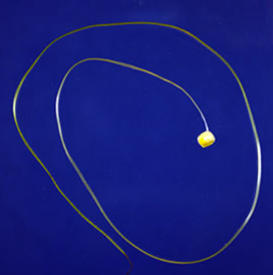 | Scientific advisors: Dr. Jaspreet Sandhu (JSandu@danforthcenter.orgJsandhu@danforthcenter.org) & Dr. Andrea Eveland (AEveland@danforthcenter.org)  Lab website  Research Program: Studies on the regulation of architecture traits and yield potential in cereal crops.
Maize  (Zea mays) | Male flower (floret) in tassel | 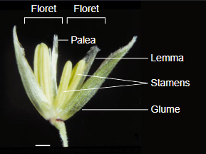
Maize  (Zea mays) | Tassel (where male flowers are hanging) | 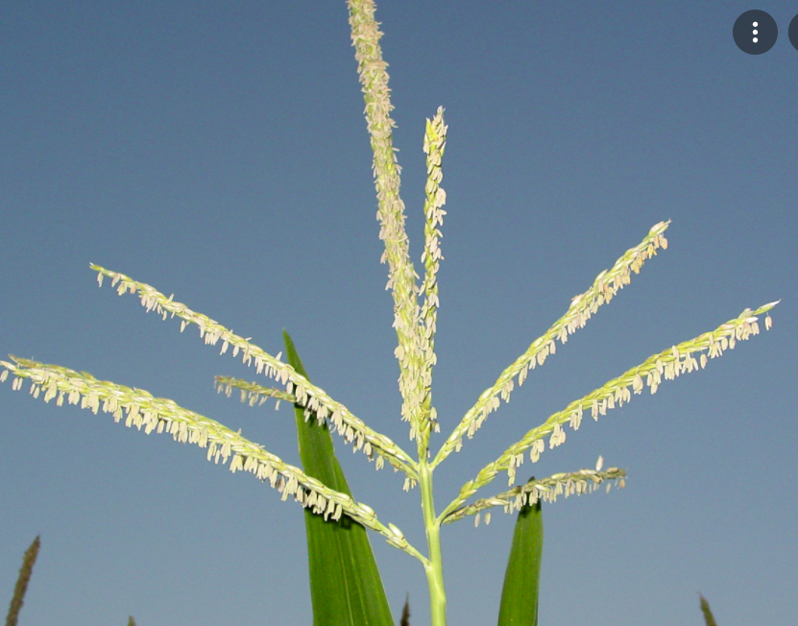
Barrel medic (Medicago trunculata) | Arbuscular Mycorrhizal Fungi (AMF) | 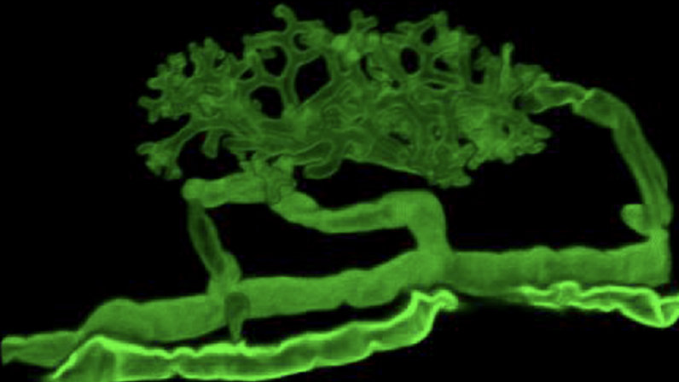 | Scientific advisor: Dr. Armando Bravo (ABravo@danforthcenter.org)  Lab website  Research Program: Studies on the relationships between plants and soil microbes.
Barrel medic (Medicago trunculata) | Root colonized with arbuscular mycorrhizal fungus | 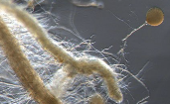
Barrel medic (Medicago trunculata) | Flower | 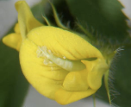
Barrel medic (Medicago trunculata) | Flower, seeds, leaves, seeds | 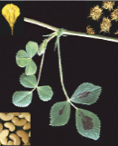
Liverwort (Marchantia polymorpha) |  | 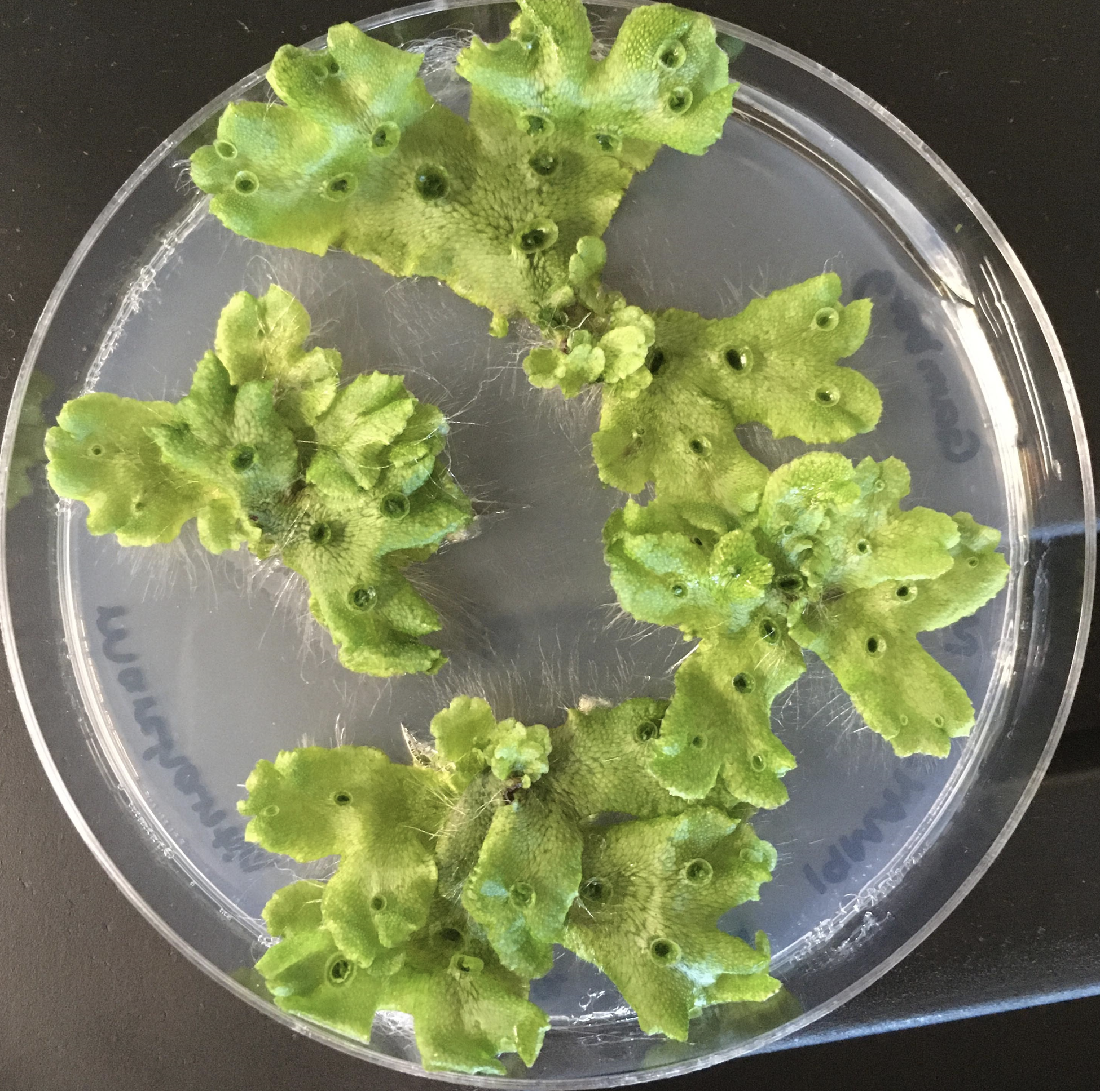
Tomato (Solanum lycopersicum) |  | 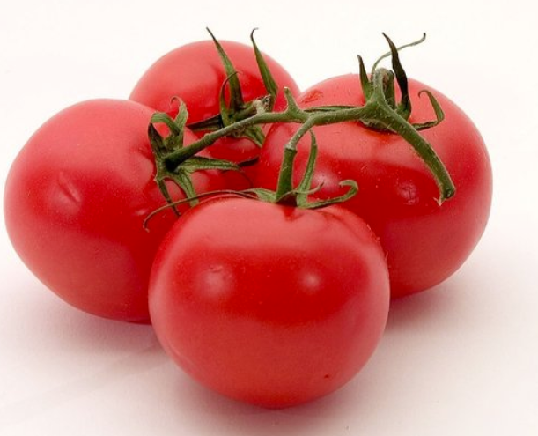
Cassava (Manihot esculenta) | Male flower | 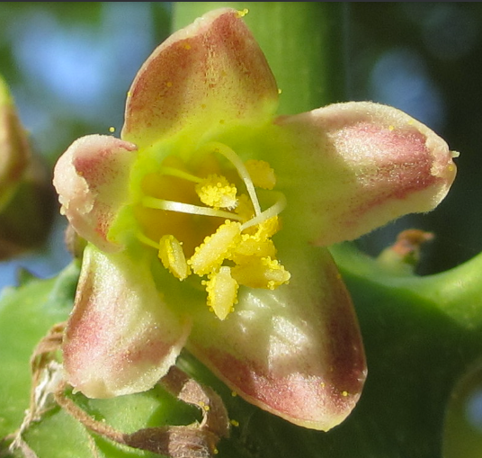 | Scientific advisor: Claire Albin (CAlbin@danforthcenter.org)  Lab website  Research Program: Developing virus-resistant cassava in collaboration with researchers in Uganda and Kenya.
Cassava (Manihot esculenta) | Female flower | 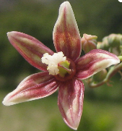
Benth  (Nicotiana benthamiana) | Leaf | 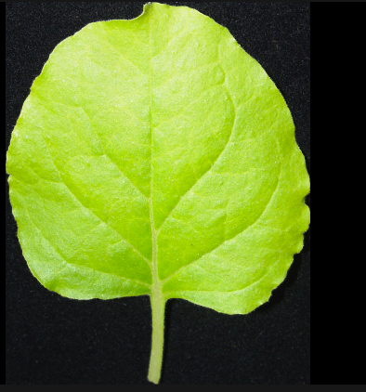 | Scientific advisor: Mohammad Azim (mfazleazim@danforthcenter.org)  Lab website  Research Program: Studies to understand how plant cells communicate with each other through intercellular channels called plasmodesmata.
Black cottonwood (Populus trichocarpa) | Flower, leaf, stem | 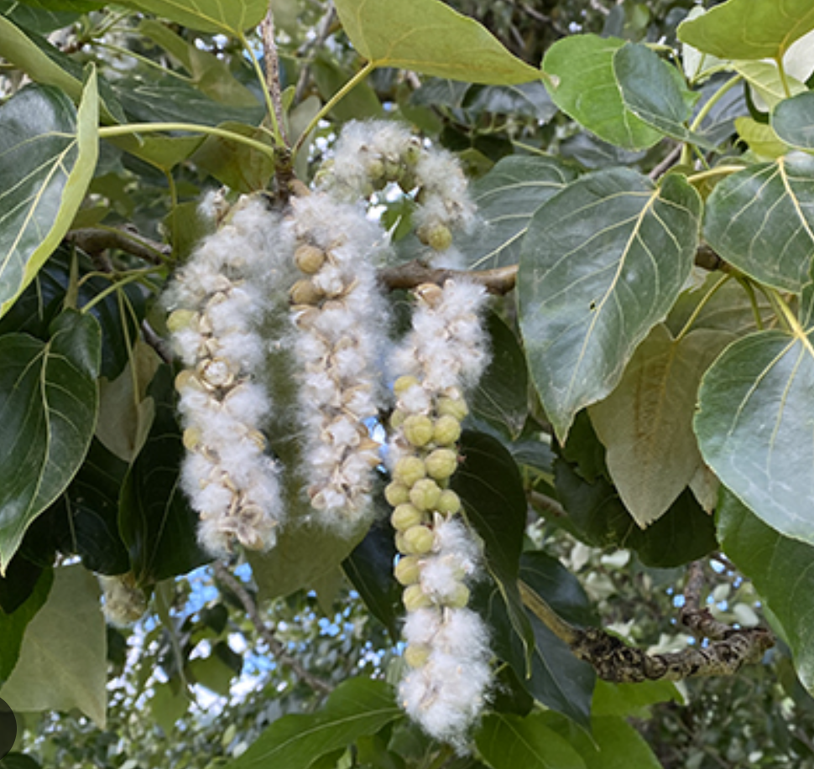 | Scientific advisor: Dr. James Rauschendorfer (jrauschendorfer@danforthcenter.org)  Lab website  Research Program: Studies on the ways in which the environment affects the interactions between plants and microbes.
Sorghum (Sorghum bicolor) | Leaf, stem, root | 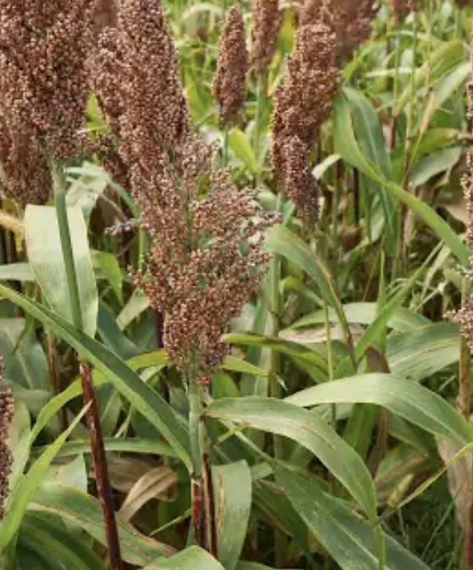 | Scientific advisor: Marie De Gracia, Research Associate (MDeGracia@danforthcenter.org)  Lab website  Research Program: Develops and uses integrated digital agriculture systems to study the effects of phenotype, genotype, and environment on crop productivity.

The links below give access to general information and images of most of the plants in the table above.
- PLANTS Database – US Department of Agriculture
- Plant Finder – Missouri Botanical Garden
- Native Plant Database – Grow native!
- Plants For A Future – Database of edible plants

Supplementary Material C. Target species and structures modeled in 3D

Plant Type | Common Name | Species Name | 3D model (plant parts) | Institution
Forb | Common milkweed | Asclepias syriaca | Plant | G
Small weed | Barrel medic | Medicago truncatula | Leaf | B, D
Green algae | Chlamydomonas | Chlamydomonas reinhardtii | Cell | C, G
Green algae | Volvox | Volvox carteri | Colony | G
Grass | Big bluestem | Andropogon gerardii | Spikelet pair | E
 |  |  | Inflorescence | D
Grass | Fox millet | Setaria viridis | Plant - 3 life stages | G
Grass | Indiangrass | Sorghastrum nutans | Spikelet | E
Grass | Little bluestem | Schizachyrium scoparium | Spikelet pair | E
Grass | Seashore paspalum | Paspalum vaginata | Stolon | D
Crop | Alfalfa | Medicago sativa | Stem and leaves | C
Crop | Barley | Hordeum vulgare | Inflorescence | B
Crop | Cassava | Manihot esculenta | Female flower | D
Crop | Maize (corn) | Zea mays | Male flower | E
 |  |  | Female flower, germinated kernel | D
 |  |  | Leaf, seed | E
 |  |  | Stem, leaves, female and male inflorescence | C
Crop | Oat | Avena sativa | Flower | D
Crop | Soybean | Glycine max | Plant and seed | B

Supplementary Material D. Examples of concept arts
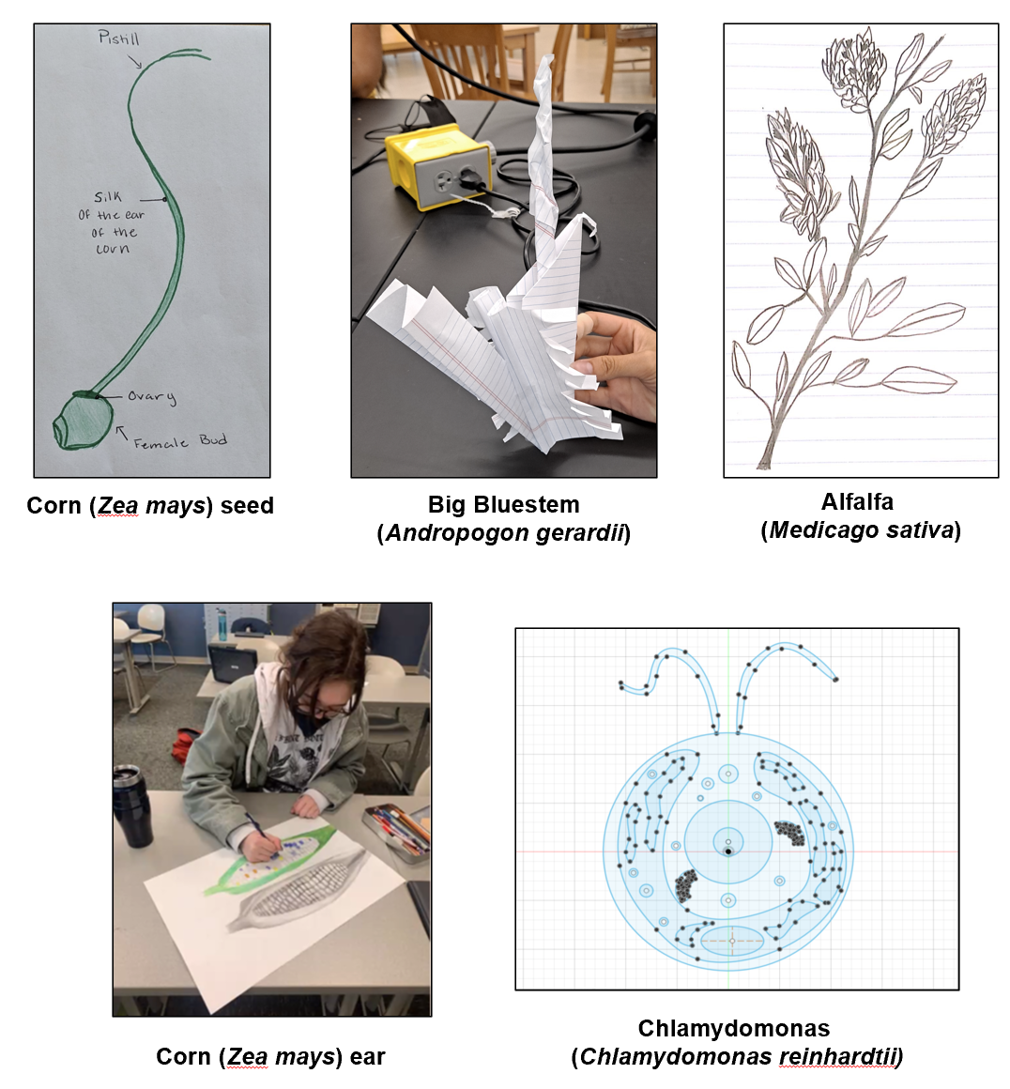
Supplementary Material E. Demographics of participating students

Students | No. | %
Gender
Female | 83 | 51.9
Male | 54 | 33.7
Prefer not to answer | 11 | 6.8
Unknown | 12 | 7.5
Grade
9 | 11 | 6.9
10 | 7 | 4.4
11 | 69 | 43.1
12 | 63 | 39.3
Unknown | 10 | 6.3
Race/Ethnicity
White | 62 | 39
American Indian/Alaska Native | 2 | 1
Asian | 23 | 14
Black/African American | 19 | 12
Hispanic/Latino | 34 | 21
Native Hawaiian/Pacific Islander | 1 | 0.6
Prefer not to answer | 1 | 0.6
Mixed race* | 3 | 2
Unknown | 16 | 10
Subject identity
Science-oriented | 26 | 16
Tech-oriented | 25 | 16
Art-oriented | 39 | 24
Other | 22 | 14
Unknown | 48 | 30
3D modeling experience
Yes | 70 | 43
No | 79 | 48.5
Unknown | 14 | 8.5
AVR immersive experiences
Yes | 68 | 41.7
No | 85 | 52.2
Unknown | 10 | 6.1
Total number of students | 160
*This category includes mixed race/ethnicity (e.g., Black/African American/White/Hispanic and Black/White).
Supplementary Material F. Master codebook for themes extracted from reflection questions
1. Intersection of art and science
1.1. The role art plays in science
1.1.1. Foster new ideas
1.1.1.1. Technological advances & Tools creation
1.1.1.2. Aid in problem solving
1.1.2. Communication and furthering understanding
1.1.2.1. Visual representations
1.1.2.1.1. Models
1.1.2.2. Understanding scientific content
1.1.2.2.1. Organism details
1.1.2.2.2. Survival of organisms
1.1.2.3. Outreach (younger people) (accessible to all, make science easier to
understand and more widely appreciated)
1.1.2.4. Communicate ideas between scientists
1.1.6. Other
1.1.7. Interactive / brings ideas to life
1.1.7.1. Brings science into everyday life/routines
1.1.8. Equal relationship/complementary
1.1.9. No role/unsure/did not respond
1.1.10. Not relevant to question (answered wrong question)
1.2. The role science plays in art
1.2.1. Science influences artistic creation process
1.2.1.1. Design logistics and specifics
1.2.1.1.1. Modeling
1.2.1.1.1.1. Scientific accuracy
1.2.1.2. Inspire artistic ideas
1.2.1.3. Innovation / create new types of art
1.2.2. Similar processes, skills, and principles
1.2.2.1. Creative process and scientific method
1.2.2.2. Attention to detail
1.2.3. Technological advances
1.2.4. Science influences interactions with art
1.2.6. Other
1.2.7. Equal relationship/complementary (science and art in everything / science is art)
1.2.8. Not relevant to question (answered wrong question)
1.2.9. No role/unsure/did not respond
2. Learning
2.1. Learn new/interesting/useful things
2.2. Learning about the integration (connection) of art, design, science, technology
2.2.1. Learning about multiple perspectives (arts/science)
2.2.2. Use of technology in science
2.2.3. Research skills and apply to digital design and technology
2.2.4. Technology and design skills
2.2.5. Connection of art and science
2.3. Learning about Science
2.3.1. Scientific content/knowledge
2.3.1.1. Learning about the environment/world/intricacies of nature/ecosystems
2.3.1.2. Learning about DDPSC and its research
2.3.1.3. Women in STEM
2.3.1.4. Learning about plants
2.3.1.4.1. Biology of plants (structure and function)
2.3.1.4.2. Care about plants
2.3.1.4.3. Diversity of plants
2.3.1.4.4. Interactions among plants, and plants with other organisms (fungi)
2.3.1.4.5. Where to find them
2.3.1.4.6. Importance of plants
2.3.1.4.6.1. Uses/benefits
2.3.1.4.6.2. Impact on communities/Climate change/ecosystems
2.3.1.4.6.3. For science
2.3.1.4.7. Want to learn more about plants
2.3.2. Learning research skills
2.3.2.1. Plant/ecosystem care
2.3.2.2. Detail observations
2.3.2.3. Project development/planning
2.3.2.4. Accomplished the project
2.3.2.5. Working in research-like settings
2.3.2.6. Best lab practices
2.3.2.7. Learning about results
2.3.2.8. Already know research skills
2.4. Use of technology
2.4.1. Learning about the usefulness of technology
2.4.2. Computer skills
2.4.3. AVR
2.4.4. Learning/practicing 3D modeling
2.4.4.1. Fusion 360®
2.4.4.2. Learning 3D to teach about plants
2.5. Use of design/art
2.5.1. 3D art
2.6. Sof skills
2.6.1. Teamwork/friendship/collaboration
2.6.2. Communication
2.6.2.1. Communicating with team members
2.6.2.2. Teaching others
2.6.2.3. Presenting (individually or as a group)
2.6.3. Science communication
2.6.3.1. Presenting project results
2.6.3.2. Written documents
2.6.4. Perseverance
2.6.5. Leadership
2.6.6. Memory skills
2.6.7. Resolve problems/mistakes
2.6.8. Make me more active
2.6.9. Efficiency/Time management
2.6.10. Get out of comfort zone
2.7. Gaining experience/skills for future careers and work
2.8. Other (how to improve life, want to help others)
2.9. Not learning, not gaining skills
2.10. Not sure of learning, skills, or outcomes
2.11. Not applicable (not responding the question)

3. Relevancy
3.1. Relevant for project/classes
3.1.1. 3D modeling
3.1.2. Teamwork
3.1.3. Perseverance
3.1.4. Memory/efficiency
3.2. Relevance of skills outside of class
3.2.1. Research
3.2.2. Problem solving
3.2.3. Use of time efficiently
3.2.4. Creating new things
3.2.5. Integration of art, science, tech
3.3. Relevance of skills for future careers/college
3.3.1. 3D modeling
3.3.2. Communication
3.3.3. Science knowledge/research
3.4. Relevance of skills for jobs/jobs interviews/later in life
3.4.1. Drawing/artistic ability
3.4.2. Communication
3.4.3. Science knowledge/research
3.4.4. 3D modeling
3.4.5. Teamwork
3.4.6. Educate others
3.5. Not relevant

4. Changes in careers in science and or art/design
4.1. No change because already interested in science and or art/design careers
4.1.1. Already interested in science careers (wildlife biology)
4.1.1.1. Already interested in science and other fields (journalism)
4.1.2. Already interested in art/design careers
4.1.3. Already interested in STEAM careers
4.1.4. Already interested in other careers different to STEAM
4.1.4.1. Not interested in STEAM careers
4.1.4.2. Not interested in science
4.1.4.3. Not interested in STEAM careers but activity help me with career
decisions/or solidify what I want
4.2. Positive change - Interested in careers in:
4.2.1. Interested in science careers
4.2.1.1. Interested in plant science
4.2.2. Interested in STEAM careers
4.2.2.1. Interested in the intersection of forensic psychology with plant science
4.2.3. Interested in design careers
4.2.4. Interested in the intersection of other careers with STEAM careers
4.2.5. Interested in non-STEAM careers (journalism)
4.3. No change due to unknown reason
Supplementary Material G. Student counts and percentages by main themes to the following questions per Figure.

Number and percentage of students per theme who responded to the question "How does art and design play a role in science?" only before, before and after, or only after the implementation of the module (Figure 2)
 | All students with pre responses  (A = B + C) |  | Students with only pre responses (B) |  | Students with pre and post responses (C) |  | Students with only post responses (D) |  | All students with post responses  (E = C + D) |  | Total students per theme (F)
Themes | No. | %* | No. | % | No. | % | No. | % | No. | % | No.
Communication and further understanding
Communication (e.g., public, scientists) | 4 | 6.7 | 3 | 5 | 1 | 1.7 | 2 | 3.3 | 3 | 6.7 | 6
Visual representations | 22 | 36.7 | 11 | 18.3 | 11 | 18.3 | 13 | 21.7 | 24 | 40 | 35
Models | 14 | 23.3 | 9 | 15 | 5 | 8.3 | 6 | 10 | 11 | 18.3 | 20
General understanding | 4 | 6.7 | 3 | 5 | 1 | 1.7 | 3 | 5 | 4 | 6.7 | 7
Understanding scientific content |  |  |  |  |  |  | 10 | 16.7 | 10 | 16.7 | 10
Make science more accessible and  appreciated | 5 | 8.3 | 3 | 5 | 2 | 3.3 | 3 | 5 | 5 | 8.3 | 8
Foster new ideas
Generate ideas | 2 | 3.3 | 2 | 3.3 |  |  | 3 | 5 | 3 | 5 | 5
Creativity | 2 | 3.3 | 2 | 3.3 |  |  | 2 | 3.3 | 2 | 3.3 | 4
Technological advances and tools creation | 3 | 5 | 1 | 1.7 | 2 | 3.3 | 1 | 1.7 | 3 | 5 | 4
Aid in problem solving | 7 | 11.7 | 7 | 11.7 |  |  | 1 | 1.7 | 1 | 1.7 | 8
Brings ideas to life | 6 | 10 | 4 | 6.7 | 2 | 3.3 | 4 | 6.7 | 6 | 10 | 10
Brings science into everyday life | 2 | 3.3 | 2 | 3.3 |  |  |  |  |  |  | 2
Art and science are complementary | 4 | 6.7 | 3 | 5 | 1 | 1.7 | 1 | 1.7 | 2 | 3.3 | 5
Other | 5 | 8.3 | 5 | 8.3 |  |  | 1 | 1.7 | 1 | 1.7 | 6
Do not know | 4 | 6.7 | 3 | 5 | 1 | 1.7 | 2 | 3.3 | 3 | 5 | 8
*Percentages are calculated with respect to a total of 60 students. Percentages per column do not add to one hundred since some students provided responses for more than one theme.
Number and percentage of students per theme who responded to the question "How does science play a role in art and design?" only before, before and after, or only after the implementation of the module (Figure 4)

 | All students with pre responses  (A = B + C) |  | Students with only pre responses (B) |  | Students with pre and post responses (C) |  | Students with only post responses (D) |  | All students with post responses  (E = C + D) |  | Total students per theme (F)
Themes | No. | %* | No. | % | No. | % | No. | % | No. | % | No.
Science influences artistic creation process
Science creates art | 7 | 12.1 | 6 | 10.3 | 1 | 1.7 | 8 | 13.8 | 9 | 15.5 | 16
Design logistics and specifics | 13 | 22.4 | 9 | 15.5 | 4 | 6.9 | 7 | 12.1 | 11 | 19 | 20
Modeling | 2 | 3.4 | 2 | 3.4 |  |  | 6 | 10.3 | 6 | 10.3 | 8
Scientific accuracy | 1 | 1.7 | 1 | 1.7 |  |  | 6 | 10.3 | 6 | 10.3 | 7
Inspire artistic Ideas | 10 | 17.2 | 8 | 13.8 | 2 | 3.4 | 5 | 8.6 | 7 | 12.1 | 15
Innovation | 3 | 5.2 | 1 | 1.7 | 2 | 3.4 | 2 | 3.4 | 4 | 6.9 | 5
Similar processes, skills, and principles | 5 | 8.6 | 2 | 3.4 | 3 | 5.2 | 1 | 1.7 | 4 | 6.9 | 6
Technological advances | 4 | 6.9 | 3 | 5.2 | 1 | 1.7 | 6 | 10.3 | 7 | 12.1 | 10
Science influences interactions with art | 5 | 8.6 | 5 | 8.6 |  |  |  |  |  |  | 5
Art and science are complementary | 5 | 8.6 | 3 | 5.2 | 2 | 3.4 | 3 | 5.2 | 5 | 8.6 | 8
Not relevant to question | 2 | 3.4 | 2 | 3.4 |  |  | 3 | 5.2 | 3 | 5.2 | 5
Other | 5 | 8.6 | 4 | 6.9 | 1 | 1.7 | 3 | 5.2 | 4 | 6.9 | 8
Do not know | 9 | 15.5 | 7 | 12.1 | 2 | 3.4 | 1 | 1.7 | 3 | 5.2 | 10
*Percentages are calculated with respect to a total of 58 students. Percentages per column do not add to one hundred since some students provided responses for more than one theme.

Supplementary Material H. Student counts and percentages by main themes to the following questions.

Number and percentage of students per theme who responded to the questions “What do you hope to learn by participating in this project?” (before the module) and “Describe any skills or knowledge you developed during this project” (after the module). Themes were consolidated between responses from the two questions only before, before and after, or only after the implementation of the module (Figure 4).
 | No. students with pre responses  (A = B + C) |  | No. students with only pre responses (B) |  | No. students with pre and post responses (C) |  | No. students with only post responses  (D) |  | No. students with post responses  (E = C + D) |  | Total No. students per theme (F)
Themes | No. | % | No. | % | No. | % | No. | % |  | % | No.
Learning new/interesting things | 11 | 17.5 | 11 | 17.5 |  |  |  |  |  |  | 11
Learning about the integration/connection  of art, design, science, and technology | 9 | 14.3 | 8 | 12.7 | 1 | 1.6 | 2 | 3.2 | 3 | 4.8 | 11
Learning about science
Learning about science | 5 | 7.9 | 5 | 7.9 |  |  | 5 | 7.9 | 5 | 7.9 | 10
Learning about plants (e.g., biology,  diversity, uses, etc.) | 13 | 20.6 | 7 | 11.1 | 6 | 9.5 | 25 | 39.7 | 31 | 49.2 | 38
Learning about research skills (e.g., detail  observations, lab practices, etc.) | 3 | 4.8 | 3 | 4.8 |  |  | 13 | 20.6 | 13 | 20.6 | 16
Learning about the use of technology
Learning about technology | 5 | 7.9 | 4 | 6.3 | 1 | 1.6 | 4 | 6.3 | 5 | 7.9 | 9
Learning about 3D modeling | 24 | 38.1 | 15 | 23.8 | 9 | 14.3 | 11 | 17.5 | 20 | 31.7 | 35
Learning about design/art | 9 | 14.3 | 8 | 12.7 | 1 | 1.6 | 7 | 11.1 | 8 | 12.7 | 16
Learning soft skills
Learning about future workplace/college | 3 | 4.8 | 3 | 4.8 |  |  |  |  |  |  | 3
Learning about communication | 1 | 1.6 | 1 | 1.6 |  |  | 7 | 11.1 | 7 | 11.1 | 8
Learning about science communication | 1 | 1.6 |  |  | 1 | 1.6 | 4 | 6.3 | 5 | 7.9 | 5
Wanting to help others | 2 | 3.2 | 1 | 1.6 | 1 | 1.6 | 2 | 3.2 | 3 | 4.8
Learning about teamwork/collaboration |  |  |  |  |  |  | 17 | 27.0 | 17 | 27.0 | 17
Learning about perseverance |  |  |  |  |  |  | 3 | 4.8 | 3 | 4.8 | 3
Learning about other soft skills (time  management, memory) |  |  |  |  |  |  | 6 | 9.5 | 6 | 9.5 | 6
Other
Already have a skill |  |  |  |  |  |  | 1 | 1.6 | 1
No outcome | 2 | 3.2. | 1 | 1.6 | 1 | 1.6 | 5 | 7.9 | 6
No response | 2 | 3.2 |  |  | 1 | 1.6 | 10 | 15.9 | 11
Percentages are calculated with respect to a total of 63 students participating in the pre- and post-reflection questions (100%). Percentages per column or row do not add to one hundred since some students provided responses for more than one theme.
Number and percentage of students per theme who responded to the question [“Describe any skills or knowledge you developed during this project and whether you feel these will be relevant or applicable outside of the class.] How will these be relevant?” (after the module)
Skills and knowledge gained | Relevancy themes |  |  |  | Total students per skill / knowledge
Skills and knowledge gained | Relevance for projects / classes | Relevance for endeavors outside of class | Relevance for future college or careers | Relevance for jobs / job interviews / endeavors later in life | No. | %
Integration of science, art, design, and technology |  | 2 |  |  | 2 | 5.7
Science
Science content &  research skills |  | 1 | 2 | 6 | 9 | 25.7
Technology/Design
3D modeling | 7 |  | 4 | 2 | 13 | 37.1
Creation things in the computer |  | 1 |  |  | 1 | 2.9
Artistic creation - drawing |  |  |  | 1 | 1 | 2.9
Soft skills
Communication |  |  | 2 | 4 | 6 | 17.1
Teamwork | 1 |  |  | 6 | 7 | 20.0
Time management | 1 | 2 |  |  | 3 | 8.6
Problem solving |  | 2 |  |  | 2 | 5.7
Educate others |  |  |  | 1 | 1 | 2.9
Perseverance | 1 |  |  |  | 1 | 2.9
Undetermined relevance |  | 1 | 1 | 2 | 4 | 11.4
Total students per relevance | 10 | 9 | 9 | 22 | N/A  N/A | N/A  N/A
% Students per relevance* | 28.6 | 25.7 | 25.7 | 62.9 | N/A  N/A | N/A  N/A
Percentages are calculated with respect to a total of 35 students participating in the pre- and post-reflection questions (100%). Percentages do not add to 100% because some students reported more than one skill or knowledge per type of relevance.

