Name_______________________________________________________ Date ________________________

Part 1
Eastern Grey Squirrels are tree squirrels. They live in forests with many trees they can climb. Antelope Squirrels are ground squirrels. They live in dry, hot areas with lots of sand that they can dig into to escape the heat of the sun. Both animals are squirrels, but they look different and they live in different habitats.

The chart below provides information about both squirrels.

Type of Squirrel | Structures | Food | Shelter
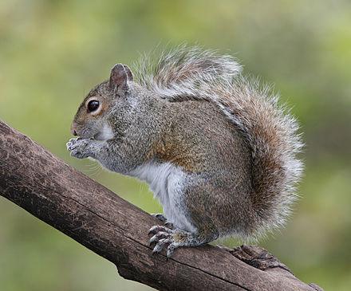  Tree Squirrel:  Eastern Grey Squirrel | - sharp claws  - feet that turn backward  - powerful hind legs  - long bushy tail | - tree bark  - tree buds  - berries  - seeds  - acorns  - nuts  - mushrooms | Tree squirrels make nests out of leaves and sticks in the forks of trees.  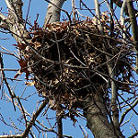
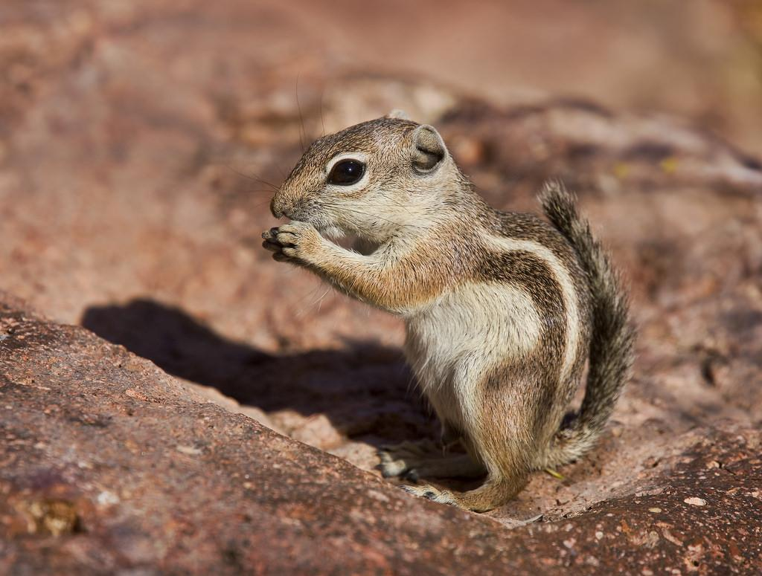  Ground Squirrel: Antelope Squirrel | - small rounded ears  - short, strong legs  - short thin tail  - brown or tan fur | - plants  - insects  - lizards  - seeds  - dead animals | Ground squirrels build burrows (holes) in the soil.  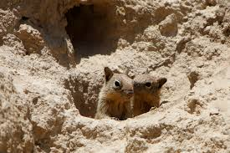

1a. Using information from the chart, describe how the two squirrels are different from one another.

______________________________________________________________________

______________________________________________________________________

1b. How do the structures of the Eastern Grey Squirrel help it survive?

______________________________________________________________________

______________________________________________________________________

Part 2
Using the chart on page 1, think about what the Eastern Grey Squirrels need from the forest.
If someone cuts down all the trees, what could happen to the Eastern Grey Squirrels?

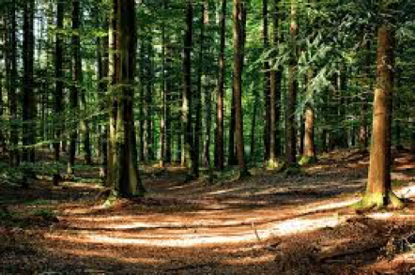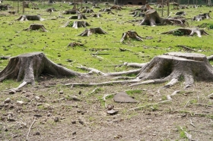

Before After

2a. Draw a model to show what could happen to the Eastern Grey Squirrels if all the trees are cut down. Make sure you show what would cause that to happen.

2b. Explain your model.
My model shows that…

___________________________________________________________________________________

___________________________________________________________________________________

___________________________________________________________________________________

2c. You shared one idea of what could happen to the squirrels if the trees were cut down.
Now, think of a very different idea about what might happen to the squirrels. Explain your thinking.

___________________________________________________________________________________

___________________________________________________________________________________

___________________________________________________________________________________

Part 3
Look at the picture on Page 2 where all the trees have been cut down, and imagine that the land is flooded. After millions of years, the land is still covered with water.
Think about the squirrels that are still living in the area. What possible changes might you see in the squirrels? How would those changes help them survive?
3a. Draw a model to show the squirrels. Show how they survive.

3b. Explain your model.
My model shows that…

__________________________________________________________________________________

__________________________________________________________________________________

__________________________________________________________________________________

Part 4
4a. What would you do if you wanted to learn more about squirrels and their changing habitats?

_________________________________________________________________________________

_________________________________________________________________________________

_________________________________________________________________________________

4b. How is learning about squirrels and their habitats useful for people?

_________________________________________________________________________________

_________________________________________________________________________________

_________________________________________________________________________________

Image Attributions:
Trees in forest by https://cdn.pixabay.com/photo/2015/10/05/15/37/forest-972792_960_720.jpg
Tree stumps by "Free Image on Pixabay - Deforestation, Forest, Tree Stump." Free Photo: Deforestation, Forest, Tree Stump - Free Image on Pixabay - 62486. Web. 22 Dec. 2016. (https://sites.google.com/a/franklinps.net/united-nations-sustainable-development-goals/home/goal-15?tmpl=%2Fsystem%2Fapp%2Ftemplates%2Fprint%2F&showPrintDialog=1)
Eastern Grey Squirrel By BirdPhotos.com (BirdPhotos.com) [CC BY 3.0 (http://creativecommons.org/licenses/by/3.0)], via Wikimedia Commons
Eastern Grey Squirrel Nest
https://www.flickr.com/photos/heart_windows_art/1819644421/
Belding’s ground squirrel pups By Alan Vernon - originally posted to Flickr as A tender moment between sibling Belding's ground squirrel pups, CC BY 2.0, https://commons.wikimedia.org/w/index.php?curid=10302738

