Name____________________________________ Date _________________

Unit 3: How can we help the birds around our school grow up and thrive?

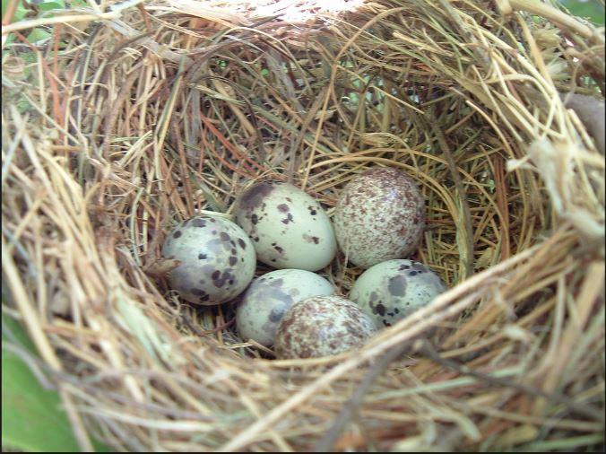
Credit: Cedar Waxwing nest & eggs + 2 Brown-headed Cowbird eggs. C. Gibbons

The Cedar Waxwing mother laid eggs in her nest. Then the Brown-headed Cowbird laid her eggs in the Cedar Waxwing nest, too.

After she laid her eggs, the Brown-headed Cowbird left the nest and did not return.

Questions to think about:

What do you think will happen when the birds hatch?

Why do you think the Brown-headed Cowbird laid her eggs in the Waxwing nest?

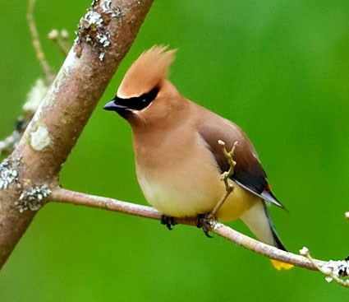
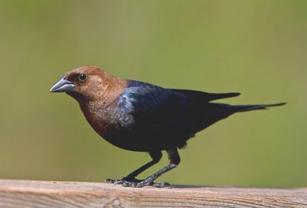

Cedar Waxwing Brown-headed Cowbird

Read the information about what the birds eat and how big they are.

Brown-headed Cowbird Adult  Length is 16–22 cm.  They eat seeds, grains and insects. | Brown-headed Cowbirds feed mostly on seeds and grains. Insects such as grasshoppers and beetles make up about a quarter of a Cowbirds’ diet.
Cedar Waxwing Adult  Length is 15–18 cm.  They eat berries and fruit. | In summer, Cedar Waxwings feed on fruits such as strawberries, mulberries, and raspberries. The bird gets its name from its appetite for cedar berries in winter; they also eat mistletoe, juniper, mountain ash, honeysuckle, and crabapple fruits.

Think about what you know about birds’ traits (their behavior and what they look like), and how birds live in their environments.

Respond to the prompts and questions that follow.

You can use these science ideas in your answers.
- Traits come from parents.
- Certain traits support survival.
- The environment influences how animals look and behave.

Make a prediction.
1. What do you think will happen when the Cedar Waxwing mother brings food to the chicks?

______________________________________________________________________________

______________________________________________________________________________

______________________________________________________________________________

2. Draw a model to show your prediction. Make sure to show what helps or hurts the two different birds’ chances of survival.

The model showing my prediction:

3. Explain your model.

_______________________________________________________________________________

_______________________________________________________________________________

_______________________________________________________________________________

_______________________________________________________________________________

You made one prediction about what will happen to the brown-headed cowbirds and the cedar Waxwing chicks in the nest, and if they will or will not survive.
4. Now think of a very different idea of what might happen as the mother bird brings food to the chicks. Write your very different idea and explain your thinking.

______________________________________________________________________________

______________________________________________________________________________

______________________________________________________________________________

5. Will the Brown-headed Cowbirds look and behave the same as the Cedar Waxwings? Explain your answer.

______________________________________________________________________________

______________________________________________________________________________

______________________________________________________________________________

6. Think about just the Cedar Waxwings.
Will each of the Cedar Waxwing chicks grow up to look and behave exactly the same as one another? Explain your answer.

______________________________________________________________________________

______________________________________________________________________________

______________________________________________________________________________

7. Why is it important for people to know about how animals survive and thrive? Explain your thinking.

_______________________________________________________________________________

_______________________________________________________________________________

_______________________________________________________________________________

8. Describe ways that scientists figure out how to help birds in the community grow up and thrive.

_______________________________________________________________________________

_______________________________________________________________________________

_______________________________________________________________________________

