Toys Performance Task

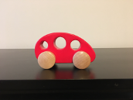
1 Observe the toy car. It is at rest. List the parts of the car that make up the system that would allow it to move.

_______________________________________________________________________

_______________________________________________________________________

2 The car is at rest. Describe all of the forces that are acting on the car when it is at rest.

_______________________________________________________________________

_______________________________________________________________________

3 Now draw the forces acting on the car when it is at rest. Make sure you show if the forces are balanced or unbalanced.

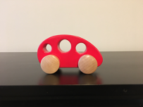

Adam pushes the car so it hits the wall, bounces off the wall, and moves backwards until it stops. Think about the motion of the car and the forces that influence its motion.

4 Draw the car and show the balanced or unbalanced forces when it 1. starts moving, 2. hits the wall, 3. moves backward, and 4. then stops.

5 How would you describe the changing motion of the car?

Speed: _________________________________________________________________

Direction: ______________________________________________________________

6 When are the forces acting on the car balanced?

_______________________________________________________________________

7 How do you know?

_______________________________________________________________________

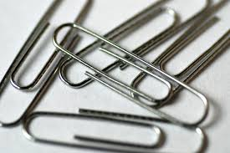 |  | 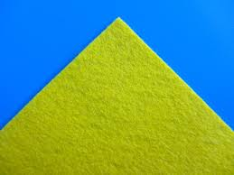 | 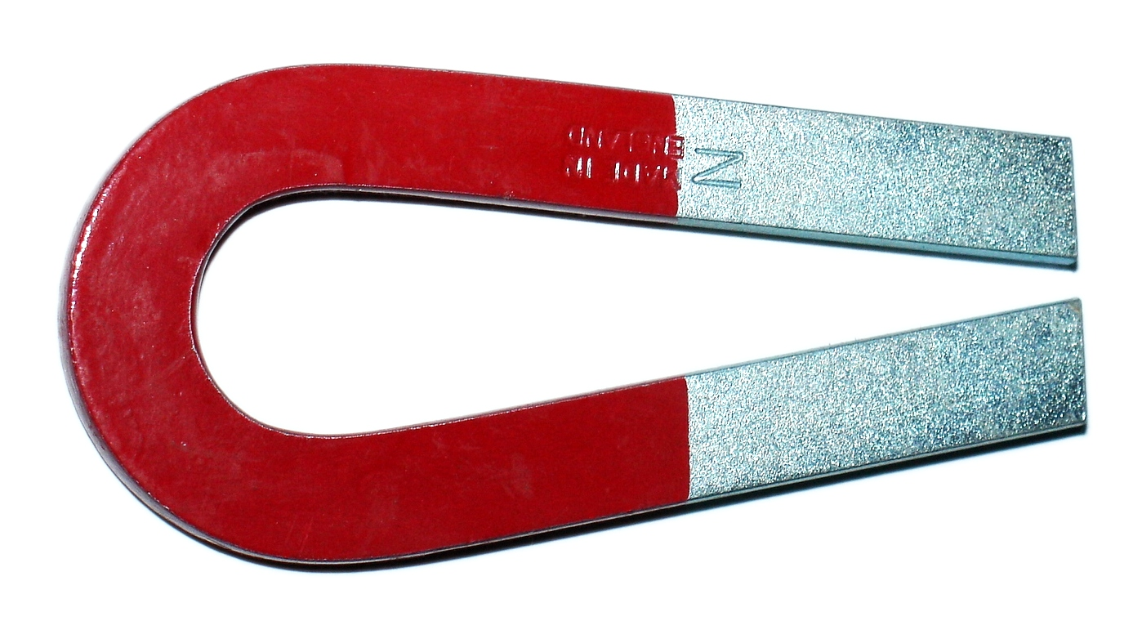 | 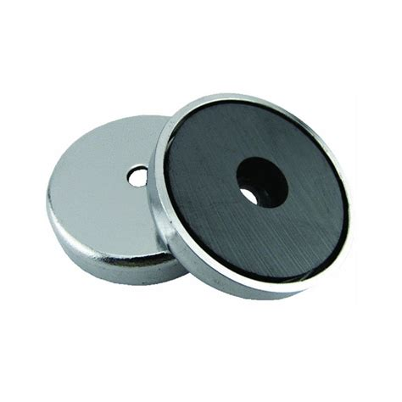 | 
Paper Clips Balloon Felt Cloth Magnet Magnets Hair Dryer

Look at the materials above and consider each one.
8 What materials above would you place on the car or near the car so when Adam pushes the car, the car stops before it hits the wall?

_______________________________________________________________________

9 Draw your solution below.

10 How does the solution work? Explain how the design will make the car stop.

_______________________________________________________________________

_______________________________________________________________________

11 You described one way to make the car stop suddenly. Now think of a very different design that would make the car stop before it hits the wall.

_______________________________________________________________________

_______________________________________________________________________

Look at the car in the picture below. Adam pushed this orange car on the table and it rolled fast and then fell off the table. The dotted line shows how the car moved off the table.
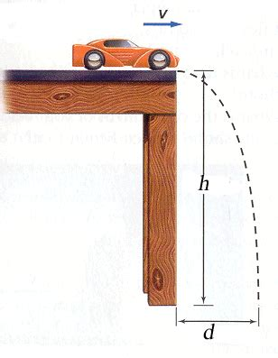

12 Think about all the forces that were acting on the car as it fell. Explain why the car did not fall straight down.

Think about what you know about how and why things move and the statement below:

-- Unbalanced forces cause a change in motion.

______________________________________________________________________

______________________________________________________________________

13 What can people do to learn about forces and motion?

___________________________________________________________________________

___________________________________________________________________________

___________________________________________________________________________

14 Why is knowing about forces and motion and engineering design important to the community?

______________________________________________________________________

______________________________________________________________________

______________________________________________________________________

