Additional file
Supplementary Table 1 The structures of the compounds under investigation
S/NO. | Structures | S/NO. | Structures
1 | 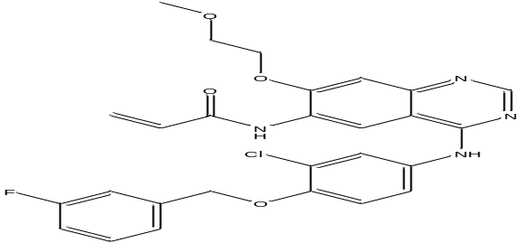 | 6 | 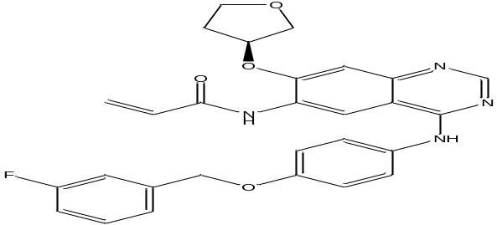
2 | 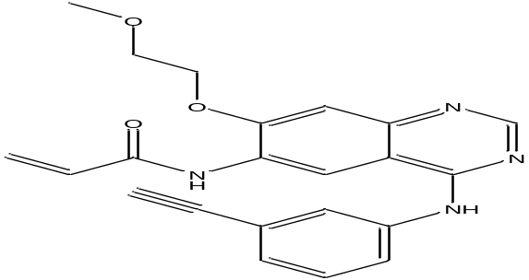 | 7 | 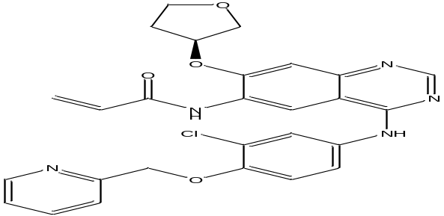
3 | 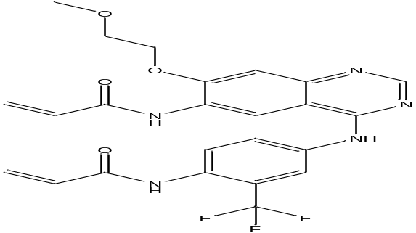 | 8 | 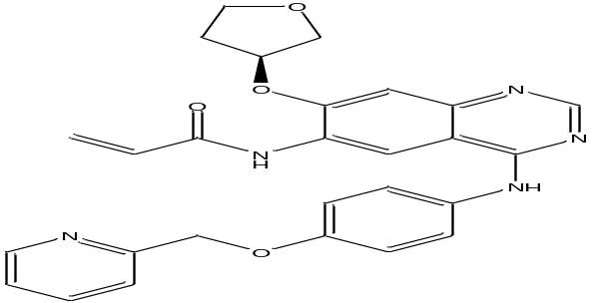
4 | 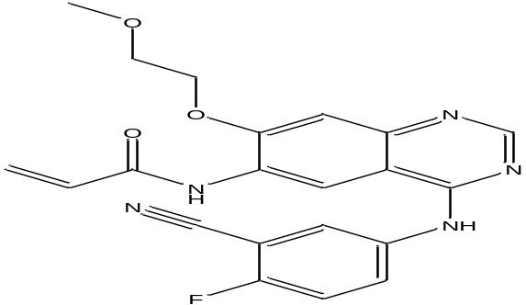 | 9 | 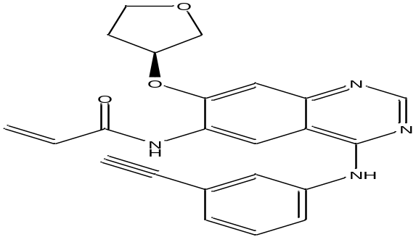
5 | 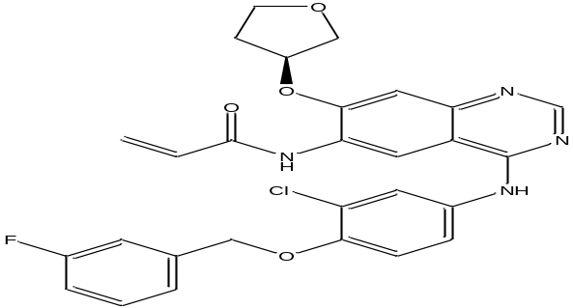 | 10 | 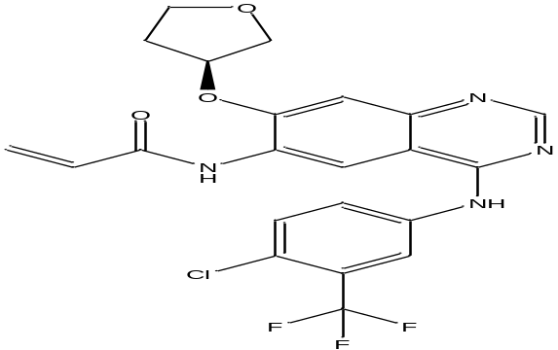
11 | 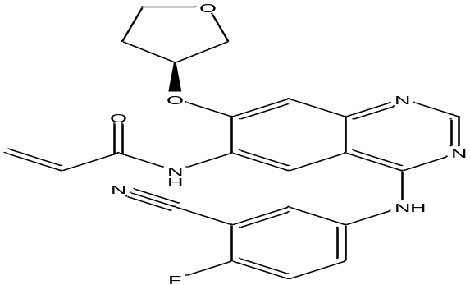 | 16 | 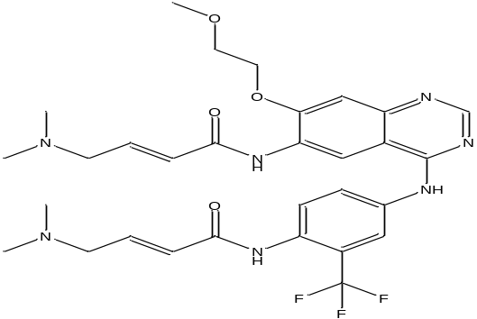
12 | 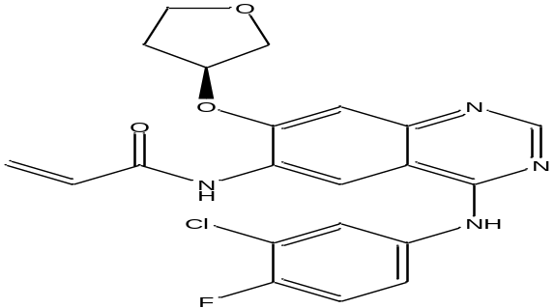 | 17 | 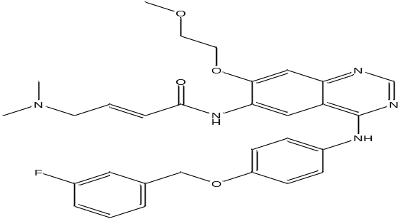
13 | 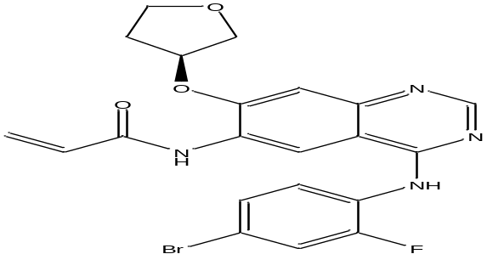 | 18 | 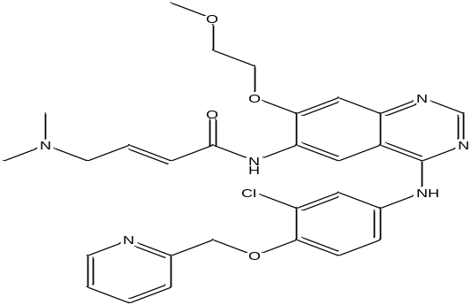
14 | 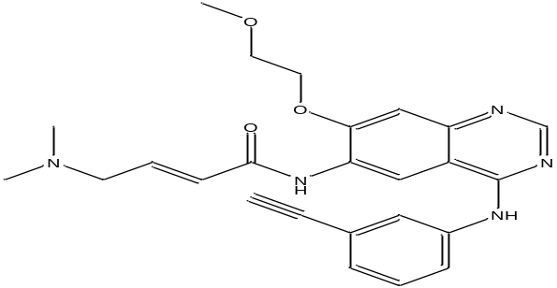 | 19 | 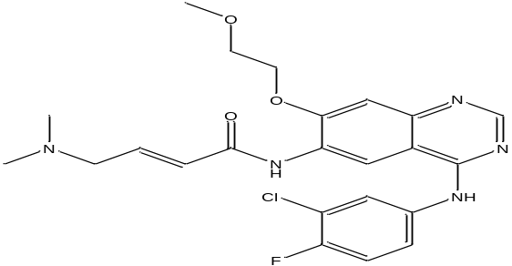
15 | 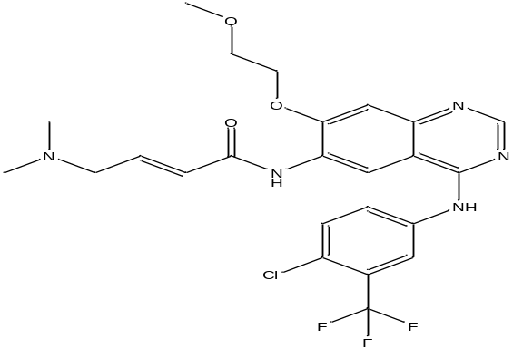 | 20 | 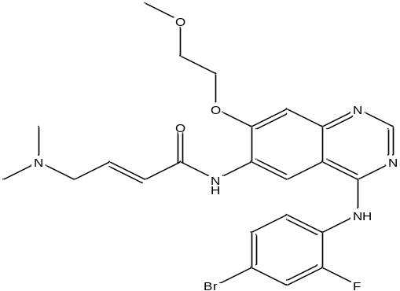
21 | 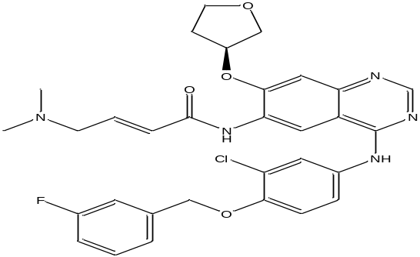 | 26 | 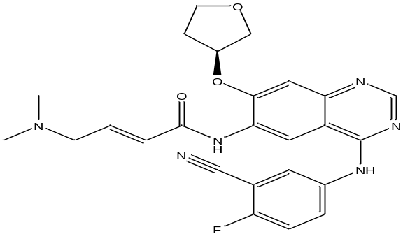
22 | 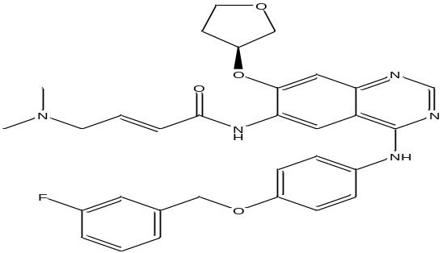 | 27 | 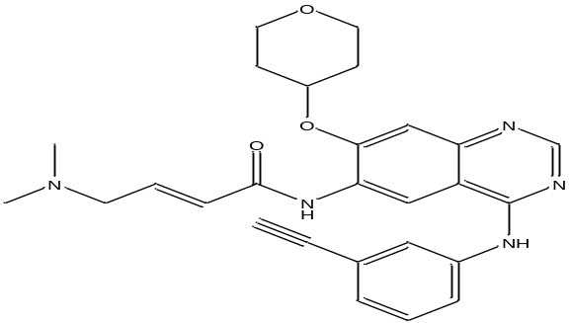
23 | 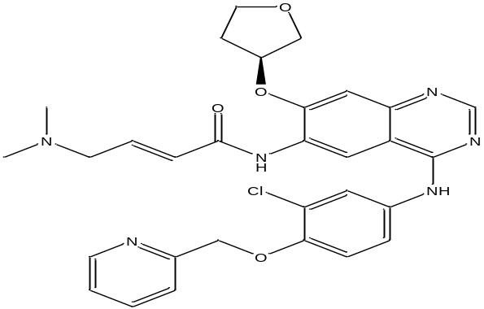 | 28 | 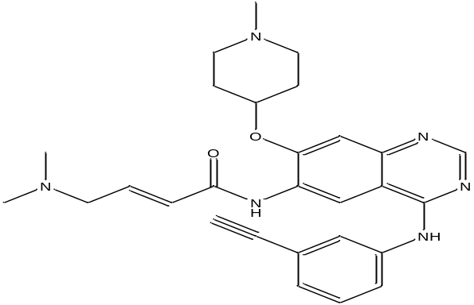
24 | 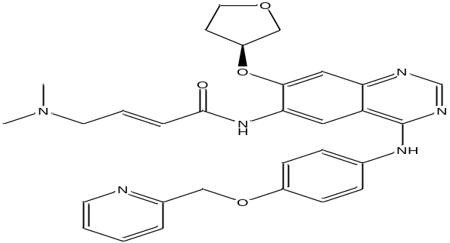 | 29 | 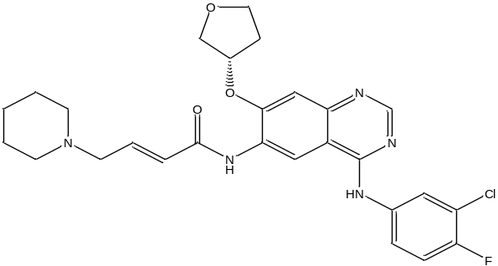
25 | 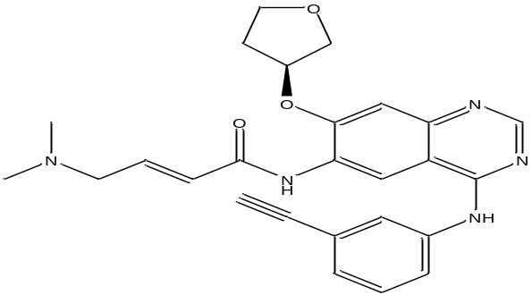 | 30 | 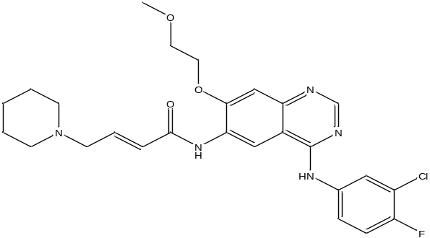
31 | 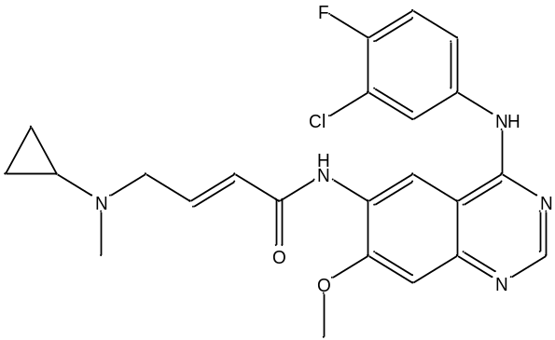 | 36 | 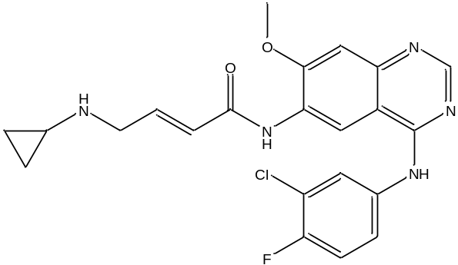
32 | 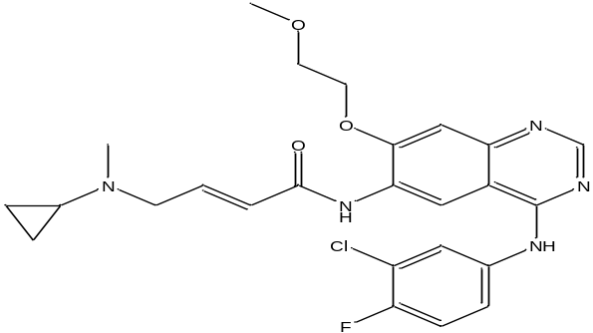 | 37 | 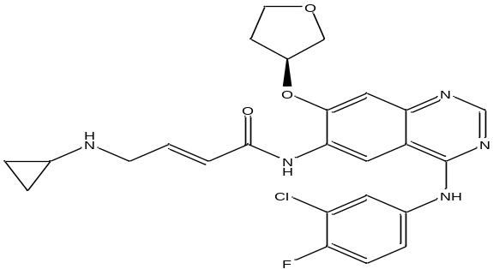
33 | 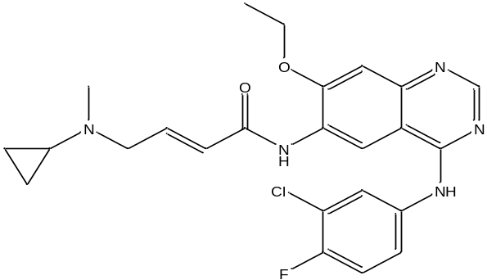 | 38 | 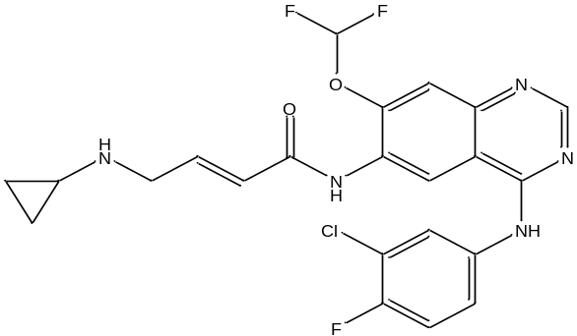
34 | 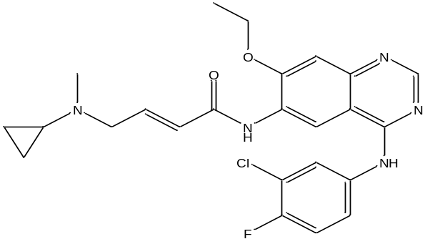 | 39 | 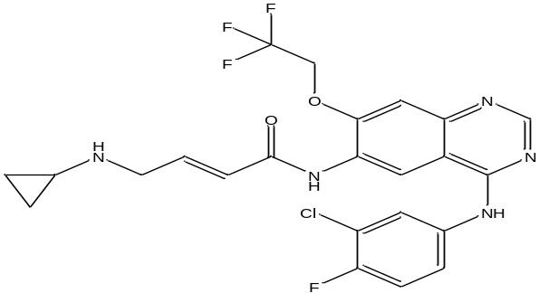
35 | 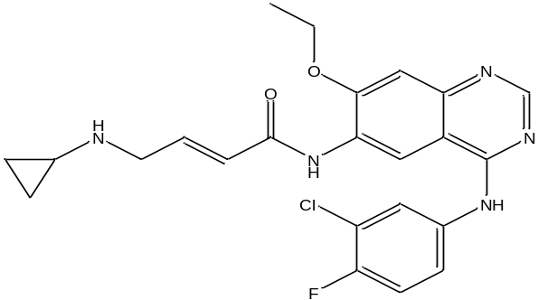 | 40 | 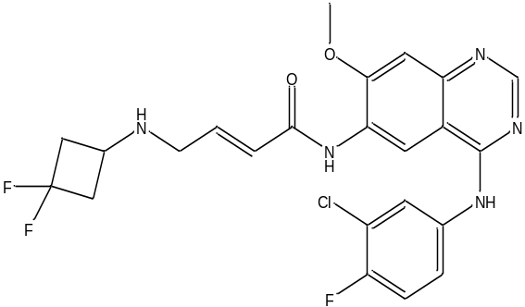
41 | 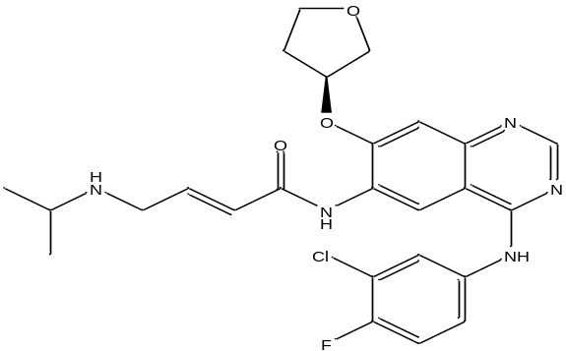 | 46 | 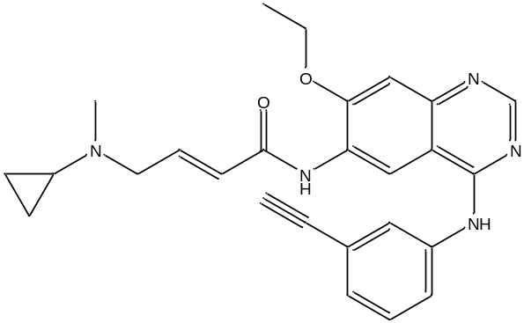
42 | 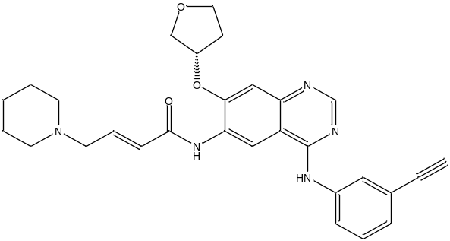 | 47 | 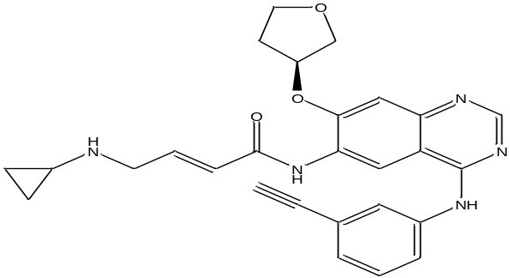
43 | 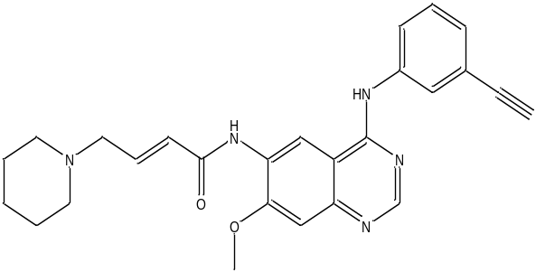 | 48 | 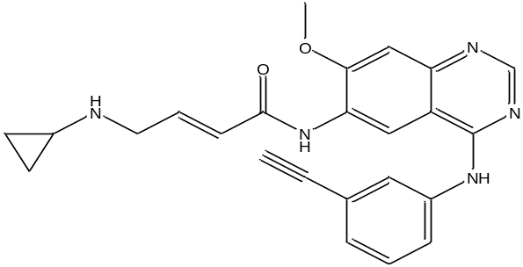
44 | 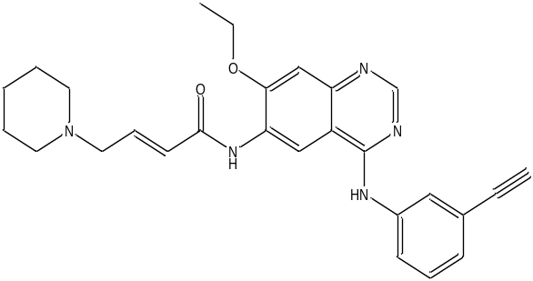 | 49 | 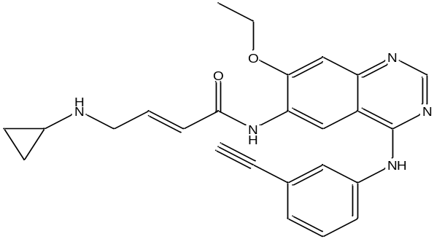
45 | 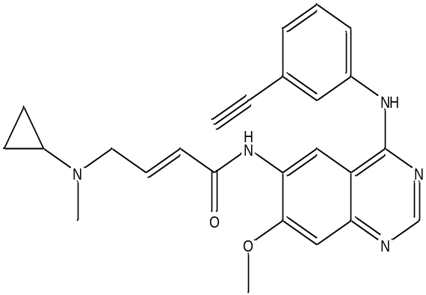 | 50 | 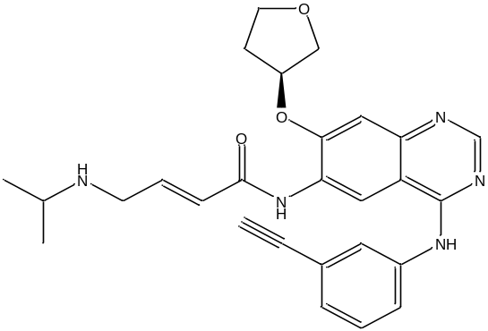
Supplementary Table 2 The binding affinity and different Interactions of the ligands under investigation with EGFR tyrosine kinase receptor.
Ligand-Receptor (3IKA) | Binding Energy  (kcal/mol) | Hydrogen Bond | Bond distance (Å) | Hydrophobic and Electrostatic Interactions
1 | -8 | GLN791, UNK1, MET793 & GLY796 | 2.92758, 2.79983,  3.40173 & 3.39398 | VAL726 (2), LYS745, & PHE723
2 | -7.7 | GLN791 & GLY796 | 2.81119 & 3.31648 | LYS745, VAL726, LEU718, ALA743, LEU844 & PHE723
3 | -8.4 | GLN791, UNK1  LYS745, CYS797 &  GLY796 | 2.76935, 2.67256,  2.19566, 2.86768 &  3.27741 | UNK1, LYS745, VAL726 (2), LYS745 & PHE723
4 | -7.6 | GLN791, CYS797 &  GLY796 | 2.77578, 2.88167 &  3.33429 | ASP855, LYS745, LEU718,  VAL726, ALA743 & LEU844
5 | -9.1 | GLN791, LYS745, CYS797, ASN842 PRO794 & GLY796 | 2.8768, 2.83195,  2.80635, 3.65564  3.22827 & 3.2556 | A:ASP855 (2)LEU718, VAL726 (2) & PHE723
6 | -9.3 | GLN791, PRO794 & GLY796 | 2.87813, 3.44185 &  3.37399 | LYS745, ASP855, PHE723, LEU718 & VAL726
7 | -9 | GLN791, ASP855, CYS797, ASN842, PRO794 & GLY796 | 2.98981, 2.09941,  2.78308, 3.61807,  3.31544 & 3.23449 | ASP855, VAL726 (2), LEU718 & PHE723
8 | -9.1 | GLN791, ASP855 PRO794 & GLY796 | 2.92147, 2.69743,  3.3526 & 3.30683 | LYS745, LEU718 & VAL726
9 | -8.3 | UNK1 | 3.48721 | LEU718 (2), LYS728, LEU792, VAL726, LEU844 & PHE723
10 | -9 | GLN791, LYS745, CYS797, PRO794, GLY796 | 2.8852, 2.36994,  2.93082, 3.27227 &  3.28787 | ASP855 (2), LYS745, LEU718, VAL726 & PHE723
11 | -8.4 | GLN791, GLY796 & CYS797 | 3.08864, 3.05239 &  2.6405 | ASN842, ASP855, LEU718 (2), LEU792, ALA743 & LEU844
12 | -8.5 | GLN791, PRO794 &  GLY796 | 2.91912, 3.33444 &  3.32438 | ASP855, LYS745 (2), VAL726 (2), LEU718 PHE723
13 | -8.4 | GLN791, CYS797,  PRO794 & GLY796 | 2.82595, 2.72833,  3.35501 & 3.30898 | ASP855, LEU718 & VAL726
14 | -7.1 | ASP855, UNK1, ARG841 & MET793 | 2.17037, 2.76912,  3.79658 & 3.30967 | ASP855, LEU844 & PHE723
15 | -8.1 | GLN791, LYS745 &  CYS797 | 2.7179, 2.32347 &  2.8208 | ASP855 (2), LYS745, VAL726 & PHE723
16 | -8 | GLN791, UNK1, LYS745 & CYS797 | 2.73545, 2.65809,  2.31736 & 2.8777 | UNK1, ASP855, UNK1, LYS745, VAL726 & PHE723
17 | -8.2 | GLN791, MET793 & GLY796 | 2.82476, 3.36347 &  3.32375 | LYS745, ASP855, PHE723, VAL726 & LYS745
18 | -7.3 | GLN791, UNK1, ASN842, UNK1, MET793 & GLY796 | 2.86998, 2.60483,  3.73055, 3.66299,  3.38354 & 3.41314 | ASP855, VAL726 (2) & PHE723
19 | -7.4 | GLN791, UNK1 & GLY796 | 2.81803, 3.54143 &  3.31266 | ASP855, LYS745, LYS745, VAL726 (2) & PHE723
20 | -7.2 | GLN791, CYS797 &  GLY796 | 2.7597, 2.80202 &  3.34037 | LYS745, ASP855 & VAL726
21 | -8.1 | ARG841, UNK1 & UNK1 | 2.40809, 3.51335 &  3.65623 | ASP855, PHE723, VAL726, LYS745 & LEU718
22 | -8.8 | GLN791, GLN791, ARG841, PRO794 & GLY796 | 3.04006, 3.10979,  3.52195, 3.44184 &  3.31464 | LYS745, ASP855, PHE723 LEU718, VAL726 & LYS745
23 | -8.8 | GLN791, ASP855, GLY796, CYS797, ASN842 & PRO794 | 2.80989, 2.08358,  3.09632, 2.68375,  3.64562 & 3.49088 | ASP855, VAL726 (2), LEU718, LEU792 & PHE723
24 | -8.1 | GLN791, ARG841, CYS797, ASN842,  LEU718, PRO794 & GLY796 | 2.82281, 2.5383,  2.77745, 3.35865,  3.36852, 3.31052 &  3.30548 | LEU718 & VAL726
25 | -8.1 | GLN791, PRO794 &  GLY796 | 3.01775, 3.34967 &  3.17168 | LEU718 (2), LEU844, LYS745,  ALA743 & PHE723
26 | -7.9 | CYS797 & MET793 | 2.62932 & 3.49644 | ASP855, LEU844 & LEU718 (2)
27 | -8 | ASN842, LYS745,  ARG841, GLU762,  ASP855, ASP837 & PHE723 | 2.87815, 2.7038,  3.76262, 3.33241,  3.50047, 3.4874 &  2.68122 | ASP855, VAL726, PHE723, ALA743, LEU792, MET793, LEU844 & LEU858
28 | -8.2 | GLN791, GLY796,  CYS797 & ARG841 | 2.96179, 3.06955,  2.68538 & 3.69224 | LEU718 (2), LEU844, VAL726, ALA743 & PHE723
29 | -8.7 | GLN791, PRO794 & GLY796 | 2.93488, 3.37212 &  3.30043 | ASP855, LYS745 (2), LEU718,  ARG841, VAL726 (2) & PHE723
30 | -7.7 | GLN791, UNK1 & GLY796 | 2.87839, 3.53726 &  3.38034 | ASP855, LYS745 (2), VAL726 (2), ARG841 & PHE723
31 | -7.8 | GLN791 & GLY796 | 2.6987 & 3.26685 | ASP855, LYS745 (2), VAL726 (2) & PHE723
32 | -7.5 | GLN791, UNK1 & GLY796 | 2.81591, 3.56461 &  3.36361 | ASP855, VAL726 (2), LYS745 & PHE723
33 | -7.7 | GLN791, UNK1 & GLY796 | 2.82586, 3.6071 &  3.26777 | ASP855, VAL726 (2), LEU718, LYS745 & PHE723
34 | -8.6 | GLN791, PRO794,  GLY796 & ARG841 | 2.89571, 3.36852,  3.34267 & 3.44426 | ASP855, LYS745 (2), LEU718, VAL726 (2) & PHE723
35 | -7.4 | GLN791 & GLY796 | 2.82769 & 3.3047 | ASP855, LEU718, LYS745, VAL726 & PHE723
36 | -7.5 | GLN791 & GLY796 | 2.89831 & 3.29986 | ASP855, LYS745, LYS745,  VAL726 & PHE723
37 | -7.8 | GLN791, PRO794 & GLY796 | 3.03841, 3.3697 &  3.28125 | ASP855, LYS745 (2), LEU718,  VAL726 (2) & PHE723
38 | -7.9 | GLN791, GLY796 & GLY796 | 2.87346, 2.90091 &  3.23034 | MET793, ASP855, LYS745, VAL726 & PHE723
39 | -7.7 | GLN791 & GLY796 | 2.88292 & 3.46628 | MET793, PRO794, PHE795, ASP855, LEU718, LYS745, VAL726 & PHE723
40 | -8 | GLN791, GLY796,  CYS797 & GLY796 | 2.88492, 3.08605,  2.83363 & 3.11192 | ARG841 (2), ASP855, LYS745,  VAL726 & PHE723
41 | -8 | GLN791 & GLY796 | 2.85603 & 3.26182 | ASP855, LYS745 (2), LEU718,  VAL726 (2) & PHE723
42 | -8.4 | PRO794 & GLY796 | 3.35021 & 3.18593 | LEU718 (2), LYS745, VAL726, ALA743, LEU844 & PHE723
43 | -8.3 | GLN791, GLY796 &  CYS797 | 2.75731, 3.07241 & 2.74183 | LEU718, LYS745, VAL726, ALA743, LEU844 & PHE723
44 | -7.8 | CYS797 & GLY796 | 2.58879 & 3.23107 | LEU844, ARG841, LEU718 (20), ALA743 & PHE723
45 | -7.7 | GLN791, GLY796 & CYS797 | 2.84398, 3.02794 &  2.71345 | LEU718, LYS745, VAL726,  ALA743, LEU844 & PHE723
46 | -7.7 | GLN791, CYS797 & GLY796 | 2.7475, 2.8489 &  3.21949 | LEU844, LYS745, VAL726, LEU718 (2), ALA743 & PHE723
47 | -7.5 | THR854, ASP855, ARG841, ASN842 & ARG841 | 2.9527, 2.06651,  2.20898, 3.35118 &  3.4582 | LEU844, LEU718 & ALA743
48 | -7.6 | GLN791 | 2.83871 | LEU718, LYS745, VAL726, ALA743, LEU844 & PHE723
49 | -7.6 | GLN791 | 2.78654 | LEU718, LYS745, VAL726, ALA743, LEU844 & PHE723
50 | -7.9 | LYS745 & LYS745 | 2.51051 & 2.71438 | ASP855, PHE723 & LEU747

Supplementary Table 3 Drug-likeness Properties of compounds under investigation
Molecule | MW | TPSA | WLOGP | No. of H-bond donors | No of H-bond acceptors | RO5 violations
Molecule 1 | 522.96 | 94.6 | 4.97 | 2 | 7 | 1
Molecule 2 | 388.42 | 85.37 | 3.39 | 2 | 5 | 0
Molecule 3 | 501.46 | 114.47 | 4.44 | 3 | 9 | 1
Molecule 4 | 407.4 | 109.16 | 3.76 | 2 | 7 | 0
Molecule 5 | 534.97 | 94.6 | 4.11 | 2 | 7 | 1
Molecule 6 | 500.52 | 94.6 | 4.46 | 2 | 7 | 1
Molecule 7 | 517.96 | 107.49 | 4.95 | 2 | 7 | 1
Molecule 8 | 483.52 | 107.49 | 4.3 | 2 | 7 | 0
Molecule 9 | 400.43 | 85.37 | 3.54 | 2 | 5 | 0
Molecule 10 | 478.85 | 85.37 | 4.3 | 2 | 8 | 0
Molecule 11 | 419.41 | 109.16 | 3.91 | 2 | 7 | 0
Molecule 12 | 428.84 | 85.37 | 4.69 | 2 | 6 | 0
Molecule 13 | 473.3 | 85.37 | 4.8 | 2 | 6 | 0
Molecule 14 | 445.51 | 88.61 | 3.33 | 2 | 6 | 0
Molecule 15 | 523.94 | 88.61 | 4.09 | 2 | 9 | 1
Molecule 16 | 615.65 | 120.95 | 4.3 | 3 | 11 | 2
Molecule 17 | 545.6 | 97.84 | 4.25 | 2 | 8 | 1
Molecule 18 | 563.05 | 110.73 | 4.74 | 2 | 8 | 1
Molecule 19 | 473.93 | 88.61 | 4.48 | 2 | 7 | 0
Molecule 20 | 518.38 | 88.61 | 4.59 | 2 | 7 | 1
Molecule 21 | 592.06 | 97.84 | 4.05 | 2 | 8 | 1
Molecule 22 | 557.62 | 97.84 | 4.39 | 2 | 8 | 1
Molecule 23 | 575.06 | 110.73 | 4.88 | 2 | 8 | 1
Molecule 24 | 540.61 | 110.73 | 4.23 | 2 | 8 | 1
Molecule 25 | 457.52 | 88.61 | 3.47 | 2 | 6 | 0
Molecule 26 | 476.5 | 112.4 | 3.84 | 2 | 8 | 0
Molecule 27 | 471.55 | 88.61 | 3.86 | 2 | 6 | 0
Molecule 28 | 484.59 | 82.62 | 3.39 | 2 | 6 | 0
Molecule 29 | 526 | 88.61 | 4.16 | 2 | 7 | 1
Molecule 30 | 513.99 | 88.61 | 4.02 | 2 | 7 | 1
Molecule 31 | 455.91 | 79.38 | 4.93 | 2 | 6 | 0
Molecule 32 | 499.96 | 88.61 | 4.95 | 2 | 7 | 0
Molecule 33 | 469.94 | 79.38 | 4.32 | 2 | 6 | 0
Molecule 34 | 560.04 | 124.89 | 4.61 | 2 | 8 | 1
Molecule 35 | 455.91 | 88.17 | 4.98 | 3 | 6 | 0
Molecule 36 | 441.89 | 88.17 | 4.59 | 3 | 6 | 0
Molecule 37 | 497.95 | 97.4 | 4.75 | 3 | 7 | 0
Molecule 38 | 477.87 | 88.17 | 5.02 | 3 | 8 | 1
Molecule 39 | 509.88 | 88.17 | 4.78 | 3 | 9 | 1
Molecule 40 | 491.89 | 88.17 | 4.13 | 3 | 8 | 0
Molecule 41 | 499.96 | 97.4 | 3.06 | 3 | 7 | 0
Molecule 42 | 497.59 | 88.61 | 4.01 | 2 | 6 | 0
Molecule 43 | 441.52 | 79.38 | 3.85 | 2 | 5 | 0
Molecule 44 | 455.55 | 79.38 | 4.24 | 2 | 5 | 0
Molecule 45 | 427.5 | 79.38 | 3.78 | 2 | 5 | 0
Molecule 46 | 441.52 | 79.38 | 4.17 | 2 | 5 | 0
Molecule 47 | 469.53 | 97.4 | 3.6 | 3 | 6 | 0
Molecule 48 | 413.47 | 88.17 | 3.44 | 3 | 5 | 0
Molecule 49 | 427.5 | 88.17 | 3.83 | 3 | 5 | 0
Molecule 50 | 471.55 | 97.4 | 3.9 | 3 | 6 | 0

Supplementary Table 4 ADME Properties of compounds under investigation
Molecule | GI absorption | BBB permeant | Pgp substrate | Bioavailability Score | Synthetic Accessibility
Molecule 1 | High | No | Yes | 0.55 | 3.66
Molecule 2 | High | No | No | 0.55 | 3.14
Molecule 3 | Low | No | No | 0.55 | 3.54
Molecule 4 | High | No | No | 0.55 | 3.06
Molecule 5 | High | No | Yes | 0.55 | 4.18
Molecule 6 | High | No | Yes | 0.55 | 4.11
Molecule 7 | High | No | Yes | 0.55 | 4.16
Molecule 8 | High | No | Yes | 0.55 | 4.08
Molecule 9 | High | No | No | 0.55 | 3.67
Molecule 10 | High | No | No | 0.55 | 3.68
Molecule 11 | High | No | Yes | 0.55 | 3.59
Molecule 12 | High | No | No | 0.55 | 3.58
Molecule 13 | High | No | No | 0.55 | 3.69
Molecule 14 | High | No | No | 0.55 | 3.65
Molecule 15 | High | No | No | 0.55 | 3.66
Molecule 16 | Low | No | Yes | 0.17 | 4.49
Molecule 17 | High | No | Yes | 0.55 | 4.11
Molecule 18 | High | No | Yes | 0.55 | 4.14
Molecule 19 | High | No | No | 0.55 | 3.56
Molecule 20 | High | No | No | 0.55 | 3.67
Molecule 21 | Low | No | Yes | 0.55 | 4.68
Molecule 22 | High | No | Yes | 0.55 | 4.63
Molecule 23 | High | No | Yes | 0.55 | 4.65
Molecule 24 | High | No | Yes | 0.55 | 4.59
Molecule 25 | High | No | Yes | 0.55 | 4.17
Molecule 26 | High | No | Yes | 0.55 | 4.09
Molecule 27 | High | No | Yes | 0.55 | 3.77
Molecule 28 | High | No | Yes | 0.55 | 3.85
Molecule 29 | High | No | Yes | 0.55 | 4.32
Molecule 30 | High | No | Yes | 0.55 | 3.77
Molecule 31 | High | No | No | 0.55 | 3.36
Molecule 32 | High | No | Yes | 0.55 | 3.71
Molecule 33 | High | No | Yes | 0.55 | 3.5
Molecule 34 | Low | No | Yes | 0.55 | 4.67
Molecule 35 | High | No | Yes | 0.55 | 3.39
Molecule 36 | High | No | Yes | 0.55 | 3.24
Molecule 37 | High | No | Yes | 0.55 | 4.14
Molecule 38 | High | No | No | 0.55 | 3.36
Molecule 39 | Low | No | Yes | 0.55 | 3.4
Molecule 40 | High | No | Yes | 0.55 | 3.37
Molecule 41 | High | No | Yes | 0.55 | 4.22
Molecule 42 | High | No | Yes | 0.55 | 4.4
Molecule 43 | High | No | Yes | 0.55 | 3.48
Molecule 44 | High | No | Yes | 0.55 | 3.63
Molecule 45 | High | No | Yes | 0.55 | 3.43
Molecule 46 | High | No | Yes | 0.55 | 3.58
Molecule 47 | High | No | Yes | 0.55 | 4.22
Molecule 48 | High | No | Yes | 0.55 | 3.31
Molecule 49 | High | No | Yes | 0.55 | 3.46
Molecule 50 | High | No | Yes | 0.55 | 4.31

