Supplementary materials:

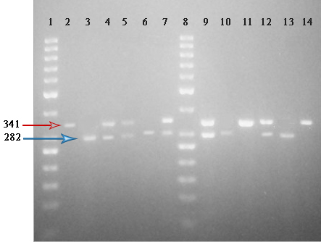  Agarose gel electrophoresis of VDR (FokI) polymorphism, Molecular DNA ladder 100 – 1000 bp (lane 1 &8), homozygous CC (wild type) yielded 1 band of 341 bp (lane 2, 11, 14), heterozygous CT yielded 3 bands 341, 282, 59 bp (lane 4,5,7,9,12), homozygous TT (mutant) yielded 2 bands 282, 59 bp (lane 3,6,10,13), band of size 59 is not appeared here in the photo | 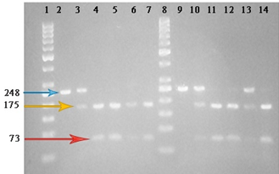  Agarose gel electrophoresis of VDR (BsmI) polymorphism, Molecular DNA ladder 100 – 1000 bp (lane 1 &8), homozygous AA (wild type) yielded 1 band of 248 bp (lane 2, 9), heterozygous AG yielded 3 bands 248, 175, 73 bp (lane 3, 10, 13), homozygous GG (mutant) yielded 2 bands 175, 73 bp (lane 4, 5, 6, 7, 11, 12, 14).

Supplementary figure (1):Agarose gel electrophoresis of VDR polymorphism

Supplementary figure (2): Allele frequency for VDR polymorphism at FokI (VDR 2228570 C > T) in all study groups
. a: significant difference from group D, b: significant difference from group C, c: significant difference from group B. *: significant ˂0.05

Supplementary figure (3): Allele frequency for VDR polymorphism at BsmI (VDR 1544410 A > G) in all study groups
. a: significant difference from group D, b: significant difference from group C, c: significant difference from group B. *: significant ˂0.05

