Karyotype Images

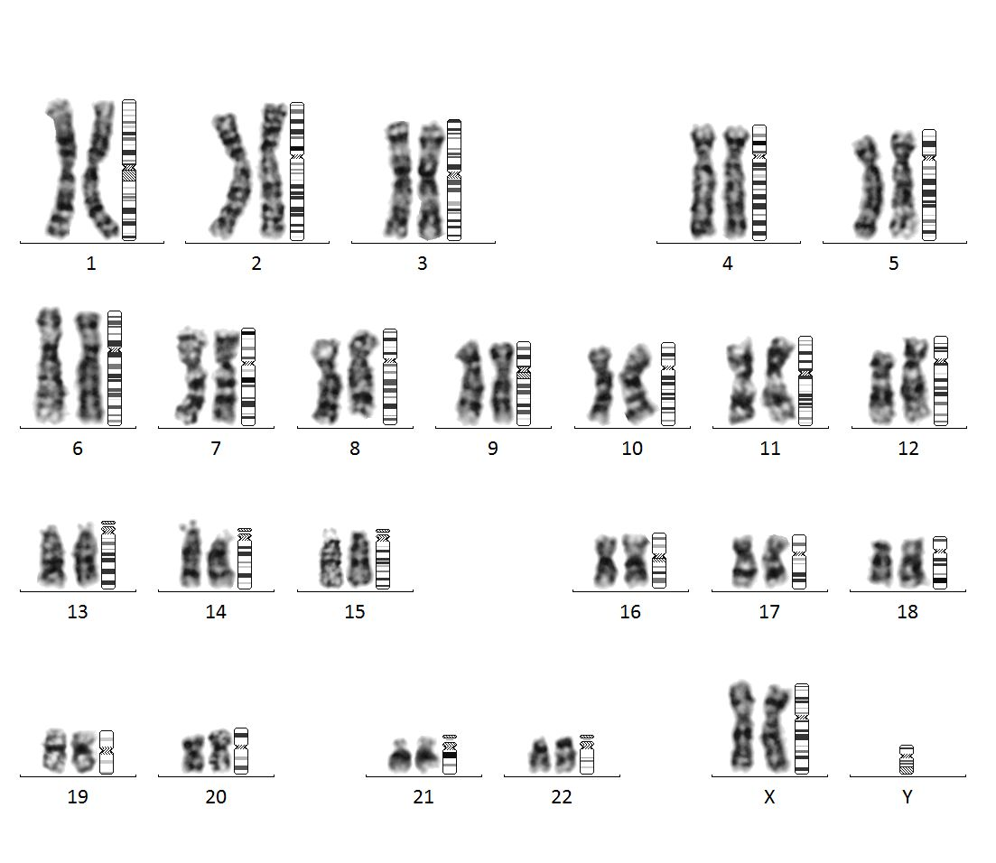
FIGURE S1: Normal female karyotype (46,XX)

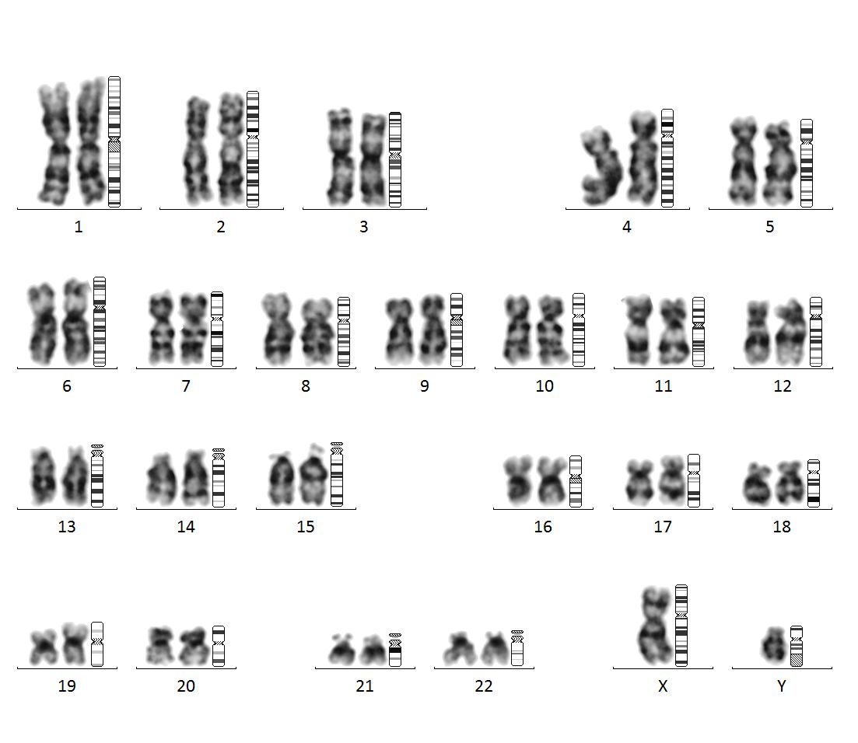
FIGURE S2: Karyotype of the case group female showing the presence of Y chromosome (46,XY)

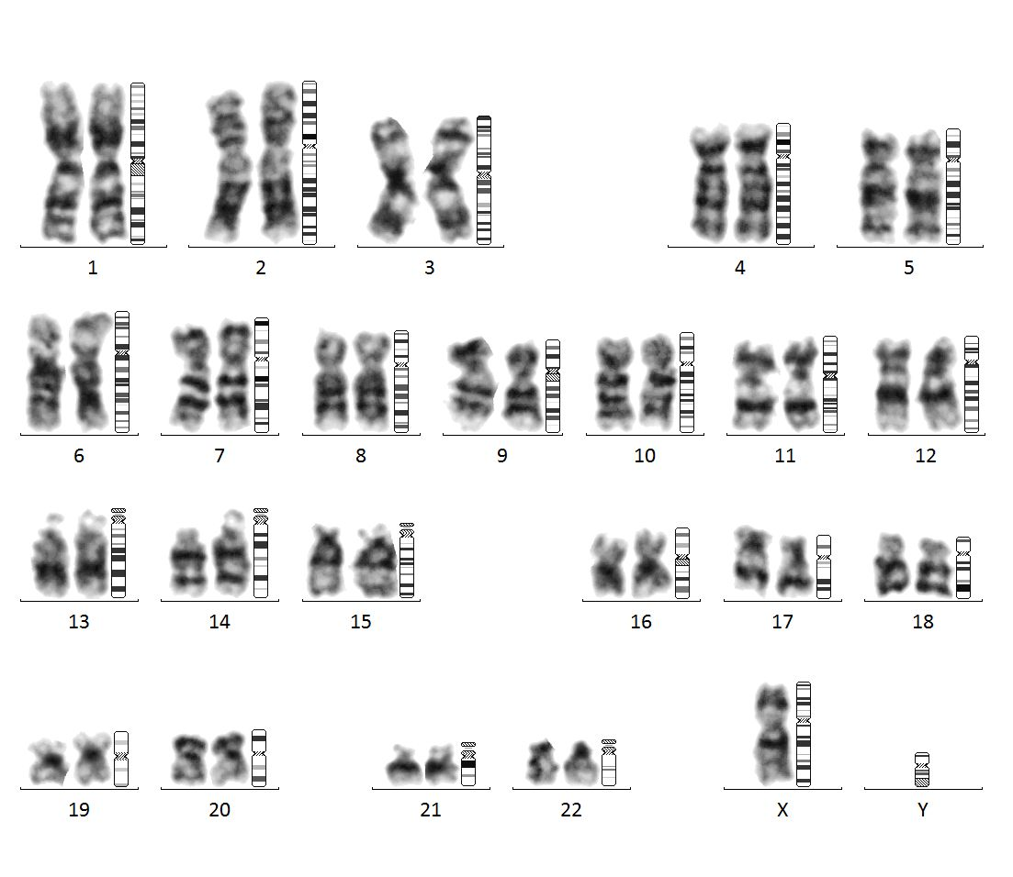
FIGURE S3: Karyotype of the case group female showing Turner syndrome (45,X)

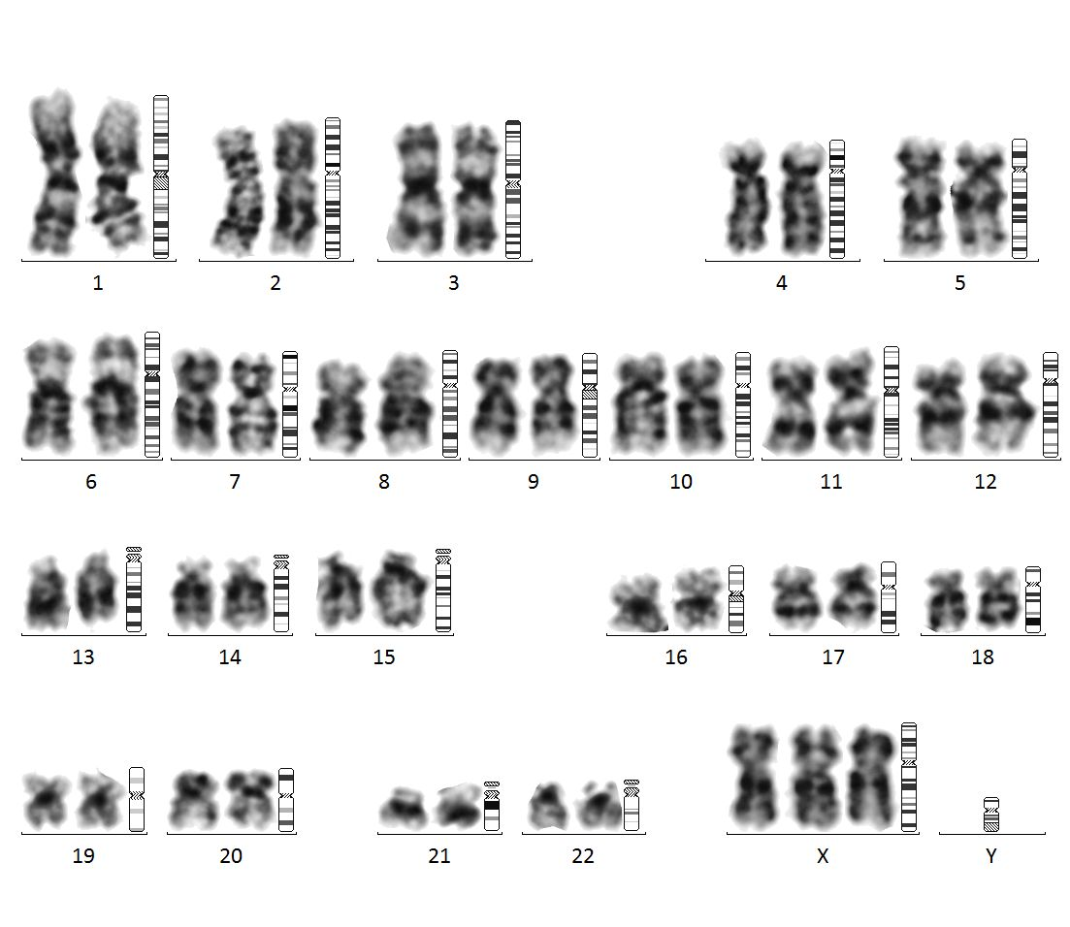
FIGURE S4: Figure showing 47,XXX, in a case group female with a mosaic karyotype: mos 45,X[84]/47,XXX[16]

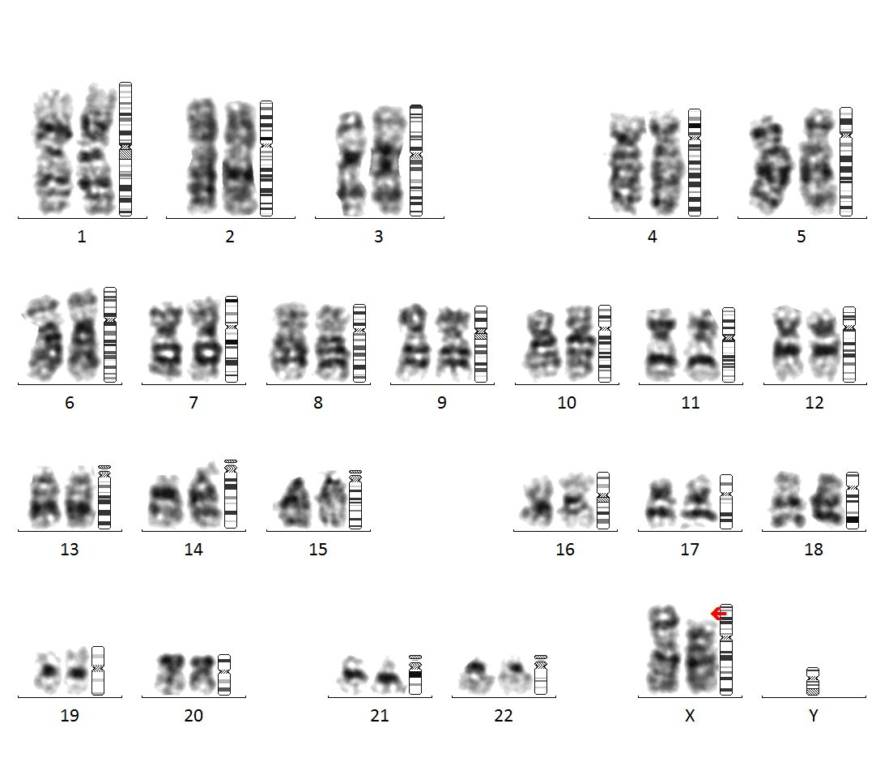
FIGURE S5: Showing deletion in the short arm of the X chromosome with karyotype:46,X,del(X)(p22.2)

FIGURE S6: Showing Isochromosome X in the case group female with karyotype: 46,X,i(X)(q10)

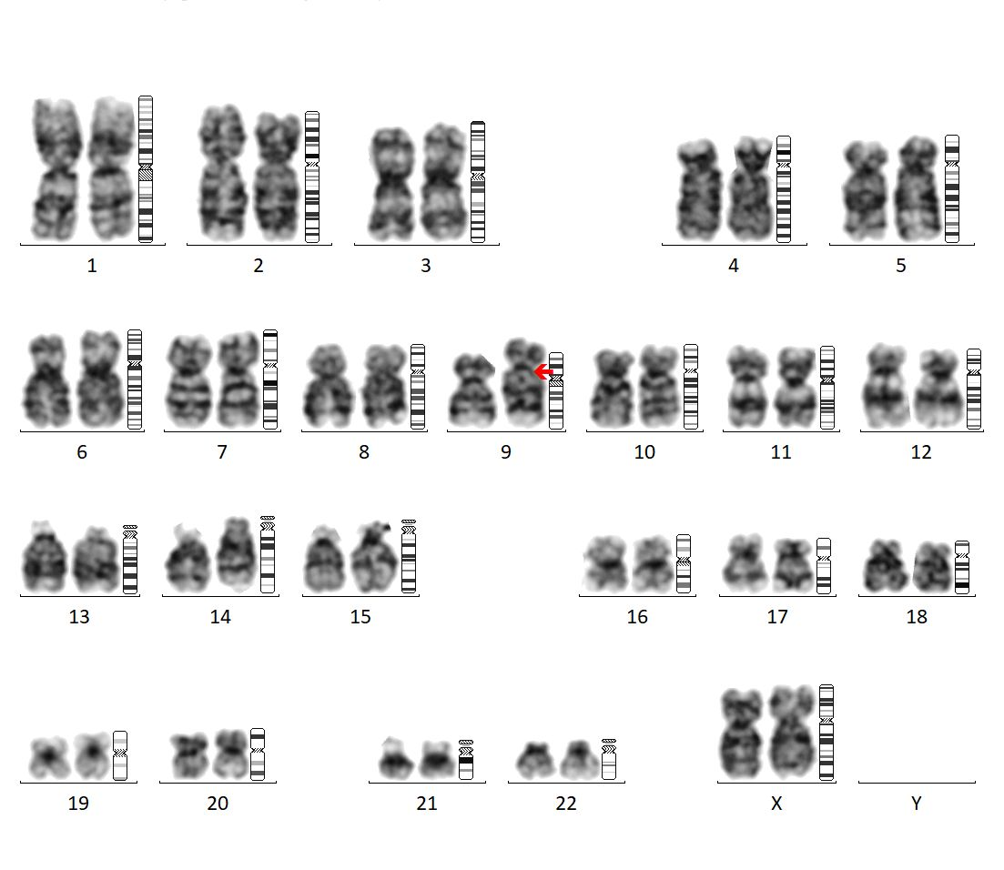
FIGURE S7: Karyotype of a female with normal variant (46,XX,9qh+)

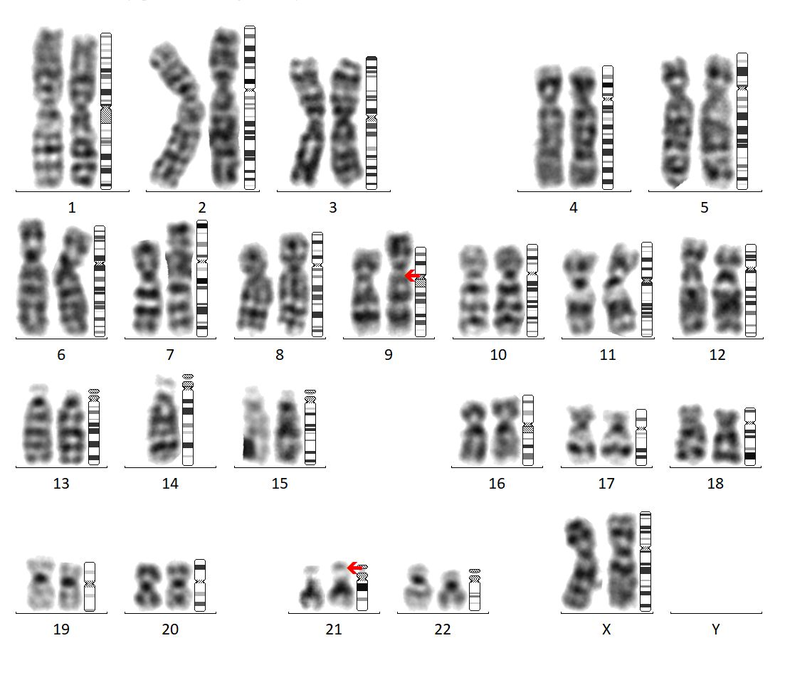
FIGURE S8: Female karyotype with normal variants (46,XX,9qh+,21ps+)

