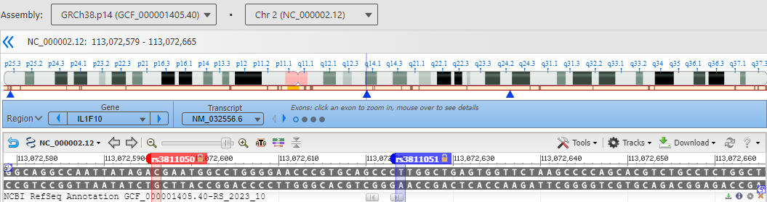
Supplementary Figure I: Gene map of the IL1F10 gene single nucleotide polymorphisms, rs3811050 and rs3811051 (https://www.ncbi.nlm.nih.gov/variation/view/).
Supplementary Figure II: Column-bar plot of serum IL-38 concentrations in patients with systemic lupus erythematosus (SLE) and healthy control women (HCW). Columns represent median. Bars represent interquartile range (IQR). Mann-Whitney test was used to assess significant difference (*p < 0.05).

Supplementary Figure III: Column-bar plot of serum IL-38 concentrations stratified by rs3811050 and rs3811051 genotypes. Columns represent median. Bars represent interquartile range (IQR). Mann-Whitney test was used to assess significant difference (ns: Not significant).

