Supplementary Material

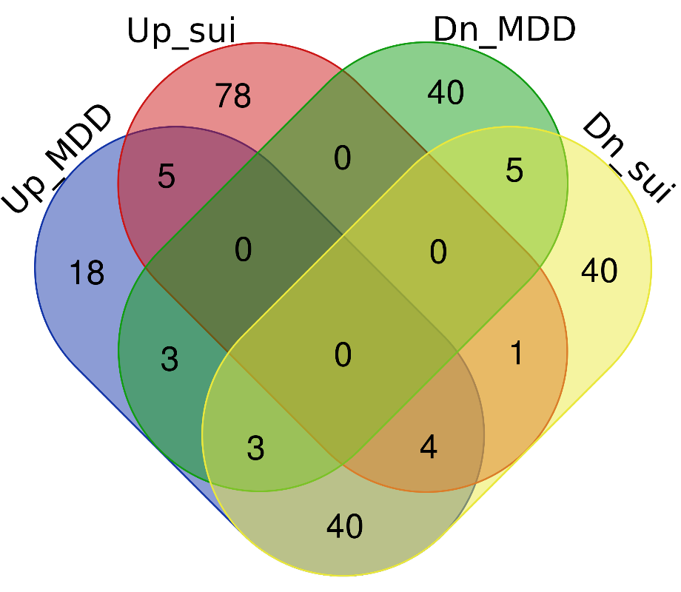
Supplementary Fig. 1. Number of TRs having overrepresented binding sites in the regulatory regions of the genes differentially expressed in MDD and suicide; upregulated in MDD/suicide (left), downregulated in MDD/suicide (right). 40 TRs were found to be common between the MDD-upregulated, and suicide-downregulated categories.

Supplementary Table 1. Transcriptional regulators (TRs) having overrepresented binding sites in the regulatory genomic regions of the genes upregulated in MDD and downregulated in suicide
S. No. | TR | Function/s | Reference/s
1 | PAF1 | Transcription elongation, transcription-coupled histone modifications, chromatin organization | [1]
2 | WDR5 | Involved in chromatin modifications; associated with the mixed lineage leukaemia (MLL) complex | [2]
4 | ZNF783 | - Regulation of transcription by RNA pol II (predicted)  - Uncharacterized repressor | NCBI Gene ID: (100289678)  [3]
5 | AFF4 | - Transcriptional elongation  - Chromatin remodelling | [4]
6 | SETD1A | Histone modification | [5]
7 | CBFB | Transcription and translational regulation | [6]
8 | INO80 | Chromatin remodelling | [7]
9 | MYC | Recruits transcription machinery to promoters | [8]
10 | TET3 | Chromatin modification | [9]
11 | EZH1 | Chromatin modification, a component of polycomb repressive complex | [10]
12 | MAX | Transcriptional regulation; a component of Myc/Max/Mad network | [11]
13 | BCL11B | Activation/repression of gene expression by direct binding to DNA or by associating with other transcription factors. | [12]
14 | E2F1 | Transcriptional activator important for progression through the G1/S transition | [13]
15 | CDK9 | Regulation of transcription by RNA pol II | [14]
16 | NCAPH2 | Chromatin condensation | [15]
17 | TRIM25 | A global transcriptional regulator | [16]
18 | KLF9 | Transcriptional regulation by binding to regulatory DNA | [17]
19 | PCGF1 | A component of polycomb repressive complexes involved in chromatin modifications | [18]
20 | MBD2 | Epigenetic modifier | [19]
21 | SPIN1 | Histone code reader | [20]
22 | PHF6 | Chromatin modifier | [21]
23 | MAZ | Controls transcription initiation | [22]
24 | MYH11 | Transcriptional regulation via multiple mechanisms | [23]
25 | HDAC1 | Histone modification | [24]
26 | DDX21 | Ribosomal RNA processing, RNA polymerase II-mediated transcription | [25]
27 | EGR1 | Transcriptional regulation, brain epigenetic reprogramming | [26]
28 | KMT2A | Transcriptional regulation and histone modification | [27]
29 | SP1 | Transcriptional regulation by interacting with corepressors or coactivators | [28]
30 | RYBP | Epigenetic modification, a component of polycomb complex | [29]
31 | ZBTB14 | Transcriptional regulation | [30]
32 | POLR2A | Transcriptional regulation, a component of RNA pol II machinery | [31]
33 | ZNF282 | Transcriptional co-activation | [32]
34 | PHF8 | Histone modifications | [33]
35 | ZBTB7A | Chromatin remodelling, epigenetic regulation | [34]
36 | KLF12 | Transcriptional co-activation and co-repression | [35]
37 | ZFX | Transcriptional regulation | [36]
References
1. Park J, Park S, Lee JS (2023) Role of the Paf1 complex in the maintenance of stem cell pluripotency and development. FEBS J. 290
2. Song JJ, Kingston RE (2008) WDR5 interacts with mixed lineage leukemia (MLL) protein via the histone H3-binding pocket. J Biol Chem 283:. https://doi.org/10.1074/jbc.M806900200
3. Tycko J, DelRosso N, Hess GT, et al (2020) High-Throughput Discovery and Characterization of Human Transcriptional Effectors. Cell 183:. https://doi.org/10.1016/j.cell.2020.11.024
4. Xiao Q, Zhang Y, Qi X, et al (2020) AFF4 regulates osteogenic differentiation of human dental follicle cells. Int J Oral Sci 12:. https://doi.org/10.1038/s41368-020-0083-9
5. Yang L, Jin M, Park SJ, et al (2020) Setd1a promotes proliferation of castration-resistant prostate cancer cells via FOXM1 transcription. Cancers (Basel) 12:. https://doi.org/10.3390/cancers12071736
6. Malik N, Yan H, Moshkovich N, et al (2019) The transcription factor CBFB suppresses breast cancer through orchestrating translation and transcription. Nat Commun 10:. https://doi.org/10.1038/s41467-019-10102-6
7. Gowans GJ, Schep AN, Wong KM, et al (2018) INO80 Chromatin Remodeling Coordinates Metabolic Homeostasis with Cell Division. Cell Rep 22:. https://doi.org/10.1016/j.celrep.2017.12.079
8. Das SK, Lewis BA, Levens D (2023) MYC: a complex problem. Trends Cell Biol. 33
9. Montalbán-Loro R, Lozano-Ureña A, Ito M, et al (2019) TET3 prevents terminal differentiation of adult NSCs by a non-catalytic action at Snrpn. Nat Commun 10:. https://doi.org/10.1038/s41467-019-09665-1
10. Margueron R, Li G, Sarma K, et al (2008) Ezh1 and Ezh2 Maintain Repressive Chromatin through Different Mechanisms. Mol Cell 32:. https://doi.org/10.1016/j.molcel.2008.11.004
11. Grandori C, Cowley SM, James LP, Eisenman RN (2000) The Myc/Max/Mad network and the transcriptional control of cell behavior. Annu. Rev. Cell Dev. Biol. 16
12. Lennon MJ, Jones SP, Lovelace MD, et al (2017) Bcl11b-A critical neurodevelopmental transcription factor-roles in health and disease. Front. Cell. Neurosci. 11
13. Wu L, Timmers C, Malti B, et al (2001) The E2F1-3 transcription factors are essential for cellular proliferation. Nature 414:. https://doi.org/10.1038/35106593
14. Bacon CW, D’Orso I (2019) CDK9: a signaling hub for transcriptional control. Transcription 10
15. Murphy ZC, Wells M, Murphy K, et al (2021) The Condensin II Complex Subunit NCAPH2 Is Essential for Erythropoiesis and Regulates Erythroid Gene Expression. Blood 138:. https://doi.org/10.1182/blood-2021-151957
16. Li F, Sun Q, Liu K, et al (2020) OTUD5 cooperates with TRIM25 in transcriptional regulation and tumor progression via deubiquitination activity. Nat Commun 11:. https://doi.org/10.1038/s41467-020-17926-7
17. Gans IM, Grendler J, Babich R, et al (2021) Glucocorticoid-Responsive Transcription Factor Krüppel-Like Factor 9 Regulates fkbp5 and Metabolism. Front Cell Dev Biol 9:. https://doi.org/10.3389/fcell.2021.727037
18. Scelfo A, Fernández-Pérez D, Tamburri S, et al (2019) Functional Landscape of PCGF Proteins Reveals Both RING1A/B-Dependent-and RING1A/B-Independent-Specific Activities. Mol Cell 74:. https://doi.org/10.1016/j.molcel.2019.04.002
19. Menafra R, Stunnenberg HG (2014) MBD2 and MBD3: Elusive functions and mechanisms. Front. Genet. 5
20. Greschik H, Duteil D, Messaddeq N, et al (2017) The histone code reader Spin1 controls skeletal muscle development. Cell Death Dis 8:. https://doi.org/10.1038/cddis.2017.468
21. Feliciano YMS, Bartlebaugh JME, Liu Y, et al (2017) PHF6 regulates phenotypic plasticity through chromatin organization within lineage-specific genes. Genes Dev 31:. https://doi.org/10.1101/gad.295857.117
22. Zheng C, Wu H, Jin S, et al (2022) Roles of Myc-associated zinc finger protein in malignant tumors. Asia. Pac. J. Clin. Oncol. 18
23. Martens J, Mandoli A, Singh A, et al (2013) CBFB-MYH11/RUNX1 together with a compendium of hematopoietic regulators, chromatin modifiers and basal transcription factors occupies self-renewal genes in inv(16) acute myeloid leukemia. Exp Hematol 41:. https://doi.org/10.1016/j.exphem.2013.05.198
24. Gallinari P, Di Marco S, Jones P, et al (2007) HDACs, histone deacetylation and gene transcription: From molecular biology to cancer therapeutics. Cell Res 17:. https://doi.org/10.1038/sj.cr.7310149
25. Miao W, Porter DF, Lopez-Pajares V, et al (2023) Glucose dissociates DDX21 dimers to regulate mRNA splicing and tissue differentiation. Cell 186:. https://doi.org/10.1016/j.cell.2022.12.004
26. Sun Z, Xu X, He J, et al (2019) EGR1 recruits TET1 to shape the brain methylome during development and upon neuronal activity. Nat Commun 10:. https://doi.org/10.1038/s41467-019-11905-3
27. Li X, Song Y (2021) Structure, function and inhibition of critical protein–protein interactions involving mixed lineage leukemia 1 and its fusion oncoproteins. J. Hematol. Oncol. 14
28. Kaczynski J, Cook T, Urrutia R (2003) Sp1- and Krüppel-like transcription factors. Genome Biol. 4
29. Henry S, Kokity L, Pirity MK (2023) Polycomb protein RYBP activates transcription factor Plagl1 during in vitro cardiac differentiation of mouse embryonic stem cells. Open Biol 13:. https://doi.org/10.1098/rsob.220305
30. Deng Y, Wang H, Liu X, et al (2022) Zbtb14 regulates monocyte and macrophage development through inhibiting pu.1 expression in zebrafish. Elife 11:. https://doi.org/10.7554/eLife.80760
31. Jiang Q, Zhang J, Li F, et al (2021) POLR2A Promotes the Proliferation of Gastric Cancer Cells by Advancing the Overall Cell Cycle Progression. Front Genet 12:. https://doi.org/10.3389/fgene.2021.688575
32. Yeo SY, Ha SY, Yu EJ, et al (2014) ZNF282 (Zinc finger protein 282), a novel E2F1 co-activator, promotes esophageal squamous cell carcinoma. Oncotarget 5:. https://doi.org/10.18632/oncotarget.2630
33. Kleine-Kohlbrecher D, Christensen J, Vandamme J, et al (2010) A Functional Link between the Histone Demethylase PHF8 and the Transcription Factor ZNF711 in X-Linked Mental Retardation. Mol Cell 38:. https://doi.org/10.1016/j.molcel.2010.03.002
34. Constantinou C, Spella M, Chondrou V, et al (2019) The multi-faceted functioning portrait of LRF/ZBTB7A. Hum. Genomics 13
35. Presnell JS, Schnitzler CE, Browne WE (2015) KLF/SP transcription factor family evolution: Expansion, diversification, and innovation in eukaryotes. Genome Biol Evol 7:. https://doi.org/10.1093/gbe/evv141
36. Rhie SK, Yao L, Luo Z, et al (2018) ZFX acts as a transcriptional activator in multiple types of human tumors by binding downstream from transcription start sites at the majority of CpG island promoters. Genome Res 28:. https://doi.org/10.1101/gr.228809.117

