Supplementary Information

Supplementary Table-1: Quality control parameters of sequencing data
Sample type | Number of samples | Sequencing platform | Sequencing type | Average Q20 | mtDNA coverage | Average Depth
Colon Cancer | 30 | Ion Torrent PGM | Amplicon Sequencing | 99.5% | 100% | 1080±530
Rectal Cancer | 20 | Ion Torrent PGM | Amplicon Sequencing | 99.6% | 100% | 1010±620

Supplementary Table-2: Prosa and QmeanDisco values of Homology modelled structures: ProSA measures quality of model and Z-scores generated indicate the quality of model. Z-scores are acceptable in range of -10 to 10. QmeanDisco indicates the Global quality scores of protein models.
S.No | Protein | ProSA Score[Z-score] | QmeanDisco
1 | ATP6WT | -3.68 | 0.44±0.06
2 | ATP6-L137F | -2.9 | 0.43±0.06
3 | ATP6-L220P | -3.57 | 0.41±0.06
4 | ND5WT | -5.47 | 0.53±0.05
5 | ND5-V302M | -5.26 | 0.51±0.05
6 | ND5-S461G | -5.46 | 0.53±0.05

Supplementary Table 3: Dynamut analysis of effect of variants on Protein structure.
S.No. | AA Mutant | AA Ref | Position | Vibrational Entropy  [kcal.mol⁻¹.K⁻¹ ] | Molecular Flexibility | ΔΔG  [kcal/mol] | Effect on the protein
1 | L | F | 137 | -0.084 | Decrease | 0.066 | Stabilizing
2 | L | P | 220 | -0.227 | Decrease | -0.120 | Destabilizing
3 | V | M | 302 | -0.340 | Decrease | -0.024 | Destabilizing
4 | G | S | 461 | 0.457 | Increase | -1.374 | Destabilizing

Supplementary Figure-1:Characteristics of mitochondrial DNA mutations in coding regions (mtCOR) and control regions (mtCRL) of non-tumor[adjacent normal tissues] and tumor variants.(A) Proportion percentage of mutations in mtCOR and mtCRL (B) Mutation density in mtCOR and mtCRL as per the average number of mutations per sample in kilobase (kb). Heteroplasmic level of accumulated mutations in mtCOR and mtCRL for (C) Non-tumor[adjacent normal tissues] and (D) Tumor variants. The data's were analysed using Kolmogorov-Smirnov test with P < 0.05 and P <0.001.

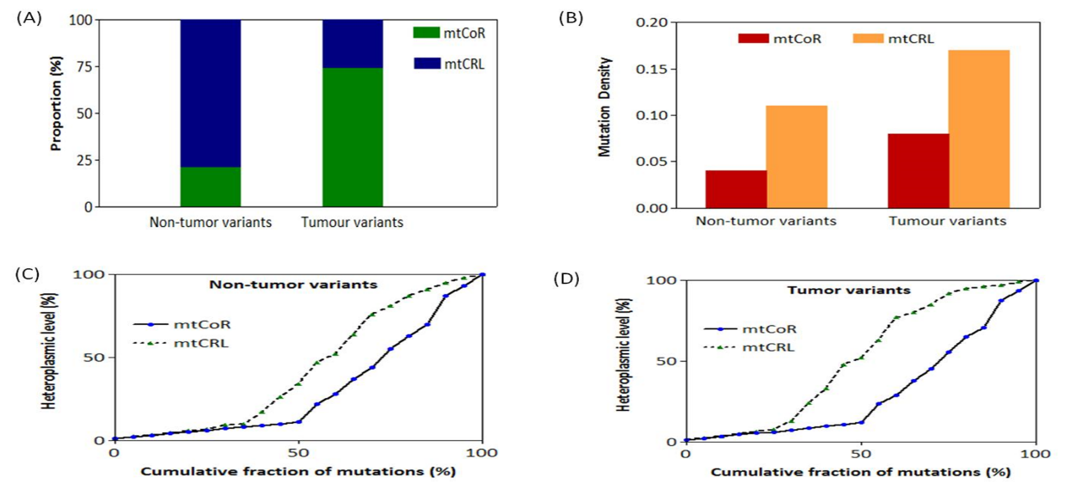

Supplementary Figure-2[A]: The interatomic interaction between wild type and mutant. There can be observed disruption in various bonds between the molecules. Bonds colors: Orange- Polar bonds; Pink- clashes; Red: Hydrogen bonds; Green-Hydrophobic bonds; Blue-Carbonyl. The Valine residue at position 302 is replaced my Methionine on acquiring mutation shows change in the interactions with surrounding residues.
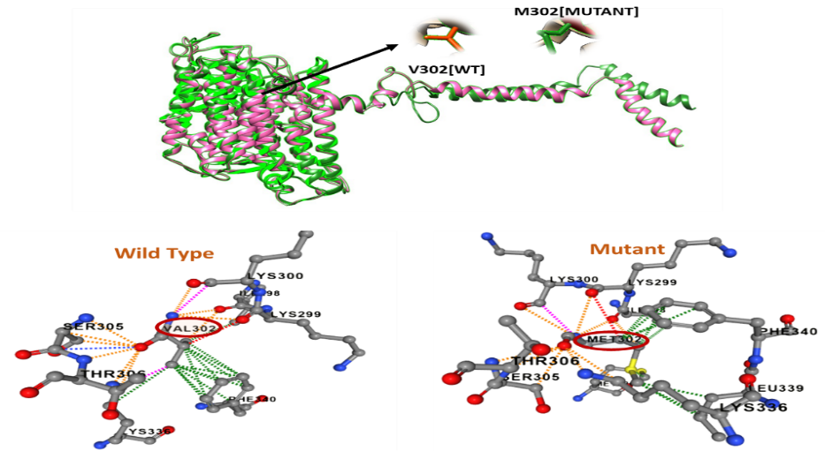
Supplementary Figure-2[B]: The interatomic interactions between the wild-type and mutant forms reveal disruptions in several types of bonds. The bond colors are as follows: orange for polar bonds, pink for clashes, red for hydrogen bonds, green for hydrophobic interactions, and blue for carbonyl bonds. The mutant S461G has a mutation that has Glycine at replacing Serine at 461 position which causes a major disruption in the bonds and interactions.

