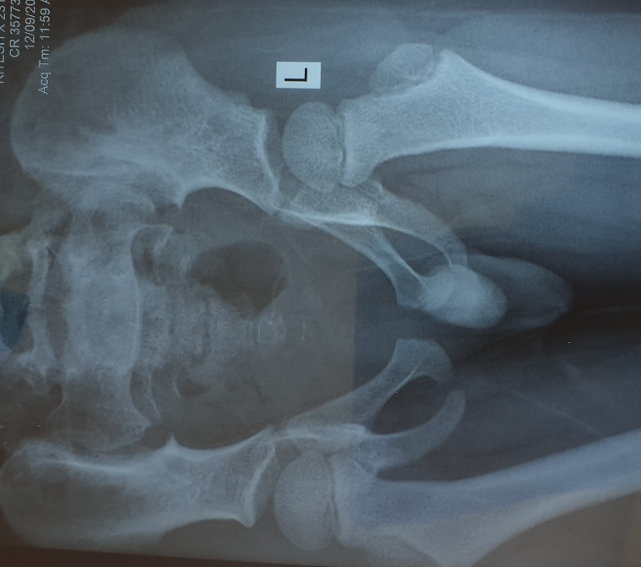
Xray P4

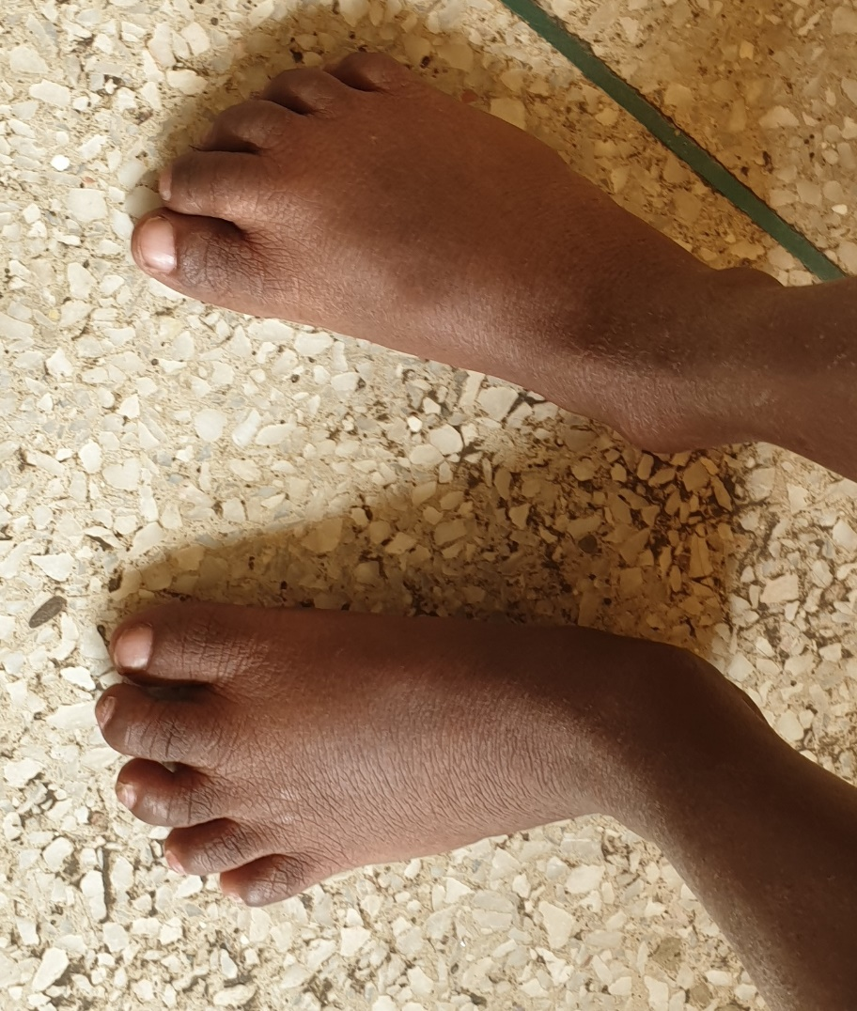
Feet P4 showing short deformed toes

Xray P1: Hip dislocation and metaphyseal changes

