Supplementary material
Genetic and phenotypic characteristics of 3 patients with Limb Girdle Muscular Dystrophy: Experience in a medical center in Mexico.

Figure S1. Pedigree chart of P1. The arrow indicates the proband. Blue figures indicate family members with myopathy.
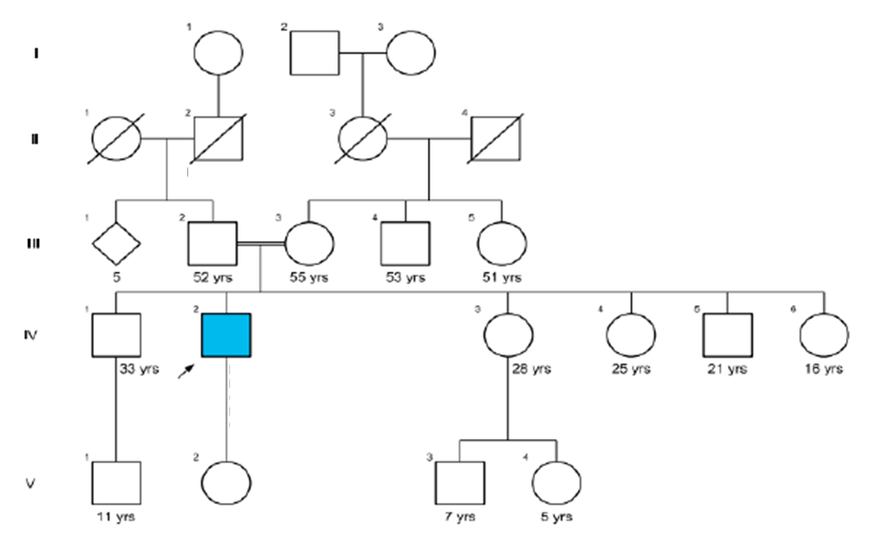

Figure S2. Pedigree chart of P2. The arrow indicates the proband. Blue figures indicate family members with myopathy.
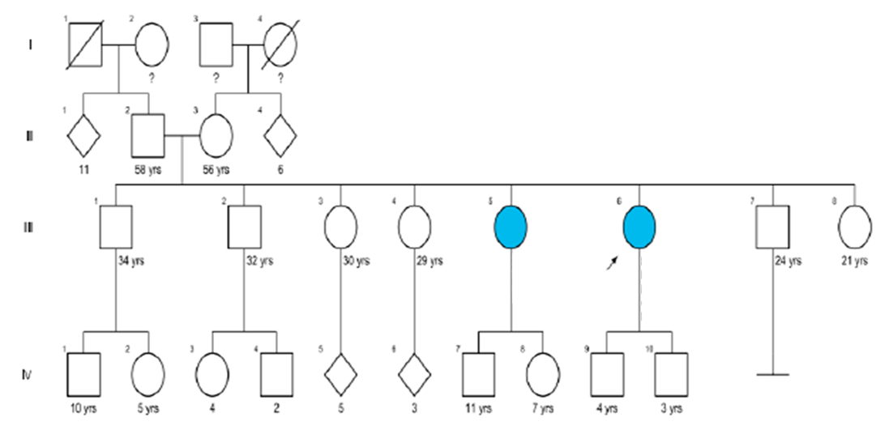

Figure S3. Pedigree chart of P3. The arrow indicates the proband. Blue figures indicate family members with myopathy. Gray figures indicate developmental disability.
