Supplementary Table 1. Top enriched HUB genes based on eigenvector, degree, betweenness and closeness centrality. The genes are arranged based on the highest eigen centrality.
Genes | Eigen Centrality | Degree Centrality | Betweeness Centrality | Closness Centrality
AURKA | 1 | 167 | 93.76624698 | 0.833333333
AURKB | 0.99446334 | 169 | 61.96941374 | 0.8203125
TOP2A | 0.991602612 | 164 | 64.38125373 | 0.807692308
BUB1 | 0.989802618 | 165 | 43.33886814 | 0.807692308
PLK1 | 0.982973352 | 160 | 64.42776011 | 0.813953488
CDC6 | 0.982414821 | 156 | 43.92900156 | 0.807692308
CCNA2 | 0.98131061 | 172 | 86.71117614 | 0.826771654
CDC20 | 0.980935678 | 166 | 93.75670371 | 0.826771654
CCNB1 | 0.980708834 | 173 | 83.15605518 | 0.813953488
CDK1 | 0.980653232 | 181 | 83.03101475 | 0.826771654
CDC45 | 0.975476096 | 161 | 32.83900058 | 0.795454545
KIF23 | 0.972898545 | 157 | 53.33999675 | 0.795454545

Supplementary Table 2. Top KEGG pathways enriched by HUB genes based on combined score.
Index | Pathway | Adjusted P-value | Combined Score
1 | Cell Cycle | 1.479e-22 | 2419.95
2 | P53 Signaling Pathway | 7.097e-9 | 646.53
3 | DNA Replication | 0.00001305 | 430.95
4 | Progesterone-mediated Oocyte Maturation | 6.179e-8 | 396.39
5 | Cellular Senescence | 1.855e-8 | 333.13
6 | Oocyte Meiosis | 4.690e-7 | 265.76
7 | Mismatch Repair | 0.001790 | 241.57
8 | Small Cell Lung Cancer | 0.000006901 | 236.57
9 | Human T-cell Leukemia Virus 1 Infection | 0.000003558 | 148.87
10 | Viral Carcinogenesis | 0.0001166 | 93.01
11 | Pancreatic Cancer | 0.004934 | 78.22
12 | Pyrimidine Metabolism | 0.01810 | 62.40
13 | Ubiquinone And Other Terpenoid-quinone Biosynthesis | 0.1428 | 54.32
14 | Base Excision Repair | 0.04764 | 53.32
15 | Non-homologous End-joining | 0.1583 | 42.71
16 | Human Immunodeficiency Virus 1 Infection | 0.005970 | 40.00
17 | Pathways In Cancer | 0.0009881 | 38.98
18 | Chronic Myeloid Leukemia | 0.03753 | 38.50
19 | Homologous Recombination | 0.06623 | 38.33
20 | Bladder Cancer | 0.06623 | 38.33
21 | Foxo Signaling Pathway | 0.02707 | 32.08
22 | Nucleotide Excision Repair | 0.08225 | 31.04
23 | Ecm-receptor Interaction | 0.04531 | 30.33
24 | Micrornas In Cancer | 0.007839 | 30.30
25 | Fanconi Anemia Pathway | 0.1024 | 24.96
26 | Cushing Syndrome | 0.04088 | 23.95
27 | One Carbon Pool By Folate | 0.2147 | 22.85
28 | Hepatitis B | 0.04514 | 22.15
29 | Hepatocellular Carcinoma | 0.04640 | 20.75
30 | Human Papillomavirus Infection | 0.03875 | 17.27
31 | Mitophagy | 0.1399 | 17.24
32 | Melanoma | 0.1428 | 15.70
33 | Non-small Cell Lung Cancer | 0.1428 | 15.70
34 | Glioma | 0.1468 | 14.68
35 | Gastric Cancer | 0.1284 | 12.23
36 | Chemical Carcinogenesis | 0.1139 | 10.69
37 | Prostate Cancer | 0.2103 | 9.49
38 | Hematopoietic Cell Lineage | 0.2119 | 9.16
39 | Drug Metabolism | 0.2327 | 7.85
40 | Toxoplasmosis | 0.2353 | 7.36
41 | Epstein-barr Virus Infection | 0.2103 | 6.87
42 | Purine Metabolism | 0.2886 | 5.69
43 | Measles | 0.3135 | 4.95
44 | Ubiquitin Mediated Proteolysis | 0.3135 | 4.88
45 | Apoptosis | 0.3135 | 4.75
46 | Pi3k-akt Signaling Pathway | 0.2353 | 4.66
47 | Glutathione Metabolism | 0.4524 | 4.52
48 | Cell Adhesion Molecules | 0.3269 | 4.39
49 | Lysine Degradation | 0.4608 | 3.83
50 | Gnrh Secretion | 0.4608 | 3.72

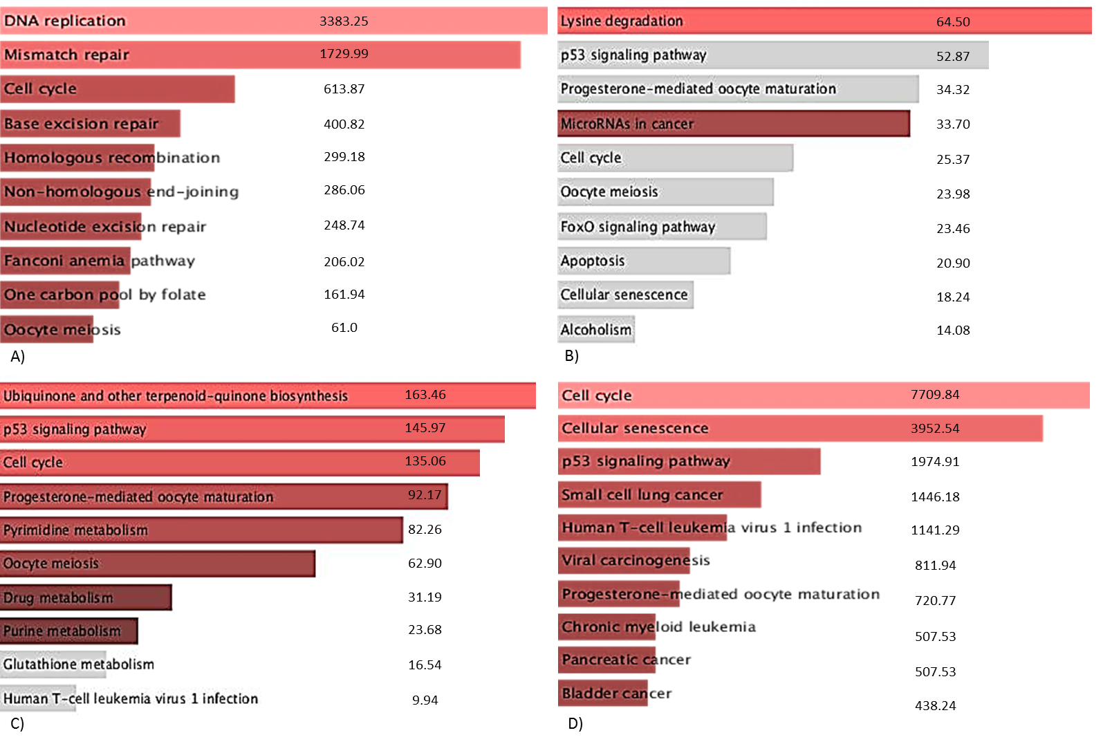
Supplementary Figure 1. KEGG pathway enrichment analysis for each network module identified by Louvain clustering. (A) Cluster 1, (B) Cluster 2, (C) Cluster 3, and (D) Cluster 4. Pathways are ranked based on combined enrichment scores. Distinct functional enrichment patterns highlight biological specialization of each module.

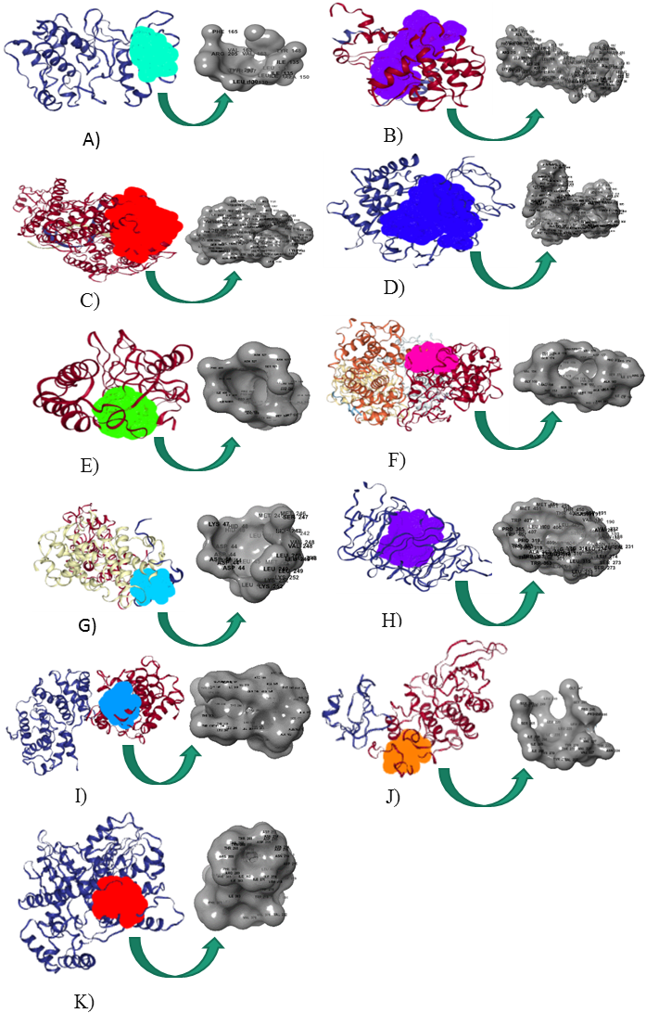
Supplementary Figure 2. Structural visualization of predicted druggable pockets for top hub proteins using the PockDrug server. Each panel (A–K) represents a protein with its highest-scoring binding pocket. Druggability probability scores (>0.5 considered druggable) indicate strong potential for small-molecule targeting, particularly for CDC6, CDC20, and CDC45.

