The determination of estrous cycles in adult female Wistar rats before and after extract administration

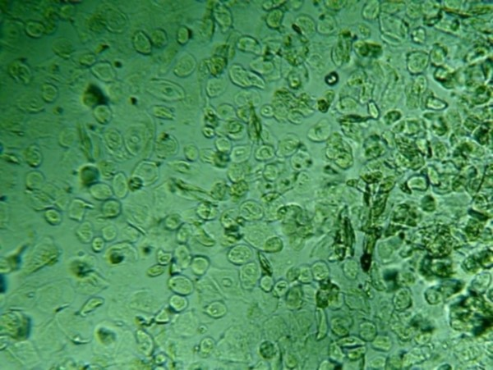
- Day 1 (before administration of extract) showing estrous cycle.
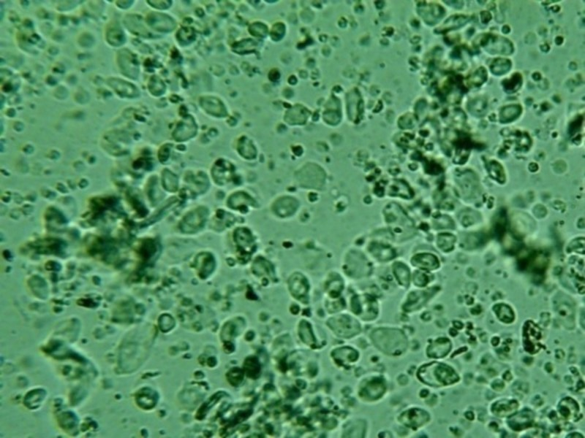
Day 1 (after administration of extract) showing estrous cycle.
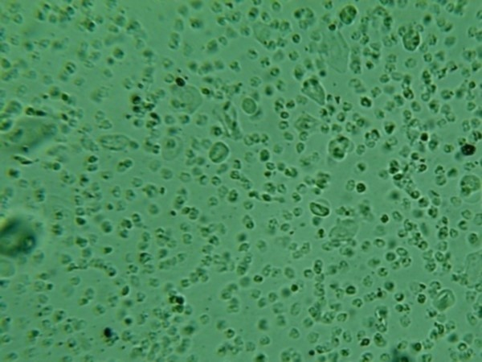
Day 2 (before administration of extract) showing metestrus cycle.
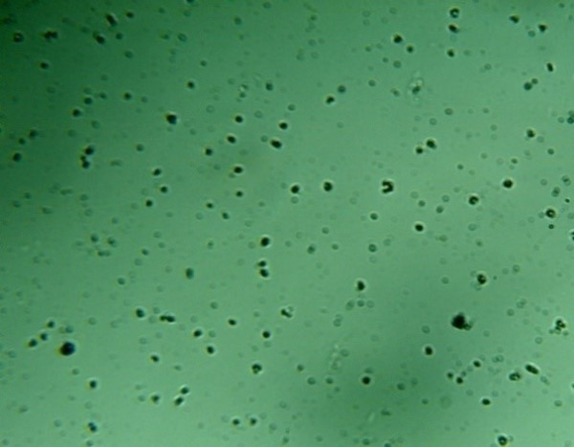Day 2 (after administration of extract) showing metestrus.
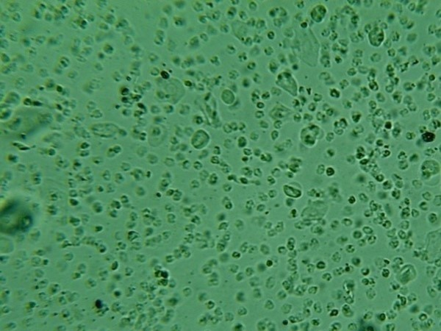
Day 3 (before administration of extract) showing metestrus.
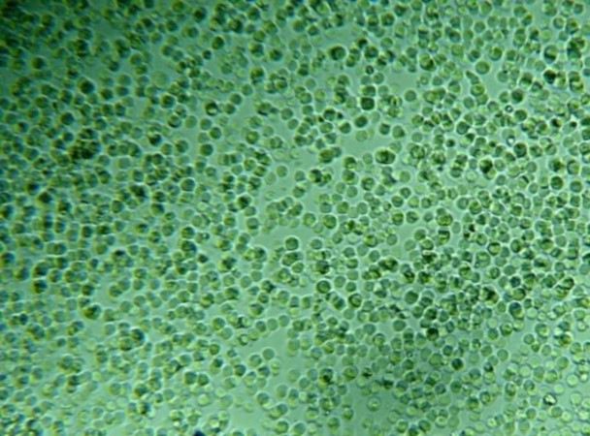
Day 3 (after administration of extract) showing metestrus
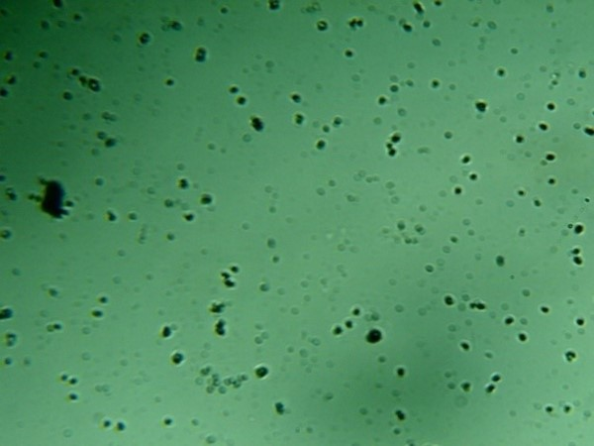
Day 4 (before extract administration) showing diestrus
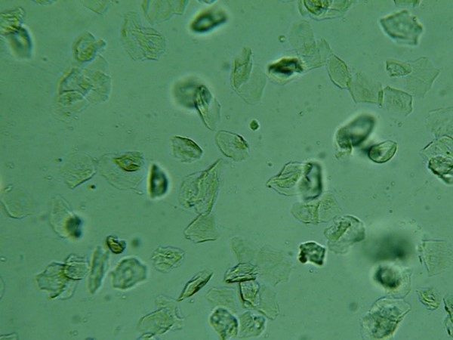
Day 4 (after administration of extract) showing diestrus.

