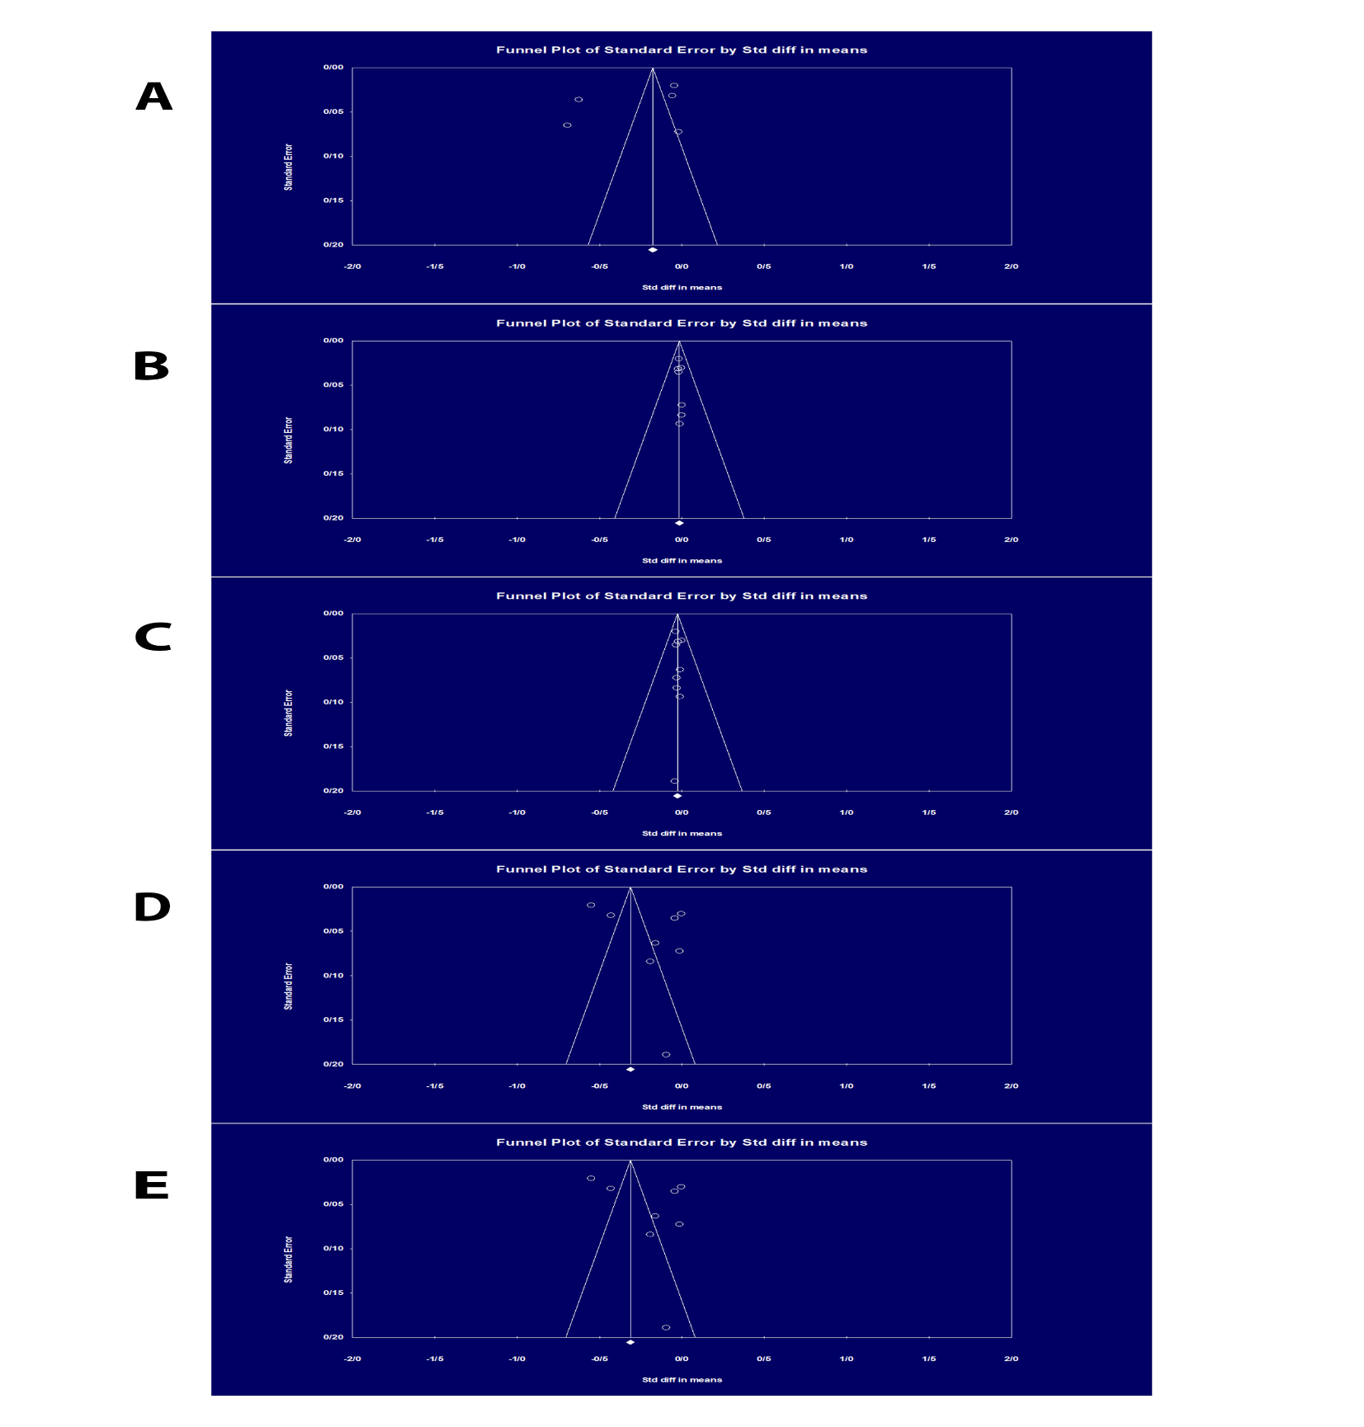
Supplementary Fig 4. Funnel plot to assess the presences of publication bias about PM2.5 exposure and semen parameters, including A) semen volume, B) sperm concentration, C) total sperm count, D) total motility, and E) progressive motility.

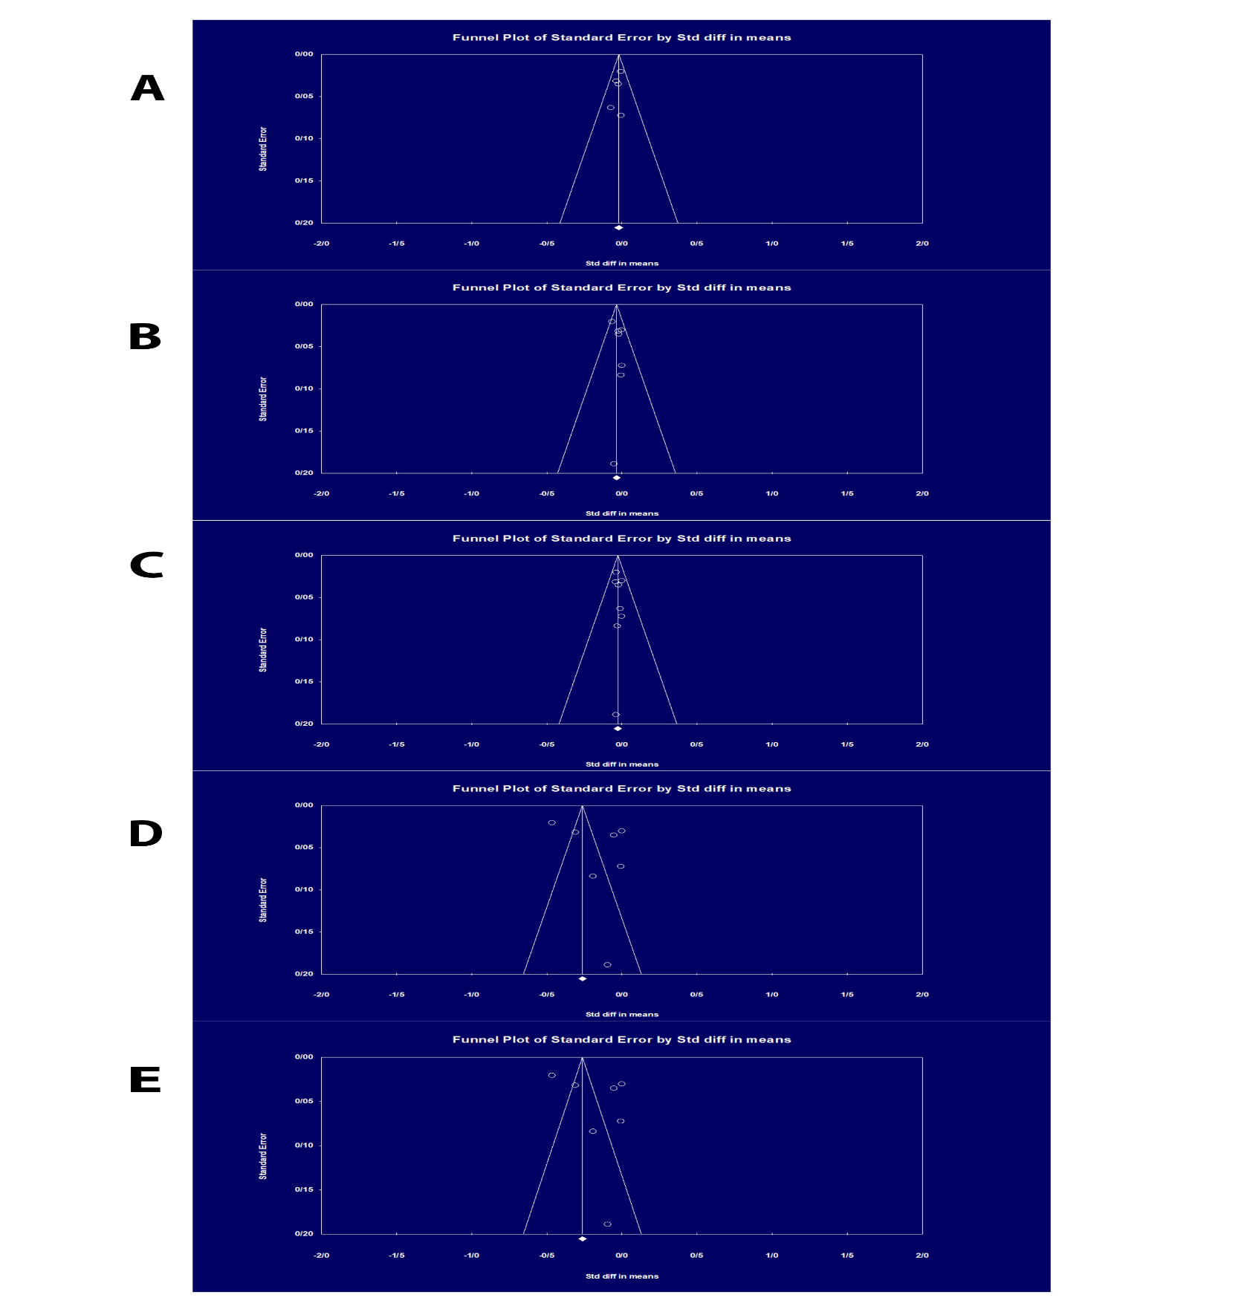
Supplementary Fig 5. Funnel plot to assess the presences of publication bias about PM10 exposure and semen parameters, including A) semen volume, B) sperm concentration, C) total sperm count, D) total motility, and E) progressive motility.

