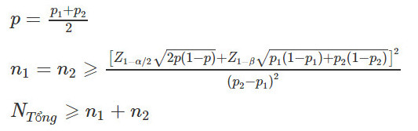
Sample size calculation:

In this study, we assume:
Type I error (α) = 0.05
Type II error (β) = 0.2
Outcome rate in group 1 (p1) = 0.0083
Outcome rate in group 2 (p2) = 0.0645
Using these assumptions, we calculate the sample size for each group as: N1 = N2 = 174. Total sample size (N) = 348
To account for a potential loss to follow-up of ≤ 10%, the actual sample size required is: N_actual = 348 + 10% of 348 = 380
Sampling Method:
Participants will be continuously selected based on inclusion criteria and then randomly assigned into two study groups: oral estradiol and transdermal estradiol.
Randomization:
Participants will be randomly assigned to the study groups using software from www.random.org. Block randomization (block sizes: 2, 4, 6) with permutation will be employed. A staff member not involved in the study will print the randomized assignments (A or B), place them in sealed envelopes, and assign them according to the randomization table. Each participant has an equal probability (1:1) of being selected into either group after screening and signing the consent form. Envelopes will be numbered sequentially, and participants will be assigned drugs as follows upon opening their envelopes:
Group A: Oral estradiol
Group B: Transdermal estradiol
Blinding:
All study members, including doctors, midwives, and staff, will be blinded to the randomization table. Pharmacists dispensing the medications will not be blinded but will have no other role in the study.

