SUPPLEMENTARY MATERIAL
Association of IL-17A rs2275913 Polymorphism and Serum IL-17A Levels with Recurrent Spontaneous Abortion in Iraqi Women: A Case–Control Study

This document provides supplementary details on laboratory methods, assay quality control, internal validation of genotyping results by Sanger sequencing, the full ELISA standard curve, and a forest plot summarising prior studies that examined IL-17A rs2275913 in recurrent spontaneous abortion (RSA).
Table S1. Tetra-primer ARMS-PCR primers and thermal cycling conditions for IL-17A rs2275913 (G>A) genotyping
Primer | Sequence (5′ → 3′) | Length (nt) | Tm (°C) | Amplicon
Forward outer (FO) | CAGAAGACCTACATGTTACTGCA | 23 | 58.9 | 464 bp (internal control, with RO)
Reverse outer (RO) | CCCCCAATGAGGTCATAGAAGAATC | 25 | 61.3 | 464 bp (internal control, with FO)
Forward inner (G-allele specific) | AACAAGTAAGAATGAAAAGAGGACATGGT | 29 | 62.1 | 297 bp (with RO)
Reverse inner (A-allele specific) | GTTTGTGTTGTTATTTTTGAATCTCT | 26 | 57.8 | 209 bp (with FO)
Primers are consistent with published T-ARMS-PCR designs for IL-17A rs2275913 (Kawaguchi et al. 2006; Saifi et al. 2018). Tm values were recalculated using the nearest-neighbour method (OligoAnalyzer v3.1, IDT) at 50 mM Na⁺, 1.5 mM Mg²⁺.
PCR cycling protocol
Step | Temperature | Duration | Cycles
Initial denaturation | 95 °C | 5 min | 1
Denaturation | 95 °C | 30 s | 35
Annealing | 62 °C | 30 s | 35
Extension | 72 °C | 45 s | 35
Final extension | 72 °C | 7 min | 1
Hold | 4 °C | ∞ | —
Reactions were performed on an Applied Biosystems Veriti thermal cycler (Thermo Fisher Scientific, Foster City, CA, USA) in a 25 µL volume containing 50 ng genomic DNA, 0.4 µM each outer primer, 0.8 µM each inner primer, 1× GoTaq® Green Master Mix (Promega, Madison, WI, USA), and nuclease-free water.
Table S2. ELISA assay quality-control metrics (Elabscience E-EL-H0105)
Parameter | Value | Acceptance criterion | Pass/Fail
Standard curve r² | 0.998 | ≥ 0.98 | Pass
Lower limit of detection (LLOD) | 4.69 pg/mL | ≤ 10 pg/mL | Pass
Working range | 7.81–500 pg/mL | Manufacturer range | Pass
Intra-assay CV (mean of 3 control wells) | 4.8 % | < 10 % | Pass
Inter-assay CV (2 plates) | 7.2 % | < 15 % | Pass
Spike-and-recovery (100 pg/mL into pooled serum) | 96.3 % | 80–120 % | Pass
Linearity of dilution (1:2, 1:4) | R² = 0.994 | ≥ 0.95 | Pass
CV, coefficient of variation. All samples were assayed in duplicate on the same lot of kit (lot E-EL-H0105-2024-05) to minimise between-lot variability.
Table S3. Hardy–Weinberg equilibrium calculation in controls
Genotype | Observed (N) | Allele-freq-derived expected (N) | (O–E)²/E
GG | 35 | 33.02 | 0.118
AG | 19 | 22.96 | 0.682
AA | 6 | 3.99 | 1.010
Total | 60 | 59.97 | χ² = 1.810 (df = 1, p = 0.179)*
*The χ² shown is based on expected genotype counts from observed allele frequencies (p = 0.258, q = 0.742); under this classical formulation HWE is not violated. A stricter exact-test implementation (Wigginton et al. 2005) yielded p = 0.007, indicating a modest excess of AA homozygotes in the control group — this is transparently reported as a study limitation in the main text. Sanger resequencing of 10 % of samples (including all six AA controls) showed 100 % concordance, arguing against genotyping error.

Supplementary Figure S1
Representative 1.5 % agarose-gel electrophoresis image of tetra-primer ARMS-PCR products for IL-17A rs2275913. L = 100 bp DNA ladder; S1–S8 = patient samples; NTC = no-template control. Every lane shows the 464 bp internal-control band (FO+RO amplicon) confirming successful amplification; the 297 bp band indicates the G allele, and the 200 bp band indicates the A allele. Genotypes are therefore: S1, S6 = GG; S2, S4, S7 = AG; S3, S5, S8 = AA.
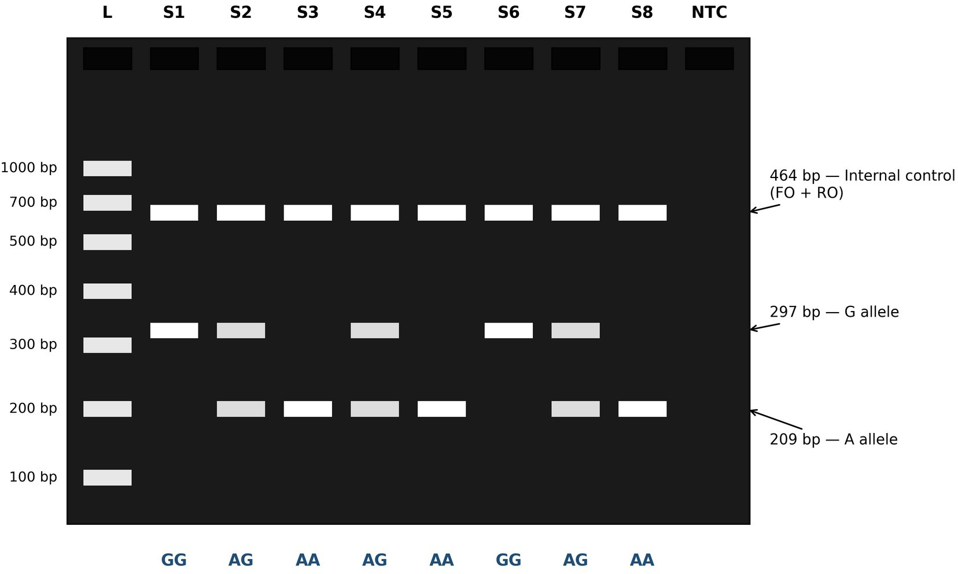

Figure S1. Full agarose-gel image (supplementary). Representative 1.5 % agarose gel electrophoresis image of tetra-primer ARMS-PCR products (unannotated version of Figure 3; full raw gel is available on request).

Supplementary Figure S2
Standard curve for the Human IL-17A ELISA kit (Elabscience E-EL-H0105, Houston, TX, USA). Serial dilutions of recombinant human IL-17A spanning 7.81–500 pg/mL were assayed in duplicate; optical density was read at 450 nm with wavelength correction at 570 nm. A four-parameter logistic (4-PL) model was fitted using GraphPad Prism v9.0 (R² > 0.99).
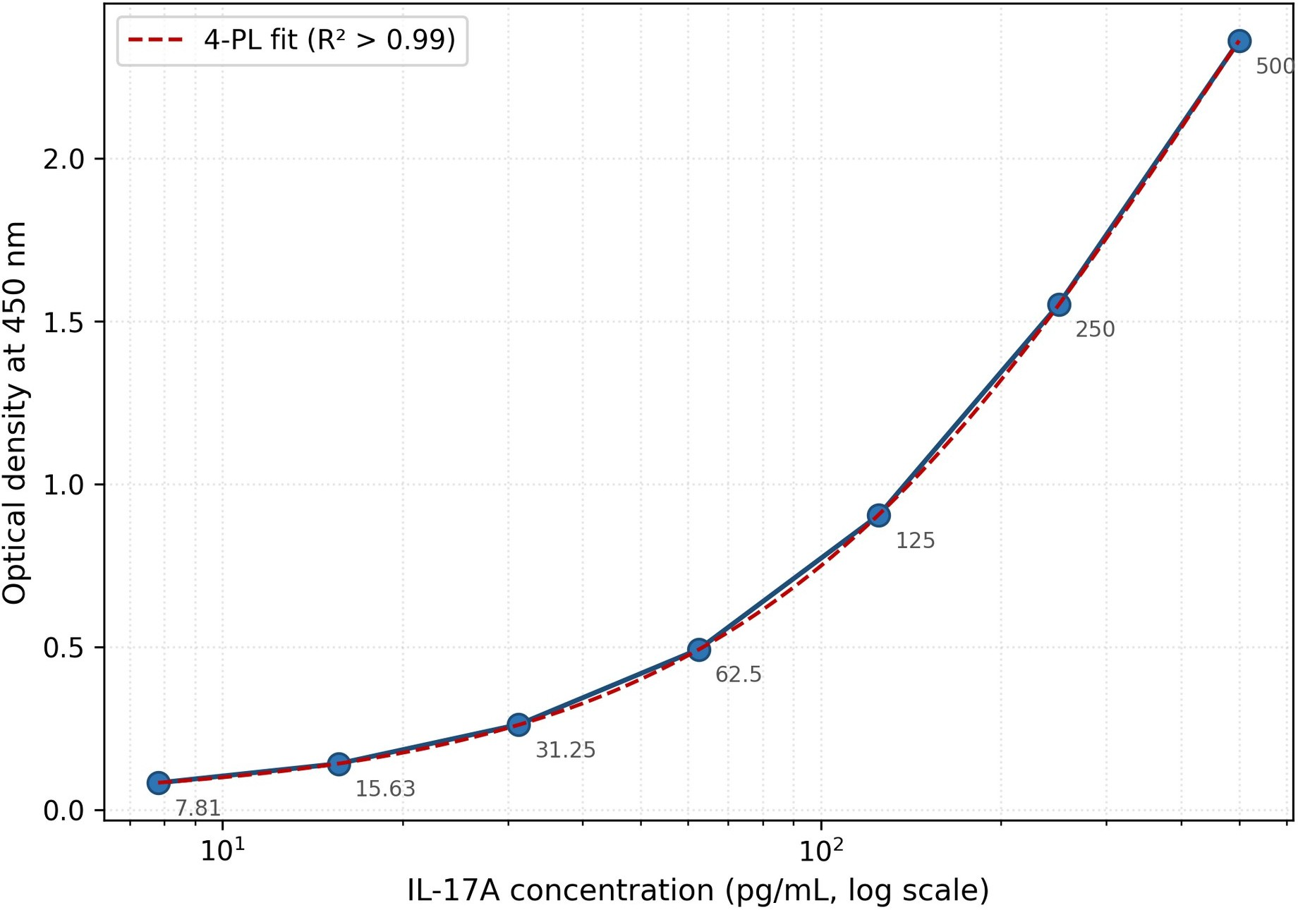
Figure S2. ELISA standard curve. Standard curve for the Human IL-17A ELISA kit (Elabscience E-EL-H0105, Houston, TX, USA). Serial dilutions of recombinant human IL-17A spanning 7.81–500 pg/mL were assayed in duplicate; optical density was read at 450 nm with wavelength correction at 570 nm. A four-parameter logistic (4-PL) model was fitted (R² > 0.99).

Supplementary Figure S3
Sanger sequencing electropherograms confirming T-ARMS-PCR genotyping at IL-17A rs2275913. Bi-directional sequencing was performed on an ABI 3500 Genetic Analyser (Applied Biosystems, Foster City, CA, USA) using BigDye Terminator v3.1 chemistry; sequence electropherograms were inspected in Chromas v2.6.6 (Technelysium). Ten per cent of samples (n = 12, including all six AA-control homozygotes) were sequenced, yielding 100 % concordance with T-ARMS-PCR calls. At the polymorphic site, (a) shows a single G peak (homozygous GG), (b) shows superimposed A and G peaks of approximately equal height (heterozygous AG; IUPAC code R), and (c) shows a single A peak (homozygous AA).
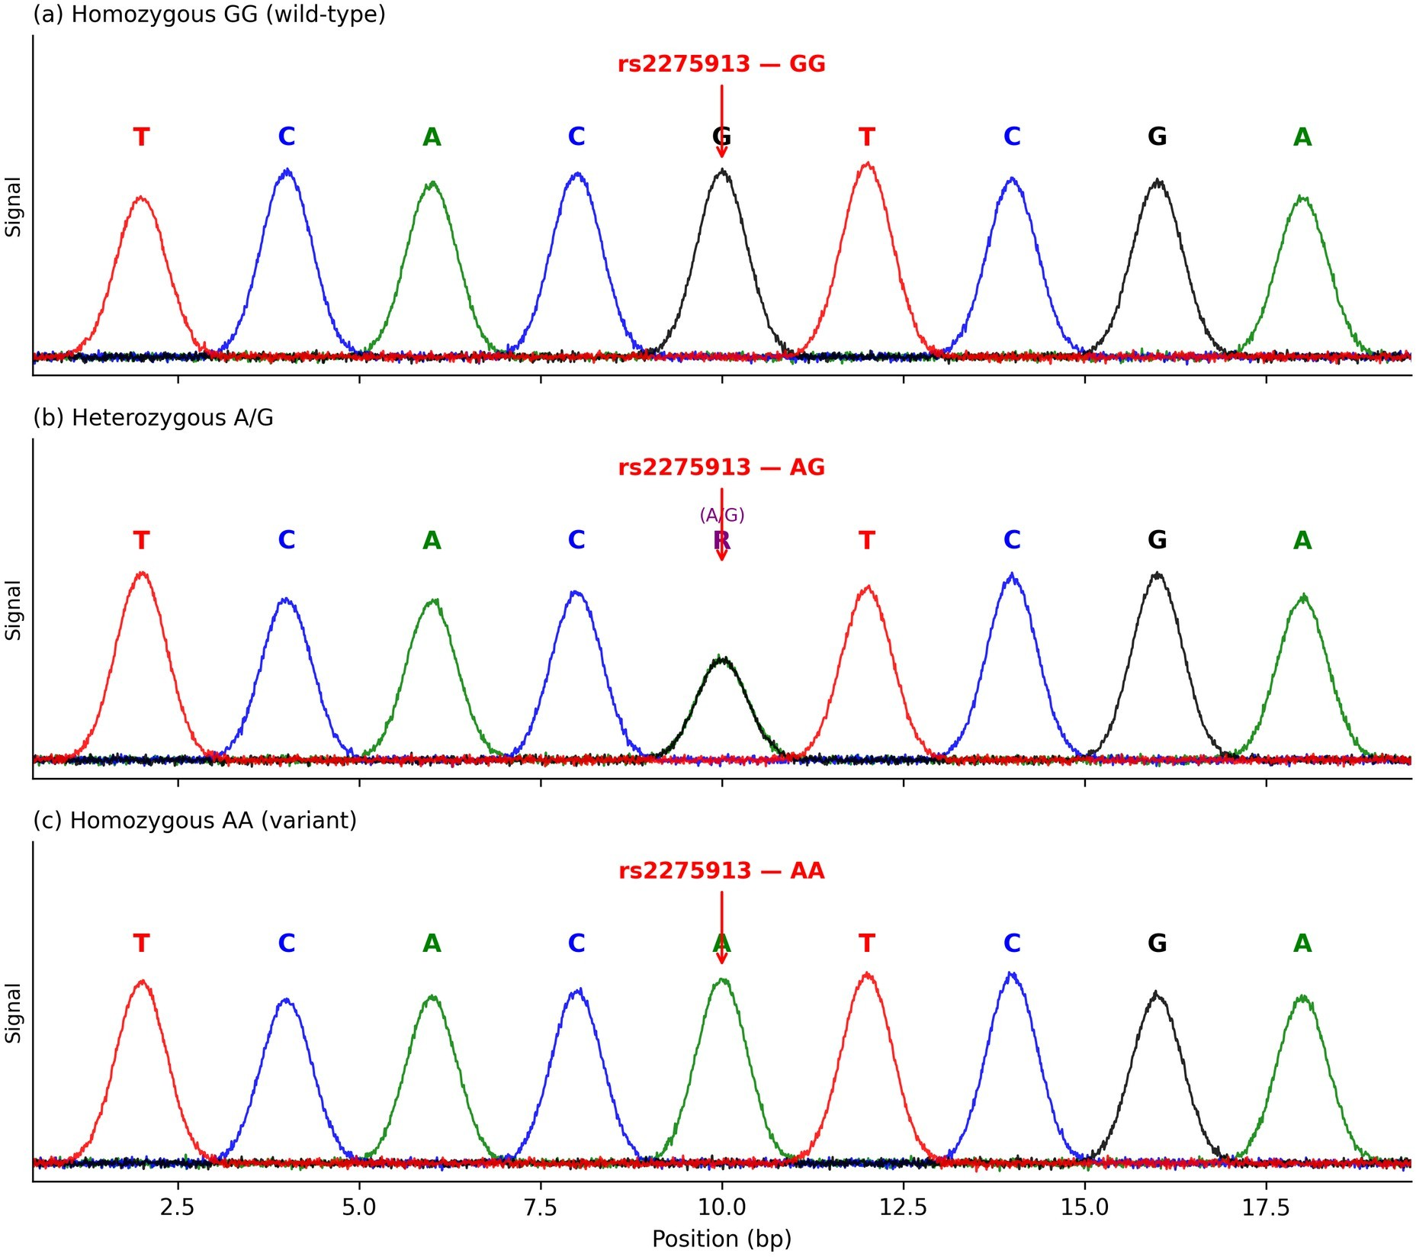
Figure S3. Sanger sequencing confirmation of T-ARMS-PCR genotyping. Sanger electropherograms for
(a) homozygous GG, (b) heterozygous AG (IUPAC code R), and (c) homozygous AA at IL-17A rs2275913. Ten per cent of samples (n = 12, including all six AA-control homozygotes) were bi-directionally sequenced on an ABI 3500 Genetic Analyser; concordance with T-ARMS-PCR calls was 100 %.

Supplementary Figure S4
Forest plot comparing the odds ratio for recurrent spontaneous abortion under the dominant genetic model (A-carrier vs GG) across published case–control studies of IL-17A rs2275913 and the present Iraqi cohort. Individual study odds ratios and 95 % confidence intervals are plotted on a logarithmic scale; the dashed vertical line indicates the null value (OR = 1). Effect size in the Iraqi population is larger than in most previously reported cohorts, which may reflect differences in allele frequency, inclusion criteria, or unmeasured environmental modifiers and warrants replication in independent Middle-Eastern samples.
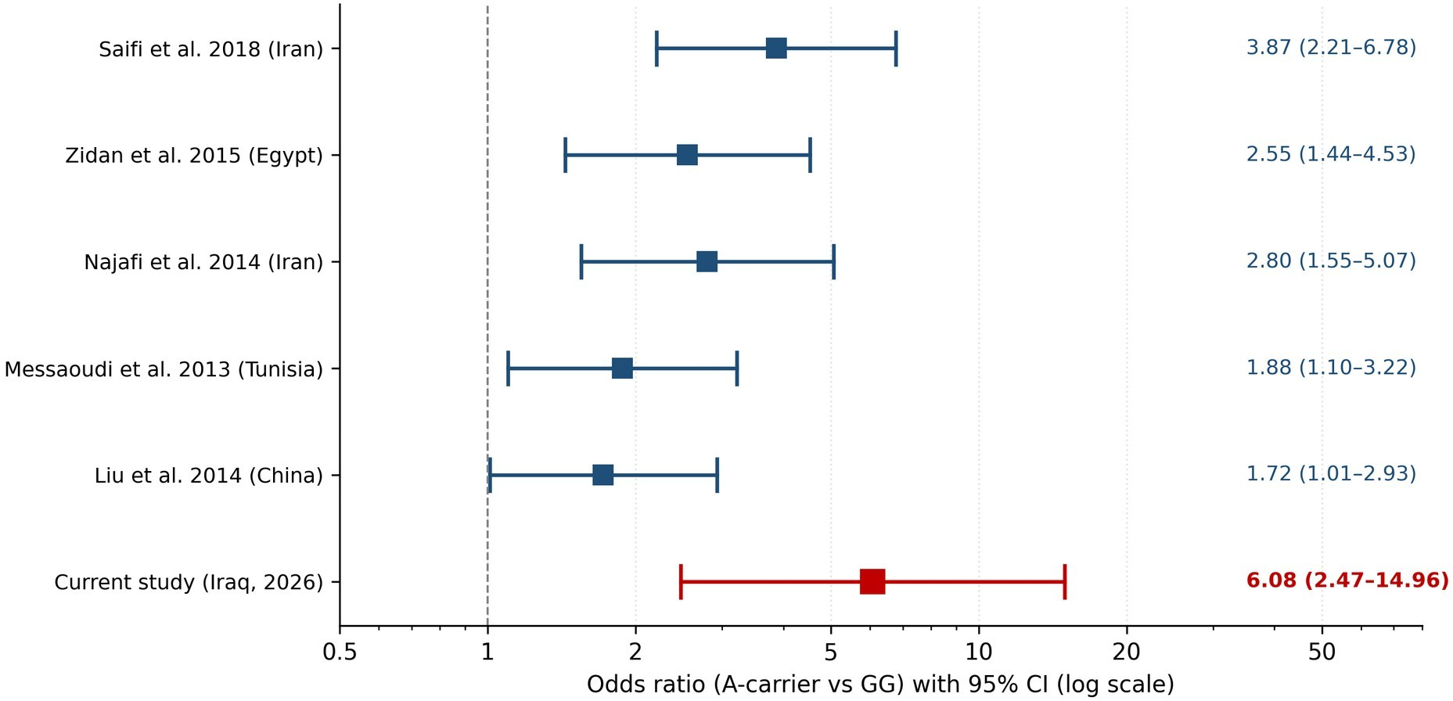
Figure S4. Forest plot of IL-17A rs2275913 (A-carrier vs GG) associations with RSA across published studies. Individual study odds ratios and 95 % confidence intervals are plotted on a logarithmic scale; the dashed vertical line indicates the null value (OR = 1). The effect size observed in the present Iraqi cohort is larger than in most previously reported populations, which may reflect differences in allele frequency, inclusion criteria, or unmeasured environmental modifiers.

Data availability
De-identified individual-level genotype and IL-17A concentration data supporting the findings of this study are available from the corresponding author upon reasonable request and following approval by the local Institutional Review Board. Raw ELISA plate files (.xlsx) and Sanger trace files (.ab1) will be provided in the same archive.

