Supplementary Figure S5: Postoperative Bleeding
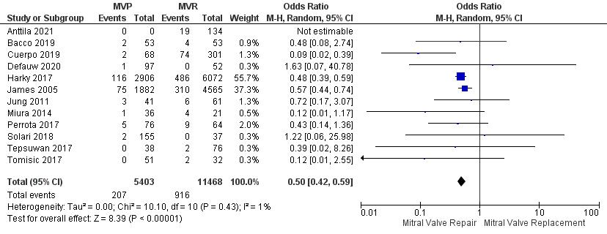

Supplementary Figure S6: Mortality

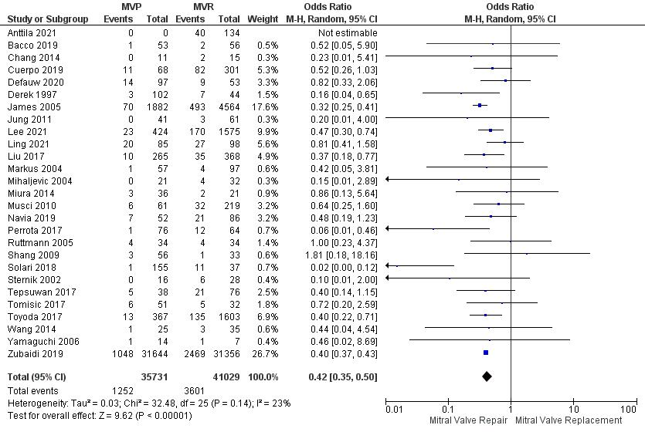

Supplementary Figure S7: Recurrent endocarditis
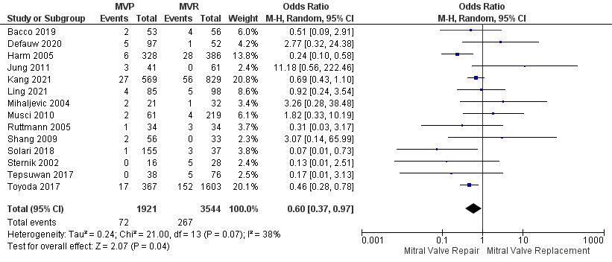

Supplementary Figure S8: Postoperative Stroke

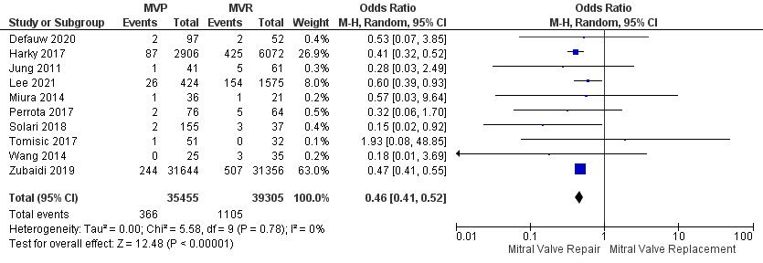

Supplementary Figure S9: Funnel plots for Postoperative Bleeding

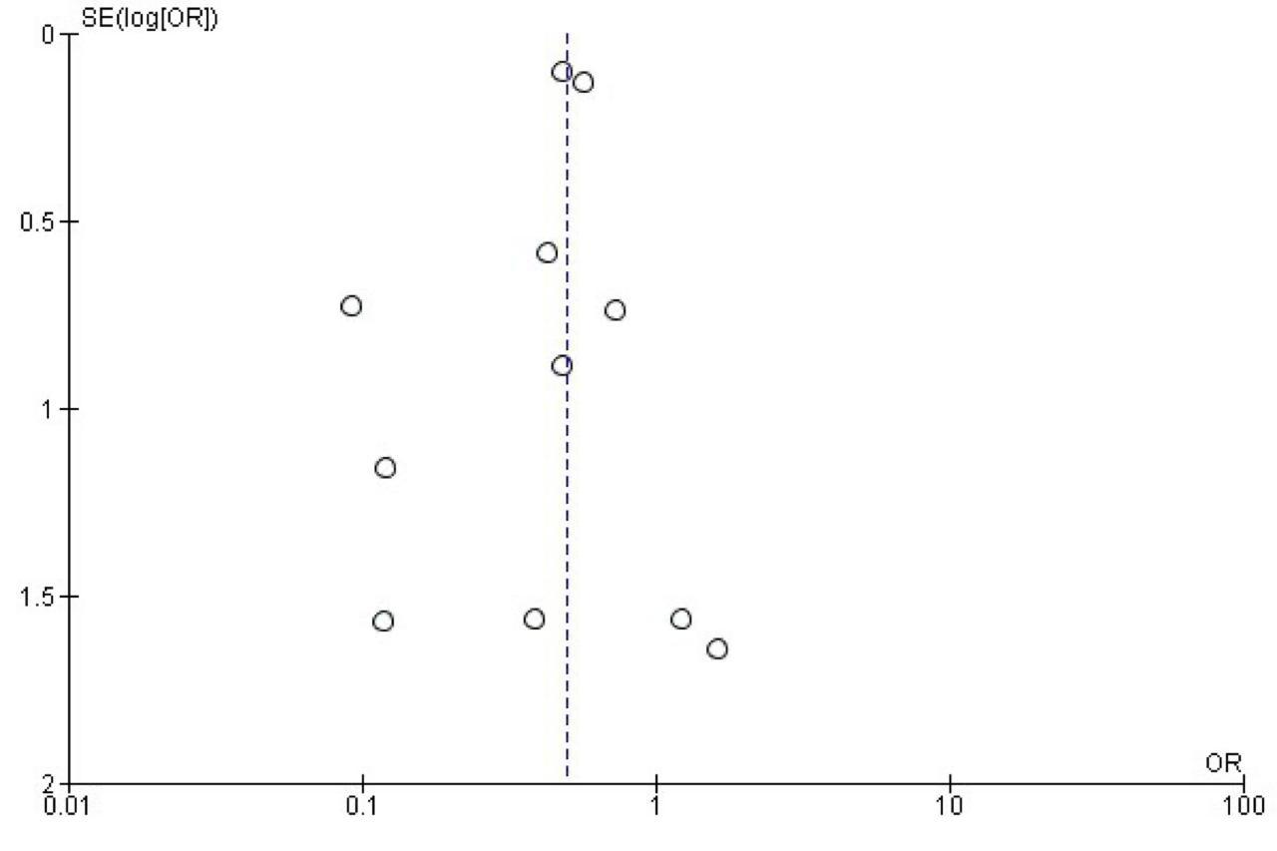

Supplementary Figure S10: Funnel plots for Mortality

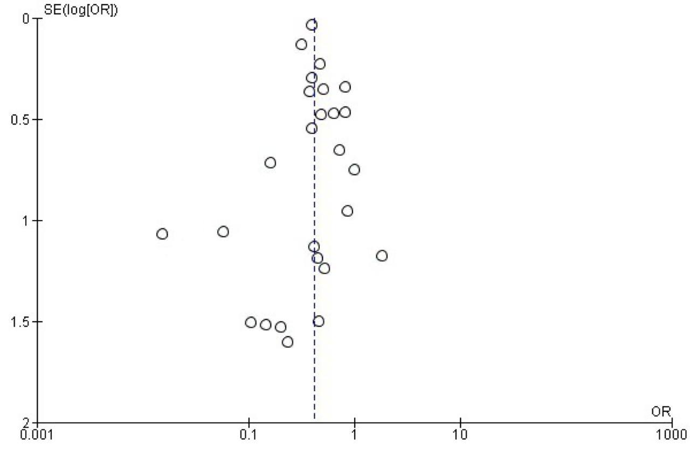

Supplementary Figure S11: Funnel plots for Recurrent Endocarditis

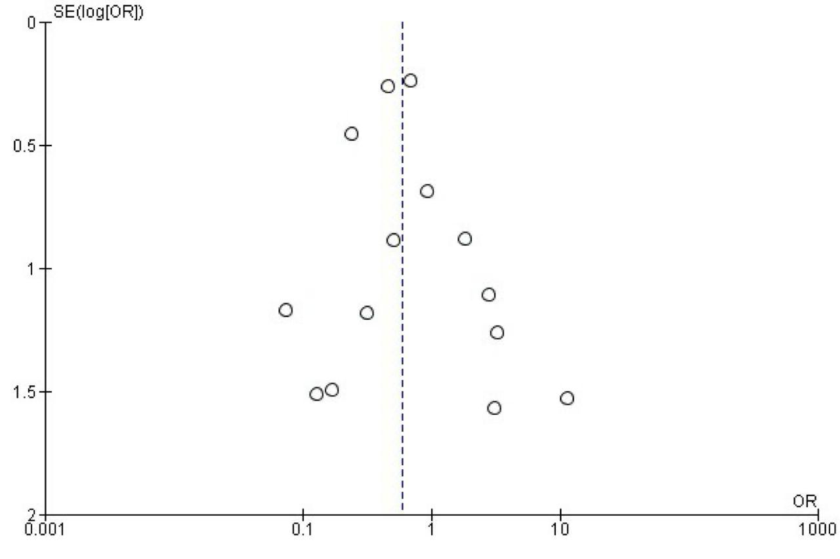

Supplementary Figure S12: Funnel plots for Post-operative stroke

