Supplementary Material 3:
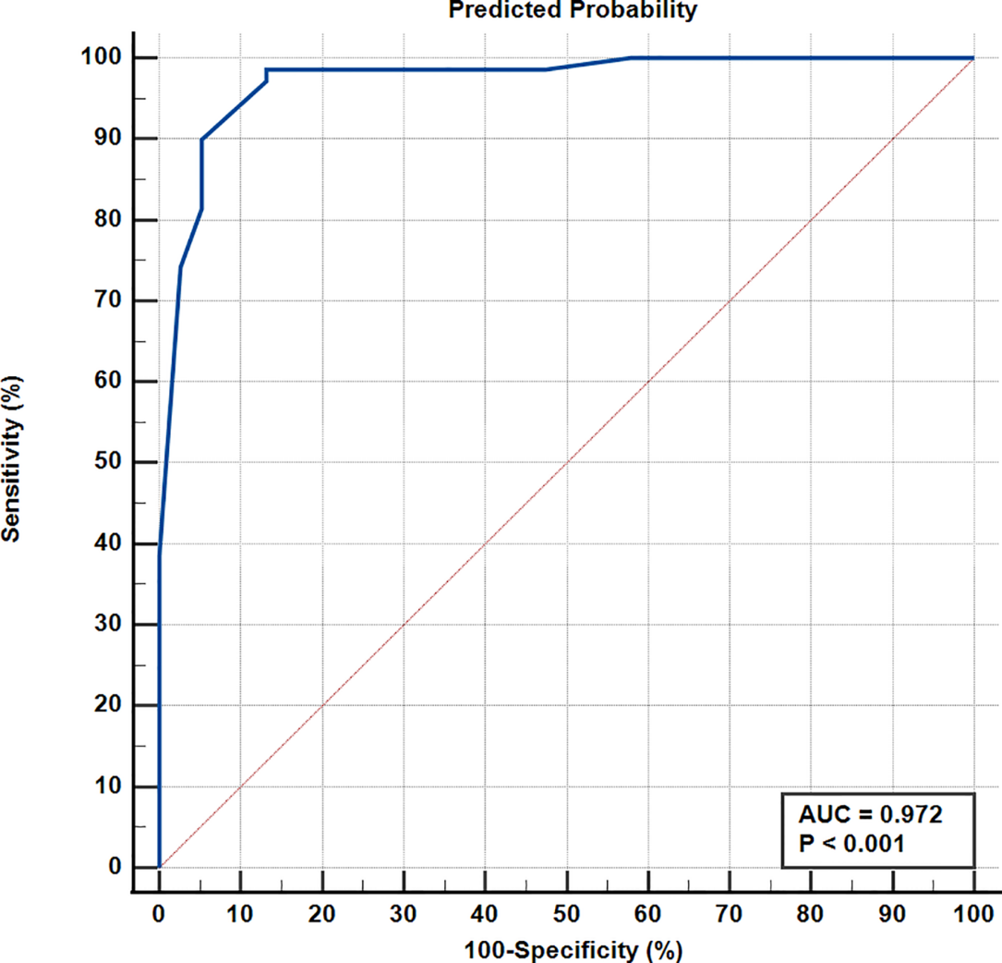
Figure S2: The newly proposed Scoring System: ROC curve derived from the predicted probabilities, as per the multivariable binary logistic regression model.

