Supplementary Material 4:
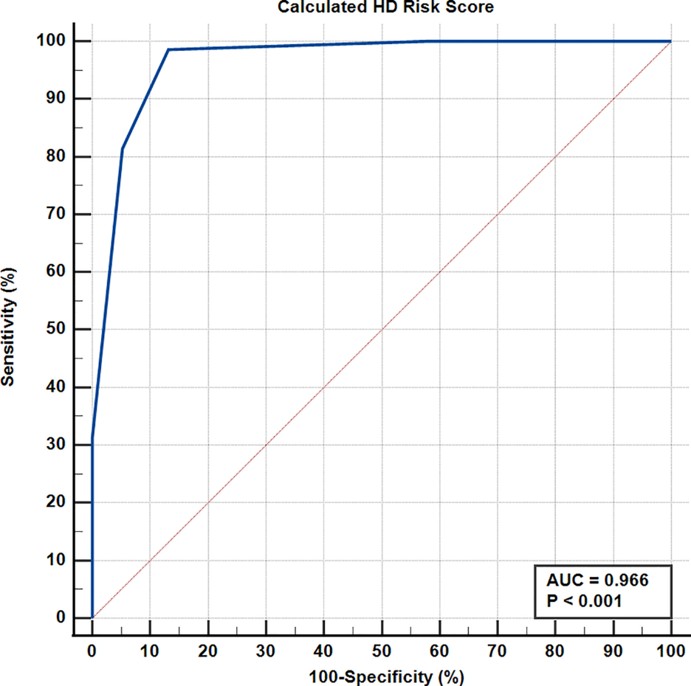
Figure S3: Application of the Newly Proposed Scoring System/Model to the Retrospective Group: Receiver operating characteristic (ROC) curve for discrimination between patients with HD or CC using the calculated HD risk score.

