Supplementary Material 5:
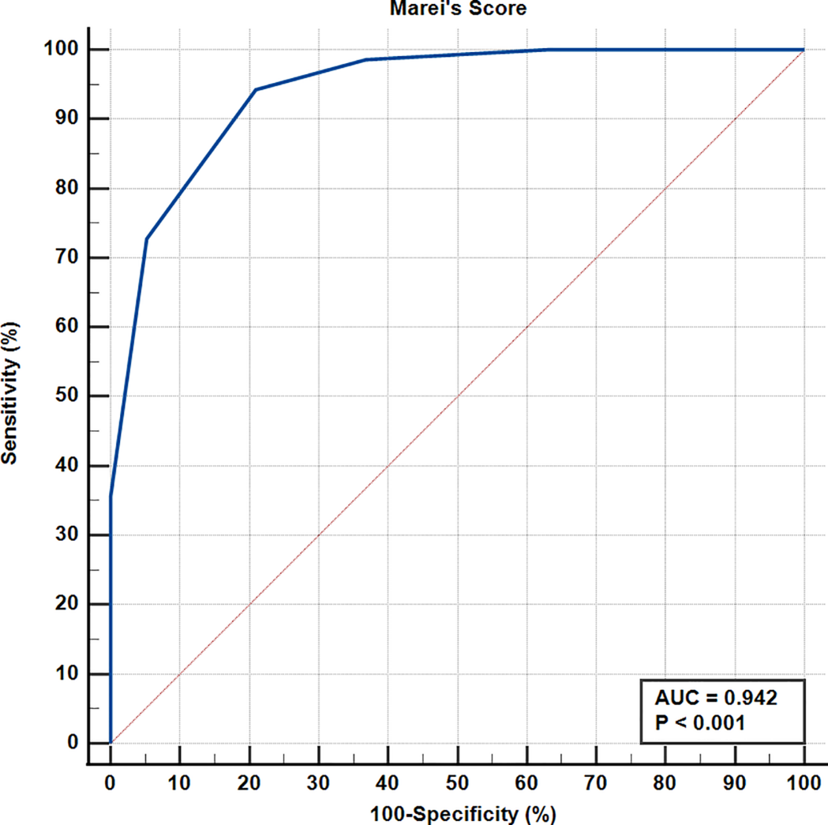
Figure S4: Application of the Old Checklist to the Retrospective Group: Receiver operating characteristic (ROC) curve for discrimination between patients with HD or IC, using the previously proposed HD checklist.

