Supplementary Figures:
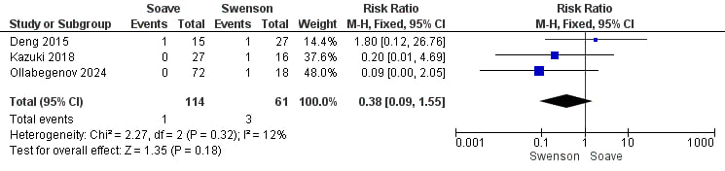
Supplementary Figure 1: Forest plot of urinary retention meta-analysis

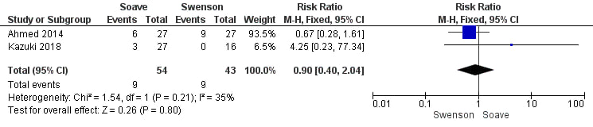
Supplementary Figure 2: Forest plot of post-operative obstructive symptoms meta-analysis

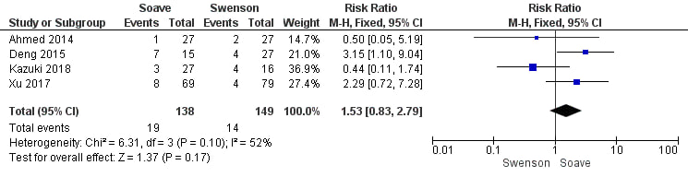
Supplementary Figure 3: Forest plot of perianal dermatitis meta-analysis

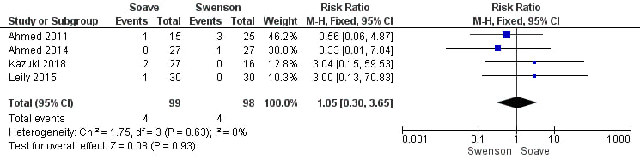
Supplementary Figure 4: Forest plot of intestinal obstruction meta-analysis

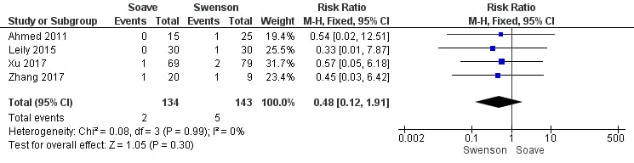
Supplementary Figure 5: Forest plot of anastomotic leakage meta-analysis

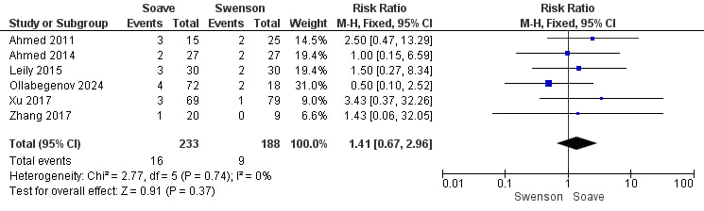
Supplementary Figure 6: Forest plot of anastomotic stricture meta-analysis

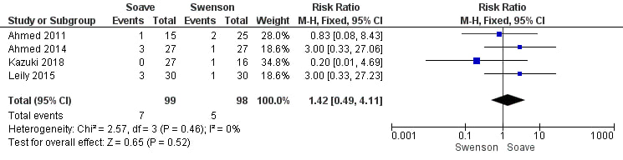
Supplementary Figure 7: Forest plot of post-operative abscess meta-analysis

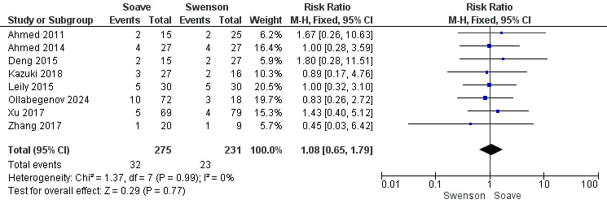
Supplementary Figure 8: Forest plot of HAEC meta-analysis

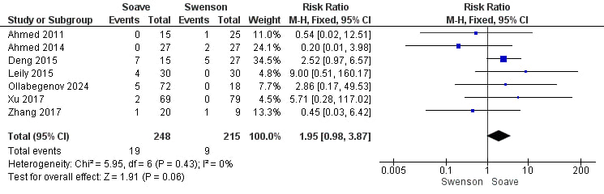
Supplementary Figure 9: Forest plot of fecal incontinence meta-analysis

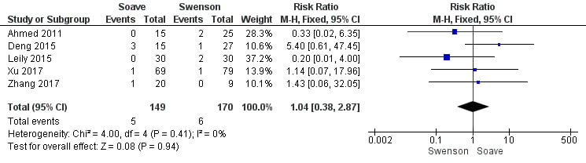
Supplementary Figure 10: Forest plot of constipation meta-analysis

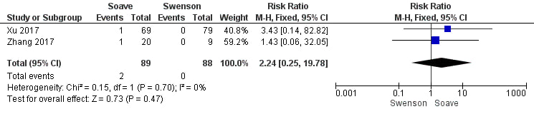
Supplementary Figure 11: Forest plot of colon prolapse meta-analysis

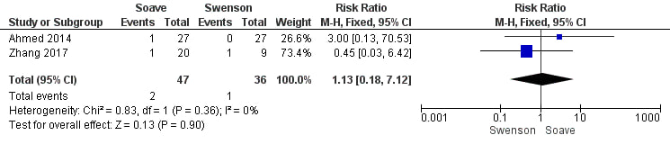
Supplementary Figure 12: Forest plot of urethral injury meta-analysis

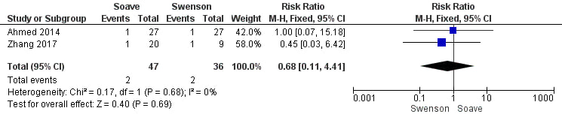
Supplementary Figure 13: Forest plot of bowel injury meta-analysis

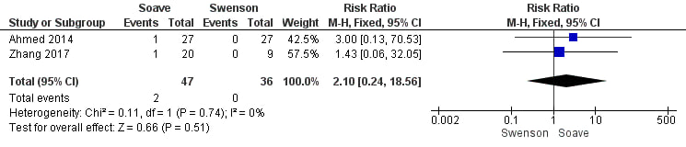
Supplementary Figure 14: Forest plot of aganglionic bowel left behind meta-analysis

