SUPPLEMENTARY MATERIAL
1a. Posterior View | 1b. Lateral View | 1c. Extremity Detail | 1d. Facial Features
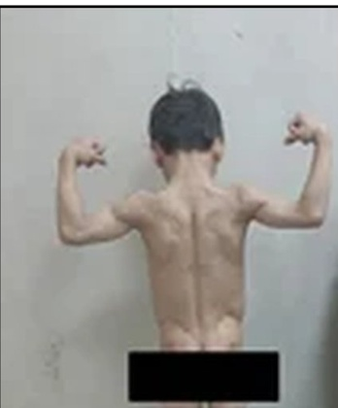 | 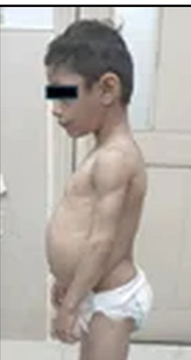 | 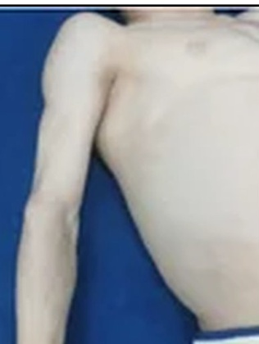 | 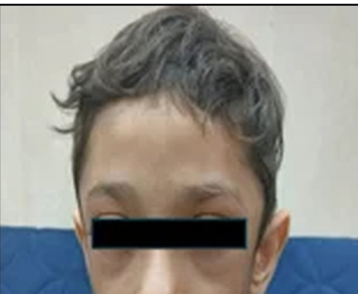

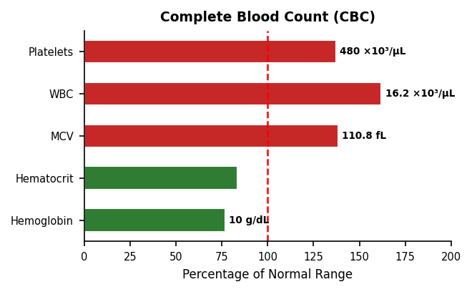 | 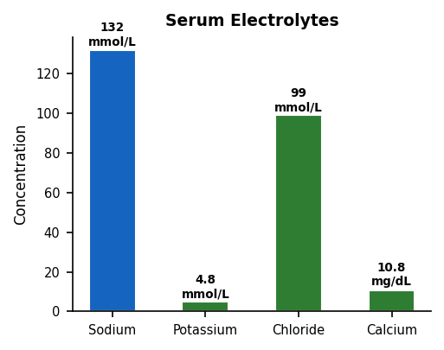 | 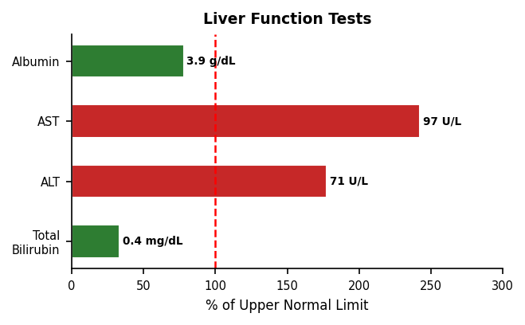

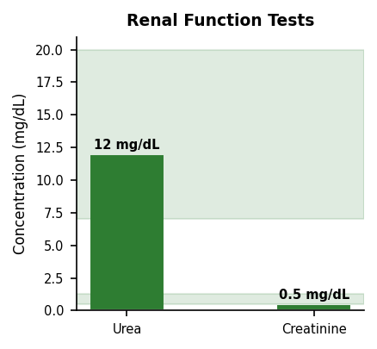 | 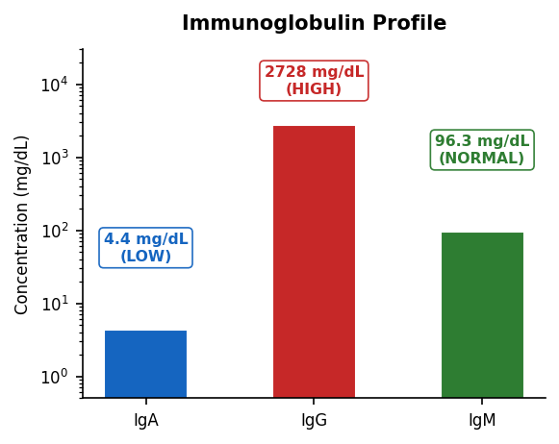 | 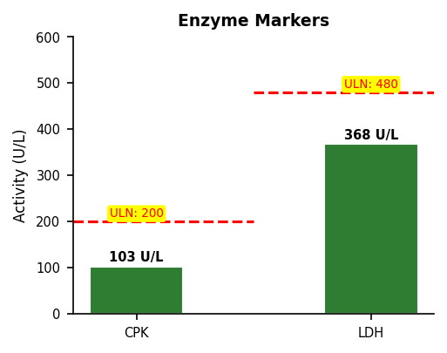

Infectious Disease Screening | Additional Investigations | WBC Differential Count Total: 16,200/µL
 |  | 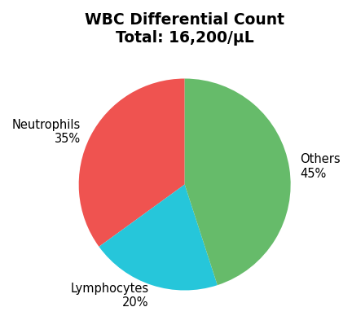
  HIV | ✓ Negative
  Hepatitis C | ✓ Non-Reactive
  Hepatitis B | ✓ Non-Reactive
  Skeletal Survey | ✓ NORMAL
  TTG Antibodies | ✓ NORMAL
  ■ Within Normal | ■ Below Normal | ■ Above Normal | ■ Pending
Supplementary Material S1; (a) Posterior view demonstrating complete absence of subcutaneous adipose tissue with pronounced muscular definition and prominent superficial venous pattern. (b) Lateral view showing abdominal distension with everted umbilicus and acromegaloid limb appearance. (c) Extremity detail illustrating marked lipoatrophy with visible musculature and prominent subcutaneous veins. (d) Facial features demonstrating coarse appearance with absence of facial fat padding. Eyes obscured to preserve patient confidentiality in accordance with Declaration of Helsinki principles. Graphical summary of Hematological and biochemical laboratory findings
Table S1. Haematological, Biochemical, and Metabolic Investigations
Investigation | Result | Reference Range | Status
HAEMATOLOGY
Haemoglobin | 10.0 g/dL | 11.5–15.5 g/dL | ↓ LOW
MCV | 110.8 fL | 80–100 fL | ↑ HIGH — macrocytic
WBC | 16,200 /µL | 4,500–13,000 /µL | ↑ Elevated
LIVER FUNCTION TESTS
ALT | 71 U/L | 7–45 U/L | ↑ Elevated
AST | 97 U/L | 10–40 U/L | ↑ Elevated
IMMUNOGLOBULINS
IgG | 2,727.98 mg/dL | 700–1,600 mg/dL | ↑↑ Markedly elevated
IgA | 4.39 mg/dL | 70–312 mg/dL | ↓ Low
METABOLIC PANEL (newly available — added in revision)
Fasting Triglycerides | 862 mg/dL | < 150 mg/dL | ↑↑ SEVERELY elevated
HDL-Cholesterol | 18 mg/dL | > 35 mg/dL | ↓ Low
Fasting Insulin | 42 µIU/mL | 2–25 µIU/mL | ↑ Elevated
HOMA-IR | 10.4 | < 2.5 | ↑↑ Severe insulin resistance
Serum Leptin | 0.4 ng/mL | 2–15 ng/mL | ↓↓ Critically low
MUSCLE ENZYMES
Creatine Phosphokinase | 103 U/L | 30–200 U/L | Normal
INFECTIOUS / SEROLOGICAL
Anti-tTG IgA | Non-reactive | Negative | Normal
Hepatitis B sAg | Non-reactive | Negative | Normal
Anti-HCV | Non-reactive | Negative | Normal
HIV Ag/Ab | Negative | Negative | Normal

