Table S1. MP positivity was calculated as the number of MP-positive cases divided by the total number of tested cases for each year
Year | No. tested (n) | No. MP-positive (n) | MP positivity (%)
2005 | 296 | 90 | 30.41
2006 | 2181 | 661 | 30.31
2007 | 2192 | 637 | 29.06
2008 | 2153 | 991 | 46.03
2009 | 2234 | 1041 | 46.60
2010 | 1920 | 562 | 29.27
2011 | 2377 | 605 | 25.45
2012 | 2347 | 922 | 39.28
2013 | 2114 | 1002 | 47.40
2014 | 2207 | 713 | 32.31
2015 | 2065 | 659 | 31.91
2016 | 1913 | 862 | 45.06
2017 | 1985 | 519 | 26.15
2018 | 2163 | 505 | 23.35
2019 | 2103 | 782 | 37.18
2020 | 2172 | 487 | 22.42
2021 | 2121 | 543 | 25.58
2022 | 2192 | 494 | 22.54
2023 | 2223 | 1004 | 45.16
2024 | 7079 | 2035 | 28.75
2025 | 5362 | 972 | 18.13

Table S2. Age-specific MP positivity across successive calendar periods [% (n)]
 | 2005~2009 | 2010~2015 | 2016~2020 | 2021~2025 | χ² | P
<6 months | 18.34(587/3201) | 16.46(612/3718) | 8.95(262/2927) | 6.59(190/2881) | 267.414 | <0.001
6~12 months | 29.38(612/2083) | 28.53(610/2138) | 20.03(282/1408) | 17.41(255/1465) | 99.543 | <0.001
1~3 years | 43.94(1317/2997) | 43.26(1153/2665) | 33.49(916/2735) | 22.65(1025/4526) | 615.168 | <0.001
3~7 years | 51.39(1107/2154) | 57.47(1138/1980) | 47.75(1176/2463) | 29.80(1894/6355) | 693.841 | <0.001
>7years | 66.36(359/541) | 63.71(388/609) | 64.63(519/803) | 44.91(1684/3750) | 204.830 | <0.001
χ² | 989.321 | 1339.302 | 1596.080 | 1367.246
P | <0.001 | <0.001 | <0.001 | <0.001

Table S3. Sex-specific MP positivity across successive calendar periods [% (n)]
 | 2005~2009 | 2010~2015 | 2016~2020 | 2021~2025 | χ² | P
Male | 33.39(2272/6804) | 32.08(2239/6979) | 28.02(1756/6268) | 23.73(2584/10890) | 245.544 | <0.001
Female | 40.99(1710/4172) | 40.23(1662/4131) | 34.39(1399/4068) | 30.47(2464/8087) | 187.024 | <0.001
χ² | 64.540 | 75.661 | 47.276 | 107.990
P | <0.001 | <0.001 | <0.001 | <0.001

Table S4. Comparison of seasonal MP positivity across successive calendar periods [% (n)]
 | 2005~2009 | 2010~2015 | 2016~2020 | 2021~2025 | χ² | P
Spring | 32.79(873/2662) | 28.61(818/2859) | 28.59(681/2382) | 21.70(945/4354) | 113.938 | <0.001
Summer | 40.56(1070/2638) | 41.02(1140/2779) | 32.90(876/2663) | 33.76(1597/4731) | 73.523 | <0.001
Autumn | 42.27(1225/2898) | 40.61(1092/2689) | 33.78(929/2750) | 26.41(1304/4938) | 266.122 | <0.001
Winter | 28.54(914/3203) | 32.12(859/2674) | 23.64(616/2606) | 24.92(1147/4603) | 64.485 | <0.001
χ² | 162.799 | 140.166 | 81.970 | 182.988
P | <0.001 | <0.001 | <0.001 | <0.001

Table S5. Comparison of age-specific MP positivity before, during, and after the COVID-19 pandemic [% (n)]
 | Overall (2005~2025) | Pre-pandemic (2005~2019) | Pandemic Period (2020~2022) | Post-pandemic (2023~2025) | χ² | P
<6 months | 12.97(1651/12727) | 15.35(1449/9437) | 5.71(74/1296) | 6.42(128/1994) | 183.827 | <0.001
6~12 months | 24.80(1759/7094) | 27.22(1447/5315) | 20.09(141/702) | 15.88(171/1077) | 71.107 | <0.001
1~3 years | 34.13(4411/12923) | 41.52(3195/7695) | 27.73(518/1868) | 20.77(698/3360) | 487.575 | <0.001
3~7 years | 41.04(5315/12952) | 54.12(3264/6031) | 26.40(528/2000) | 30.95 (1523/4921) | 810.712 | <0.001
>7years | 51.73(2950/5703) | 67.49(1196/1772) | 42.49(263/619) | 45.02(1491/3312) | 257.285 | <0.001
χ² | 3853.773 | 3683.295 | 384.796 | 1136.454
P | <0.001 | <0.001 | <0.001 | <0.001

Table S6. Comparison of Sex-specific MP positivity before, during, and after the COVID-19 pandemic [% (n)]
 | Overall (2005~2025) | Pre-pandemic (2005~2019) | Pandemic Period (2020~2022) | Post-pandemic (2023~2025) | χ² | P
Male | 28.61(8851/30941) | 32.06(6017/18767) | 20.49(789/3850) | 24.57(2045/8324) | 300.268 | <0.001
Female | 35.37(7235/20458) | 39.48(4534/11483) | 27.89(735/2635) | 31.01(1966/6340) | 202.214 | <0.001
χ² | 261.659 | 172.814 | 47.653 | 75.159
P | <0.001 | <0.001 | <0.001 | <0.001

Table S7. Comparison of seasonal MP positivity before, during, and after the COVID-19 pandemic [% (n)]
 | Overall (2005~2025) | Pre-pandemic (2005~2019) | Pandemic Period (2020~2022) | Post-pandemic (2023~2025) | χ² | P
Spring | 27.06(3317/12257) | 30.43(2279/7492) | 22.19(253/1140) | 21.66(785/3625) | 110.158 | <0.001
Summer | 36.55(4683/12811) | 39.46(2953/7484) | 26.20(442/1687) | 35.38(1288/3640) | 107.326 | <0.001
Autumn | 34.29(4551/13273) | 40.71(3072/7546) | 24.05(474/1971) | 26.51(962/3629) | 327.308 | <0.001
Winter | 27.07(3535/13058) | 29.37(2181/7425) | 19.36(321/1658) | 25.97(908/3497) | 71.967 | <0.001
χ² | 181.874 | 345.884 | 23.719 | 181.874
P | <0.001 | <0.001 | <0.001 | <0.001

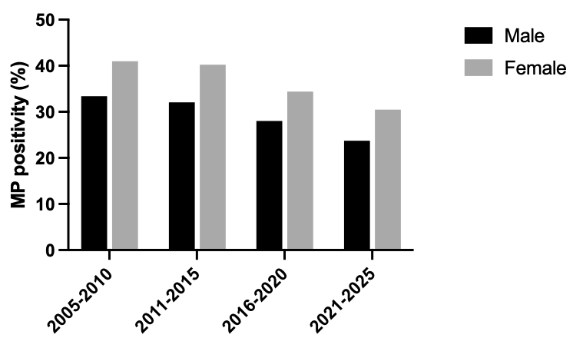
Figure S1. Sex variation in MP positivity across different calendar periods.

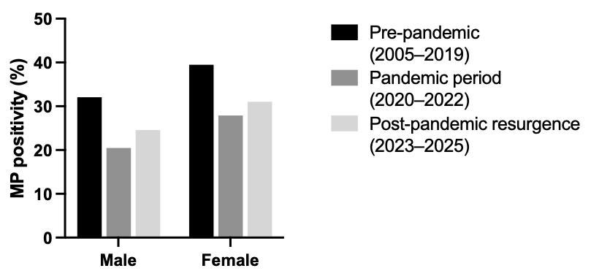
Figure S2. Sex-specific positivity rates of MP infection stratified by study period.

