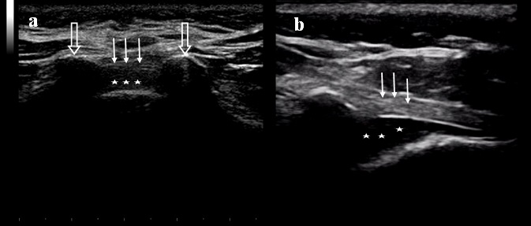
Supplementary Fig 1: Ultrasound imaging of sacrum at the sacral hiatus level.
(a) Transverse scan (b) Longitudinal scan.
These images were captured during this study showing the two sacral cornua (open arrows), and the hyperechoic sacrococcygeal ligament (line arrows) that stretches out between the two cornua and the sacral hiatus (asterisk) which is the hypoechoic space between the sacrococcygeal ligament and the sacral posterior surface.

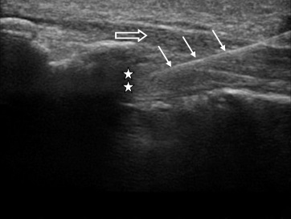
Supplementary Fig 2: Ultrasound image of sacral canal; longitudinal view showing the advancement of the needle (white arrows) piercing through the sacrococcygeal ligament (open arrow) into the sacral hiatus (asterisk).
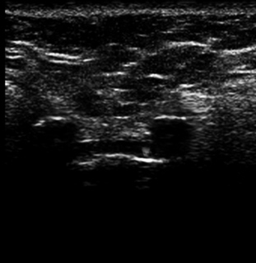

Supplementary Fig 3: Ultrasound image at the sacral hiatus; the arrow indicate to the needle in the out of plane view mainly to the left side.

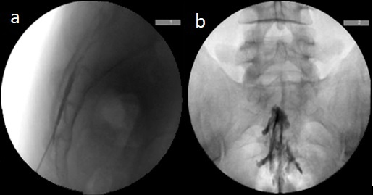

Supplementary Fig 4: Fluoroscopically guided caudal epidural injection of contrast medium before administration of the injectate.

(a) Lateral view of sacrum with the needle in the sacral canal.
(b)Anteroposterior view of the pelvis showing the distribution of the radio-opaque material in the epidural space.

