Table S1. The key hyperparameters of each model
Model | Hyperparameters
DNN with CT Images | optimizer = adam, learning rate: 1e-3, batch size: 8, epochs: 150
KNN | number of neighbors = 5
Random Forest | maximum feature = sqrt, minimum samples split = 2, maximum depth = None, number of estimators = 100, criterion = gini
XGBoost | maximum depth = 6, minimum child weight = 1, subsample = 1, gamma = 0, colsample bytree = 1
Naïve Bayes | -
Logistic Regression | penalty = l2, solver = lbfgs, C = 1
LDA | solver = svd, n_components = None

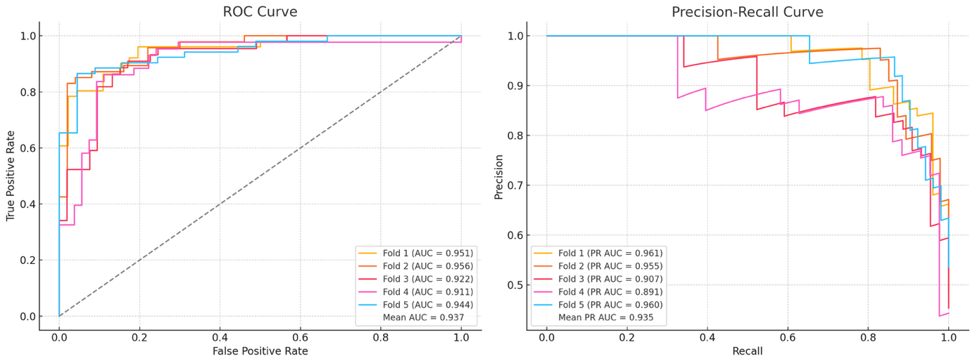
Figure S1. Receiver Operating Characteristic (ROC) curve (left) and Precision-Recall (PR) curve (right) for the Deep Neural Network (DNN) with Computed Tomography (CT) Images model.

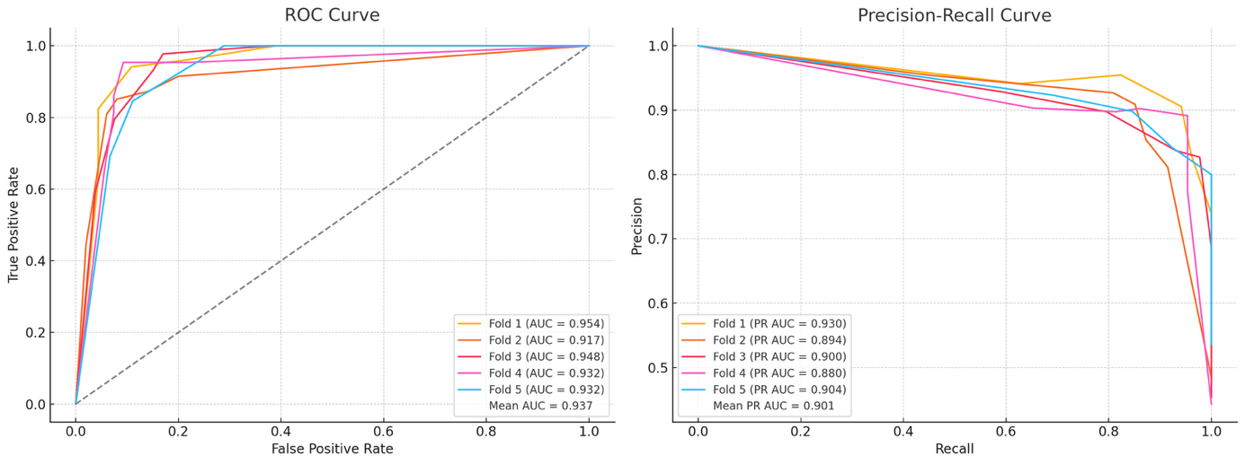
Figure S2. Receiver Operating Characteristic (ROC) curve (left) and Precision-Recall (PR) curve (right) for the K-nearest neighbors (KNN) model.
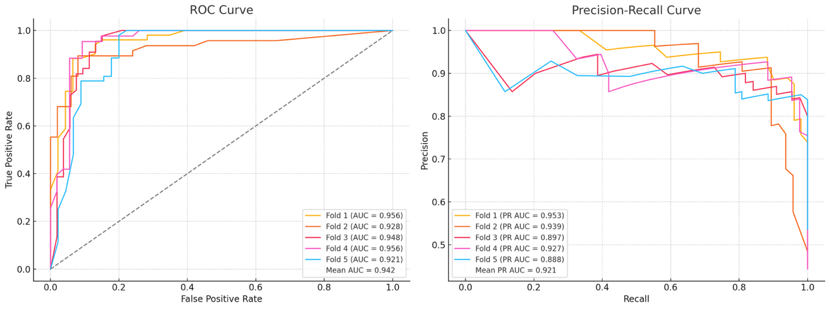
Figure S3. Receiver Operating Characteristic (ROC) curve (left) and Precision-Recall (PR) curve (right) for the Random Forest model.

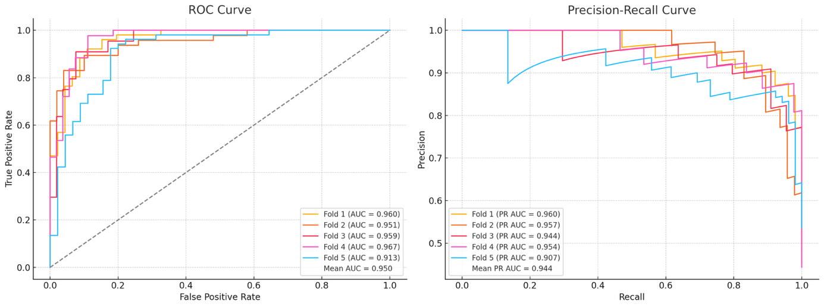
Figure S4. Receiver Operating Characteristic (ROC) curve (left) and Precision-Recall (PR) curve (right) for the XGBoost model.

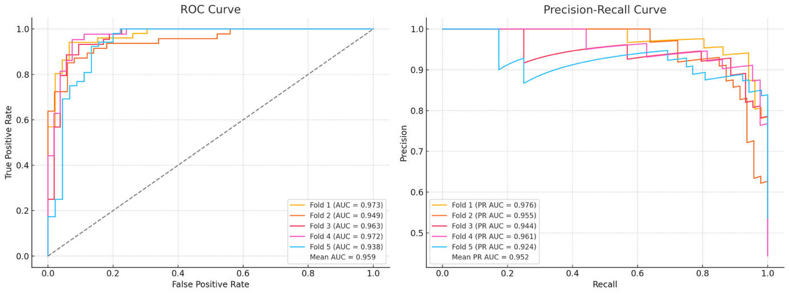
Figure S5. Receiver Operating Characteristic (ROC) curve (left) and Precision-Recall (PR) curve (right) for the Naïve Bayes model.

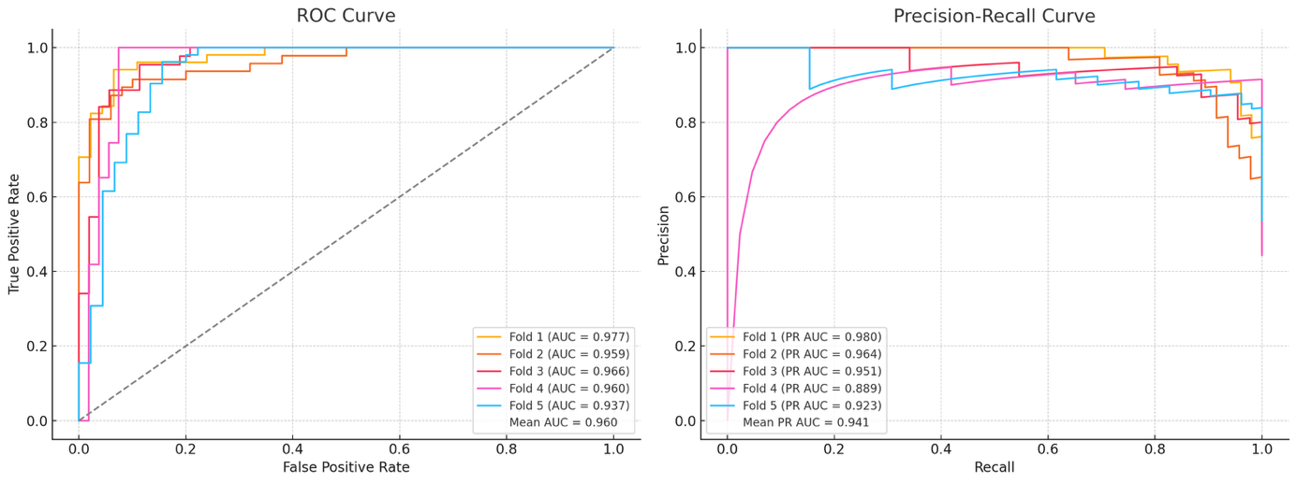
Figure S6. Receiver Operating Characteristic (ROC) curve (left) and Precision-Recall (PR) curve (right) for the Logistic Regression model.

