Supplementary file (Reviewer 3)
Table 1. Baseline demographic, maternal and clinical characteristics of preeclampsia and control groups (N=88)
Variables | Preeclampsia Group (N=44) | Control Group (N=44) | p-value
Maternal Age (years)  Mean (SD)  Age Subgroups  20-30  30-40  More than 40 | 33.7 (SD=7.2)  18 (41%)  14 (32%)  12 (27%) | 32.7 (SD=5.4)  18 (41%)  21 (47.7%)  5 (11.3%) | 0.46  0.11
BMI (kg/m²)  Mean (SD)  (Range) | 22.8 (SD=4.5)  (18-27) | 20.1 (SD=4.6)  (16-25) | 0.001
Gravidity  Mean (SD)  (Range) | 3.7 (SD=1.5)  (2-7) | 3.9 (SD=1.6)  (1-7) | 0.54
Parity  Primigravida  Multigravida | 23 (52.3%)  21 (47.7%) | 25 (57%)  19 (43%) | 0.66
Socioeconomic Status  Lower middle  Upper middle | 26 (59%)  18 (41%) | 24 (55%)  20 (45%) | 0.66
Residence  Rural  Urban | 16 (36%)  28 (64%) | 30 (68%)  14 (32%) | 0.001
Gestational Age at Examination (weeks)  Mean (SD)  (Range) | 35.2 (SD=0.8)  (34 – 36) | 34.9 (SD=0.7)  (34 – 36) | 0.06

Table 2. Standard obstetric B-mode ultrasound findings and Doppler ultrasound parameters in preeclampsia and control groups (N=88)
Variables |  | Preeclampsia Group (N=44) | Control Group (N=44) | p-value
Basic US Findings
AFI (cm)  Mean (SD)  (Range) |  | 8.5 (SD=5.0)  (3.5-13) | 12.1(SD=3.6)  (8.5-15.7) | <0.001
Oligohydramnios  (AFI < 5 cm), N (%) |  | 12 (27.27%) | 2 (4.54%) | <0.001
Placental Thickness (cm)  Mean ± SD  (Range) |  | 4.1 (SD=1.4)  (3-6) | 3.2 (SD=1.5)  (2-4.5) | <0.001
Placental Grading  Grade II, N (%)  Grade III, N (%) |  | 20 (45%)  24 (54%) | 40 (90.9%)  4 (9.1%) | <0.001
Subcutaneous Skin Thickness (mm)  Mean (SD)  (Range) |  | 28.8 (SD=7.9)  (12-49) | 22.9(SD=11.4)  (2-50) | 0.001
 | Doppler Parameter
 | Uterine artery (PI)  Mean (SD)  (Range) | 1.84 (SD=0.1)  (1.6-2.1) | 1.12 (SD=0.2)  (0.8-1.5) | <0.001
 | Umbilical artery (PI)  Mean (SD)  (Range) | 1.3 (SD=0.6)  (0.7- 1.9) | 0.87 (SD=0.2)  (0.6-1) | <0.001
 | MCA (PI)  Mean (SD)  (Range) | 0.98 (SD=0.3)  (0.7- 1.2) | 1.6 (SD=0.5)  (1.1-2.1) | <0.001
 | Cerebroplacental ratio (CPR)  Mean (SD)  (Range) | 1.1 (SD=0.6)  (0.5-1.6) | 2.0 (SD=0.6)  (1.4-2.6) | <0.001

Table 3. Quantitative elastographic parameters of placental tissue in preeclampsia and control groups across different placental regions (N=88)
Elastography Parameter | Preeclampsia Group (n=44) | Control Group (n=44) | p-value
1-Maternal-Central  Velocity (m/s)  Mean (SD)  (Range)  Mean Elasticity (kPa)  Mean (SD)  (Range)  IQR (kPa)  Mean± SD  (Range) | 1.85 (SD=0.033)  (1.81- 1.9)  24.2 (SD=2.0)  (22- 26)  5.98 (SD=0.75)  (5-7) | 1.27 (SD=0.033)  (1.2-1.3)  6.8(SD=1.2)  (5- 8)  3.15 (SD=1.06)  (1.33-4.5) | <0.001  <0.001  <0.001
2- Maternal-Peripheral  Velocity (m/s)  Mean (SD)  (Range)  Mean Elasticity (kPa)  Mean (SD)  (Range)  IQR (kPa)  Mean (SD)  (Range) | 1.86 (SD=0.033)  (1.8-1.9)  20.9 (SD=1.03)  (19.0-23)  6.1 (SD=0.4)  (5-7) | 1.2 (SD=0.034)  (1.2-1.3)  7.3 (SD=0.9)  (5.1-9)  2.85 (SD=0.8)  (1.3-4.5) | <0.001  <0.001  <0.001
- Fetal-Central  Velocity (m/s)  Mean (SD)  (Range)  Mean (kPa)  Mean (SD)  (Range)  IQR (kPa)  Mean (SD)  (Range) | 1.84 (SD=0.035)  (1.8-1.9)  23.9 (SD=0.8)  (21.9-26.4)  6.1 (SD=0.52)  (5-7) | 1.26 (SD=0.031)  (1.2-1.3)  7.2 (SD=1.2)  (4.8- 9.6)  2.94 (SD=0.8)  (1.42- 4.5) | <0.001  <0.001  <0.001
- Fetal-Peripheral  Velocity (m/s)  Mean (SD)  (Range)  Mean (kPa)  Mean (SD)  (Range)  IQR (kPa)  Mean (SD)  (Range) | 1.86 (SD=0.034)  (1.8-1.9)  21.02 (SD=1.4)  (17.4-22.9)  6.1 (SD=0.4)  (5-7) | 1.2 (SD=0.030)  (1.2-1.3)  7.4 (SD=1.1)  (5.5-9)  2.85 (SD=0.8)  (1.3-4.5) | <0.001  <0.001  <0.001
5-Overall Mean Placenta  Velocity (m/s)  Mean (SD)  (Range)  Mean (kPa)  Mean (SD)  (Range)  IQR (kPa)  Mean (SD)  (Range) | 1.85 (SD=0.016)  (1.82- 1.9)  20 (SD=4.1)  (15-25)  6.5 (SD=2.5)  (3-10) | 1.27 (SD=0.017)  (1.2-1.3)  7.6 (SD=3.6)  (4-11)  2.5 (SD=1.5)  (1-4) | <0.001

Table 4. Regional and overall placental shear wave elastography parameters according to preeclampsia severity (N=44)
Elastography Parameter | Preeclampsia without Severe Features (N=19) | Preeclampsia with Severe Features (N=25) | p-value
- Maternal-Central SWE (kPa)  Mean (SD)  (Range) | 16.3 (SD=3.92)  (12-20) | 20.1 (SD=2.24)  (18-22) | <0.001
- Maternal-Peripheral SWE (kPa)  Mean (SD)  (Range) | 15.2 (SD=2.36)  (13-18) | 20.5 (SD=3.92)  (17-24) | <0.001
- Fetal-Central SWE (kPa)  Mean (SD)  (Range) | 16.1 (SD=3.42)  (13-20) | 19.1 (SD=3.64)  (15-23) | <0.001
- Fetal-Peripheral SWE (kPa)  Mean (SD)  (Range) | 16.1 (SD=2.43) (14-19) | 18.5 (SD=3.52)  (15-22) | <0.001
- Overall placental SWE (kPa)  Mean (SD)  (Range) | 15.93 (SD=0.49)  (15-19) | 19.68 (SD=0.74)  (18-25) | < 0.001
Table 5. Comparison of neonatal outcomes between preeclampsia and control groups (N=88)
Neonatal Outcome | Preeclampsia Group (n=44) | Control Group (n=44) | p-value
Mode of Delivery  Vaginal Delivery  Cesarean Delivery | 15 (34.1%)  29 (65.9%) | 26 (59.1%)  18 (40.9%) | 0.033
Composite Adverse Neonatal Outcome, N (%) | 19 (43.2%) | 6 (13.6%) | <0.001
Gestational Age at Delivery (weeks)  Mean (SD)  (Range) | 36.5 (SD=1.2)  (35-38) | 37.2 (SD=1.1)  (36-38) | <0.001
Birth Weight (Grams)  Mean± SD  (Range) | 2796.3 (SD=396.2)  (2400-3192) | 3125.5 (SD=456)  (2670-3581) | <0.001
Small for Gestational Age (SGA), N (%) | 17 (38.63%) | 1 (2.27%) | <0.001
Preterm Birth (<37 weeks), N (%) | 10 (22.7%) | 3 (6.8%) | 0.03
NICU Admission, N (%) | 8(18.2%) | 2(4.5%) | 0.04
5-minute Apgar < 7, N (%) | 5 (11.36%) | 1 (2.27%) | 0.09
Neonatal complications, N (%) | 4 (9.1%) | 0 | 0.116
Still birth/neonatal death, N (%) | 7 (15.9%) | 1 (2.3%) | 0.058

Table 6. Correlation between shear wave elastography parameters and composite adverse neonatal outcome
 | Composite Adverse Neonatal Outcome (CANO)
Parameter (kPa) | Correlation Coefficient r | p-value
Central-Maternal SWE | 0.58 | 0.001
Central-Fetal SWE | 0.35 | 0.02
Peripheral-Maternal SWE | 0.19 | 0.04
Peripheral-Fetal SWE | 0.15 | 0.03
Overall Mean SWE | 0.47 | 0.001

Table 7: Diagnostic accuracy of regional and overall mean placental stiffness by shear wave elastography in predicting adverse neonatal outcomes (N=88)
SWE Measure | AUC (95% CI) | Optimal Cut-off (kPa) | Sensitivity % (95% CI) | Specificity % (95% CI) | PPV % (95% CI) | NPV % (95% CI) | Accuracy  % (95% CI)
Overall Mean Placental SWE | 0.85 (0.76-0.94) | >19.0 | 78.9 (54.4–93.9) | 88.9 (73.9–96.9) | 75.0 (56.6–87.3) | 90.9 (81.3–96.1) | (75.0-90.3)
  84.1%
Maternal-Central SWE | 0.88 (0.80-0.96) | > 20.0 | 84.2 (65.3–93.6) | 88.9 (78.8–94.5) | 80.0 (61.4–91.1) | 92.6 (83.7–97.0) | (77.7-92.0)
  86.4%
Maternal-Peripheral SWE | 0.82 (0.72-0.92) | >18.5 | 73.7 (52.4–85.7) | 85.2 (75.0–92.3) | 70.0 (50.6–84.0) | 88.5 (78.5–94.2) | 80.7% (71.2–87.6)
Fetal-Central SWE | 0.80 (0.69-0.91) | >17.5 | 73.7 (52.4–85.7) | 81.5 (69.6–88.8) | 66.7 (47.6–81.1) | 85.2 (74.6–92.0) | 77.3% (67.5–84.8)
Fetal-Peripheral SWE | 0.78 (0.66-0.90) | >17.0 | 68.4 (48.4–82.8) | 81.5 (69.6–88.8) | 65.0 (45.8–80.8) | 83.3 (72.1–90.5) | 75.0% (65.0–82.9)

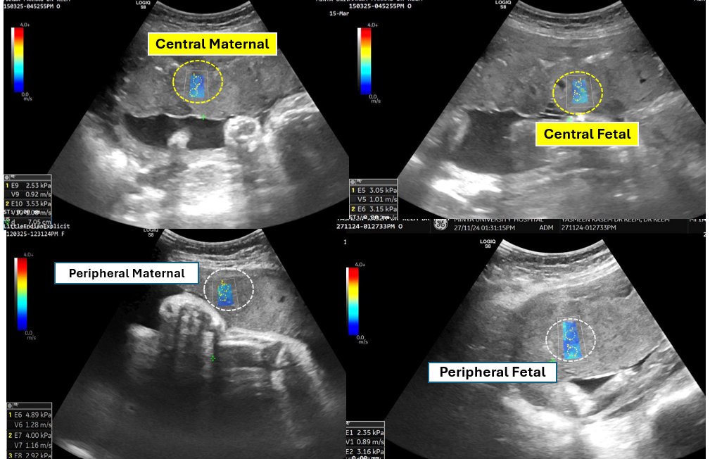
Fig. 1. Illustrative guide to placental SWE and regional ROI placement in a low-risk participant.

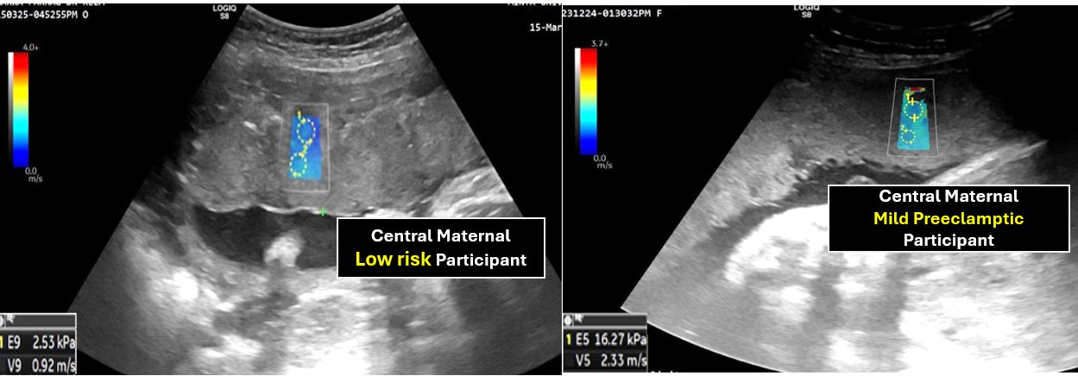
Fig. 2. Side-by-side comparison: central maternal SWE in a control vs. mild preeclamptic pregnancy with quantitative values overlaid.
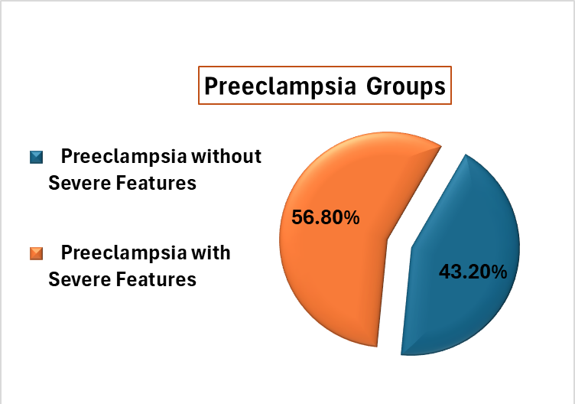

Fig. 3. Distribution of preeclampsia severity and risk factors.

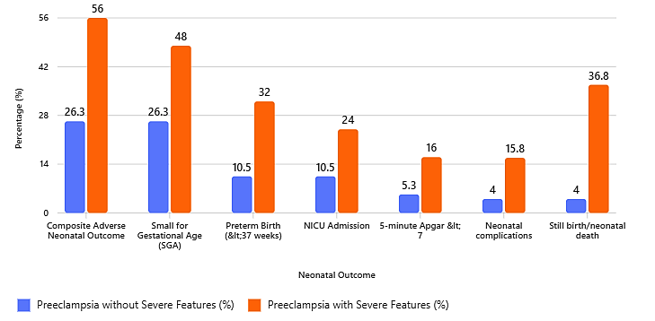
Fig. 4. Neonatal outcomes in severe vs. non-severe preeclampsia.

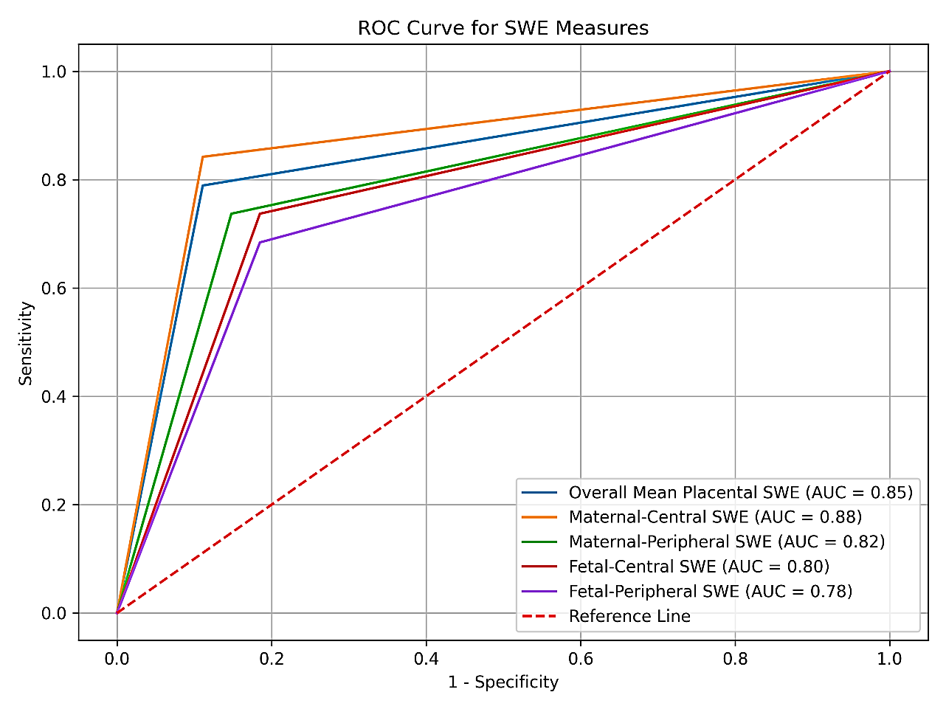
Fig. 5. ROC curves of placental SWE for prediction of adverse neonatal outcomes.

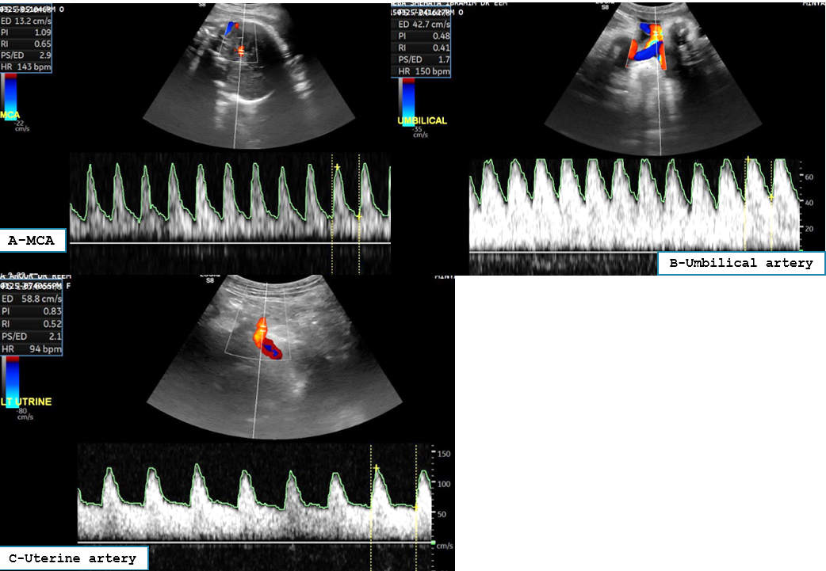
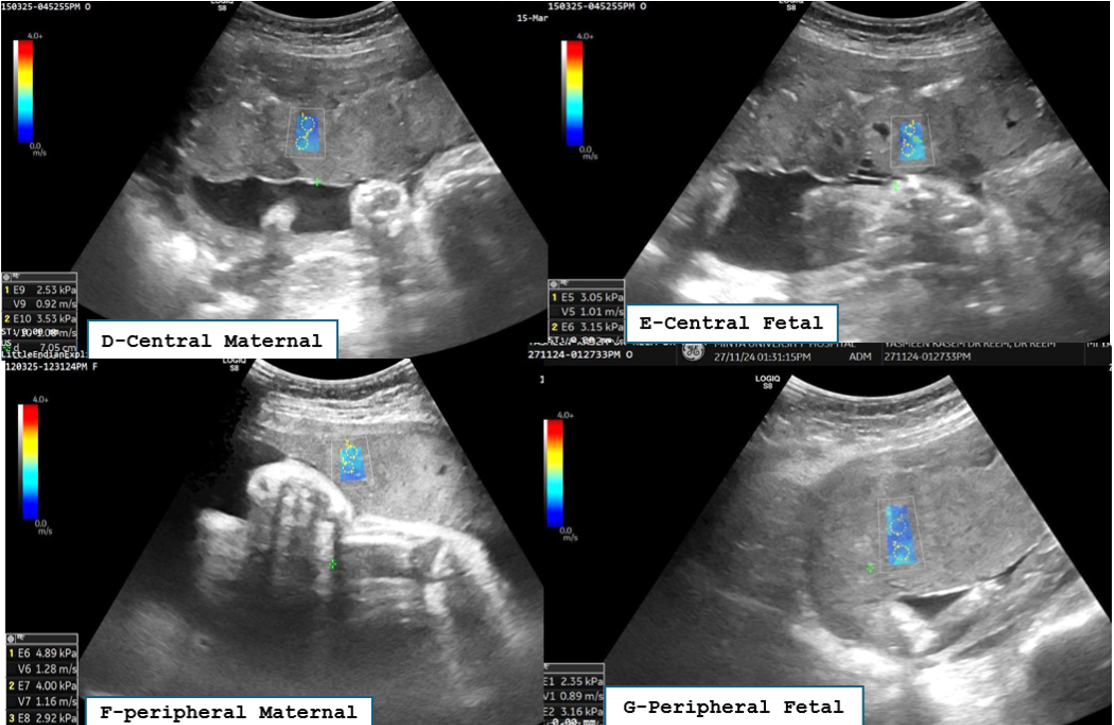

Fig. 6. Normal third-trimester placental assessment in a low-risk pregnancy at 35 weeks. (A–C) Doppler indices within normal limits: MCA PI 1.05, umbilical artery PI 0.47, mean uterine artery PI 0.8, CPR 2.23. (D–G) SWE demonstrating uniformly low placental stiffness with predominantly blue elasticity map; regional values: central fetal 3.0 kPa, central maternal 2.5 kPa, peripheral fetal 2.3 kPa, peripheral maternal 4.8 kPa; overall mean elasticity 3.15 kPa; mean SWV 1.25 m/s. Findings consistent with normal third-trimester placental biomechanics. Vaginal delivery at 39 weeks; birth weight 3200 g; Apgar 9/9.

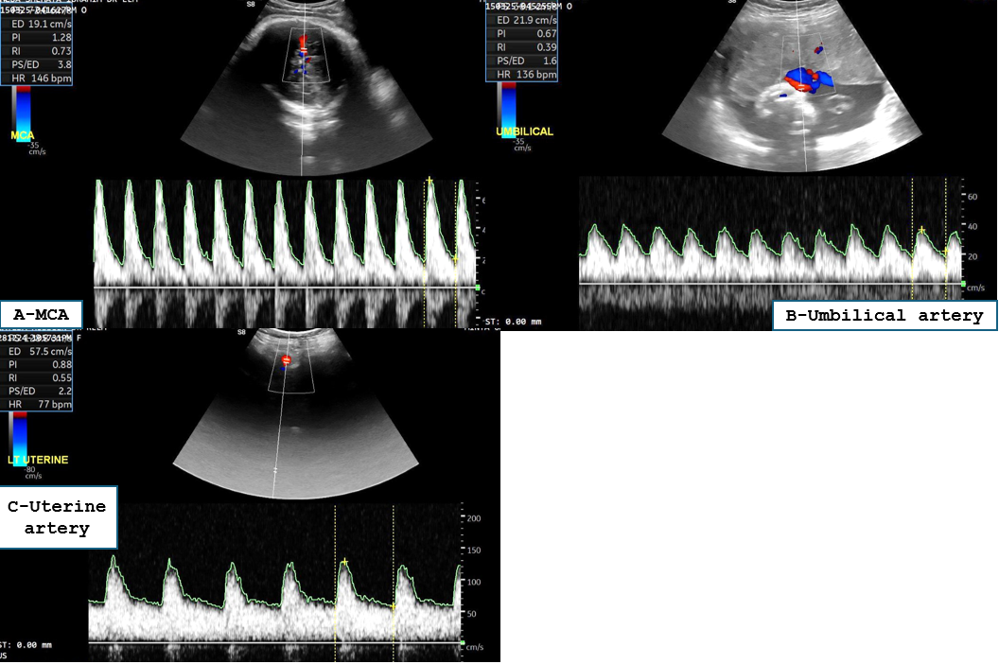
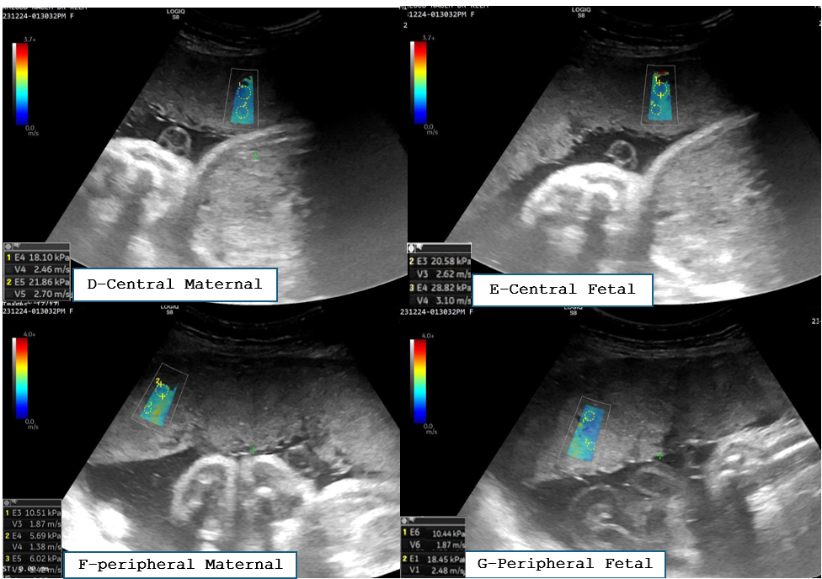
Fig. 7. Mild preeclampsia without severe features at 35+2 weeks (BP 145/100 mmHg, proteinuria <5 g/24h). (A–C) Doppler indices within normal limits: MCA PI 1.3, umbilical artery PI 0.61, mean uterine artery PI 0.9, CPR 2.1. (D–G) SWE demonstrating mildly increased placental stiffness with non-homogeneous blue elasticity map; regional values: central fetal 21.0 kPa, central maternal 22.0 kPa, peripheral fetal 17.0 kPa, peripheral maternal 19.0 kPa; overall mean 19.75 kPa; mean SWV 1.7 m/s. Despite preserved Doppler perfusion indices, elevated SWE values indicate subclinical placental microstructural changes. Vaginal delivery at 38 weeks; birth weight 2500 g (borderline SGA); Apgar 8/8.

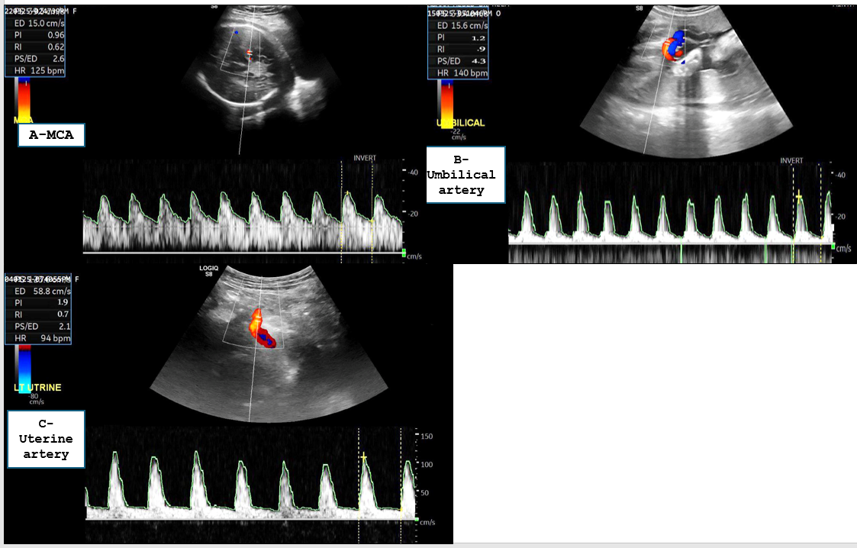
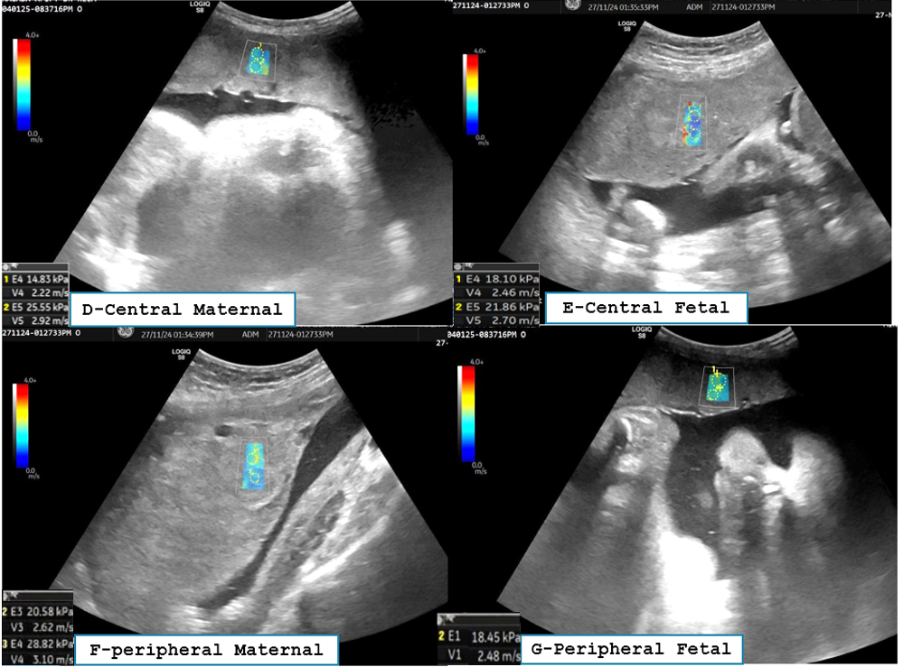

Fig. 8. Preeclampsia without severe features at 36+1 weeks with history of pre-gestational diabetes (BP 150/110 mmHg, proteinuria <5 g/24h). (A–C) Abnormal Doppler indices: MCA PI 0.6, umbilical artery PI 1.2, mean uterine artery PI 1.9, CPR 0.5, indicating impaired fetoplacental perfusion. (D–G) SWE demonstrating increased placental stiffness with heterogeneous elasticity map; regional values: central fetal 22.0 kPa, central maternal 22.5 kPa, peripheral fetal 18.0 kPa, peripheral maternal 20.0 kPa; overall mean 20.6 kPa; mean SWV 2.2 m/s. Concordant Doppler and SWE abnormalities reflect significant placental dysfunction. Cesarean delivery at 37 weeks; birth weight 2100 g; Apgar 7/7; NICU admission.

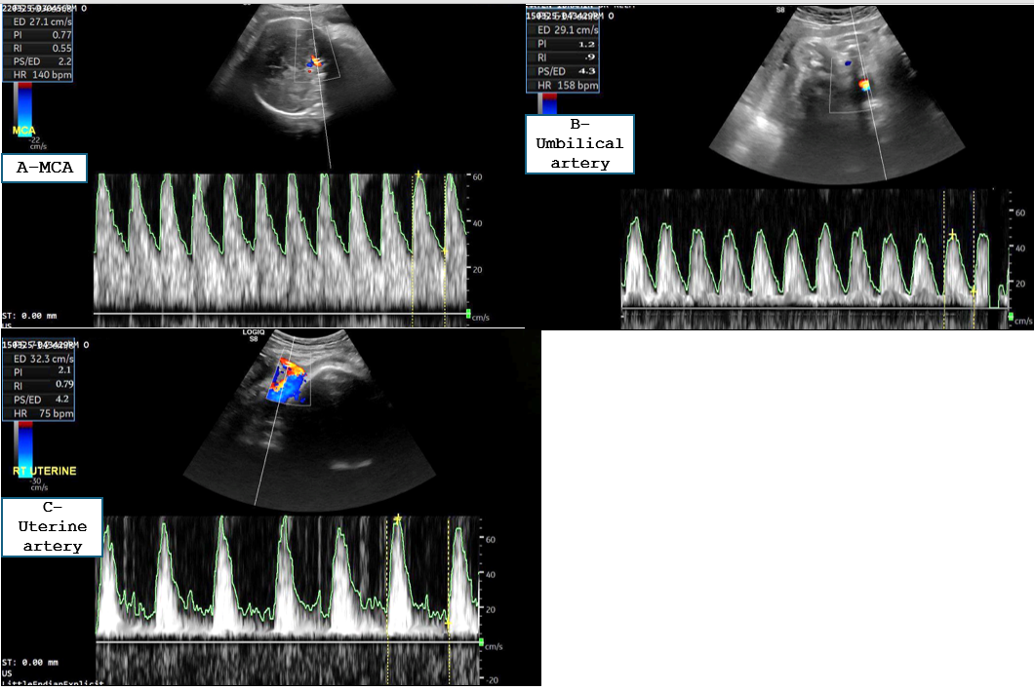
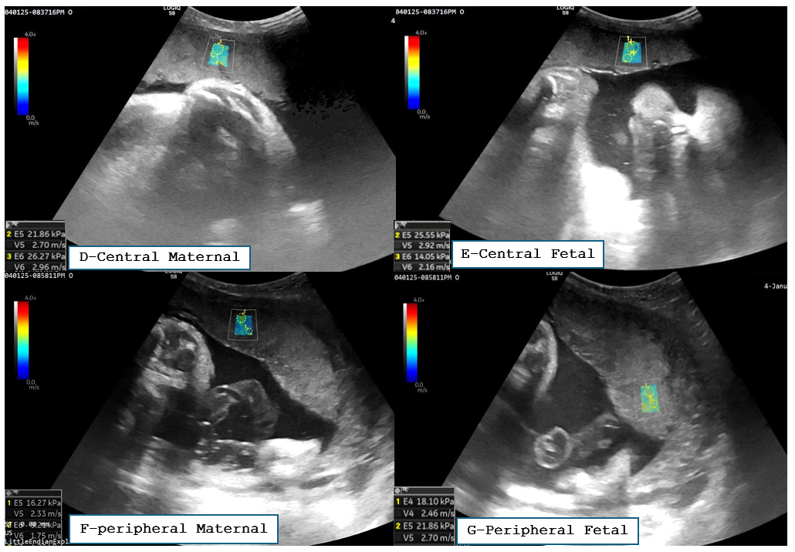
Fig. 9. Preeclampsia with severe features at 35+3 weeks (BP 160/115 mmHg, proteinuria >5 g/24h). (A–C) Markedly abnormal Doppler indices: MCA PI 0.7, umbilical artery PI 1.46, mean uterine artery PI 1.95, CPR 0.46, indicating severely impaired fetoplacental and uteroplacental circulation. (D–G) SWE demonstrating moderately-to-markedly increased placental stiffness with heterogeneous elasticity map; regional values: central fetal 23.0 kPa, central maternal 24.0 kPa, peripheral fetal 22.0 kPa, peripheral maternal 23.0 kPa; overall mean 23.0 kPa; mean SWV 2.7 m/s. Combined Doppler and SWE findings confirm placental insufficiency. Cesarean delivery at 37 weeks; birth weight 2050 g; Apgar 5/5; NICU admission; adverse neonatal outcome.

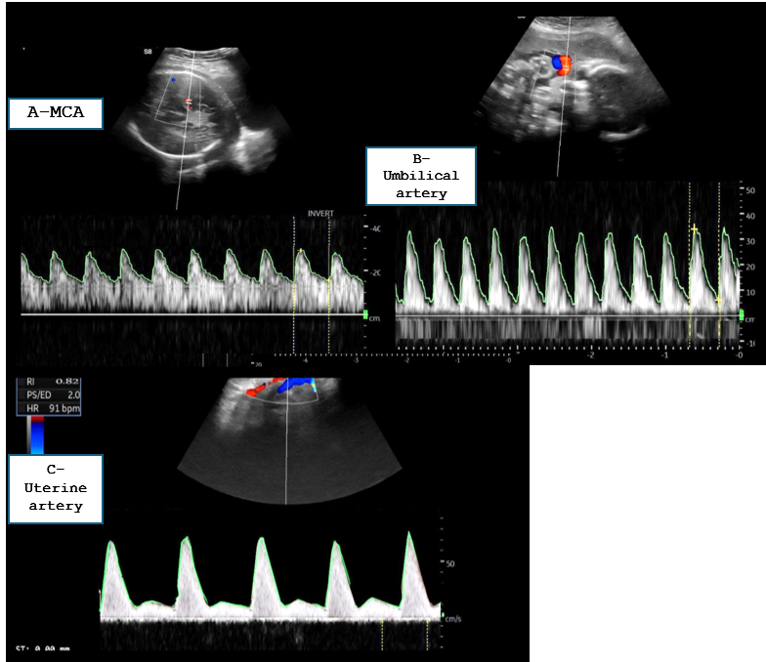
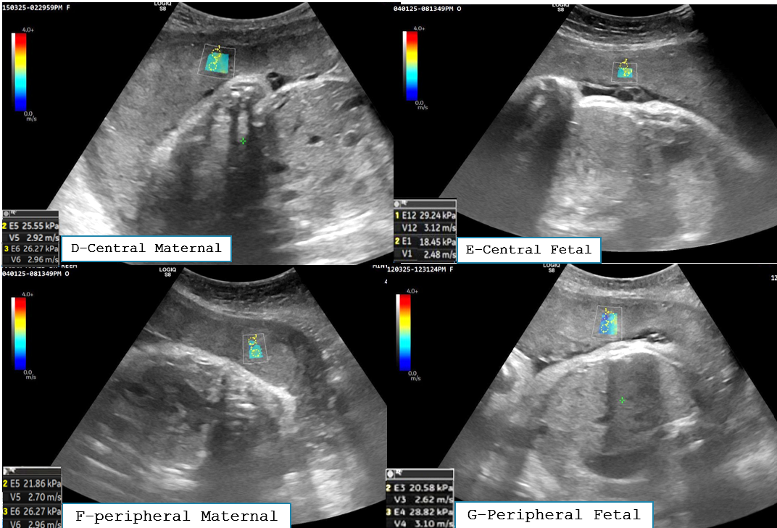

Fig. 10. Severe preeclampsia requiring ICU admission at 36 weeks (BP 170/120 mmHg, proteinuria >5 g/24h, epigastric pain, visual disturbances). (A–C) Critically abnormal Doppler indices: MCA PI 0.5, umbilical artery PI 1.5, mean uterine artery PI 1.8, CPR 0.33 with persistent pre-diastolic uterine artery notch, indicating severely compromised fetoplacental perfusion. (D–G) SWE demonstrating markedly increased placental stiffness with red-blue heterogeneous elasticity map; regional values: central fetal 25.5 kPa, central maternal 27.0 kPa, peripheral fetal 26.5 kPa, peripheral maternal 23.0 kPa; overall mean 25.5 kPa; mean SWV 2.9 m/s. Critically abnormal Doppler and SWE findings are consistent with advanced placental insufficiency in severe preeclampsia. Urgent cesarean delivery at 36 weeks; birth weight 1950 g; Apgar 3/3; NICU admission; critically adverse neonatal outcome.

