Supplementary Material S2

Inter-rater agreement for QUADAS-2 risk of bias assessment between two independent reviewers (Author 1 vs Author 2).

Supplementary Table S2. Inter-rater agreement statistics by QUADAS-2 domain

Domain | N | Observed Agreement (%) | Expected Agreement (%) | Kappa | SE | z | p-value | Interpretation*
D1 - Patient selection | 15 | 80.0 | 48.9 | 0.609 | 0.253 | 2.41 | 0.0159 | Substantial
D2 -  Index test | 15 | 93.3 | 53.3 | 0.857 | 0.276 | 3.105 | 0.0019 | Almost perfect
D3 - Reference standard | 15 | 100.0 | 100.0 | NA¹ | - | - | - | Undefined (no variability)
D4 -  Flow and timing | 15 | 100.0 | 100.0 | NA¹ | - | - | - | Undefined (no variability)
Overall | 60 | 93.3 | 67.8 | 0.793 | 0.187 | 4.236 | < 0.001 | Substantial
¹ κ is mathematically undefined for D3 and D4 because both reviewers rated every study "Low risk”, leaving no variability between expected agreement and observed agreement.
* κ values were interpreted in accordance with Landis and Koch (1977), as follows: < 0.00 poor, 0.00–0.20 slight, 0.21–0.40 fair, 0.41–0.60 moderate, 0.61–0.80 substantial, and 0.81–1.00 almost perfect agreement

Supplementary Figure S2. Heatmaps of risk of bias inter-rater agreement (Author 1 vs Author 2)
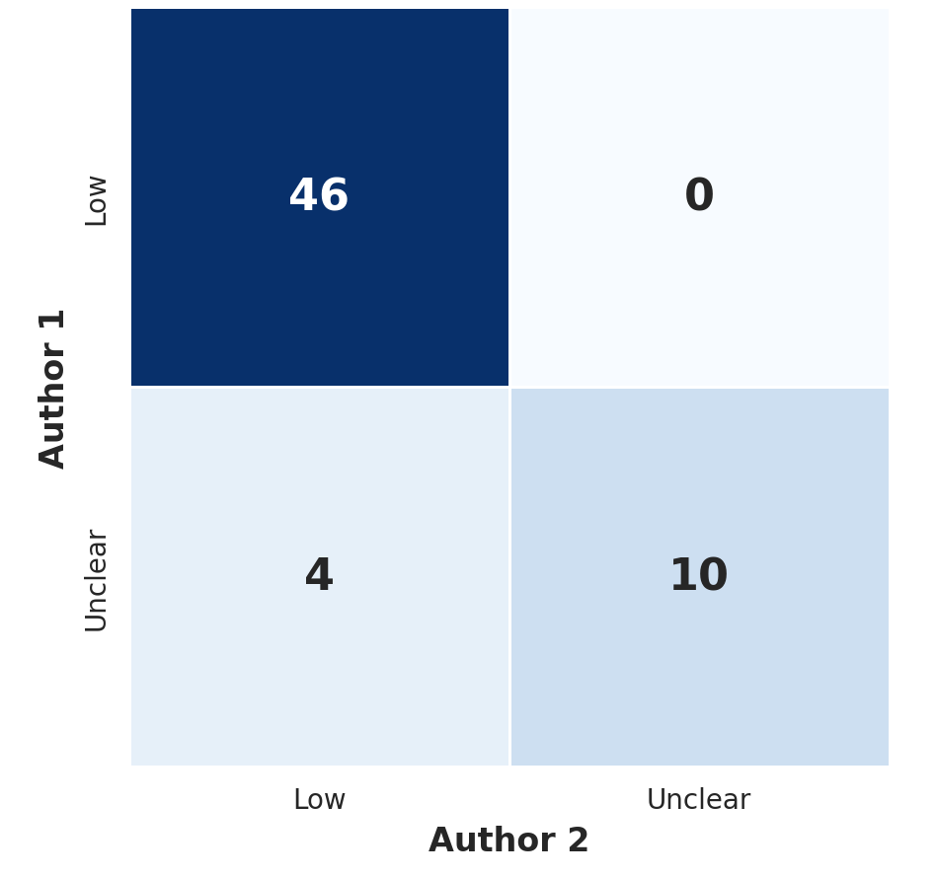
- Heatmap of pooled QUADAS-2 risk of bias inter-rater agreement
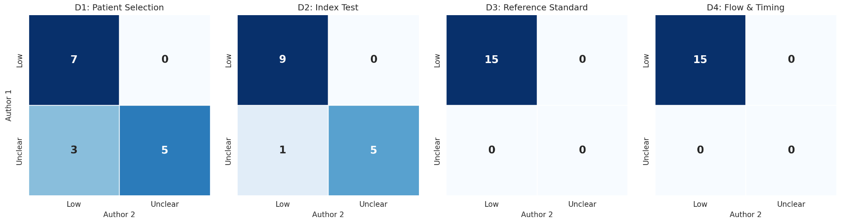
- Heatmap for individual QUADAS-2 risk of bias domains (D1-D4)

Cell values indicate the number of studies (out of N = 15 per domain; N = 60 pooled) falling into each Author 1 x Author 2 rating combination. Darker colours indicate higher agreement.

