Supplementary Material
Supplementary tables and figure for the revised manuscript "Early Mortality After Mitral Surgery for Failed MitraClip/TEER: A Systematic Review and Meta-Analysis".

Supplementary Figure 1
Supplementary Figure 1 (Figure S1). PRISMA 2020 flow diagram for study identification, screening, and inclusion. Because the original database-export logs were unavailable, the PRISMA accounting was reconstructed at the full-text report level: 15 full-text reports were assessed for eligibility, 1 was excluded (Saito 2015, 2 patients, below the prespecified sample-size threshold), 14 studies were retained for qualitative synthesis, and 8 unique surgical cohorts (N = 951 patients) were carried into the quantitative meta-analysis after overlap adjudication.
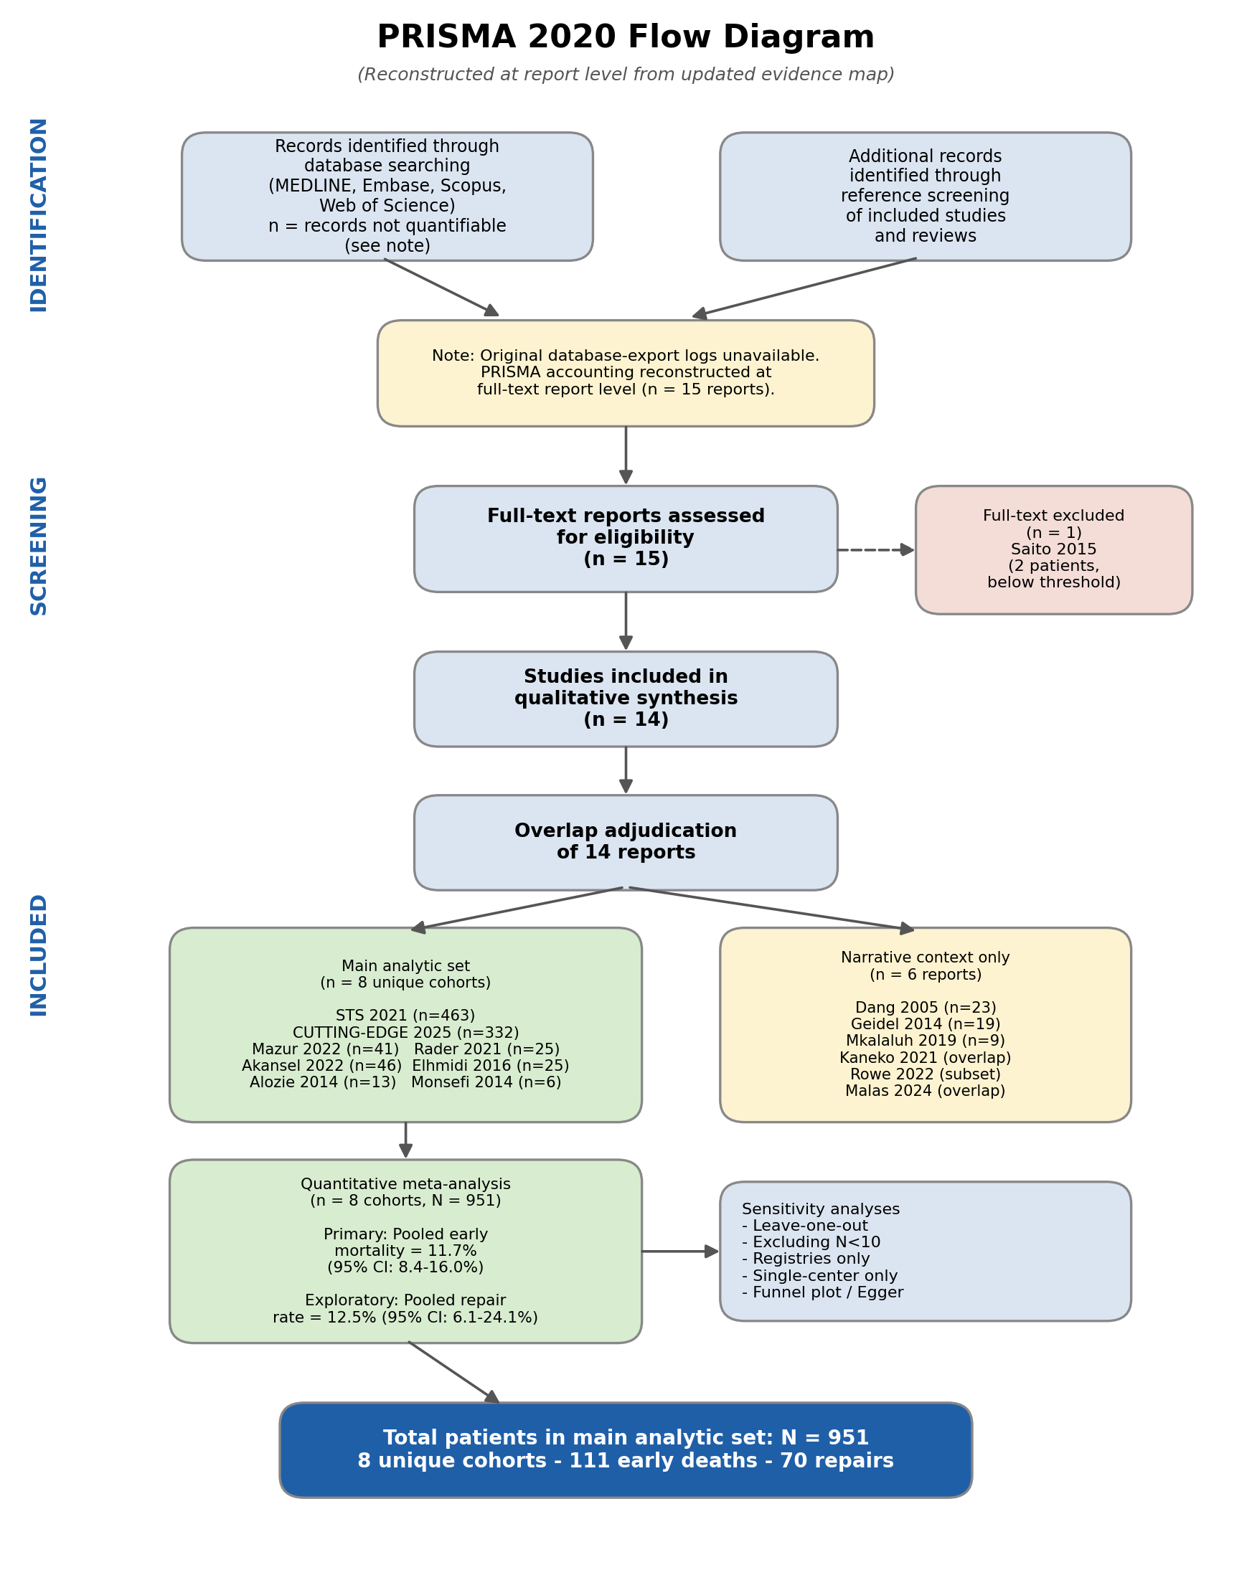

These supplementary tables were added or expanded in response to reviewer and editor requests. They are included in this revised manuscript file for transparency and may be submitted as a separate supplementary file if required by the journal.

Supplementary Table S1. Evidence map and overlap-adjudication decisions.

Abbreviations: STS, Society of Thoracic Surgeons; CUTTING-EDGE, international registry. Potential overlap between registry datasets and single-center reports cannot be excluded from aggregate publications and is addressed through sensitivity analyses.

Supplementary Table S2. Endpoint-homogeneous sensitivity analyses for early mortality.

The primary mixed-definition analysis is retained as a descriptive early-mortality benchmark. Endpoint-specific analyses are underpowered and should not be interpreted as proving equivalence among operative, in-hospital, and 30-day endpoints.

Supplementary Table S3. GRADE certainty-of-evidence assessment.

GRADE certainty was rated very low for both outcomes because the evidence base is retrospective, non-randomized, unadjusted, and clinically heterogeneous.

Supplementary Table S4. Alternative model robustness analyses.

Alternative models are presented as robustness checks for small-k proportion meta-analysis. They do not remove the fundamental limitations of retrospective aggregate data.

Supplementary Table S5. Cohort-level covariate availability relevant to heterogeneity.

This table summarizes availability and extractability of covariates rather than adjusted effects. NR indicates not reported or not extractable in a harmonized form from aggregate publications.

Supplementary Table S6. Descriptive synthesis of non-mortality early outcomes.

Non-mortality early outcomes were not meta-analyzed because definitions, ascertainment windows, and denominators varied across reports.

Supplementary Table S7. Repair-feasibility sensitivity analyses.

Excluding zero-repair cohorts or restricting to contemporary cohorts did not resolve heterogeneity. The repair estimate should not be used for individual-center decision-making.

Supplementary Table S8. Database-specific search strings.

All databases were searched from inception to 8 January 2026.
Report | Setting / cohort | Handling | Rationale
Chikwe/STS 2021 | US STS registry, n=463 | Retained in main analysis | Largest national registry; operative mortality and repair/replacement denominator clearly extractable. Potential overlap with US single-center reports cannot be resolved from aggregate data and is addressed by sensitivity analyses.
Dang 2005 | Early multicenter EVEREST-era surgical revision report | Qualitative only | Historical feasibility report with limited granularity and precontemporary device/patient selection; retained for context rather than pooled estimate.
Alozie 2014 | German single-center cohort, n=13 | Retained in main analysis | Unique extractable denominator and in-hospital mortality; no confirmed overlap with retained larger dataset.
Geidel 2014 | German surgical cohort/technical experience | Qualitative only | Potentially overlapping/serial institutional experience and less consistent endpoint reporting; not pooled to avoid possible double counting.
Monsefi 2014 | German two-center cohort, n=6 | Retained in main analysis | Unique small cohort with extractable in-hospital mortality and repair/replacement denominator; influence assessed by N<10 sensitivity analysis.
Elhmidi 2016 | German cohort, n=25 | Retained in main analysis | Unique extractable 30-day mortality and repair/replacement denominator.
Mkalaluh 2019 | German high-risk surgical revision series | Qualitative only | Potential overlap with prior regional/institutional experience could not be excluded and cohort-level endpoint granularity was limited for the main pooled dataset.
Rader 2021 | Cedars-Sinai single-center cohort, n=25 | Retained in main analysis | Parent Cedars-Sinai cohort with extractable mortality and repair denominator; later technical updates from the same institutional program were not pooled.
Kaneko/CUTTING-EDGE 2021 | International CUTTING-EDGE registry, n=332 | Excluded from main analysis due to overlap | Earlier CUTTING-EDGE publication; superseded by the 2025 CUTTING-EDGE analysis with the same registry denominator and more directly relevant repair-vs-replacement outcomes.
Mazur 2022 | Mayo Clinic single-center cohort, n=41 | Retained in main analysis | Unique institutional cohort with extractable operative mortality; potential untraceable STS overlap acknowledged and explored by registry-only and single-center-only analyses.
Akansel 2022 | German minimally invasive cohort, n=46 | Retained in main analysis | Unique contemporary cohort with extractable in-hospital mortality and repair denominator; one non-TEER case noted in sensitivity interpretation.
Rowe 2022 | Cedars-Sinai robotic repair technical update | Qualitative only | Technical update likely overlapping with the Cedars-Sinai/Rader institutional experience; used only to inform narrative repair-feasibility discussion.
Saito 2015 | Two-patient report | Excluded before quantitative synthesis | Below prespecified minimum sample-size threshold (N<5); case-report-level evidence.
Malas 2024 | Cedars-Sinai institutional technical update | Qualitative only | Institutional update likely overlapping with the Cedars-Sinai parent cohort; used only for operative-technique narrative synthesis.
Marin-Cuartas/CUTTING-EDGE 2025 | International CUTTING-EDGE registry, n=332 | Retained in main analysis | Most informative CUTTING-EDGE dataset; retained instead of the 2021 CUTTING-EDGE report.
Analysis | k (N) | Events | Pooled % (95% CI) | 95% prediction interval | I2
Primary mixed early-mortality endpoint | 8 (951) | 111 | 11.7 (8.4-16.0) | 5.5-23.1 | 39.2%
Operative mortality only | 2 (504) | 51 | 9.5 (5.6-15.7) | Not estimable with k=2 | 21.6%
In-hospital mortality only | 5 (422) | 56 | 11.9 (6.2-21.7) | 1.8-49.5 | 39.3%
30-day mortality only | 3 (382) | 59 | 15.3 (9.4-23.9) | Very imprecise with k=3 | 23.1%
Outcome | Evidence base | Risk of bias | Inconsistency | Indirectness | Imprecision | Publication bias | Certainty | Interpretation
Early mortality | 8 retrospective cohorts/registries; 951 patients | Very serious: all data retrospective, non-randomized, high risk of selection bias | Serious: endpoint definitions mixed; PI 5.5-23.1% | Serious: no patient-level adjustment; variable acuity and centers | Not serious for pooled CI, but PI remains clinically wide | Undetected/uncertain; formal tests underpowered | Very low | The pooled estimate is a crude descriptive benchmark, not an individual risk-prediction tool
Repair feasibility | 8 retrospective cohorts/registries; 951 patients | Very serious: selection for repair is highly non-random | Very serious: I2 85.1%; PI 1.1-64.4% | Serious: anatomy, mechanism of failure, clip burden, and expertise inconsistently reported | Serious: only 70 repairs overall and sparse zero-event cohorts | Undetected/uncertain; asymmetry may reflect center selection | Very low | Repair feasibility should be interpreted narratively and locally, not as a generalizable probability
Outcome | Model | Pooled estimate % (95% CI) | Interpretation
Early mortality | Primary random-effects logit/DL | 11.7 (8.4-16.0) | Reference analysis
Early mortality | Hartung-Knapp/Sidik-Jonkman small-k adjustment | 11.7 (7.7-17.4) | Wider CI, same interpretation
Early mortality | Logit-normal GLMM | 10.8 (7.5-15.4) | Consistent point estimate
Early mortality | Beta-binomial model | 10.9 (7.7-15.3) | Consistent point estimate
Repair feasibility | Primary random-effects logit/DL | 12.5 (6.1-24.1) | Reference analysis
Repair feasibility | Hartung-Knapp/Sidik-Jonkman small-k adjustment | 12.5 (4.6-30.0) | Wider CI, persistent uncertainty
Repair feasibility | Logit-normal GLMM | 11.2 (7.6-16.0) | Consistent low average repair frequency; heterogeneity remains high
Repair feasibility | Beta-binomial model | 14.6 (6.6-29.4) | Consistent with broad uncertainty
Study | N | Design | Age | LVEF | Risk score | Time TEER-surgery | Clips / device burden | Endocarditis / urgency | Center profile | Concomitant procedures
STS 2021 | 463 | Registry | Reported at aggregate level | Reported | Reported | Reported | NR/incompletely extractable | Reported | Reported; center-volume signal available | Reported
CUTTING-EDGE 2025 | 332 | International registry | Reported at aggregate level | Reported | Reported | Reported | Reported | Reported | Reported by participating centers; no uniform volume threshold | Reported
Mazur 2022 | 41 | Single center | Reported | Reported | Reported | Reported | Reported | NR/incompletely extractable | High-volume expert center | Reported
Rader 2021 | 25 | Single center | Reported | Reported | Reported | Reported | Reported | NR/incompletely extractable | High-volume expert center | Reported
Akansel 2022 | 46 | Single center/minimally invasive | Reported | Reported | Reported | Reported | Reported | NR/incompletely extractable | High-volume expert center | Reported
Elhmidi 2016 | 25 | Single center | Reported | Reported | Reported | Reported | Reported | NR/incompletely extractable | Specialized center | Reported
Alozie 2014 | 13 | Single center | Reported | Reported | Reported | Reported | NR/incompletely extractable | NR/incompletely extractable | Specialized center | Reported
Monsefi 2014 | 6 | Two centers | Reported | Reported | Reported | NR/incompletely extractable | NR/incompletely extractable | NR/incompletely extractable | Specialized centers | Reported
Outcome domain | Reporting across included studies | Handling in this review
Stroke/neurologic event | Reported inconsistently across selected cohorts | Not pooled; definitions and ascertainment windows differed
Renal failure/dialysis | Reported inconsistently across selected cohorts | Not pooled; baseline renal disease and postoperative definitions varied
Permanent pacemaker/conduction outcomes | Sporadically reported | Narrative only
Bleeding/reoperation | Sporadically reported | Narrative only; reoperation definitions varied
ICU length of stay and hospital length of stay | Reported by some cohorts but not uniformly | Narrative only because medians/means and discharge practices differed
Concomitant procedures | Frequently reported but heterogeneous | Summarized as a potential contributor to mortality heterogeneity rather than meta-analyzed
Analysis | k (N) | Repairs | Pooled % (95% CI) | 95% prediction interval | I2
Primary repair-feasibility analysis | 8 (951) | 70 | 12.5 (6.1-24.1) | 1.1-64.4 | 85.1%
Excluding cohorts with N < 10 | 7 (945) | 67 | 10.4 (5.0-20.3) | 1.0-58.2 | 84.4%
Excluding zero-repair cohorts | 6 (897) | 70 | 15.4 (7.3-29.9) | 1.0-77.2 | 88.7%
Contemporary cohorts (2021 onward) | 5 (907) | 62 | 9.7 (4.1-21.1) | 0.4-73.4 | 88.2%
Registry cohorts only | 2 (795) | 47 | 6.0 (3.8-9.4) | Not estimable with k=2 | 62.1%
Single-center cohorts only | 6 (156) | 23 | 17.9 (7.4-37.2) | 1.0-82.2 | 70.5%
Database | Search string
MEDLINE/PubMed | ((mitral[Title/Abstract] OR "mitral valve"[Title/Abstract]) AND (MitraClip[Title/Abstract] OR TEER[Title/Abstract] OR M-TEER[Title/Abstract] OR PASCAL[Title/Abstract] OR "transcatheter edge-to-edge repair"[Title/Abstract] OR "transcatheter mitral valve repair"[Title/Abstract]) AND (fail*[Title/Abstract] OR recurrent[Title/Abstract] OR residual[Title/Abstract] OR reintervention[Title/Abstract] OR surgery[Title/Abstract] OR "mitral valve surgery"[Title/Abstract] OR repair[Title/Abstract] OR replacement[Title/Abstract] OR explant*[Title/Abstract] OR detachment[Title/Abstract] OR endocarditis[Title/Abstract]))
Embase | (mitral:ti,ab OR "mitral valve":ti,ab) AND (MitraClip:ti,ab OR TEER:ti,ab OR M-TEER:ti,ab OR PASCAL:ti,ab OR "transcatheter edge-to-edge repair":ti,ab OR "transcatheter mitral valve repair":ti,ab) AND (fail*:ti,ab OR recurrent:ti,ab OR residual:ti,ab OR reintervention:ti,ab OR surgery:ti,ab OR "mitral valve surgery":ti,ab OR repair:ti,ab OR replacement:ti,ab OR explant*:ti,ab OR detachment:ti,ab OR endocarditis:ti,ab)
Scopus | TITLE-ABS-KEY((mitral OR "mitral valve") AND (MitraClip OR TEER OR M-TEER OR PASCAL OR "transcatheter edge-to-edge repair" OR "transcatheter mitral valve repair") AND (fail* OR recurrent OR residual OR reintervention OR surgery OR "mitral valve surgery" OR repair OR replacement OR explant* OR detachment OR endocarditis))
Web of Science | TS=((mitral OR "mitral valve") AND (MitraClip OR TEER OR M-TEER OR PASCAL OR "transcatheter edge-to-edge repair" OR "transcatheter mitral valve repair") AND (fail* OR recurrent OR residual OR reintervention OR surgery OR "mitral valve surgery" OR repair OR replacement OR explant* OR detachment OR endocarditis))

