Additional file 1: Theoretical model of the effect of the low back pain management booklet on known barriers to reducing non-indicated imaging for low back pain
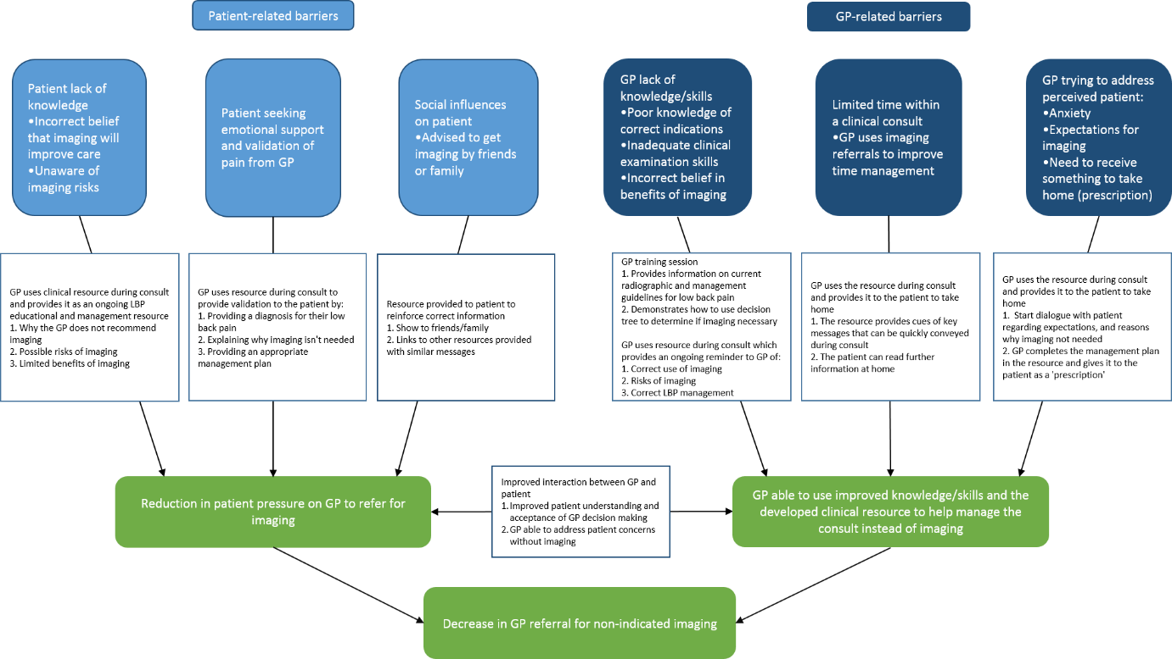
This figure has been republished with consent from Figure 3 in ‘Using behaviour change theory and preliminary testing to develop an implementation intervention to reduce imaging for low back pain’ (8): a concept map of how the intervention was designed to target identified barriers to appropriate use of imaging for low back pain.

