Supplemental File 1

Screenshots of REDCap Data Entry Tool
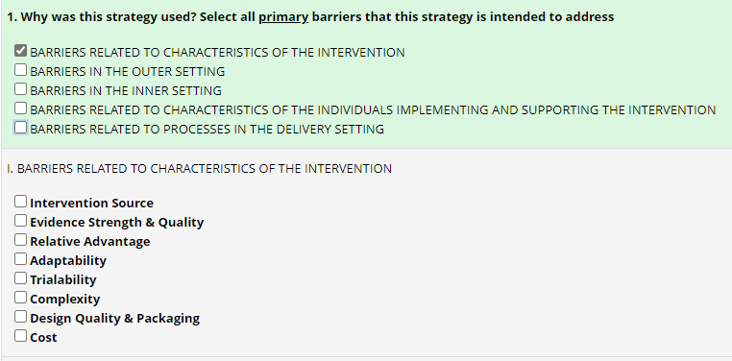
Supplemental Figure 1. Example of Implementation Barriers from the Characteristics of the Intervention Domain

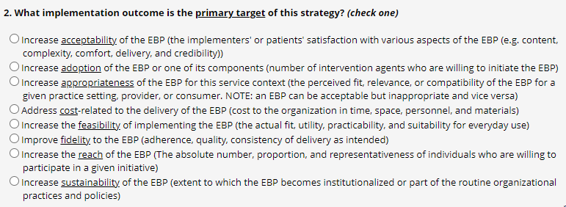
Supplemental Figure 2. Implementation Outcomes

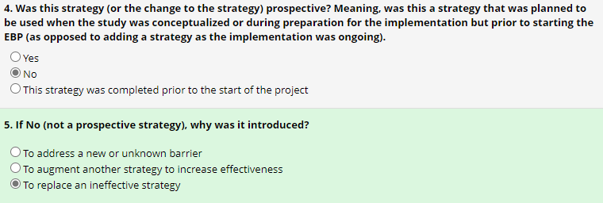
Supplemental Figure 3. Unplanned Strategy Modification

Supplemental Figure 4. Specifying Study Units
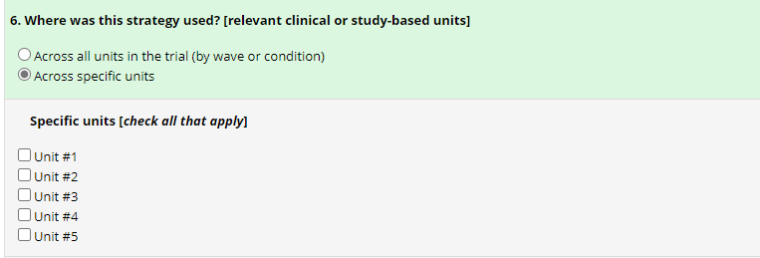

Supplemental Figure 5. Record Status Dashboard
