Figure S1. Early Prototype
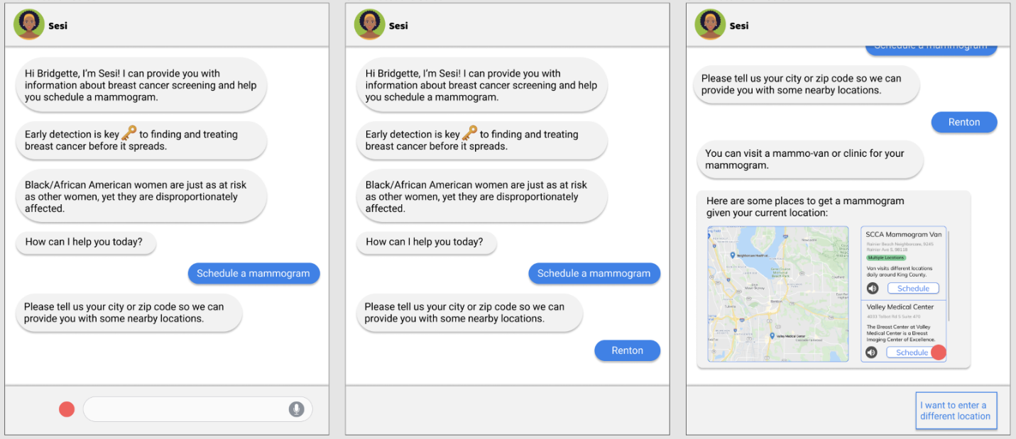
Avatar attribution: Vecteezy. Beautiful black woman avatar character icon Free Vector. https://www.vecteezy.com/vector-art/2002247-beautiful-black-woman-avatar-character-icon. Accessed on February 24, 2024.

