Appendix

Appendix 1. Average scores of cultural exchange output and process by wave.
Appendix 2. Main analytic results for covariates.
Appendix 3. Results from Type III ANOVA with Satterthwaite’s Method
Appendix 4a. Estimated temporal effect of average CEI process.
Appendix 4b. Estimated temporal effect of average CEI output.

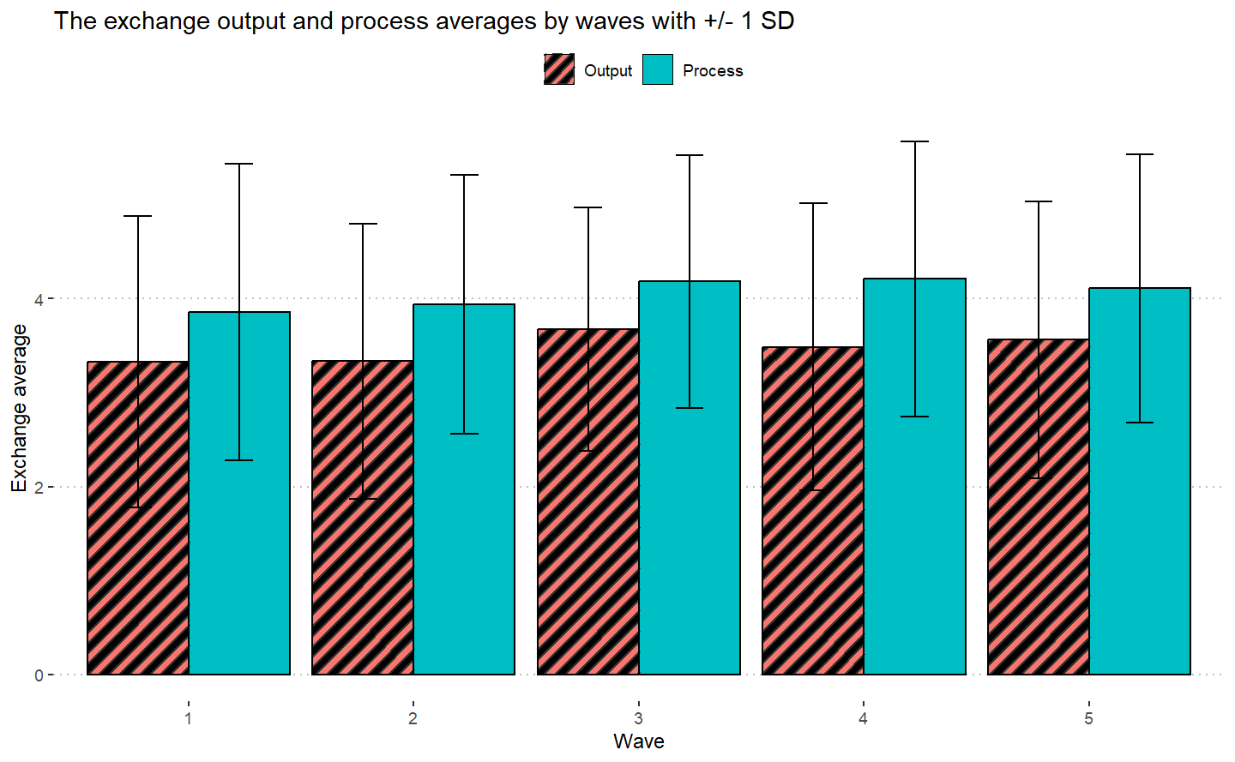
Appendix 1. Average scores of cultural exchange output and process by wave.
Note: Bars represent +/- one standard deviation.

Appendix 2. Main analytic results for covariates.
 | Outcome (B, SE)
Variable | Aim 1 |  | Aim 2
Age | CEI Processª | CEI Output^{b} | CEI Process^{c} | CEI Output^{d}
18-25 | REF | REF | REF | REF
26-35 | -0.08 (0.24) | 0.11 (0.25) | 0.04 (0.22) | 0.11 (0.23)
36-45 | -0.03 (0.27) | 0.07 (0.28) | -0.04 (0.24) | -0.04 (0.25)
46-55 | -0.33 (0.28) | -0.22 (0.29) | -0.26 (0.24) | -0.30 (0.26)
56-65 | -0.62 (0.33) | -0.38 (0.34) | -0.39 (0.30) | -0.26 (0.31)
>65 | 0.39 (0.53) | 0.06 (0.56) | 0.59 (0.47) | 0.17 (0.50)
Unknown | 1.14 (1.30) | 0.19 (1.36) | 1.71 (1.37) | 0.51 (1.45)
Race
White | REF | REF | REF | REF
Asian | -1.45 (0.59)* | -1.11 (0.61) | -1.49 (0.50)** | -1.01 (0.52)
Black | 0.27 (0.31) | 0.36 (0.33) | 0.43 (0.28) | 0.51 (0.29)
Multiracial | 0.03 (0.58) | 0.69 (0.61) | 0.24 (0.55) | 0.92 (0.58)
Prefer not to Report | -0.80 (0.74) | -0.44 (0.770 | -0.37 (0.75) | -0.37 (0.80)
Unknown race | 0.55 (0.69) | 1.81 (0.72)* | 0.03 (0.64) | 1.22 (0.68)
Gender
Female | REF | REF | REF | REF
Male | 0.09 (0.18) | -0.01 (0.18) | 0.07 (0.15) | -0.02 (0.16)
Nonbinary | -1.11 (0.57) | -1.00 (0.59) | -1.08 (0.51)* | -1.02 (0.54)
Unknown | 0.11 (0.56) | 0.10 (0.58) | -0.22 (0.62) | 0.18 (0.67)
Ethnicity
Non-Hispanic | REF | REF | REF | REF
Hispanic | 0.17 (0.35) | -0.02 (0.37) | 0.06 (0.31) | -0.05 (0.32)
Unknown | -0.10 (0.53) | -0.18 (0.55) | 0.02 (0.50) | -0.23 (0.53)
Time at Agency
< 1 year | REF | REF | REF | REF
1-4 years | -0.12 (0.19) | 0.21 (0.20) | -0.04 (0.19) | 0.28 (0.20)
5-9 years | 0.46 (0.23)* | 0.75 (0.24)** | 0.45 (0.21)* | 0.78 (0.22)**
10-14 years | 0.22 (0.29) | 0.43 (0.30) | 0.21 (0.27) | 0.43 (0.28)
15-19 years | 0.13 (0.33) | 0.26 (0.34) | 0.22 (0.30) | 0.39 (0.31)
≥20 years | 0.36 (0.30) | 0.48 (0.31) | 0.35 (0.28) | 0.46 (0.28)
Education Level
High School | -1.39 (0.82) | -0.90 (0.86) | -0.13 (0.78) | 0.25 (0.82)
Some College | -0.48 (0.59) | 0.41 (0.62) | 0.12 (0.53) | 1.17 (0.56)*
Bachelor’s | -0.99 (0.49)* | -0.71 (0.51) | -0.51 (0.44) | -0.16 (0.46)
Associate’s | REF | REF | REF | REF
Master’s | -0.92 (0.49) | -0.61 (0.51) | -0.57 (0.43) | -0.19 (0.46)
Doctorate | -0.92 (0.57) | -0.80 (0.59) | -0.21 (0.51) | -0.15 (0.53)
Job Satisfaction
Very Dissatisfied | -0.15 (0.69) | -0.06 (0.72) | 0.06 (0.74) | 0.44 (0.79)
Dissatisfied | 0.43 (0.33) | 0.42 (0.34) | 0.56 (0.31) | 0.52 (0.33)
Not Satisfied/Dissatisfied | REF | REF | REF | REF
Satisfied | 0.36 (0.17)* | 0.41 (0.17)* | 0.23 (0.16) | 0.25 (0.17)
Very Satisfied | -0.85 (0.19)*** | -0.76 (0.19)*** | 0.46 (0.18) | 0.37 (0.19)*
* p<0.05 **p<0.01 REF=reference category. ªBased on 661 repeated measurements, 287 unique individuals. ^{b}Based on 662 repeated measurements, 288 unique individuals. ^{c}Based on 629 repeated measurements, 280 unique individuals. ^{d}Based on 630 repeated measurements, 281 unique individuals.

Appendix 3. Results from Type III ANOVA with Satterthwaite’s Method
 | F-Value [Numerator DF, Denominator DF]
 | Aim 1 |  | Aim 2
Predictor | CEI Processª | CEI Output^{b} | CEI Process^{c} | CEI Output^{d}
Treatment Indicator | 1.17 [2, 380.60] | 1.43 [2, 302.28] | 1.59 [2, 305.97] | 2.30 [2, 182.25]
ICS | - | - | 55.54 [1, 576.25]** | 34.35 [1, 556.40]**
ICBS | - | - | 22.16 [1, 573.68]** | 25.18 [1, 568.86]**
Spline Parameters | 0.67 [6, 477.57] | 0.41 [6, 456.18] | 0.46 [6, 549.27] | 0.49 [6, 427.33]
Age | 1.58 [6, 364.16] | 0.80 [6, 374.56] | 1.59 [6, 356.05] | 0.99 [6, 364.98]
Race | 1.77 [5, 387.75] | 2.31 [5, 398.61]* | 2.35 [5, 358.02]* | 2.43 [5, 372.26]*
Gender | 1.39 [3, 389.91] | 0.96 [3, 395.65] | 1.63 [3, 361.21] | 1.23 [3, 373.10]
Ethnicity | 0.14 [2, 319.63] | 0.06 [2, 329.34] | 0.02 [2, 287.81] | 0.10 [2, 306.84]
Time at Agency | 3.03 [5, 512.68]* | 2.93 [5, 516.63]* | 2.59 [5, 458.18]* | 3.16 [5, 444.59]**
Education Level | 1.16 [5, 287.53] | 1.79 [5, 286.40] | 1.30 [5, 255.02] | 2.65 [5, 253.21]*
Job Satisfaction | 6.45 [4, 602.15]** | 4.26 [4, 605.44]** | 2.22 [4, 567.54] | 1.28 [4, 574.55]
CEI = Cultural Exchange Inventory. ICS = Implementation Climate Scale. ICBS = Implementation Citizenship Behavior Scale. * p<0.05 **p<0.01. ªBased on 661 observations, 287 unique individuals. ^{b}Based on 662 observations, 288 unique individuals. ^{c}Based on 629 observations, 280 unique individuals. ^{d}Based on 630 observations, 281 unique individuals.

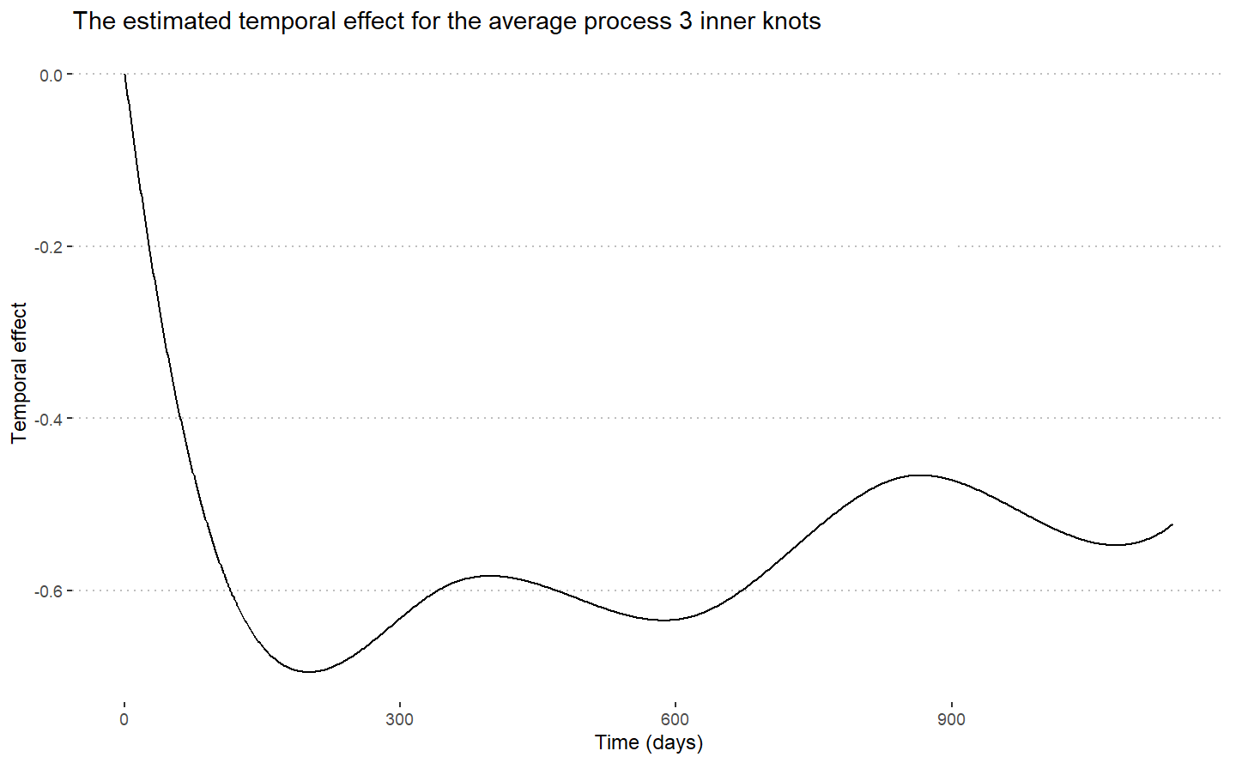Appendix 4a. Estimated temporal effect of average CEI process.
Note: Three inner knots are specified. The x-axis is continuous time in days since start of study.

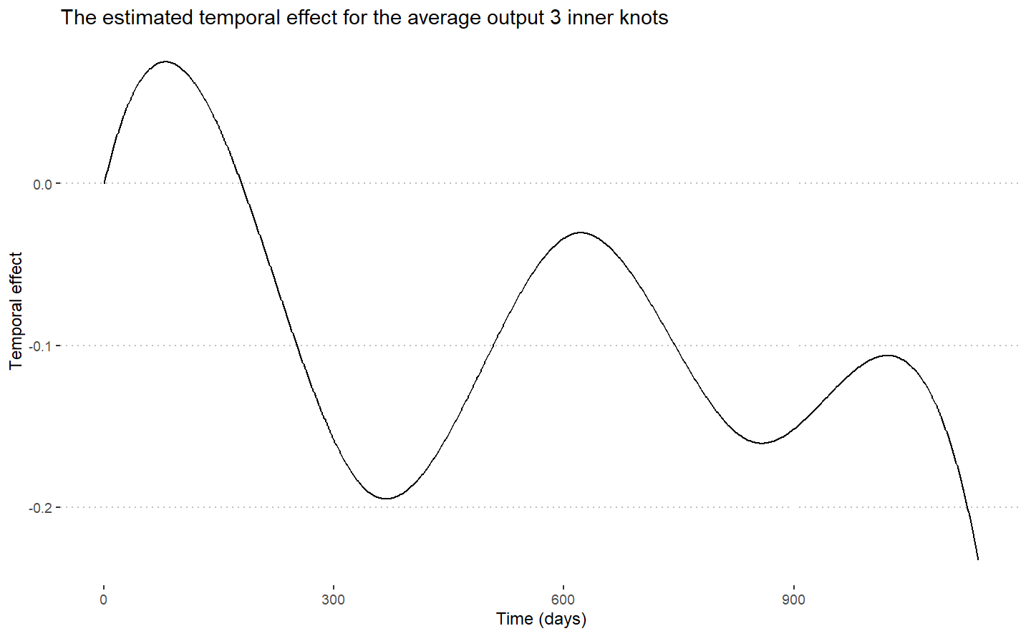
Appendix 4b. Estimated temporal effect of average CEI output.
Note: Three inner knots are specified. The x-axis is continuous time in days since start of study.

