Supplementary Information

Appendix 1: Standards for Reporting Implementation Studies (StaRI) checklist 2
Appendix 2: Strengthening the Reporting of Observational Studies in Epidemiology (STROBE) checklist 6
Appendix 3: Implementation strategy specifications 9
Appendix 4: Relationship between HEARTS, strategies, and ERIC taxonomy 19
References 20

Appendix 1: Standards for Reporting Implementation Studies (StaRI) checklist


Standards for Reporting Implementation Studies: the StaRI checklist for completion
The StaRI standard should be referenced as: Pinnock H, Barwick M, Carpenter C, Eldridge S, Grandes G, Griffiths CJ, Rycroft-Malone J, Meissner P, Murray E, Patel A, Sheikh A, Taylor SJC for the StaRI Group. Standards for Reporting Implementation Studies (StaRI) statement. BMJ 2017;356:i6795
The detailed Explanation and Elaboration document, which provides the rationale and exemplar text for all these items is: Pinnock H, Barwick M, Carpenter C, Eldridge S, Grandes G, Griffiths C, Rycroft-Malone J, Meissner P, Murray E, Patel A, Sheikh A, Taylor S, for the StaRI group. Standards for Reporting Implementation Studies (StaRI). Explanation and Elaboration document. BMJ Open 2017;7:e013318
Notes: A key concept of the StaRI standards is the dual strands of describing, on the one hand, the implementation strategy and, on the other, the clinical, healthcare, or public health intervention that is being implemented. These strands are represented as two columns in the checklist.
The primary focus of implementation science is the implementation strategy (column 1) and the expectation is that this will always be completed. | The evidence about the impact of the intervention on the targeted population should always be considered (column 2) and either health outcomes reported or robust evidence cited to support a known beneficial effect of the intervention on the health of individuals or populations.
The StaRI standards refer to the broad range of study designs employed in implementation science. Authors should refer to other reporting standards for advice on reporting specific methodological features. Conversely, whilst all items are worthy of consideration, not all items will be applicable to, or feasible within every study.
Checklist item |  | Reported on page # | Implementation Strategy | Reported on page # | Intervention
 |  |  | “Implementation strategy” refers to how the intervention was implemented |  | “Intervention” refers to the healthcare or public health intervention that is being implemented.
Title and abstract
Title | 1 | Title | Identification as an implementation study, and description of the methodology in the title and/or keywords
Abstract | 2 | Background | Identification as an implementation study, including a description of the implementation strategy to be tested, the evidence-based intervention being implemented, and defining the key implementation and health outcomes.
Introduction
Introduction | 3 | Background | Description of the problem, challenge or deficiency in healthcare or public health that the intervention being implemented aims to address.
Rationale | 4 | Background; Methods/Design: Implementation intervention | The scientific background and rationale for the implementation strategy (including any underpinning theory/framework/model, how it is expected to achieve its effects and any pilot work). | Background; Methods/Design: Implementation intervention | The scientific background and rationale for the intervention being implemented (including evidence about its effectiveness and how it is expected to achieve its effects).
Aims and objectives | 5 | Background; Methods/Design: Study design | The aims of the study, differentiating between implementation objectives and any intervention objectives.
Methods: description
Design | 6 | Methods/Design: Study design | The design and key features of the evaluation, (cross referencing to any appropriate methodology reporting standards) and any changes to study protocol, with reasons
Context | 7 | Methods/Design: Setting | The context in which the intervention was implemented. (Consider social, economic, policy, healthcare, organisational barriers and facilitators that might influence implementation elsewhere).
Targeted ‘sites’ | 8 | Methods/Design: Setting | The characteristics of the targeted ‘site(s)’ (e.g locations/personnel/resources etc.) for implementation and any eligibility criteria. | Quantitative approaches: Reach, Effectiveness, Maintenance; Mixed methods and qualitative approaches; Cost-effectiveness and budget impact analysis | The population targeted by the intervention and any eligibility criteria.
Description | 9 | Methods/Design: Implementation intervention; Appendix 3-4 | A description of the implementation strategy | Methods/Design: Implementation intervention; Appendix 3-4 | A description of the intervention
Sub-groups | 10 | Quantitative approaches: Maintenance; Mixed methods and qualitative approaches; Cost-effectiveness and budget impact analysis | Any sub-groups recruited for additional research tasks, and/or nested studies are described
Methods: evaluation
Outcomes | 11 | Quantitative approaches: Reach, Adoption, Implementation, Maintenance | Defined pre-specified primary and other outcome(s) of the implementation strategy, and how they were assessed. Document any pre-determined targets | Quantitative approaches: Effectiveness | Defined pre-specified primary and other outcome(s) of the intervention (if assessed), and how they were assessed. Document any pre-determined targets
Process evaluation | 12 | Mixed methods and qualitative approaches | Process evaluation objectives and outcomes related to the mechanism by which the strategy is expected to work
Economic evaluation | 13 | Cost-effectiveness and budget impact analysis | Methods for resource use, costs, economic outcomes and analysis for the implementation strategy | Cost-effectiveness and budget impact analysis | Methods for resource use, costs, economic outcomes and analysis for the intervention
Sample size | 14 | Quantitative approaches: Reach | Rationale for sample sizes (including sample size calculations, budgetary constraints, practical considerations, data saturation, as appropriate)
Analysis | 15 | Quantitative approaches; Mixed methods and qualitative approaches | Methods of analysis (with reasons for that choice)
Sub-group analyses | 16 | Quantitative approaches: Maintenance; Mixed methods and qualitative approaches; Cost-effectiveness and budget impact analysis | Any a priori sub-group analyses (e.g. between different sites in a multicentre study, different clinical or demographic populations), and sub-groups recruited to specific nested research tasks

Results
Characteristics | 17 | N/A (protocol) | Proportion recruited and characteristics of the recipient population for the implementation strategy | N/A (protocol) | Proportion recruited and characteristics (if appropriate) of the recipient population for the intervention
Outcomes | 18 | N/A (protocol) | Primary and other outcome(s) of the implementation strategy | N/A (protocol) | Primary and other outcome(s) of the Intervention (if assessed)
Process outcomes | 19 | N/A (protocol) | Process data related to the implementation strategy mapped to the mechanism by which the strategy is expected to work
Economic evaluation | 20 | N/A (protocol) | Resource use, costs, economic outcomes and analysis for the implementation strategy | N/A (protocol) | Resource use, costs, economic outcomes and analysis for the intervention
Sub-group analyses | 21 | N/A (protocol) | Representativeness and outcomes of subgroups including those recruited to specific research tasks
Fidelity/ adaptation | 22 | N/A (protocol) | Fidelity to implementation strategy as planned and adaptation to suit context and preferences | N/A (protocol) | Fidelity to delivering the core components of intervention (where measured)
Contextual changes | 23 | N/A (protocol) | Contextual changes (if any) which may have affected outcomes
Harms | 24 | N/A (protocol) | All important harms or unintended effects in each group
Discussion
Structured discussion | 25 | N/A (protocol) | Summary of findings, strengths and limitations, comparisons with other studies, conclusions and implications
Implications | 26 | N/A (protocol) | Discussion of policy, practice and/or research implications of the implementation strategy (specifically including scalability) | N/A (protocol) | Discussion of policy, practice and/or research implications of the intervention (specifically including sustainability)
General
Statements | 27 | Declarations: Ethics approval and consent to participate | Include statement(s) on regulatory approvals (including, as appropriate, ethical approval, confidential use of routine data, governance approval), trial/study registration (availability of protocol), funding and conflicts of interest

Appendix 2: Strengthening the Reporting of Observational Studies in Epidemiology (STROBE) checklist
STROBE Statement—Checklist of items that should be included in reports of cohort studies

 | Item No | Recommendation | Page No
Title and abstract | 1 | (a) Indicate the study’s design with a commonly used term in the title or the abstract | Title page
Title and abstract | 1 | (b) Provide in the abstract an informative and balanced summary of what was done and what was found | Abstract
Introduction
Background/rationale | 2 | Explain the scientific background and rationale for the investigation being reported | Background
Objectives | 3 | State specific objectives, including any prespecified hypotheses | Background; Methods/Design: Study design
Methods
Study design | 4 | Present key elements of study design early in the paper | Methods/Design: Study design
Setting | 5 | Describe the setting, locations, and relevant dates, including periods of recruitment, exposure, follow-up, and data collection | Methods/Design: Setting; Methods/Design: Timeline
Participants | 6 | (a) Give the eligibility criteria, and the sources and methods of selection of participants. Describe methods of follow-up | Quantitative approaches: Reach (Outcome definitions; Data sources)
Participants | 6 | (b) For matched studies, give matching criteria and number of exposed and unexposed | N/A
Variables | 7 | Clearly define all outcomes, exposures, predictors, potential confounders, and effect modifiers. Give diagnostic criteria, if applicable | Quantitative approaches: Reach (Outcome definitions; Analysis)
Data sources/ measurement | 8* | For each variable of interest, give sources of data and details of methods of assessment (measurement). Describe comparability of assessment methods if there is more than one group | Quantitative approaches: Reach (Data sources)
Bias | 9 | Describe any efforts to address potential sources of bias | Quantitative approaches: Reach (Analysis)
Study size | 10 | Explain how the study size was arrived at | Quantitative approaches: Reach (Power)
Quantitative variables | 11 | Explain how quantitative variables were handled in the analyses. If applicable, describe which groupings were chosen and why | Quantitative approaches: Reach (Outcome definitions; Analysis)
Statistical methods | 12 | (a) Describe all statistical methods, including those used to control for confounding | Quantitative approaches: Reach (Analysis)
Statistical methods | 12 | (b) Describe any methods used to examine subgroups and interactions | Mixed methods and qualitative approaches
Statistical methods | 12 | (c) Explain how missing data were addressed | Not described
Statistical methods | 12 | (d) If applicable, explain how loss to follow-up was addressed | Quantitative approaches: Reach (Outcome definitions)
Statistical methods | 12 | (e) Describe any sensitivity analyses | Reach (Analysis)
Results
Participants | 13* | (a) Report numbers of individuals at each stage of study—eg numbers potentially eligible, examined for eligibility, confirmed eligible, included in the study, completing follow-up, and analysed | N/A (protocol)
Participants | 13* | (b) Give reasons for non-participation at each stage | N/A (protocol)
Participants | 13* | (c) Consider use of a flow diagram | N/A (protocol)
Descriptive data | 14* | (a) Give characteristics of study participants (eg demographic, clinical, social) and information on exposures and potential confounders | N/A (protocol)
Descriptive data | 14* | (b) Indicate number of participants with missing data for each variable of interest | N/A (protocol)
Descriptive data | 14* | (c) Summarise follow-up time (eg, average and total amount) | N/A (protocol)
Outcome data | 15* | Report numbers of outcome events or summary measures over time | N/A (protocol)

Main results | 16 | (a) Give unadjusted estimates and, if applicable, confounder-adjusted estimates and their precision (eg, 95% confidence interval). Make clear which confounders were adjusted for and why they were included | N/A (protocol)
Main results | 16 | (b) Report category boundaries when continuous variables were categorized | N/A (protocol)
Main results | 16 | (c) If relevant, consider translating estimates of relative risk into absolute risk for a meaningful time period | N/A (protocol)
Other analyses | 17 | Report other analyses done—eg analyses of subgroups and interactions, and sensitivity analyses | N/A (protocol)
Discussion
Key results | 18 | Summarise key results with reference to study objectives | N/A (protocol)
Limitations | 19 | Discuss limitations of the study, taking into account sources of potential bias or imprecision. Discuss both direction and magnitude of any potential bias | N/A (protocol)
Interpretation | 20 | Give a cautious overall interpretation of results considering objectives, limitations, multiplicity of analyses, results from similar studies, and other relevant evidence | N/A (protocol)
Generalisability | 21 | Discuss the generalisability (external validity) of the study results | N/A (protocol)
Other information
Funding | 22 | Give the source of funding and the role of the funders for the present study and, if applicable, for the original study on which the present article is based | Title page

*Give information separately for exposed and unexposed groups.

Note: An Explanation and Elaboration article discusses each checklist item and gives methodological background and published examples of transparent reporting. The STROBE checklist is best used in conjunction with this article (freely available on the Web sites of PLoS Medicine at http://www.plosmedicine.org/, Annals of Internal Medicine at http://www.annals.org/, and Epidemiology at http://www.epidem.com/). Information on the STROBE Initiative is available at http://www.strobe-statement.org.

Appendix 3: Implementation strategy specifications
Strategy #1: Training and supportive supervision for health workers

Category | Description
Definition | This strategy combines didactic and applied components to advance implementation of HEARTS for care of patients with hypertension and/or diabetes at MOH health centers.
Actor | External primary care physicians employed by INCAP will enact these strategies.
Action | (A) Provide in-person training sessions on HEARTS modules, consisting of lectures and skill-based learning. (B) Conduct in-person supportive supervision visits. These visits, based on a HEARTS project in Nigeria,¹ will use a structured checklist to observe performance, compare practices to standards, offer supportive feedback based on project data, provide retraining on guidelines or technical updates, identify areas for practice improvement, solve problems collaboratively across multiple disciplines, and follow up on previously identified issues.² “Supportive supervision” is recommended in WHO HEARTS materials.³ Similar to “facilitation,”⁴ supportive supervision as defined in this study emphasizes problem-solving to improve longitudinal practice performance to expected standards within the MOH’s structure.
Action target, including health system level | MOH staff at health centers, including physicians, nurses, nursing assistants, non-clinical staff, and supervisors.
Temporality | (A) Training sessions will be provided at baseline and then every 6 months during the implementation period. (B) Supportive supervision visits will be conducted every month during the implementation period.
Dose | (A) Initial training sessions will last 2 days, and follow-up sessions will last 1/2 to 1 day. (B) Supportive supervision visits will take 1/2 day.
Implementation outcome affected | This strategy primarily affects implementation fidelity, specifically the fidelity outcome relating to health workers passing the initial training exam and the percentage of core component supervision support visits completed.
Justification | This strategy aligns with the following HEARTS modules: Healthy-lifestyle counseling, Evidence-based treatment protocols, and Risk-based management.  This strategy also aligns with the following ERIC strategies: Conduct educational meetings, Provide ongoing consultation, and Facilitation.

Strategy #2: Standardized treatment protocols

Category | Description
Definition | This strategy focuses on disseminating simplified, one-page clinical algorithms (“Clinical Pathways”; Figure) for the evidence-based treatment (pharmacological and non-pharmacological) for people with hypertension-diabetes multimorbidity. To support implementation in health areas where availability of all Clinical Pathway medications is incomplete during the procurement transition (Strategy #3), the MOH has additionally developed transitional treatment protocols that adapt the standardized Clinical Pathway to the medications currently available.
Actor | Central level MOH officials in the Non-Communicable Disease (NCD) office primarily will enact these strategies with technical assistance from PAHO experts. The technical assistance team at INCAP also has a peripheral role.
Action | Central-level MOH officials will circulate memoranda officially approving use of the simplified treatment protocols (“Clinical Pathways”). Experts from PAHO will provide technical assistance in their development. The research team may assist with printing and delivery to health centers. These simplified treatment protocols were based on existing MOH clinical guidelines and recommendations from PAHO. The overarching objective of the HEARTS Clinical Pathway is to support the feasibility and consistency of guideline implementation at the primary care level among both physicians and non-physician health workers by making guidelines “standardized, straightforward, simple, and directive”.⁵ Clinical Pathways include pharmacological treatment, including stepwise titration protocols, and non-pharmacological treatment, including recommendations to counsel on diet and physical activity. In parallel, the MOH has developed transitional treatment protocols that adapt the standardized Clinical Pathway to the medications currently available in each health area. These transitional protocols are intended to ensure continuity of care and allow for progressive alignment with the standardized Clinical Pathway as supply expands through the national procurement process (Strategy #3).
Action target, including health system level | Health workers at MOH health centers, as well as MOH leaders and procurement officials at the district- and department-level MOH offices.
Temporality | Dissemination initially will occur at baseline and will be checked monthly as part of Strategy 1 above. The transitional treatment protocols will follow the same dissemination cadence. Use of the transitional protocols in any given health area is expected to taper as procurement under the 2027 Annual Operational Plan (Strategy #3) progressively realizes full availability of Clinical Pathway medications.
Dose | Not applicable.
Implementation outcome affected | This strategy primarily affects implementation fidelity, specifically, the fidelity outcome relating to availability of clinical algorithms and adherence to blood pressure measurement protocols. Where applicable, the transitional treatment protocols are included among the clinical algorithms whose availability is monitored under this fidelity outcome.
Justification | This strategy aligns with the following HEARTS modules: Healthy-lifestyle counseling, Evidence-based treatment protocols, and Team-based care.  This strategy also aligns with the following ERIC strategies: Promote adaptability and Distribute educational materials.

Figure: Clinical Pathways

Strategy #3: Strengthening availability of medications and diagnostics

Category | Description
Definition | This strategy focuses on strengthening the MOH’s capacity for transparent, efficient, and rational procurement of priority medications and diagnostics for hypertension and diabetes in primary care. The goal is to ensure consistent availability of quality-assured medications at reduced cost, aligned with the Clinical Pathway (Strategy #2). This strategy aligns with the current administration’s national health policy priority of centralized procurement to reduce prices, minimize discretionary purchasing, and improve supply chain reliability across the public health system.
Actor | Central-level MOH officials, including the National Chronic Disease Program (NCD office); the Vice Ministry of Health Regulation, Surveillance, and Control; and central- and department-level procurement officers will lead this strategy. PAHO experts will provide technical assistance. The INCAP technical assistance team will provide advocacy and support at the department and district levels, if requested by the MOH. The MOH NCD office also leads the rollout of the national medication estimation tool described below.
Action | The MOH will strengthen procurement processes for a defined set of priority medications and diagnostics aligned with the Clinical Pathway for hypertension and diabetes. PAHO will provide technical assistance to the MOH on centralized procurement, including the possibility of bulk purchasing through the PAHO Strategic Fund or similar centralized pooled procurement mechanism.^{6,7} The INCAP technical assistance team will advocate with department and district MOH officials to prioritize procurement of Clinical Pathway medications and will monitor medication availability at project health facilities as part of routine supportive supervision (Strategy #1). Medications aligned with the HEARTS Clinical Pathway have been formally incorporated into the MOH’s 2027 Annual Operational Plan, which is the institutional planning mechanism used across the health system to define and budget procurement needs. This Annual Operational Plan establishes a projected procurement mix of approximately 60% centralized procurement through the PAHO Strategic Fund and 40% local procurement at the health area level. To support area-level planning, the MOH has developed a national medication estimation tool for non-communicable disease management, which was disseminated to all 29 health areas in 2026 and will serve as the official instrument for estimating medication needs for both centralized and local procurement. Where availability of Clinical Pathway medications remains incomplete during the procurement transition, clinical care will continue under the transitional treatment protocols described in Strategy #2.
Action target, including health system level | MOH officials and procurement staff at multiple levels (central, department, district, and facility levels).
Temporality | MOH procurement actions and PAHO technical assistance will be ongoing but likely non-linear, reflecting the realities of government procurement cycles and political processes. The INCAP technical assistance team will monitor medication availability monthly during supportive supervision visits (Strategy #1) and will review procurement status quarterly during Technical Advisory Committee meetings. Procurement aligned with the standardized Clinical Pathway is expected to be progressively realized over the course of 2027 following execution of the Annual Operational Plan, with full national availability anticipated approximately one year after planning.
Dose | Medication availability monitoring will take place during each supportive supervision visit (Strategy #1). Quarterly Technical Advisory Committee meetings will include a standing agenda item on procurement status. Additional advocacy and technical assistance will be provided as needed based on identified gaps.
Implementation outcome affected | This strategy primarily affects implementation fidelity, specifically the fidelity outcome relating to the proportion of health facilities with availability of all core medications and diagnostics each month.
Justification | This strategy aligns with the following HEARTS module: Access to essential medicines and technologies.  This strategy also aligns with the following ERIC strategies: Centralize technical assistance and Mandate change.

Strategy #4: Task sharing with non-physician health workers

Category | Description
Definition | This strategy focuses on enabling non-physician health workers (professional nurses and auxiliary nurses) at health facilities to independently prescribe and monitor patients with hypertension and/or diabetes, within the scope of the Clinical Pathway (Strategy #2) and with physician supervision as needed.
Actor | Health facility leaders (physicians and head nurses) at health centers will enact this strategy at the facility level. The INCAP technical assistance team will promote task sharing during monthly supportive supervision visits (Strategy #1) and will advocate for it during Technical Advisory Committee meetings.
Action | Non-physician health workers will independently perform clinical tasks including titration of medications according to the Clinical Pathway, blood pressure and blood glucose monitoring, provision of lifestyle counseling, completion of clinical records, and maintenance of patient registries. Physicians at health centers will provide supervision and consultation for complex cases but will not be required to approve routine prescribing decisions that fall within the Clinical Pathway. The degree of task sharing will be determined at each health facility based on local staffing, capacity, and leadership, rather than mandated centrally.
Action target, including health system level | Non-physician health workers (professional nurses and auxiliary nurses) and physicians at health centers (facility level).
Temporality | Task sharing will be introduced during initial HEARTS training and is expected to develop progressively as non-physician health workers gain confidence and experience with the Clinical Pathway. The INCAP technical assistance team will reinforce task sharing monthly during supportive supervision visits (Strategy #1) and quarterly during Technical Advisory Committee meetings.
Dose | Monthly supportive supervision visits will include observation and feedback on task sharing practices. Quarterly Technical Advisory Committee meetings will include discussion of task sharing progress and barriers.
Implementation outcome affected | This strategy primarily affects implementation fidelity, specifically the fidelity outcome relating to the proportion of hypertension or diabetes prescriptions written by a non-physician health worker.
Justification | This strategy aligns with the following HEARTS module: Team-based care.  This strategy also aligns with the following ERIC strategies: Create new clinical teams and Revise professional roles.

Strategy #5: Quality monitoring systems

Category | Description
Definition | This strategy focuses on strengthening health information systems at multiple levels to enable standardized monitoring and continuous quality improvement of hypertension and diabetes care. In the HEARTS model, systems monitoring is not an end in itself but a foundation for iterative improvement cycles.⁸ This strategy encompasses multiple components as described below.
Actor | MOH health workers at health centers will record patient clinical data either on paper or digitally. At some health facilities, INCAP research staff will digitize paper medical records into DHIS2 on a monthly basis. District and department MOH administrators will use monitoring reports and dashboards for oversight and quality improvement. The INCAP technical assistance team will support implementation of these workflows during monthly supportive supervision visits (Strategy #1) and will generate and deliver monitoring reports to health facilities.
Action | At the patient level, health workers will maintain individual medical records documenting clinical status, blood pressure and glucose measurements, medications, and treatment decisions at each visit. At the facility level, each health center will maintain a patient registry listing all patients with hypertension and/or diabetes, enabling health workers to track the panel of patients under care, identify patients who have missed visits, and plan follow-up. Health facilities will also maintain information systems (paper or digital) that allow health workers to access a patient’s historical data at the point of care to support clinical decision-making and continuity. At the facility, district, and department levels, the INCAP technical assistance team will generate quality monitoring reports and dashboards that draw on three data sources: (1) SIGSA administrative data on patient encounters and prescriptions, (2) clinical data recorded by health workers such as blood pressure and glucose control, and (3) facility-level data such as medication and supply availability. These reports will be reviewed during supportive supervision visits (Strategy #1) and Technical Advisory Committee meetings, enabling health workers and MOH administrators to identify performance gaps and take corrective action as part of ongoing quality improvement cycles.
Action target, including health system level | MOH health workers at health centers (facility level); district and department MOH administrators (district and department levels).
Temporality | Medical records, patient registries, and data workflows will be introduced during initial HEARTS training. The INCAP technical assistance team will deliver monitoring reports and reinforce use of these tools monthly during supportive supervision visits (Strategy #1) and will review aggregated monitoring data quarterly during Technical Advisory Committee meetings.
Dose | Monthly delivery of quality monitoring reports to health facilities during supportive supervision visits. Monthly review of medical record and registry use and data quality at each facility. Quarterly review of aggregated monitoring data during Technical Advisory Committee meetings.
Implementation outcome affected | This strategy primarily affects implementation fidelity, specifically the fidelity outcome relating to the proportion of health facilities with an active patient registry system.
Justification | This strategy aligns with the following HEARTS module: Systems for monitoring.  This strategy also aligns with the following ERIC strategies: Develop and organize quality monitoring systems, and Audit and provide feedback.

Strategy #6: Patient engagement and community outreach

Category | Description
Definition | A patient engagement and community outreach campaign, directed at both the general population and people living with hypertension and diabetes, that uses accessible and culturally relevant communication to promote awareness of these conditions and their risk factors, prevention through healthy lifestyles, and self-management among people already living with one or both diseases. Other strategies in the HEARTS bundle focus on strengthening the health system on the supply side; this strategy complements them by generating demand for primary care and supporting retention of patients in care.
Actor | Central MOH (NCD Office, Department of Health Promotion and Education, Social Communication Office); technical assistance from INCAP and partner non-governmental organizations (Maya Health Alliance and Hospitalito Atitlán); and the communication and health promotion teams of the health areas.
Action | The “Hello, This Is My Story with Diabetes and Hypertension” campaign uses real patient testimonials to make hypertension and diabetes visible in the community and to model self-care, treatment adherence, and regular attendance for clinical care. Materials are disseminated through local radio and television, social media, mobile loudspeaker announcements at municipal events, and posters at community sites such as markets, pharmacies, and churches. Two accompanying educational pamphlets (co-designed with MOH) are used by health workers as a guided teaching aid during clinical encounters and patient education sessions. Materials are produced in Spanish and in the local Mayan languages of each implementation department, supporting culturally and linguistically appropriate engagement of Maya populations (Figure).
Action target, including health system level | Adults with hypertension and/or diabetes (both newly and previously diagnosed) and the community at large.
Temporality | Active during the implementation period in each department.
Dose | Each implementation health area carries out a standardized set of monthly activities directed at the community and at health facilities. Fidelity is tracked through a health area activity log and reviewed at monthly coordination meetings.
Implementation outcome affected | This strategy primarily affects implementation fidelity, specifically, the proportion of department-months with complete execution of the communication plan.
Justification | This strategy aligns with the HEARTS Healthy-lifestyle counseling module. The strategy additionally addresses patient-side determinants of low engagement and the proposed mechanism of positive feedback loops between strengthened service delivery and patient engagement, including retention in care.  This strategy also aligns with the following ERIC strategies: Distribute educational materials; Increase demand; Use mass media.

Figure: Patient posters
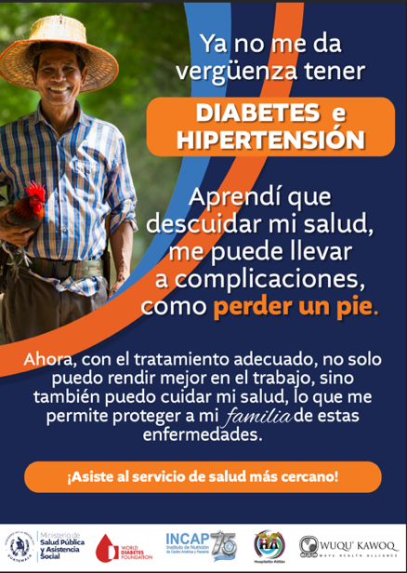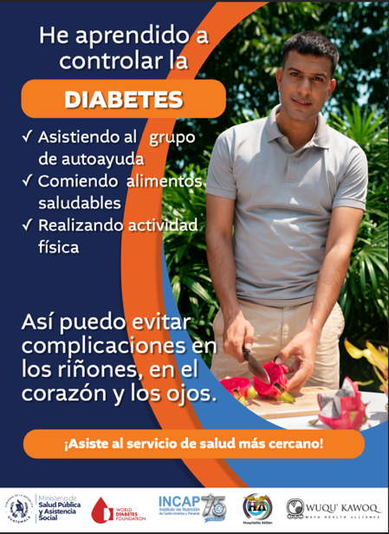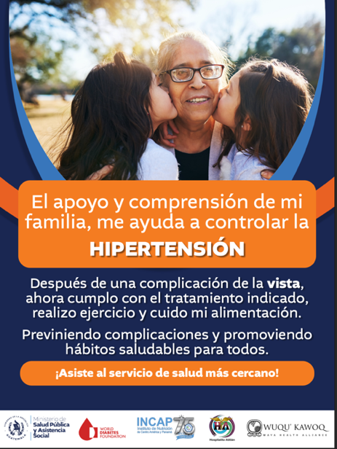

Appendix 4: Relationship between HEARTS, strategies, and ERIC taxonomy
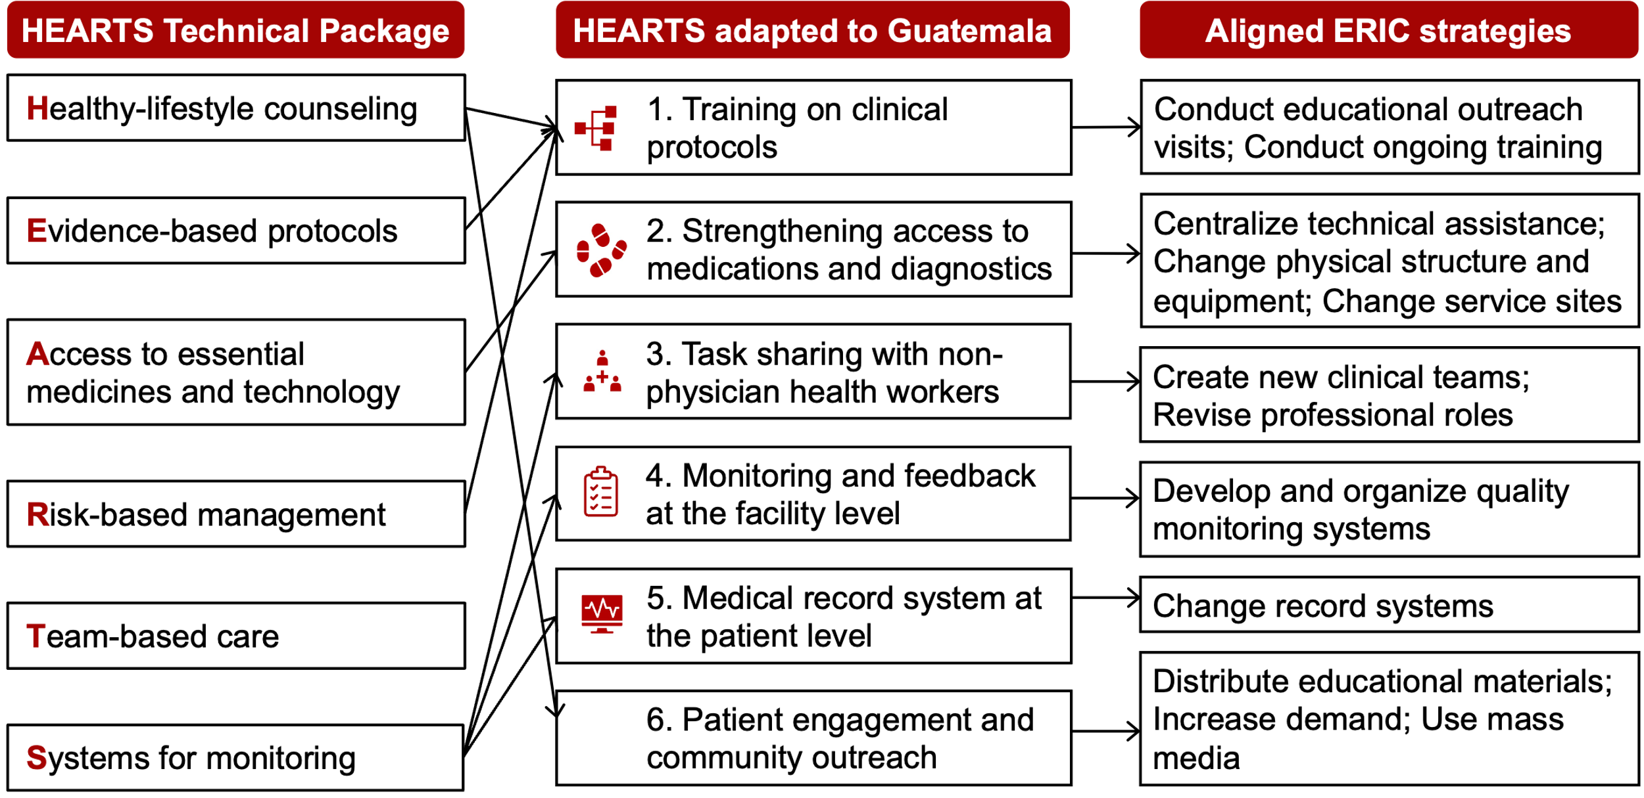

References
1. Baldridge AS, Aluka-Omitiran K, Orji IA, et al. Hypertension Treatment in Nigeria (HTN) Program: rationale and design for a type 2 hybrid, effectiveness, and implementation interrupted time series trial. Implement Sci Commun 2022; 3(1): 84.
2. Avortri GS, Nabukalu JB, Nabyonga-Orem J. Supportive supervision to improve service delivery in low-income countries: is there a conceptual problem or a strategy problem? BMJ Glob Health 2019; 4(Suppl 9): e001151.
3. WHO. Hearts: Technical package for cardiovascular disease management in primary health care. Geneva: World Health Organization, 2016.
4. Kilbourne AM, Geng E, Eshun-Wilson I, et al. How does facilitation in healthcare work? Using mechanism mapping to illuminate the black box of a meta-implementation strategy. Implement Sci Commun 2023; 4(1): 53.
5. Rosende A, DiPette DJ, Martinez R, et al. HEARTS in the Americas clinical pathway. Strengthening the decision support system to improve hypertension and cardiovascular disease risk management in primary care settings. Front Cardiovasc Med 2023; 10: 1102482.
6. MSPAS, UNOPS. Ficha Técnica del Proyecto: “Mejora del acceso a la salud, por medio de alternativas para el aprovisionamiento de medicamentos, tecnología médica y otros insumos y para la red pública de salud de Guatemala”. 2024. https://storage.googleapis.com/unops-proyectos-guatemala/images/Ficha-Te%CC%81cnica-del-Proyecto.pdf (accessed December 30, 2025).
7. de L. Horst MML, Soler O. [The PAHO Strategic Fund: a mechanism to facilitate access to medicines]. Rev Panam Salud Publica 2010; 27(1): 43-8.
8. Londoño E, Gupta R, Van der Stuyft P, et al. HEARTS quality: a policy framework to strengthen hypertension and cardiovascular risk management in primary healthcare—insights from HEARTS in the Americas. The Lancet Regional Health - Americas 2026; 53.

