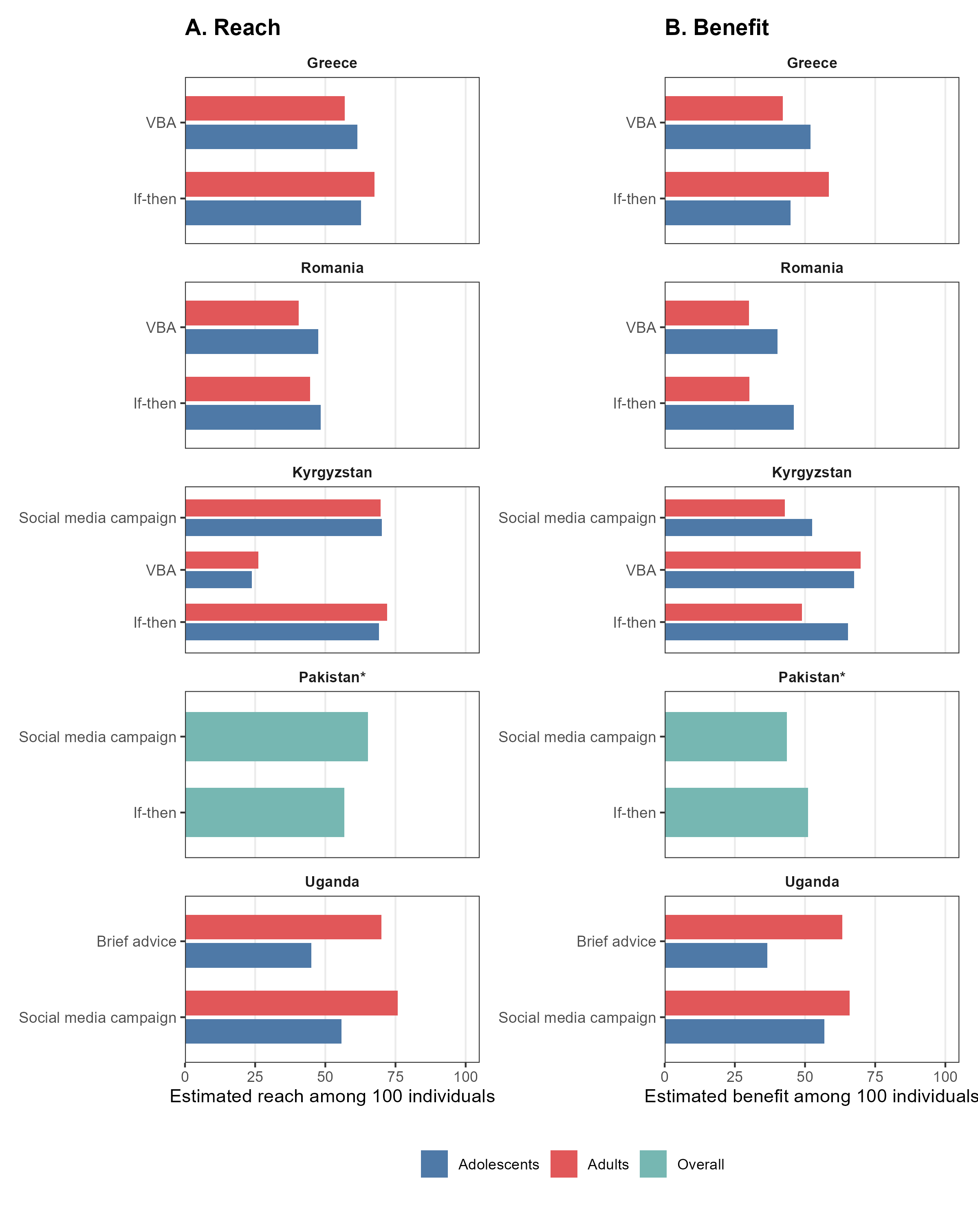
Supplementary Figure 1: Stakeholder workshop estimates of intervention reach and benefit by country, stakeholder group, and intervention
*Pakistan data are shown overall because fully anonymous data collection precluded stratification by stakeholder group (adolescents or adults).

