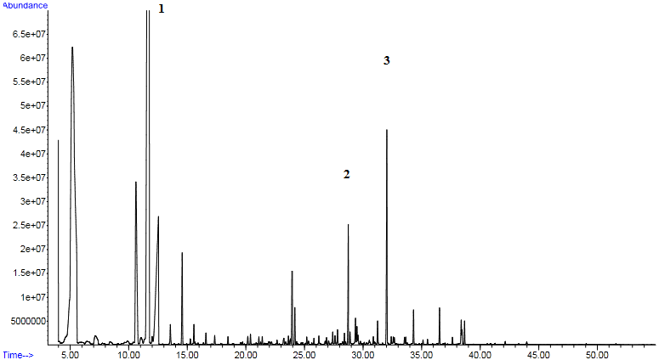
Figure (S1): A case of Methylmalonic aciduria (MMA) with elevated peaks of 1: methylmalonic acid, 2: Methyl citric acid, 3: internal standard

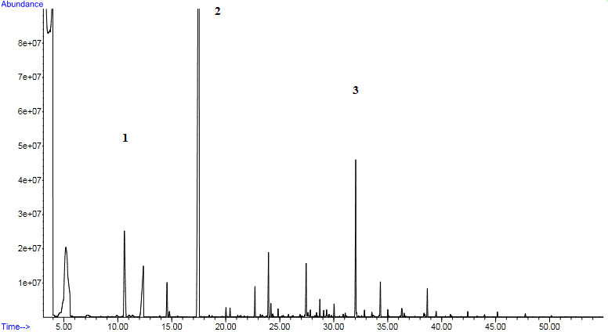
Figure (S2): A case of Glutaric Acidemia (GA) with elevated peaks of 1:3 hydroxyglutaric acid, 2: glutaric acid, 3:internal standard

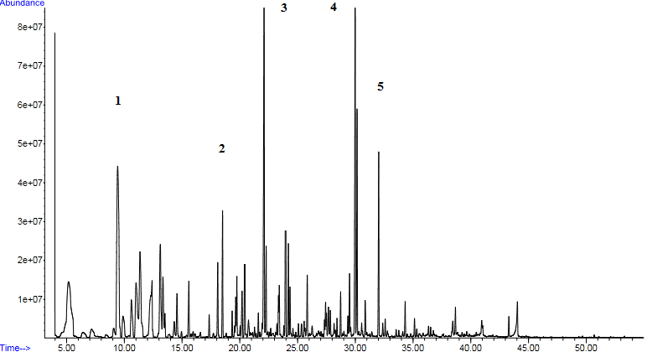
Figure (S3): A case of Propionic Acidemia (PA) with elevated peaks of 1: 3 hydroxypropionic acid, 2: propionylglycine, 3: tiglylglycine 4: methylcitric acid, 5: internal standard

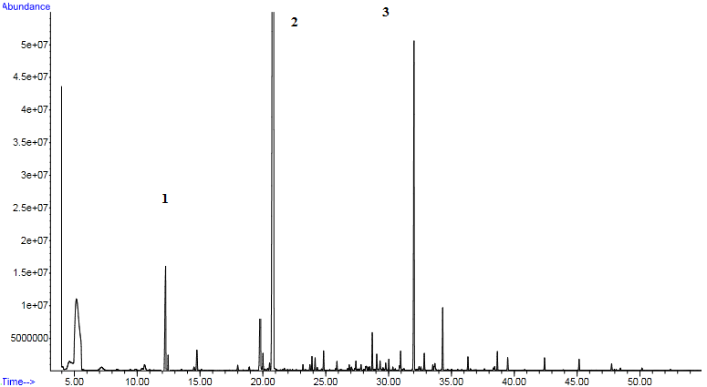
Figure (S4): A case of Isovaleric Acidemia (IVA) with elevated peaks of 1: 3 hydroxyisovaleric acid, 2: isovalerylglycine, 3: internal standard

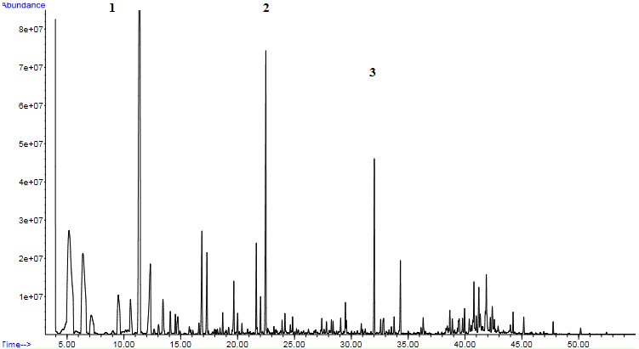
Figure (S5): A case of Methylcrotonyl Glycinuria (MCG) with elevated peaks of 1: 3 hydroxyisovaleric acid, 2: methylcrotonylglycine, 3: internal standard

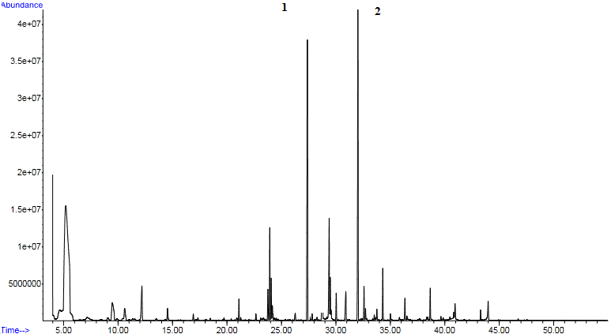
Figure (S6): A case of Orotic Acidemia (OA) with elevated peaks of 1: orotic acid, 2: internal standard

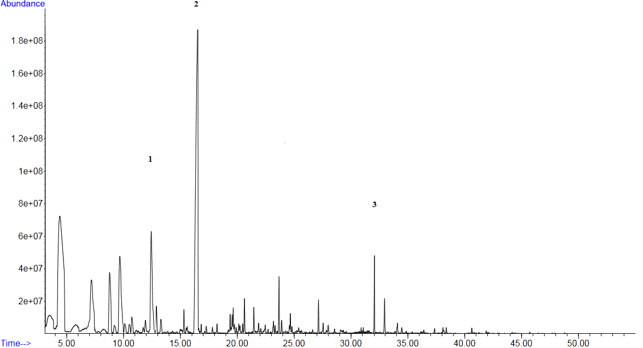

Figure (S7): A case of MSUD with elevated 1: 2-oxoisocaproic acid, 2: 2-hydroxy isovaleric acid, 3: internal standard

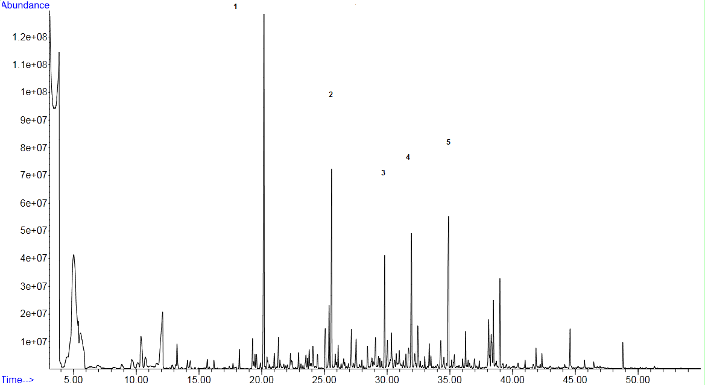
Figure (S8): A case of fatty acid oxidation defects with elevated1:adipic acid ,2 :suberic acid, 3 :sebacic acid, 4 :internal standard, 5 :3-hydroxy sebacic acid

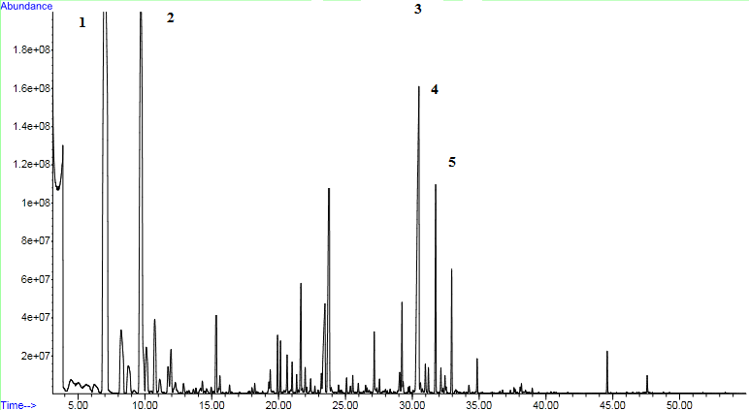

Figure (S9): A case of lactic Acidemia (LA) with elevated peaks of 1: lactic acid, 2:3 hydroxy butyric acid, 3:4 hydroxyphenyllactic acid, 4:4 hydroxyphenylpyruvic acid, 5:internal standard

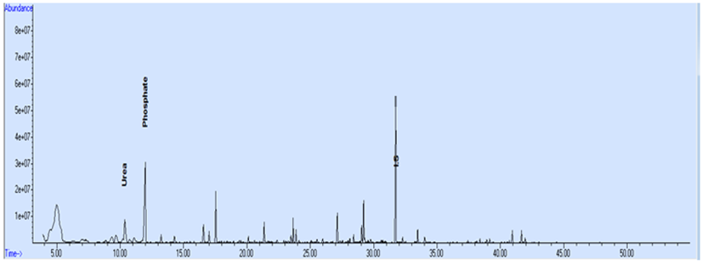
Figure (S10): Total ion chromatogram for a normal OA profile.

