Supplementary Materials for
40-user fully connected entanglement-based quantum key distribution network without trusted node
Xu Liu^{1,†}, Jingyuan Liu^{1,†}, Rong Xue¹, Heqing Wang², Hao Li², Xue Feng^{1,3}, Fang Liu^{1,3}, Kaiyu Cui^{1,3}, Zhen Wang², Lixing You², Yidong Huang^{1,3,4} and Wei Zhang^{1,3,4, *}
¹Beijing National Research Center for Information Science and Technology (BNRist), Beijing Innovation Center for Future Chips, Department of Electronic Engineering,
Tsinghua University, Beijing 100084, China
²State Key Laboratory of Functional Materials for Informatics, Shanghai Institute of Microsystem and Information Technology, Chinese Academy of Sciences, Shanghai 200050, China
³ Frontier Science Center for Quantum Information, Beijing 100084, China
⁴Beijing Academy of Quantum Information Sciences, Beijing 100193, China
* zwei@tsinghua.edu.cn
† These authors contributed equally: Xu Liu, Jingyuan Liu

Symmetric dispersive optics QKD
In the experimental system, the symmetric dispersive optics QKD¹ (DO-QKD) was used for secure key generation between the users in the network. It was modified from the conventional DO-QKD^{2,3}, which has been proven to be secure against collective attacks. The schematic of symmetric DO-QKD is shown in Supplementary Fig. 1.
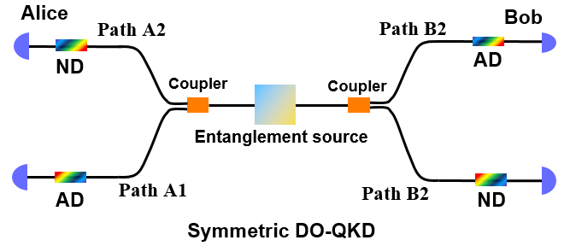
Supplementary Fig. 1: The schematic of symmetric DO-QKD.
In the symmetric DO-QKD, two dispersive components with normal and anomalous dispersions are introduced in the two paths at each user. Two measurement bases can be established by matching the paths with dispersive components with different dispersions in the symmetric DO-QKD. The measurement bases should be predefined before performing QKD that which one is the “time” basis and which one is the “frequency” basis. Hence, all the users have the same configurations and any two users can establish the symmetric DO-QKD for generating cryptographic keys between them.
Details of experimental setup
The entanglement resources are provided by a broadband entangled photon pair source based on a silicon waveguide with a length of 3 mm. The fiber coupling loss at the output end of the silicon waveguide is about 7 dB. Thanks to the high nonlinearity and the low dispersion property of the silicon waveguide, broadband photon pairs with energy-time entanglement are generated through spontaneous four wave mixing (SFWM) under CW pumping. The central wavelength of the pump light is 1545.32 nm, corresponding to the International Telecommunication Union (ITU) channel of C40. The signal and idler photons of entangled photon pairs are generated symmetrically around the central frequency of pump light. They are divided into 30 wavelength channels by an arrayed waveguide grating (AWG). The photons in two wavelength channels locating symmetrically at the two sides of the pump light wavelength are entangled, which is used as an entanglement resource. Hence, 15 entanglement resources are extracted from the quantum light source, which correspond to 15 correlated wavelength channel pairs of C35/C45, C34/C46, …, C21/C59, as shown in Fig. 2(b). It is shown in Fig. 1(c) that each subnet requires 6 wavelength channels. Two of them form a correlated wavelength channel pair. Its entanglement resource is used to support the fully connections of users in the subnet as Fig. 1(a). The other four channels belong to 4 different entanglement resources, which are used to support connections between this subnet and other four subnets as Fig. 1(b). Photons in these wavelength channels are combined by cascaded dense wavelength division multiplexers (DWDMs) as shown in Fig. 2. Then they are distributed to the users in this subnet by a beam splitter with 8 output ports. The optical loss of the entanglement distribution setup for each subnet includes the loss of the optical filter system (the AWG and DWDMs, ~6.5 dB) and the insertion loss of the multi-port beam splitter (10.4 dB).
At each user, photons are guided into two paths randomly by a 50:50 fiber coupler. In one path, photons pass through a dispersion compensation module (DCM) with normal dispersion, then they are detected by a NbN superconducting nanowire single-photon detector (SNSPD). The other path is similar with the former one, except that a DCM with abnormal dispersion is used. By this setup, symmetric entanglement-based DO-QKD can be realized between any two users in the network. The group velocity dispersions and insertion losses of the two DCMs (Proximion AB, Sweden) are ±1980 ps/nm and ~3 dB, respectively. The SNSPDs used in the experiment are provided by SIMIT, CAS, China, with detection efficiencies of ~70% and dark count rates of ~100 Hz. The fiber polarization controllers before the SNSPDs are used to maximize the detection efficiencies.
In the experiments, two pieces of transmission fibers of 1 km and 2 km are deployed to two specific users in the subnet A, respectively. They fibers are single mode fibers (SMF) at telecom band. By this way, different link conditions are realized in the measurement of QKD performance.
Key generation
In the proposed network architecture, the entangled photons with different wavelength combination sets are distributed to the users in the network by multi-port beam splitter forming a fully connected quantum communication network without trusted node. Based on the coincidence counts of the energy-time entangled photon pairs, the secure key can be generated based on symmetric DO-QKD. With no doubts, the coincidence count rates between the users would be reduced by the usage of passive beam splitter. On the other hand, the photons arrived at the users sparsely at the time domain. Hence, a high dimensional time encoding based on symmetric DO-QKD was used to enhance the utilization of coincidence, which is beneficial for increasing the key rates in large user scale quantum communication network. Supplementary Fig. 2 shows the format of the high dimensional time encoding between two users (marked with Alice and Bob here) in the network. We used a three-level format to take the time encoding and bin sifting, by which one coincidence event could generate multiple bits of raw keys. In this format, a time frame consists of M (M=2^D) consecutive time slots and a slot includes I time bins with a width of .
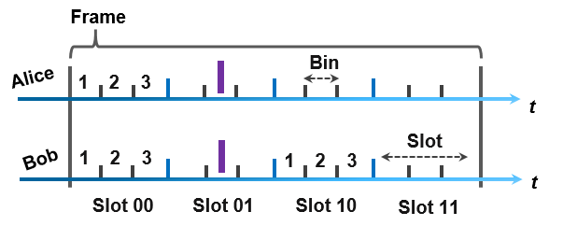
Supplementary Fig. 2: The three-level format of high dimensional time encoding in this work. A time frame consists of M (M=2^D) consecutive time slots and a slot includes I time bins with a width of τ. In this figure, I=3, D=2 and M=4.
Based on the bin sifting process by the three-level format, raw keys can be generated. Considering the raw key generation and data post-processing of the symmetric DO-QKD, the parameters of the time encoding format should be optimized for a high raw key generation rate with low QBER. In this work, the parameters were optimized by maximizing the raw key generation rate with the QBER bounding at a level of less than 8%. The detailed optimization process is similar to that of references. Please see details in the references^{1,4}. For typical two users in subnet A and B, through the optimization process, the time encoding format parameters were determined as D=3, I=3 and τ =128ps, under which the raw key generation rate between the two users are 35.2 bits per second (bps) under a QBER of 7.6%. By high time encoding process, each coincidence event can support 3 bits of raw key generation. In the experiments, these optimized parameters of time encoding format were applied on all the symmetric DO-QKDs in the network. High dimensional encoding in the photon arrival times is particularly advantageous under the photon-starved circumstances when the rate of detection events is much lower than the photon generation rate due to the large loss of experiment system sharing the quantum entangled states among large scale end users.
Security test
In symmetric DO-QKD, the security test was guaranteed by the nonlocal dispersion cancellation effect⁵. For the typical intercept-resend attack, the eavesdropper (Eve) cannot make the fake photons the same as the original photons both in the time and frequency domains, which can be used to test the eavesdropping. Supplementary Fig. 3 shows the coincidence counts in four possible basis combinations between two specific users in subnet A and subnet B. The single count rates of SNSPDs under the four corresponding bases (K1, K2, S1, S2) were 38 kHz, 37.8 kHz, 35.9 kHz and 36 kHz, respectively. The K1, K2, S1 and S2 indicate the measurement bases predefined between the two users. From Supplementary Fig. 3, we can see that the coincidence peak is narrow due to the nonlocal dispersion cancellation if it is measured under K bases at both sides. It is also narrow if measured under S bases at both sides. However,
Supplementary Fig. 3: Coincidence counts under four possible measurement bases of symmetric DO-QKD between two specific users in subnet A and subnet B.
the coincidence peaks are broadened if they are measured under different bases, which are shown in Supplementary Fig. 3(b) and Fig.3(c). Based on these single-photon events detected under the K bases and S bases, the joint measurements of time-frequency covariance matrix (TFCM)⁶⁻⁸ can be carried out. It is used to evaluate the Shannon information between the two users and the maximum accessible information of Eve, which are responsible for the system security. The secure information that could extract per coincidence is expressed as^{6,9}:
, (S1)
where is the reconciliation efficiency, is the Shannon information between two users of the network, is the Holevo information denoting Eve’s maximum accessible information. According to the experimental data acquired by Supplementary Fig. 3 and the method of security test, an upper bound on the Holevo information of was obtained, which is 0.3896 bpc (bit per coincidence) indicating the impact of the excess channel noise. The Shannon information between Alice and Bob I (A; B) can be estimated in a similar way, which is 2.7789 bpc in this experimental system. As a result, the secure key capacity is 2.11 bpc according to Equation S1, leading to a secure key rate of 22 bps. The security test and secure key rate estimation of the symmetric DO-QKD between the users in the subnets and between the five subnets were executed in the same way like this. The results are shown in Fig. 4 in the main manuscript.
Simulation methods
To investigate the performance of two-user DO-QKD systems, we have established a theoretical model¹⁰, considering the characteristics of the quantum light source, optical fiber transmission, and process of single-photon detection. In the key generation process, we firstly analyze the types of single-photon events recorded by Alice. For each event of Alice, she may record a signal photon which is one of an entangled photon pair, or a noise event (including noise photons and events of dark counts). We analyze the performance of bin-sifting process under these two cases, then obtain the performance of DO-QKD. In each case, we set the arrival time of Alice’s events as $t_{0}$, then the probability distribution of the single-photon events recorded by Bob near $t_{0}$ could be derived. Since the single-photon events of Alice randomly fall into the time bin, we consider the events at Alice under a specific$t_{0}$ $t_{0}$ in the bin to calculate the raw key rate and QBER. Then we calculate the average raw key rate and QBER as the final results by considering all the events at Alice in the bin, i.e., the contributions of events at Alice under different $t_{0}$ in the bin are calculated and averaged. After that the security test process are performed, thus the QBER and secure key rate are obtained to evaluate the performance of DO-QKD system.
In the analysis of DO-QKD network, the above theoretical model is used to analyze the connections between two users in the network, while the influence of beam splitting in the network is regarded as additional loss for each user. The time encoding format parameters for all calculation situations are fixed as D=3, I=3 and τ =128 ps that are the same with the experiment.
Since the noise of the quantum light source and the detectors are not the critical factors that cause the performance difference between different network architectures, we ignore the noise of the quantum light source and detectors in the calculations for the comparison of the three cases. For simplicity, the losses of optical components and optical fibers for entanglement distribution are also neglected. Only the beam splitting loss of the QKD link are considered, with an additional loss of 10 dB for other factors of photon collection, such as the efficiencies of SNSPDs and losses introduce by optical components and fiber transmission. At present, the counting rate of reported SNSPDs is about 10 to 40 MHz¹¹, limited by their recovery time. In the calculation, we limit the counting rate of a SNSPD to below 10 MHz. We change the user number by altering the beam splitting ratio, and change the input photon pair rate by altering the amount $δ$ of an entanglement resource. Major parameters used in the calculation are listed in Supplementary Table 1.

Supplementary Table 1: Major parameters used in the calculation of the performance of DO-QKD network
Parameter | Value | Parameter | Value
D | 3$4.08×{10}^{6}$ | I | 3
τ | 128 ps | $FWHM$ of coincidence peak | 192 ps
m | 5 | counting rate | 10 MHz

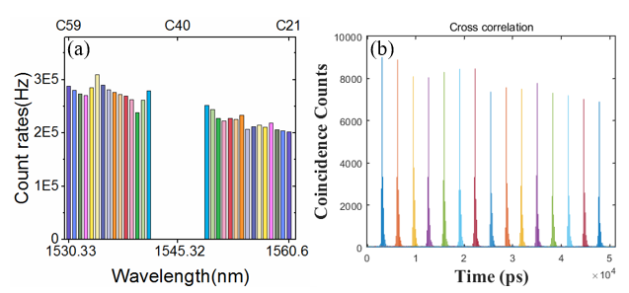
Supplementary Fig. 4: Performances of the wavelength division in the experimental system and the corresponding coincidence results between the signal and idler photons of entangled photon pairs with frequency conjugate channels. (a) Single count rates of fifteen pairs of correlated wavelength channels. (b) Coincidence counts of fifteen correlated wavelength channel combinations. The ITU channels of C45~C59 are selected as the signal channels and the C21~C35 are selected as the idler channels. The photon count rates are close to each other due to the broadband characteristics of the photon pair generation by SFWM in the silicon waveguide.

Supplementary Table 2: The wavelength allocation of users in different subnets.
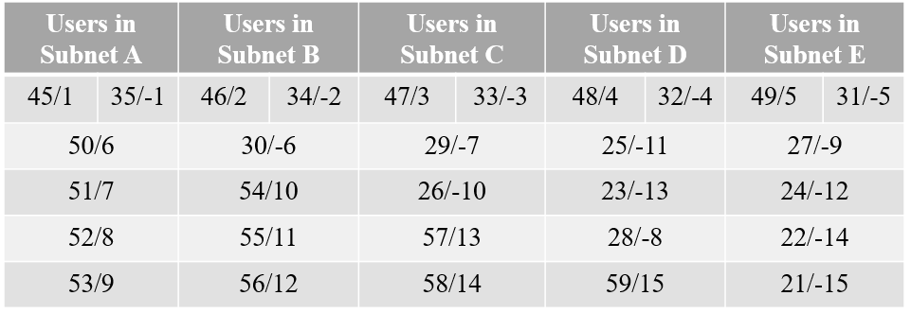
*The wavelengths are denoted by two number which correspond to their ITU 100 GHz grid DWDM channel number and serial number for marking the channels. Every user in the subnets receives six wavelength channels. A pair of matching numbers with equal absolute values and opposite sign represent a pair of correlated wavelength channels with entangled photon pairs. A user pair is connected by a certain entangled photon pairs, such as the user in the subnet A and the user in the subnet E through the entangled photon pairs with the correlated wavelength channels of C53 and C27.

Supplementary References:
1 Liu, X. et al. An entanglement-based quantum network based on symmetric dispersive optics quantum key distribution. APL Photonics 5, 076104 (2020).
2 Lee, C. et al. Entanglement-based quantum communication secured by nonlocal dispersion cancellation. Phys. Rev. A 90, 062331 (2014).
3 Mower, J. et al. High-dimensional quantum key distribution using dispersive optics. Phys. Rev. A 87, 062322 (2013).
4 Liu, X. et al. Energy-time entanglement-based dispersive optics quantum key distribution over optical fibers of 20 km. Appl. Phys. Lett. 114, 141104 (2019).
5 Franson, J. D. Nonlocal cancellation of dispersion. Physical Review A 45, 3126-3132 (1992).
6 Garcia-Patron, R. & Cerf, N. J. Unconditional optimality of Gaussian attacks against continuous-variable quantum key distribution. Phys. Rev. Lett 97, 190503 (2006).
7 Weedbrook, C. et al. Gaussian quantum information. Rev. Mod. Phys. 84, 621-669 (2012).
8 Alessio, S., Fabrizio, I. & Silvio De, S. Symplectic invariants, entropic measures and correlations of Gaussian states. Journal of Physics B: Atomic, Molecular and Optical Physics 37, L21 (2004).
9 Devetak, I. & Winter, A. Distillation of secret key and entanglement from quantum states. Proc. R. Soc. A-Math. Phys. Eng. Sci. 461, 207-235 (2005).
10 Liu, J.-Y., Liu, X., Zhang, W. & Huang, Y.-D. Impact of fiber dispersion on the performance of entanglement-based dispersive optics quantum key distribution. Journal of Electronic Science and Technology, doi:10.1016/j.jnlest.2021.100119 (2021).
11 You, L. Superconducting nanowire single-photon detectors for quantum information. Nanophotonics 9, 2673-2692, doi:10.1515/nanoph-2020-0186 (2020).
12 Wengerowsky, S., Joshi, S. K., Steinlechner, F., Hübel, H. & Ursin, R. An entanglement-based wavelength-multiplexed quantum communication network. Nature 564, 225-228 (2018).
13 Chen, C. et al. Compensation-free broadband entangled photon pair sources. Optics express 25, 22667-22678, doi:10.1364/OE.25.022667 (2017).
14 Zhu, E. Y. et al. Toward a reconfigurable quantum network enabled by a broadband entangled source. Journal of the Optical Society of America B 36, B1-B6, doi:10.1364/JOSAB.36.0000B1 (2019).

