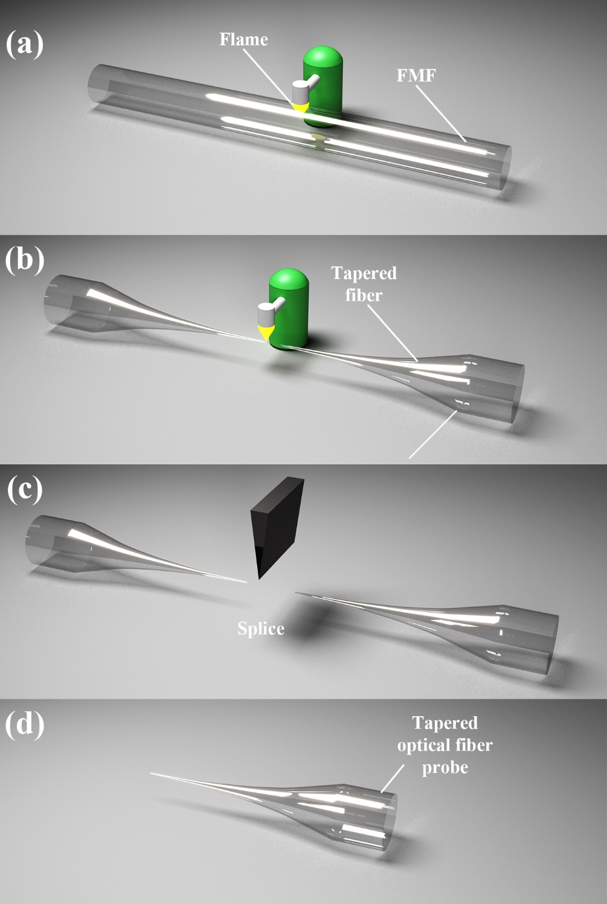
Fig. S2 The preparation process of tapered optical fiber probe.

