Supplementary Materials for

CsPbBr₃/graphene nanowall artificial optoelectronic synapses for controllable perceptual learning

Runze Li^{1,2#}, Yibo Dong^{1,2#}, Fengsong Qian³, Yiyang Xie³, Xi Chen^{1,2*}, Qiming Zhang^{1,2}, Zengji Yue^{1,2*} and Min Gu^{1,2*}
Email: xichen@usst.edu.cn, zengjiyue@usst.edu.cn, gumin@usst.edu.cn

This material includes:
Fig. S1 The fabrication flowchart and optical images of a photoelectric synapse array based on GNWs and CsPbBr₃ QDs.
Fig. S2 SEM images of the top-view GNWs.
Fig. S3 An absorption spectrum of the CsPbBr₃ QDs.
Fig. S4 Basic photoresponsive characteristics of the GNWs/CsPbBr₃ QDs optoelectronic synapse.
Fig. S5 The photocurrent values of the synapses under different laser pulse powers and illuminating times.
Fig. S6 Effects of different wavelengths and irradiation times on the photocurrent response.
Fig. S7 Comparison of photocurrent intensity before and after 400 s illumination.
Fig. S8 Transfer characteristic curve of the device.
Fig. S9 The measurement results of the PPF property of the device with different laser pulse intervals.
Fig. S10 The PPF effect of the synapse stimulated by laser pulses with different wavelengths.
Fig. S11 The photocurrent of the device stimulated by 450 (a) and 630 (b) nm laser pulse trains under different pulse numbers.
Fig. S12 Handwritten digital image processing for recognition simulation.
Fig. S13 Total current measured under the laser density of 1.90 W/cm².

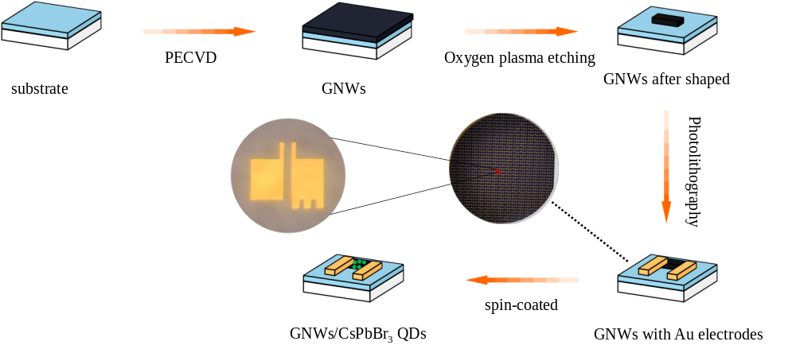

Fig. S1 The fabrication flowchart and optical images of a photoelectric synapse array based on GNWs and CsPbBr₃ QDs.

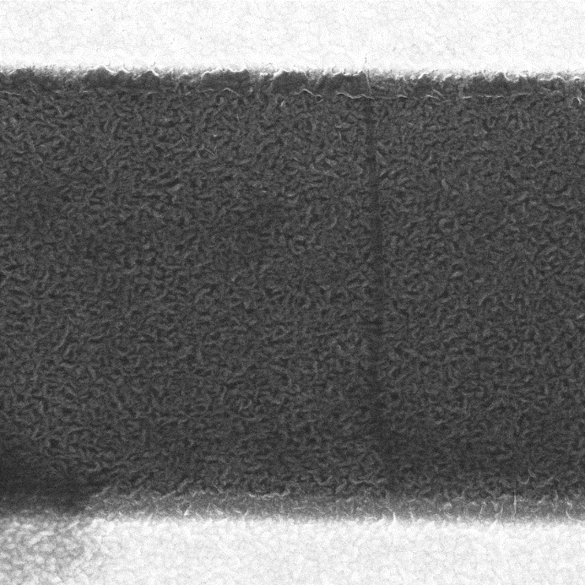
5 µm

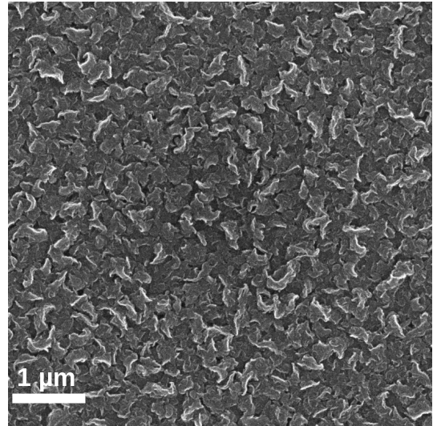

Fig. S2 SEM images of the top-view GNWs.

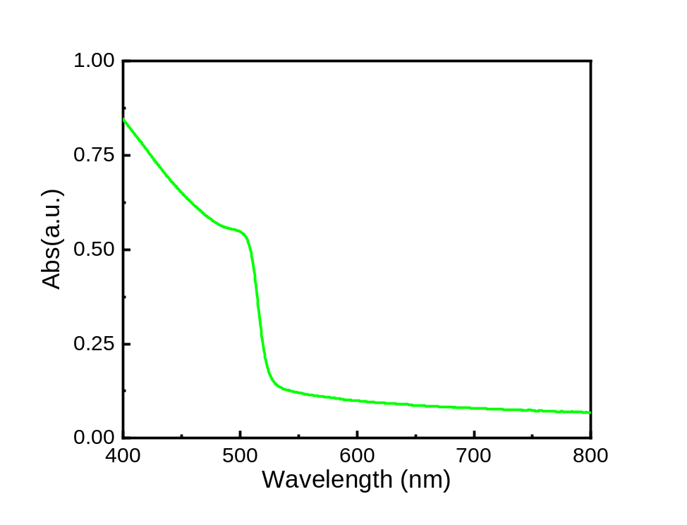

Fig. S3 An absorption spectrum of the CsPbBr₃ QDs.

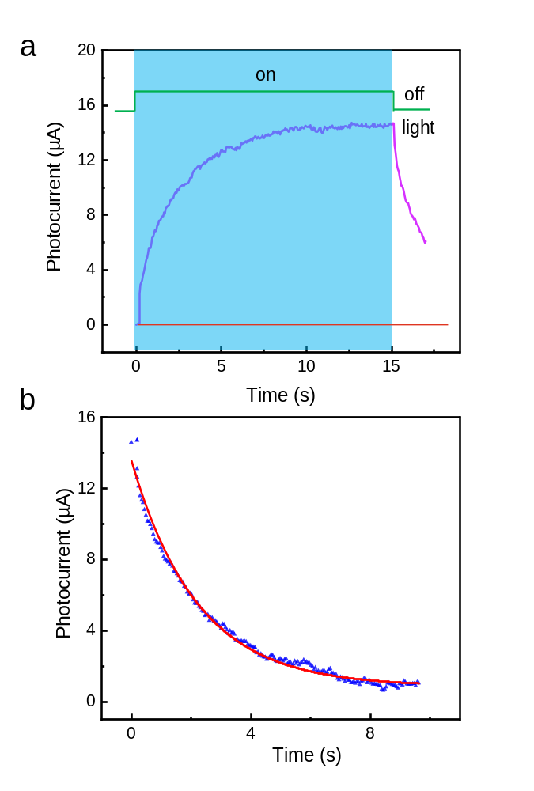
Fig. S4 Basic photo responsive characteristics of the GNWs/CsPbBr₃ QDs optoelectronic synapse. a The typical current evolution process under the irradiation of a 530 nm laser pulse with a power of 1.41 W/cm². b The fitting of the photocurrent decay. An exponential function is obtained：$y= A_{1}*\exp{ (-x/{t_{1}}})+ y_{0 }$, where A₁ = 12.669, y₀ = 0.8659, t₁ = 2.215.

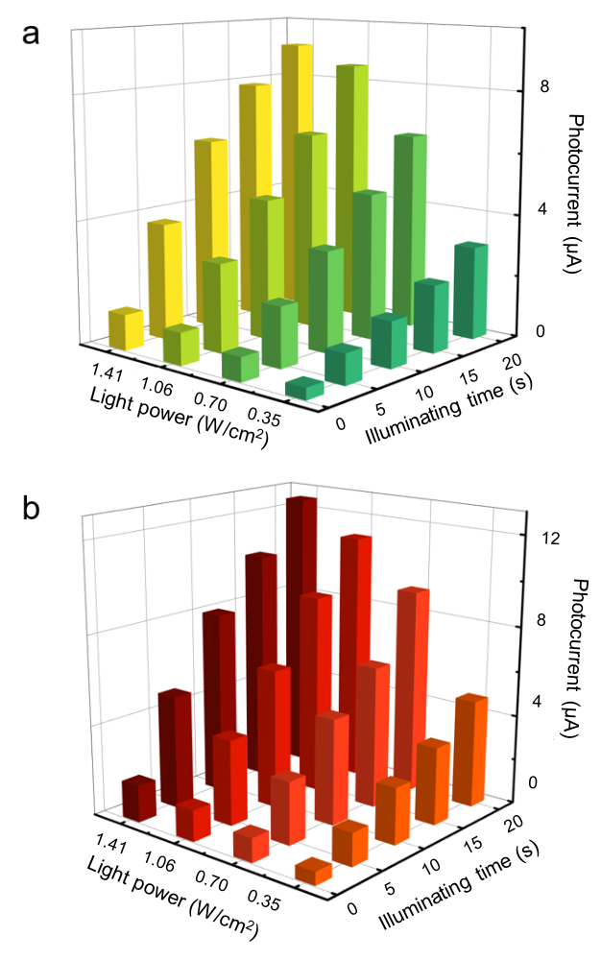

Fig. S5 The photocurrent values of the synapse under different laser pulse powers and illuminating times. a Photocurrent values stimulated by a 630 nm laser pulse. b Photocurrent values stimulated by a 450 nm laser pulse.

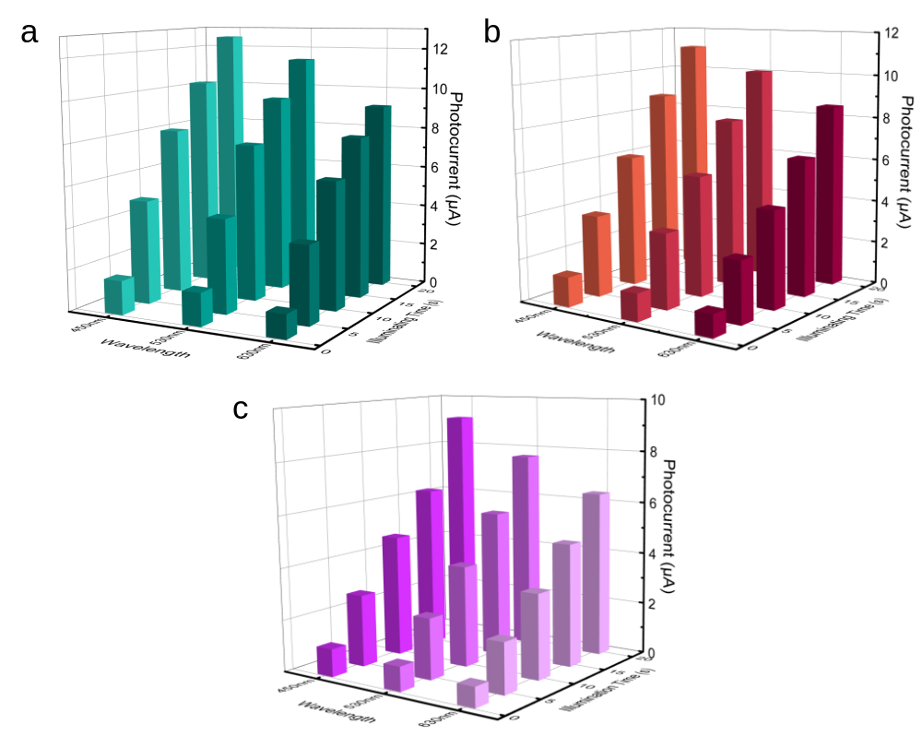
Fig. S6 Effects of different wavelengths and irradiation times on the photocurrent response. a Photocurrent generated at different illumination times and wavelengths with a pulse power of 1.41 W/cm². b Photocurrent generated at different illumination times and wavelengths with a pulse power of 1.06 W/cm². c Photocurrent generated at different illumination times and wavelengths with a pulse power of 0.70 W/cm².

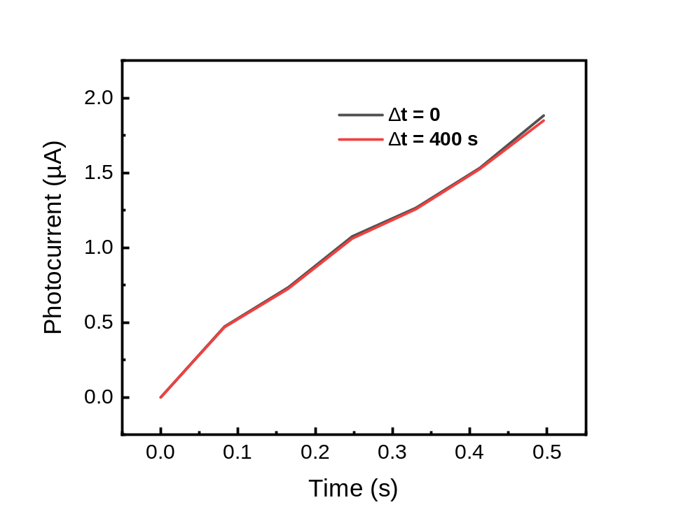

Fig. S7 Comparison of photocurrent intensity before and after 400 s illumination. The repetitive experiments were carried out at a laser intensity of 1.90 W/cm².

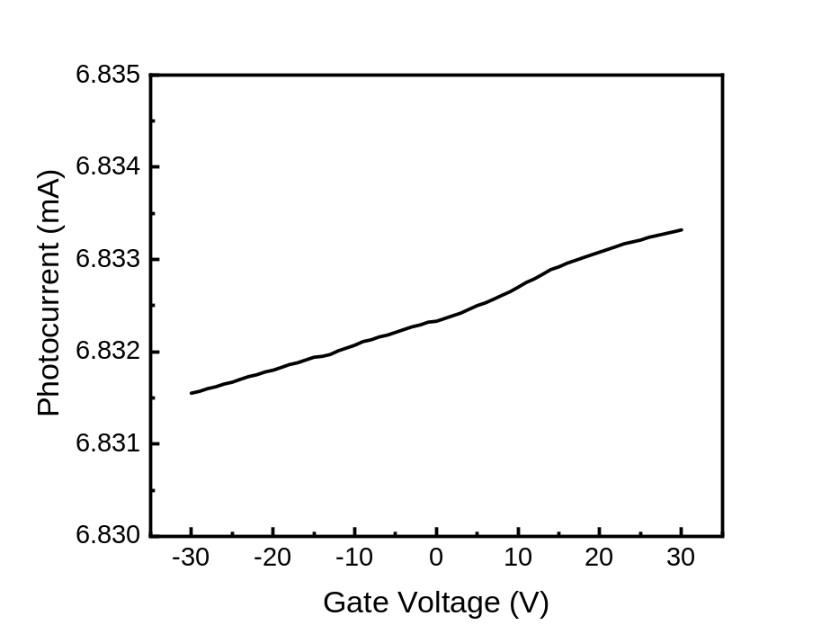
Fig. S8 Transfer characteristic curve of the device.

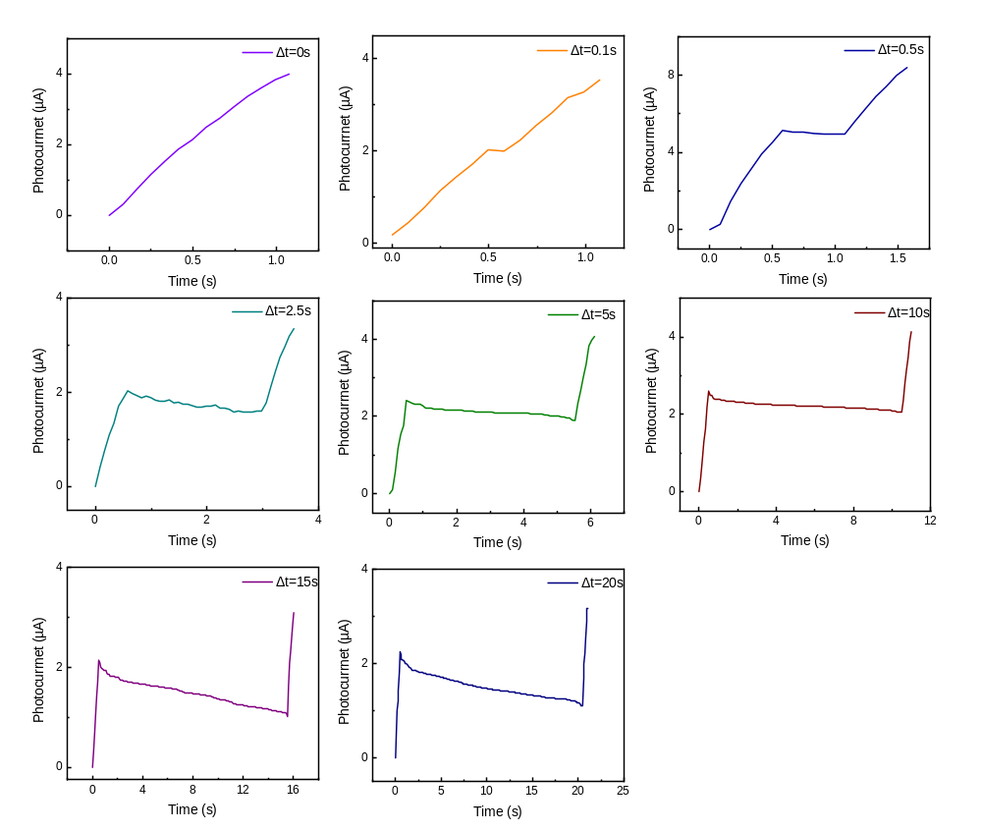

Fig. S9 The photocurrent curves of the PPF measurement under 450 nm 1.90 W/cm² laser pulses.

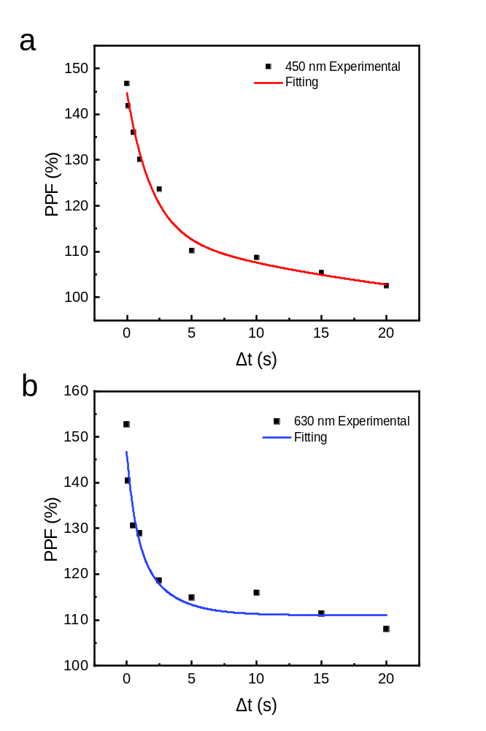

Fig. S10 The PPF effect of the synapse stimulated by laser pulses with different wavelengths. a 450 nm. b 630 nm.
t₁ of 1.90324 s and t₂ of 28.74047 s can be obtained by fitting in 450nm. t₁ of 0.68102 s and t₂ of 9.42973 s can be obtained by fitting in 450nm.
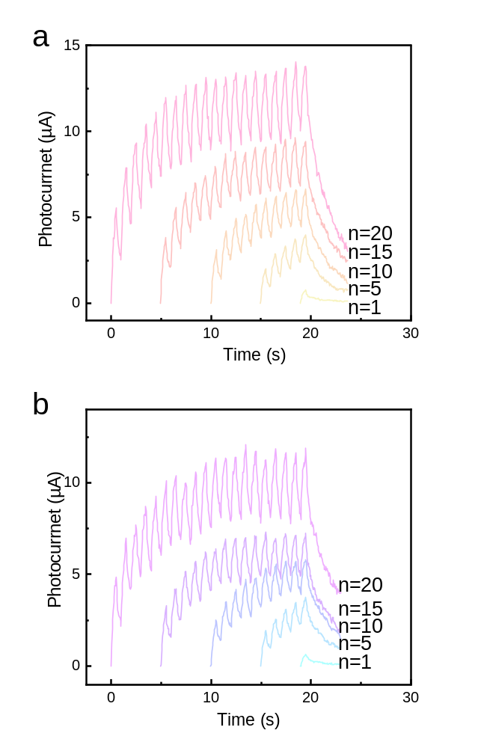

Fig. S11 The photocurrent of the device stimulated by 450 (a) and 630 (b) nm laser pulse trains under different pulse numbers. The pulse power is 1.41 W/cm². Due to the use of Pulse laser (Pulse width: 0.5 s, Pulse interval: 0.5 s), in the Pulse light interval of 0.5s, the photocurrent natural attenuation, the apparent step-like increase. Moreover, the natural attenuation at 450 nm and 630 nm is more intense than that at 530 nm, which corresponds to the PPF effect of different wavelength laser pulses stimulating synapses in Fig. S6. Thus showing sharp peaks. This phenomenon is related to the absorption peak of CsPbBr₃ near 530 nm.

a
b

Fig. S12 Handwritten digital image processing for recognition simulation. a A gray value image of “8” stimulated with 530 nm 0.4 W 20 pulses. b The gray value image of “8” after adding random noise.

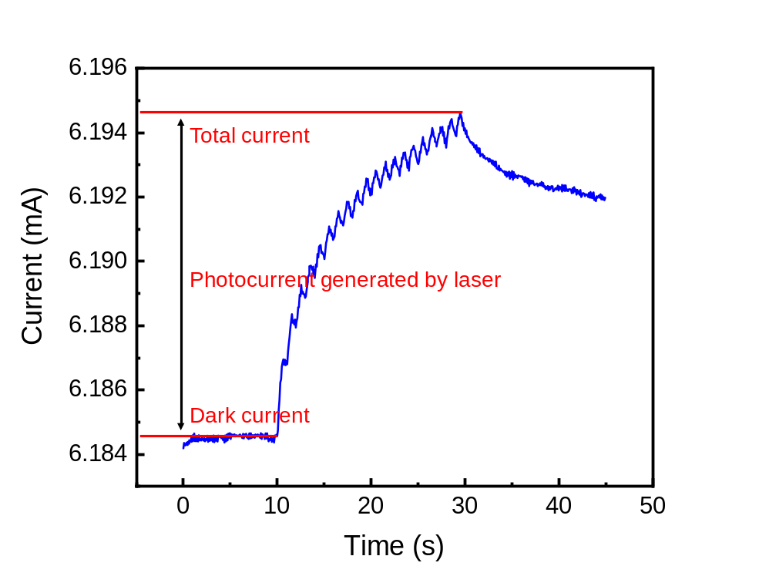
Fig. S13 Total current measured under the laser density of 1.90 W/cm². The photocurrent in the main text was obtained by subtracting the dark current from the total current.

