Supporting Information
Realization of high aspect ratio metalenses by facile nanoimprint lithography using water-soluble stamp
Hojung Choi,^{1, †} Joohoon Kim,^{2,†} Wonjoong Kim,¹ Junhwa Seong,² Chanwoong Park,¹ Minseok Choi,² Nakhyun Kim,¹ Jisung Ha,¹ Cheng-Wei Qiu,³ Junsuk Rho,^{2,4,5,6*} and Heon Lee^{1*}
¹Department of Materials Science and Engineering, Korea University, Seoul 02841, Republic of Korea
²Department of Mechanical Engineering, Pohang University of Science and Technology (POSTECH), Pohang 37673, Republic of Korea
³Department of Electrical and Computer Engineering, National University of Singapore, Singapore 117583, Singapore
⁴Department of Chemical Engineering, Pohang University of Science and Technology (POSTECH), Pohang 37673, Republic of Korea
⁵POSCO-POSTECH-RIST Convergence Research Center for Flat Optics and Metaphotonics, Pohang 37673, Republic of Korea
⁶National Institute of Nanomaterials Technology (NINT), Pohang 37673, Republic of Korea
*Corresponding author:
E-mail: jsrho@postech.ac.kr ; heonlee@korea.ac.kr
†These authors contributed equally to this work.

Supplementary Note 1: Replicated HAR nanostructures via PDMS and PVA mold
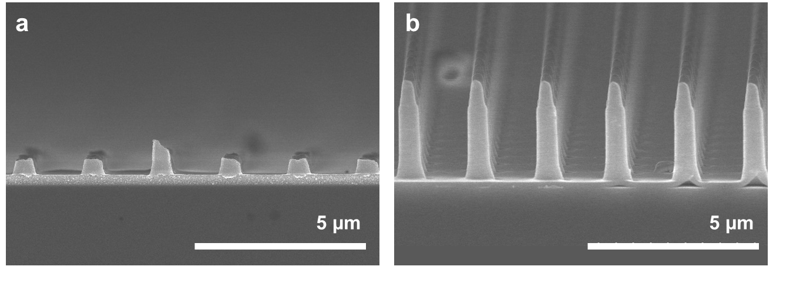
Figure S1. SEM image of replicated HAR nanostructures via (a) PDMS mold and (b) PVA mold. HAR nanostructures replicated through PDMS mold are broken during the detachment process. However, using PVA mold, replicated HAR nanostructures are unbroken with high pattern fidelity because the removal of PVA mold does not apply any shear stress to nanostructures.

Supplementary Note 2: Calculated conversion efficiency by varying residual layer thickness.
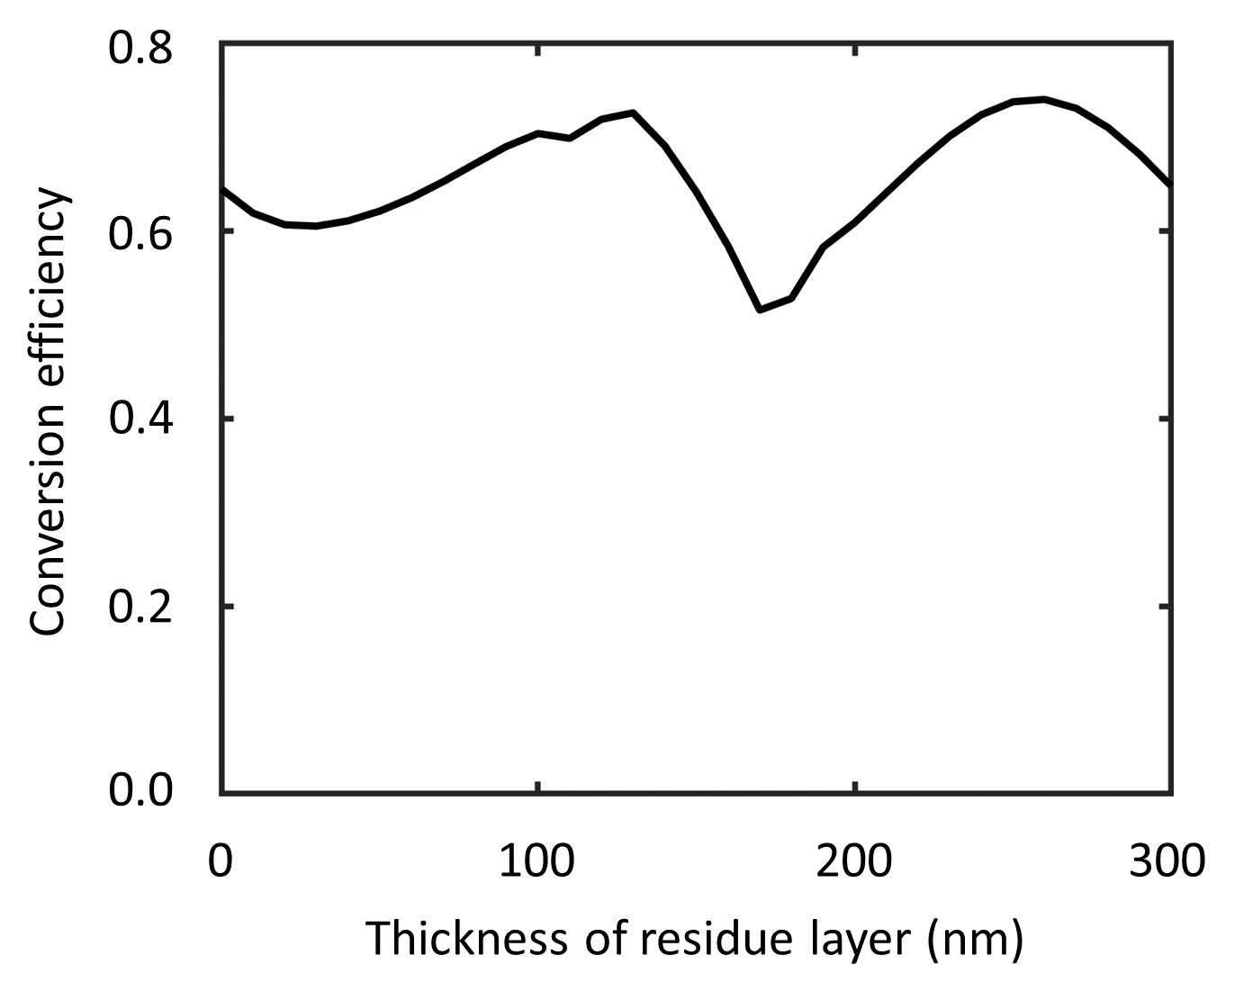
Figure S2. The simulated conversion efficiency for designed meta-atom with different thicknesses of the residual layer.
Supplementary Note 3: Tensile modulus of PVA mold
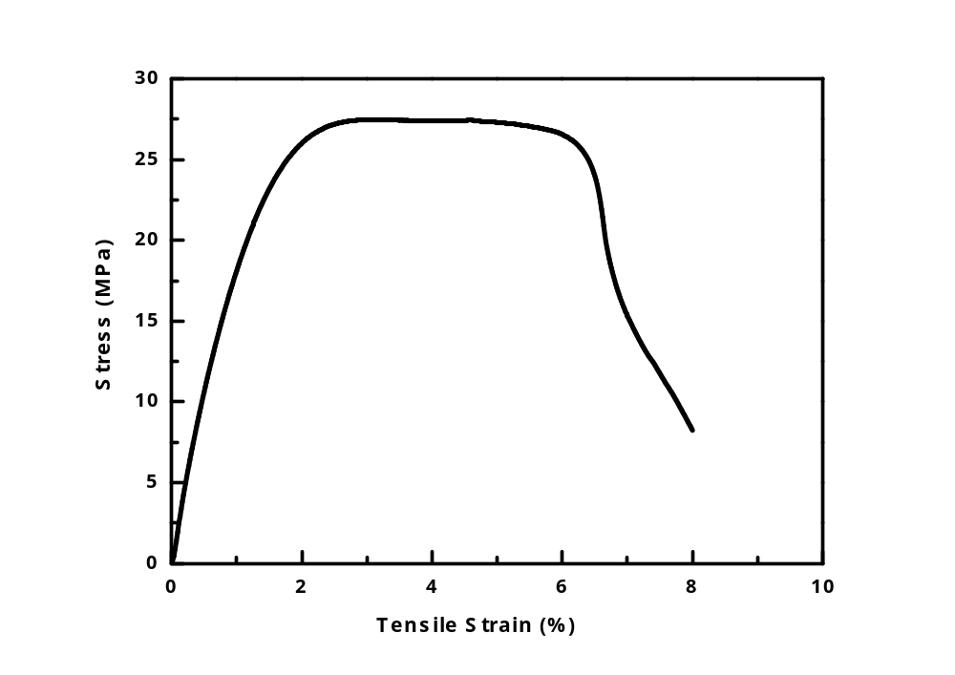
Figure S3. Tensile modulus of PVA mold is measured using Universal Testing Machine (Instron 3367) under 500N load cell, 50 mm/min. Thin film of PVA is 0.046 mm in thickness and 10.26 mm in wide and the measured tensile modulus is 2.936 MPa. Tensile modulus of PVA 1.6 times higher than commonly used PDMS mold¹, making the PVA mold less vulnerable to mechanical collapse. Pairing and sagging that occurs in PDMS mold is prevented in PVA mold, and it can mimic patterns of master stamp in high resolution, which is an appropriate soft mold in NIL process.

Supplementary Note 4: Characteristics of PVA replica mold.
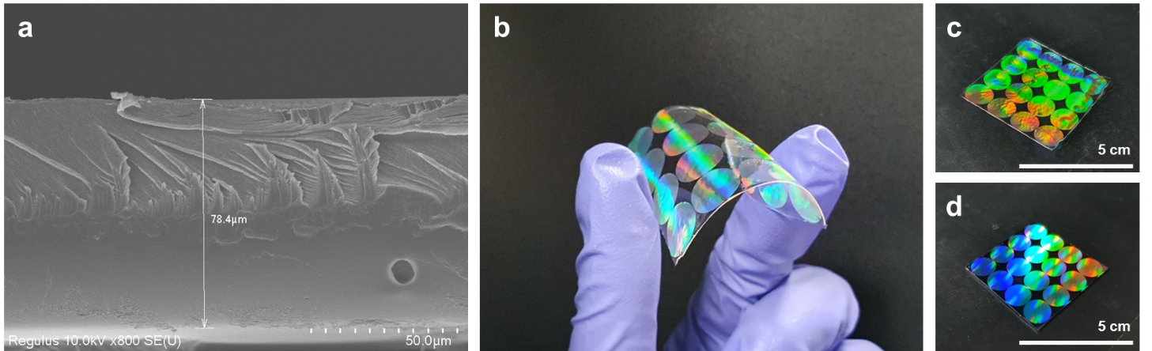
Figure S4. (a) Scanning electron microscopy (SEM) image of PVA replica mold with a thickness of 78 μm. (b) Handling of PVA mold without backbone polymer; the flexibility of the mold is suitable for direct printing. (c-d) Identically replicated 10 mm metalenses. (c) PVA mold and (d) master stamp.

Supplementary Note 5: Size distribution of TiO₂ PER
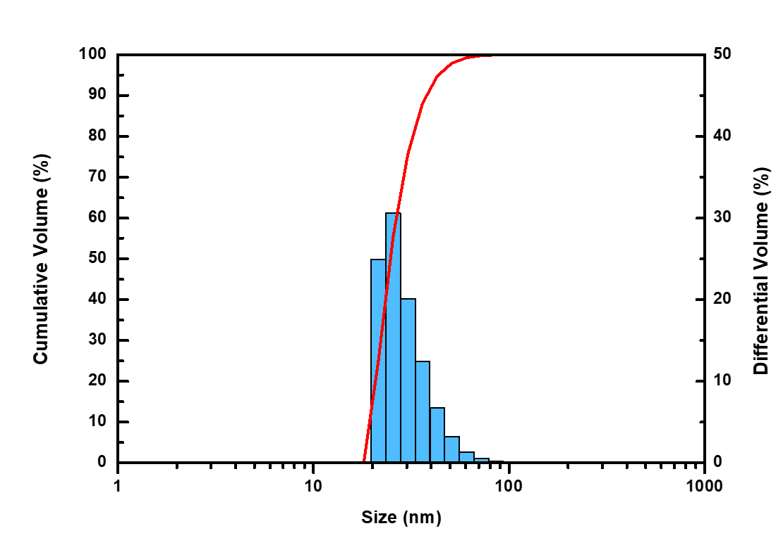
Figure S5. Size of TiO₂ NPs dispersed in MIBK is analyzed using a particle size analyzer. The peak of size distribution (blue bar) indicates that TiO₂ NPs are 30 nm in size, and the steep cumulative of its size (red line) indicates that sizes of NPs are narrowly distributed.
Supplementary Note 6: Nanoindentation test on TiO₂ PER thin film
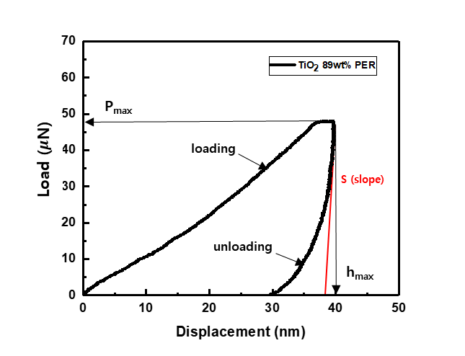
Figure S6. Load-displacement curve of TiO₂ 89wt% PER thin film measured by nanoindentation test.
Nanoindentation test was performed by applying the load of 0~50 $μN$ and measured the displacement at each applied load. We have tested at 10 different points and calculated the mean hardness H = 0.712 GPa and mean reduced modulus E_{r} = 40.422 GPa. The hardness and reduced modulus is calculated by following equations.
$$H= \frac{P_{max}}{A}$$ | (1)
$$E_{r}= \frac{\sqrt{π}}{2}∙\frac{S}{\sqrt{A}}$$ | (2)
where A is the projected contact area, P_{max} is the maximum load and S is a slope of the unloading curve at the maximum displacement (h_{max}). The measured data of TiO₂ PER is comparable with physical vapor deposited (PVD) TiO₂ thin films.²
Supplementary Note 7: Fabrication process of PVA replica mold
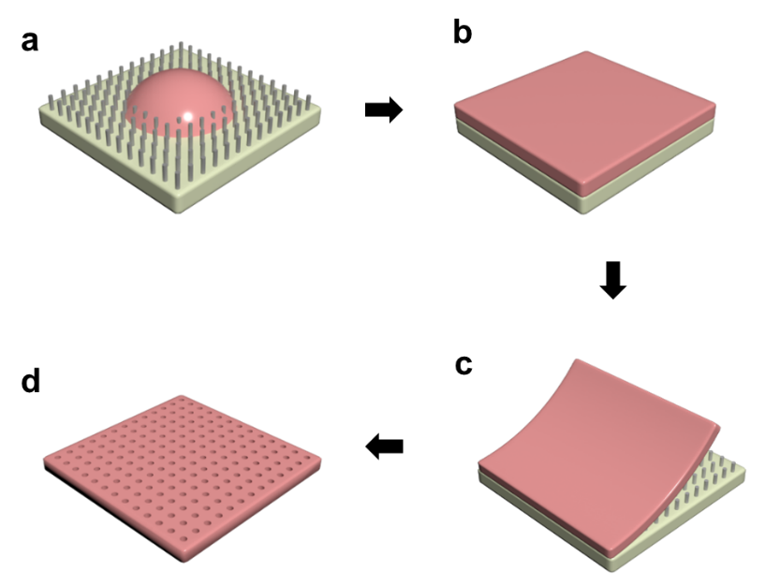
Figure S7. Schematic of PVA mold replication process. (a) Drop coating PVA 5 wt% resin on the master stamp. (b) Drying PVA resin at room temperature for 24 h. (c) Separation of PVA layer. (d) Final PVA replica mold.

The PVA resin for the PVA replica mold is prepared by placing PVA pellets in DI water and completely dissolving them by stirring at 90 ℃ for 24 hours. Subsequently, 5 wt% PVA resin is poured onto the SAM-coated master stamp. Pores in the PVA resin are removed in a vacuum using a desiccator. After drying the resin at 30 ℃ for 24 hours, a uniform PVA layer without pores is formed on the master stamp. By separating the PVA layer from the master stamp, the PVA replica mold is obtained. Separation of PVA from the master stamp is easy owing to the flexibility of the PVA mold.
Supplementary Note 8: Optical setup to characterize the focal spot of metalens
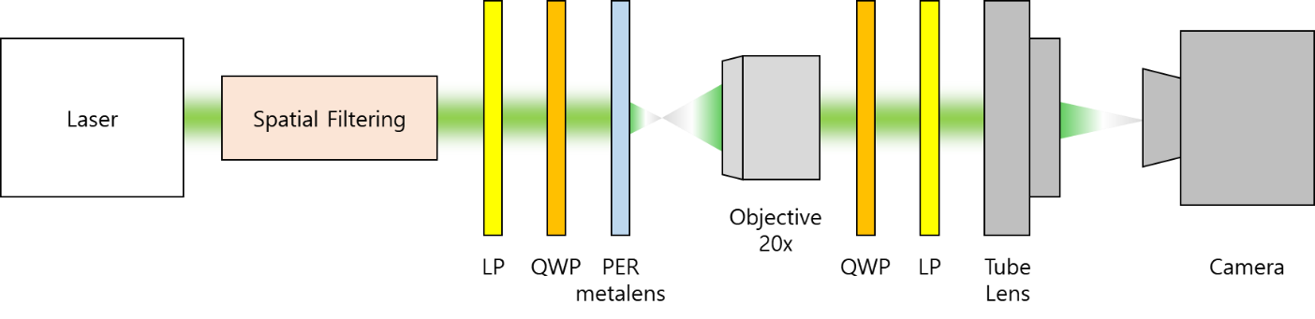
Figure S8. Schematic of the optical setup to characterize the focal spot of metalens in visible light.

Supplementary References
1. Choi KM. Rogers JA. A photocurable poly (dimethylsiloxane) chemistry designed for soft lithographic molding and printing in the nanometer regime. J. Am. Chem. Soc. 2003;125:4060-1. https://doi.org/10.1021/ja029973k
2. Gaillard Y, Rico VJ, Jimenez-Pique E, Gonzalez-Elipe AR. Nanoindentation of TiO2 thin films with different microstructures. J. Phys. D: Appl. Phys. 2009;42:145305. https://iopscience.iop.org/article/10.1088/0022-3727/42/14/145305.

