Supplementary Information for:

Full-freedom polarization hologram by freeform exposure and inkjet printing

Section S1: Details of freeform surface simulation
For the simulation of phase function ϕ(x,y), the type is set as Phase Polynomial (Kinoform/Binary) in Diffractive Properties. The construction wavelength is set as 457nm, which is the wavelength of recording laser. The coefficient of first order term for y , A₁, is fixed and determined by:
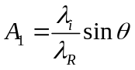 (S1)
where λ_{R} is the recording wavelength, λ_{i} is corresponding display wavelength and θ is the oblique incident angle (55° in this work). The x-y polynomial has terms up to the 10-th order, excluding x terms with odd order. The optimized spot sizes are shown in Fig S1.
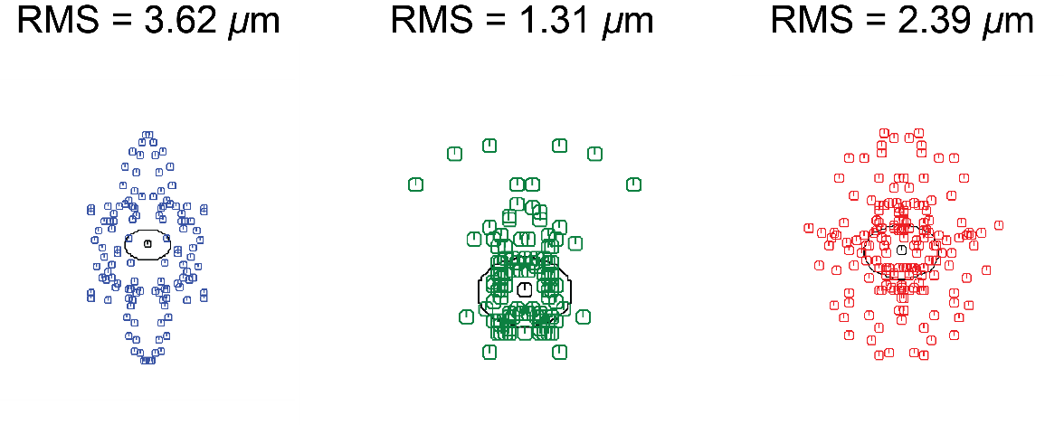
Fig. S1: Spot sizes of simulated results for blue (left), green (center) and red (right) samples, respectively. The black circles are the Airy-disks.
For the simulation of freeform surface in the exposure setup, the incident angle of reference beam on the sample is calculated by:
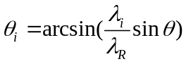 (S2)
where parameter definitions are the same as Eq. S1. Another point worth attention in the design is the distance between the sample and freeform surface. For the distance with values in a reasonable range, varying the freeform surface coefficients can produce similar final spot sizes. The main consideration here is the light intensity distribution in the recording process. Because the laser light intensity distribution is not strictly uniform due to the Gaussian beam profile. Therefore, to better match the relative intensity distributions between two beams. The distance is chosen such that the final widths of two collimated beams are close, as indicated by the arrows in Fig. S2.
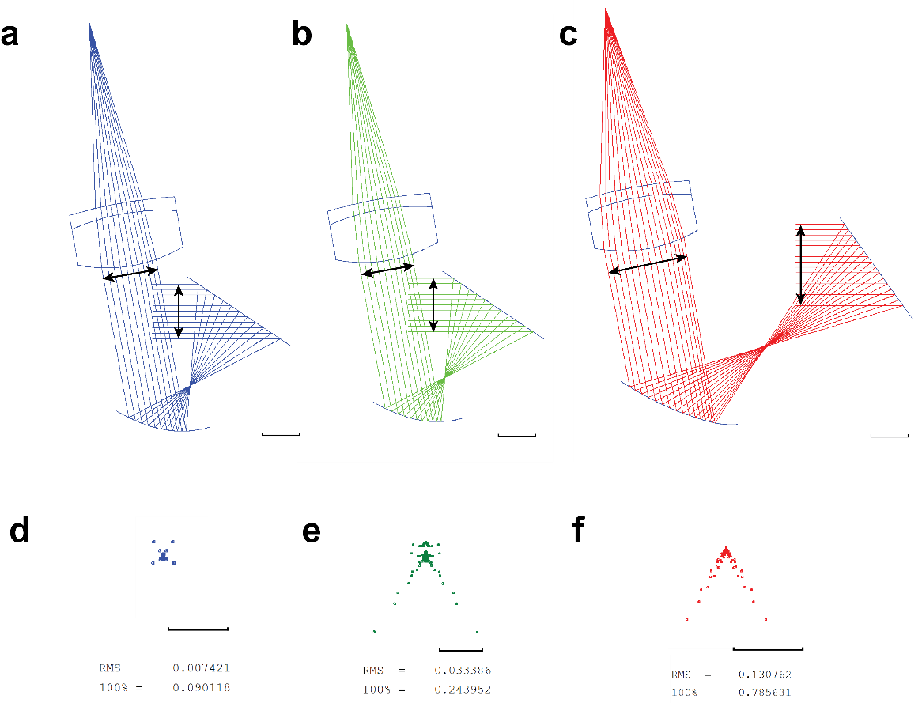
Fig. S2: Configurations and spot sizes of exposure setups. Optical paths of exposure setup for a blue, b green and c red samples. Final spot sizes for d blue, e green and f ren samples, respectively.
The final spot sizes are shown in Fig. S2 (d) - (f). The largest spot size is 0.13 mm (RMS) for the red sample. Although still far from diffraction-limited, it is still adequate for the usage in a RSD, where a focal spot near 0.1 mm is already significantly smaller than human eye pupil (~2mm) and enough to produce a good depth-of-field.
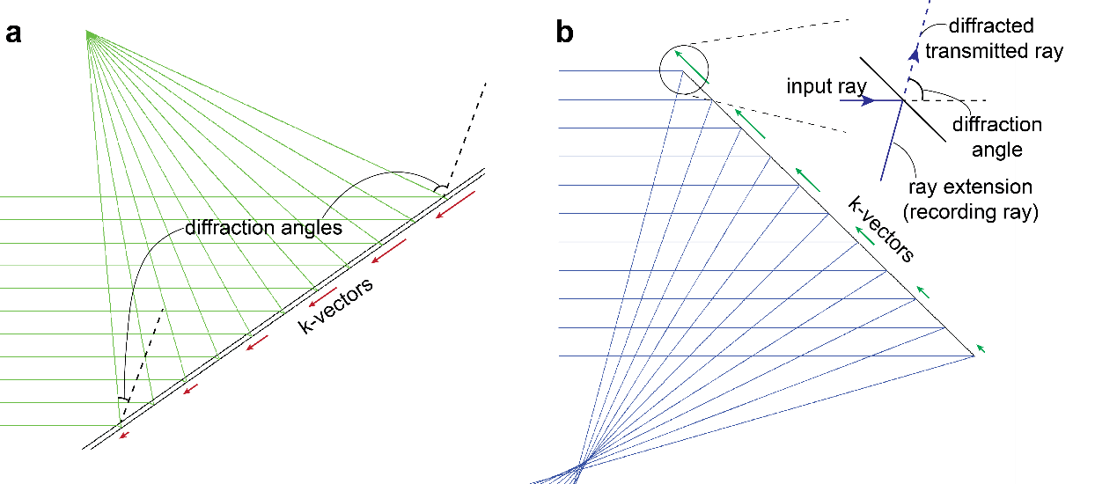
Fig. S3: Setup of diffractive surface. a k-vector and diffraction angle distribution of diffractive surface in display simulation. b Ray propagation in recording setup simulation. The upper right corner illustrates the details of ray diffraction.
Regarding the difference between simulation and actual recording situation, Fig. S3(a) shows the simulation of display system, where the length of k-vector and diffraction angle decrease from top to bottom. In the simulation of recording setup (Fig. S3(b)), because the sign of phase function ϕ(x,y) is reversed, the directions of k-vectors are also reversed. Note that the diffractive surface is now set as transmissive type. The diffracted transmitted ray follows the direction as shown in the upper right corner of Fig. S3(b), with a large diffraction angle. In Code V, there is no concept of absolute direction of ray. Therefore, even though the diffractive surface is set as transmissive type, we can set the distance after the surface to be a negative value. This way, the extended ray would behave like in the real recording situation, where the relative angle between the input ray and recording ray is large, produce a large k-vector.
For the simulation of peripheral alignment surfaces, the zoom function in Code V is adopted. Each alignment surface has a size of 6 mm by 6 mm. With a x-y polynomial up to the third terms, the spot size of all eight surfaces can reach diffraction-limited performances (Fig. S4). The final fabricated samples are shown in Fig. S5.
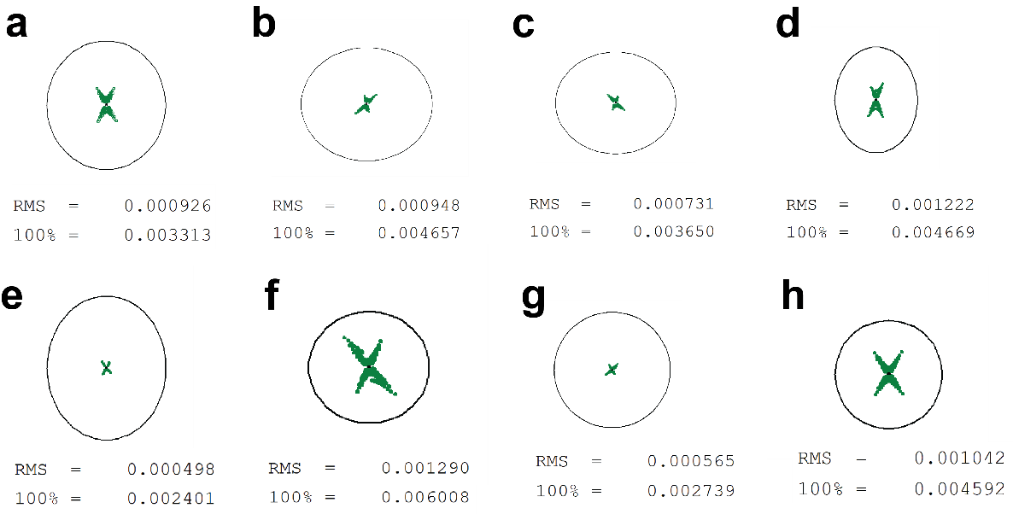
Fig. S4: Spot sizes for alignment surfaces. a-h Spot sizes for alignment surfaces z₁ to z₈ in Fig. 2c.
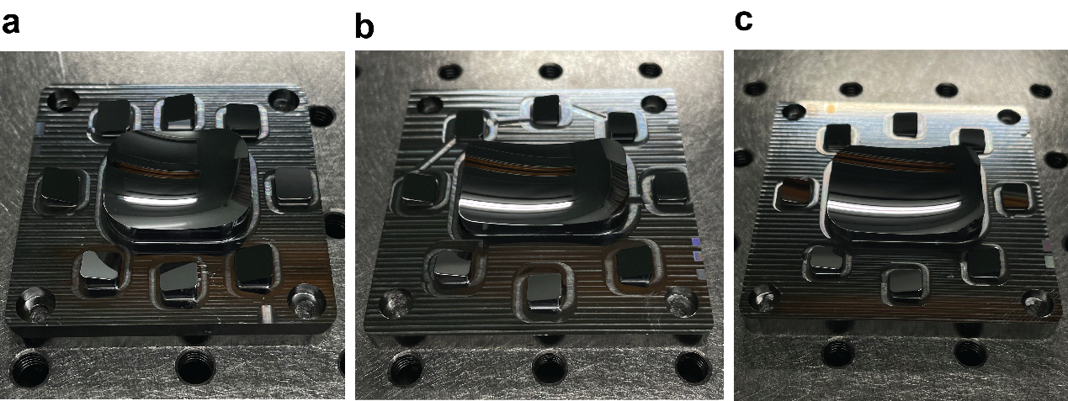
Fig. S5. Photos of fabricated freeform samples. Samples for a blue, b green and c red.

Section S2: Pitch and thickness optimization
Shown in fig. S6 are the pitch and thickness optimization results for red and blue samples.
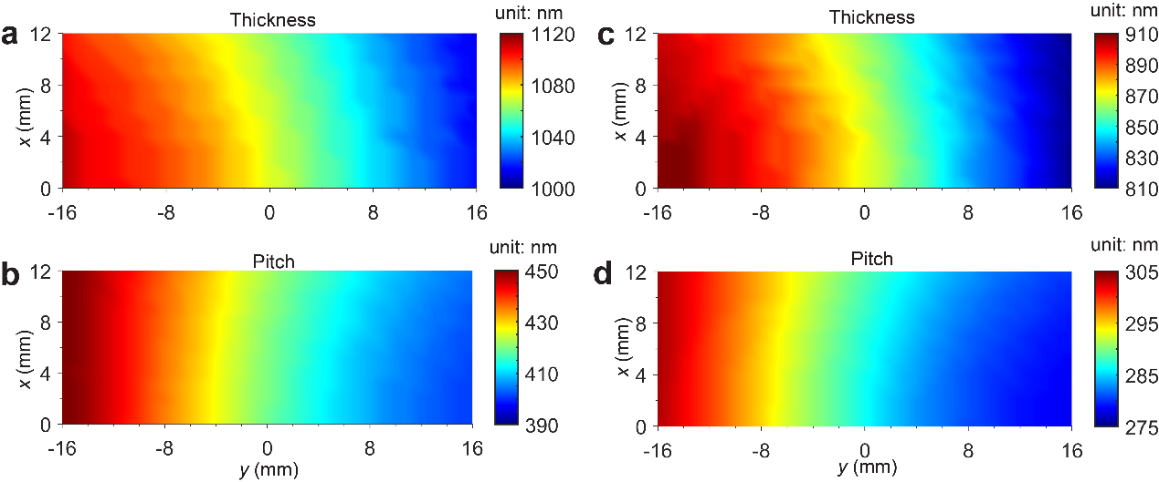
Fig. S6. Results of pitch and thickness optimization. Optimized results of a thickness and b pitch distribution for red sample, and c thickness and d pitch distribution for blue sample.
Shown in fig. S7 are the photos of fabricated blue and red sample.
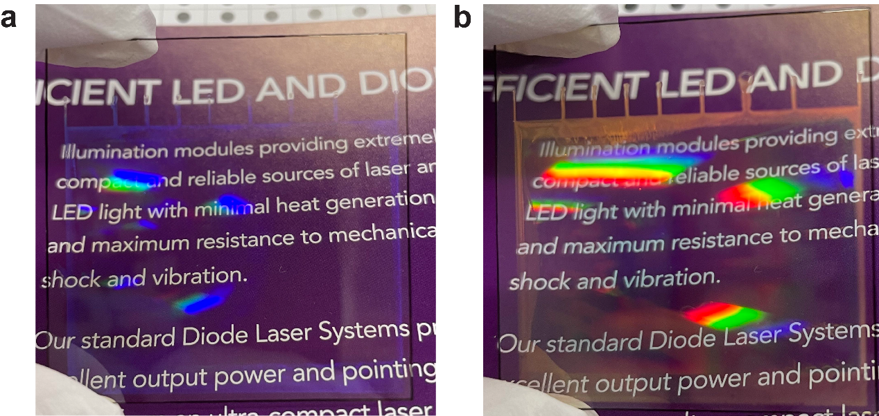
Fig. S7. Fabricated samples. Photos of fabricated DOE samples for a blue and b red.

Section S3: Characterization and analysis of focal spot
The profiles of focal points of RGB samples are shown in Fig. S6(a). The focal spots are around 0.38 mm, 0.46mm and 0.52mm in x direction for RGB, and 0.42, 0.47mm and 0.55 mm in y direction for RGB. Note these results greatly differ from the simulated spot sizes. After careful examinations, we found the reason is actually from the Gaussian beam profile (Fig. S8(g)). The final laser beam width on the focal plane is already near 0.3 mm as measured, which can be further validated by the following calculations.
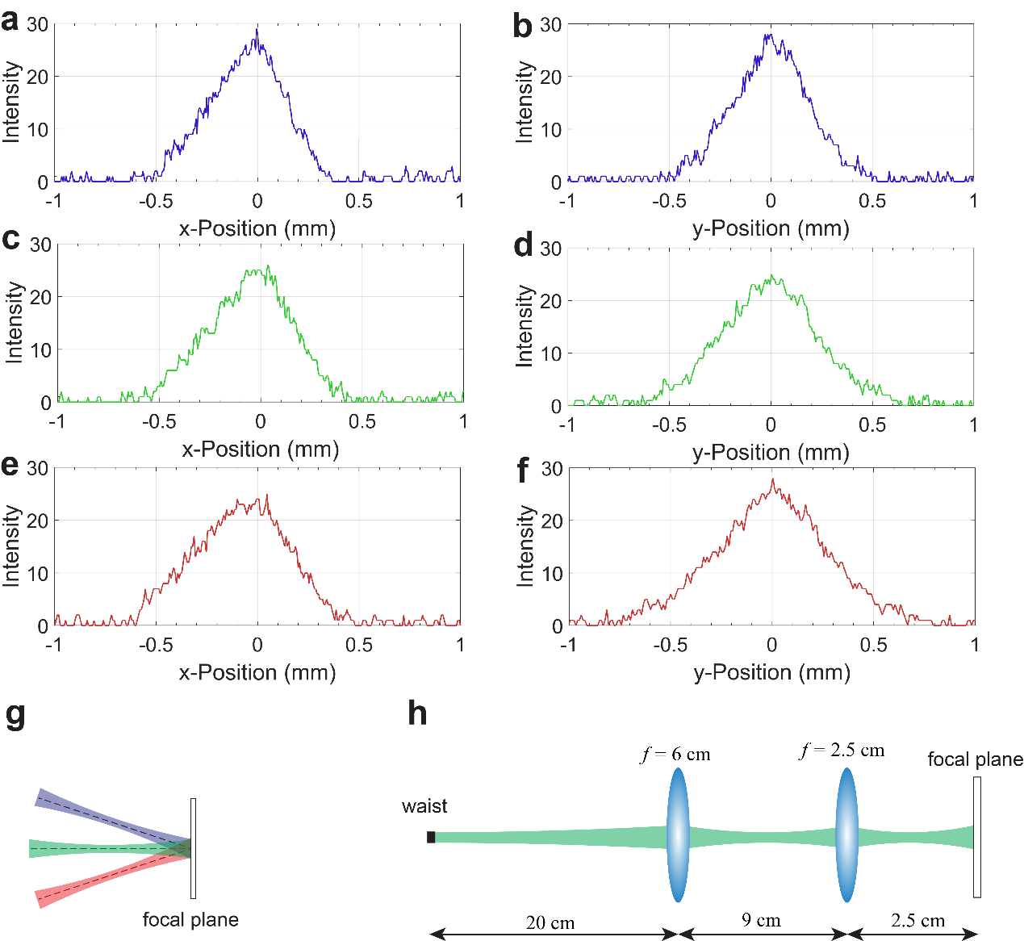
Fig. S8: Beam profiles characterization. Measured beam profile in a x direction and b y direction for blue sample, in c x direction and d y direction for green sample, and in e x direction and f y direction for red sample. g Illustration of influence of beam waist on final spot size. h Simplified optical path of Gaussian beam propagation.
The measured divergence angle of laser beam from a single pixel is measured to be around θ_{d} = 0.0015. Therefore, the beam waist w₀ can be calculated as (take green for example):
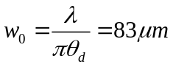 (S3)
The optical path of laser beam is simplified as Fig. S8(h). The spot size is 0.4 mm immediately after the MEMS scanner. So, the beam waist is around 20 cm from the collimation lens. Then using the ABCD matrix method, the final beam waist on the focal plane can be calculated as 0.41 mm, which is close to the measured result.
Therefore, the final spot size is mainly determined by the Gaussian beam width instead of the lens focal spot size. Still, if we can modulate the Gaussian beam before it hits the MEMS by, say, adjusting the collimation lens of the laser diode, in theory we can make the final Gaussian beam width on the focal plane smaller. In the display experiment, it seems the focal spot near 0.4 mm is also small enough to produce a decent depth of field.

Section S4: Implementation details of inkjet printing
The coffee ring effect (CRE) resulted from the capillary force causes the non-uniformity of printed film. For common solvents for RM257, such as toluene, xylene and propylene glycol monomethyl ether acetate (PGMEA), CRE is very severe, as shown in Fig. S9(a). The line-shaped defects seriously degrade the liquid crystal alignment and overall optical quality of DOE.
The Marangoni flow, as a common approach to suppress CRE, refers to the fluid flow induced by a gradient surface tension, where the fluid transports to the region with higher surface tension. When two solvents are mixed together, the one with a higher evaporation rate would have a lower ratio at the contact outer boundary. If it also has a higher surface tension, then the contact boundary would have a lower surface tension than the top of liquid drop. The Marangoni flow would therefore transport the solute accumulated at the contact boundary back to the center, alleviating the CRE. Note this type of Marangoni flow would only happen when the evaporation rate and surface tension are simultaneously higher or lower than the other solvent, or its direction would be reversed, worsening the CRE. For the water-based solution, this type of solvent is easy to find because virtually all common solvents have a lower surface tension than water due to its strong hydrogen bonding interaction between molecules. Therefore, one only needs to find a solvent with slower evaporation than water.
However, for the common solvents for RM257, to find such a solvent is difficult, because normally an organic solvent without strong intermolecular interaction would exhibit a high surface tension and slow evaporation simultaneously (for a large-molecule chemical) or vice versa (for a smaller one). For solvents with a strong intermolecular interaction like ethylene glycol, they usually do not dissolve RM257 and cannot be used either.
Even when such type of solvent is found, the difference in surface tension is typically not large to induce a strong enough Marangoni flow that would completely suppress CRE. For example, PGMEA has a saturated vapor pressure (SVP) of around 400 Pa and a surface tension of around 28 mN/m. O-xylene, on other hand, has an SVP around 1.2 kPa and a surface tension of around 30 mN/m, which satisfies the aforementioned requirement. However, the printing result of mixing PGMEA and o-xylene at any weight ratio only shows an alleviation of CRE instead of elimination of it (Fig. S9(b)).
Therefore, after trying numerous types of solvent, we finally found an approach to produce a uniform film with a single solvent, 1-methylnaphthalene. The viscosity of 1-methylnaphthalene-based solution is high (presumably > 10 cP) and the evaporation speed is not that fast, producing high-quality optical samples as shown in the article.
The effect of surfactant is also important in improving the film quality. For the LCPH, adding a surfactant that produces the planar anchoring would cancel the homeotropic anchoring at the interface between liquid crystal and air. The best case is when the surfactant exactly cancels the homeotropic anchoring and not induce a strong planar anchoring, which would allow the liquid crystal at interface to freely follow the bulk slant helical alignment. In the experiment, it is found that the addition of surfactant 8857A also improves the quality of printed film by forming a better line shape. The underlying mechanism is presumed to be the suppression of spreading of printed fluid by inducing a higher contact angle (decreasing wettability), as illustrated in Fig. S9(c).
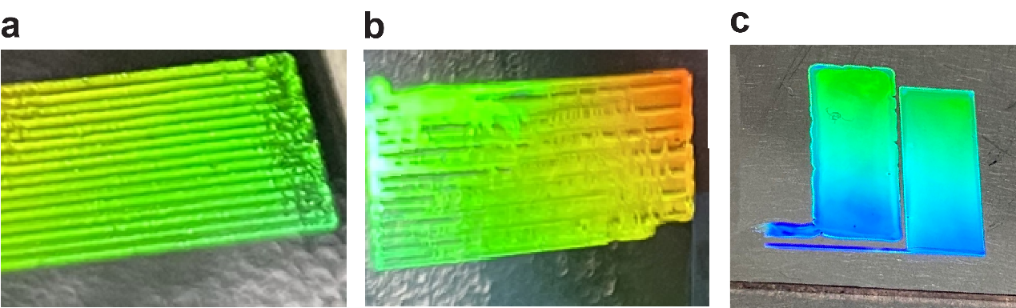
Fig. S9: Illustration of CRE and surfactant effect. Printed sample fabricated with a pure PGMEA as solvent, and b with 50% o-xylene and 50% PGMEA as solvent. c Printed sample based on 1-methylnaphthalene solvent with no surfactant (left) and 0.025% 8857A surfactant (right).
The detailed recipe of solution for the inkjet printing in eight subregions of sample is shown in Table S1. The first line and last line in each printing subregion is intentionally prolonged so that the process of reloading ink does not interfere the main DOE film region. The width of each region is different to match the slightly non-linear distribution of chiral pitch. The whole information of printing regions can be found in the pattern file (inkjet_printing.pattern) in Supplementary Data1, which is a xml-type file and can be opened with common text editors.

 | Red |  | Green |  | Blue
Region | c1 | c2 | c1 | c2 | c1 | c2
1 | 1.727% | 33.58% | 2.073% | 34.38% | 2.548% | 27.72%
2 | 1.765% | 33.11% | 2.108% | 33.46% | 2.588% | 27.30%
3 | 1.802% | 32.65% | 2.143% | 32.53% | 2.627% | 26.89%
4 | 1.840% | 32.18% | 2.179% | 31.59% | 2.667% | 26.47%
5 | 1.877% | 31.71% | 2.214% | 30.64% | 2.707% | 26.05%
6 | 1.915% | 31.23% | 2.249% | 29.68% | 2.747% | 25.63%
7 | 1.952% | 30.76% | 2.285% | 28.70% | 2.786% | 25.20%
8 | 1.990% | 30.28% | 2.320% | 27.72% | 2.826% | 24.77%
Table S1: Inkjet printing recipe. c1 refers to the concentration of chiral dopant R5011 in the solute. c2 refers to the concentration of solute in the methylnaphthalene-based solution.

Section S5: Temperature and UV stability tests
In order to investigate the temperature and UV stability of LCPH, we performed the tests accordingly. In the temperature test, the green sample is heated at 150°C for 72 hours. The measured efficiency spectrum after heating is nearly identical to the original one (Fig. S10a). In the UV test, the green sample is firstly placed under UV light (364 nm, 127 mW/cm²) for 4 hours, in order to simulate the curing condition of UV sealant. No change is observed in the efficiency spectrum. Then the sample is exposed for 72 hours to imitate the outdoor sunlight exposure. This time, a decrease around 10% in efficiency can be observed. Possible methods to improve the UV endurance of LCPH include development of new liquid crystal materials and use of UV shield (like UV-reflective coatings) to decrease the UV light intensity on sample.
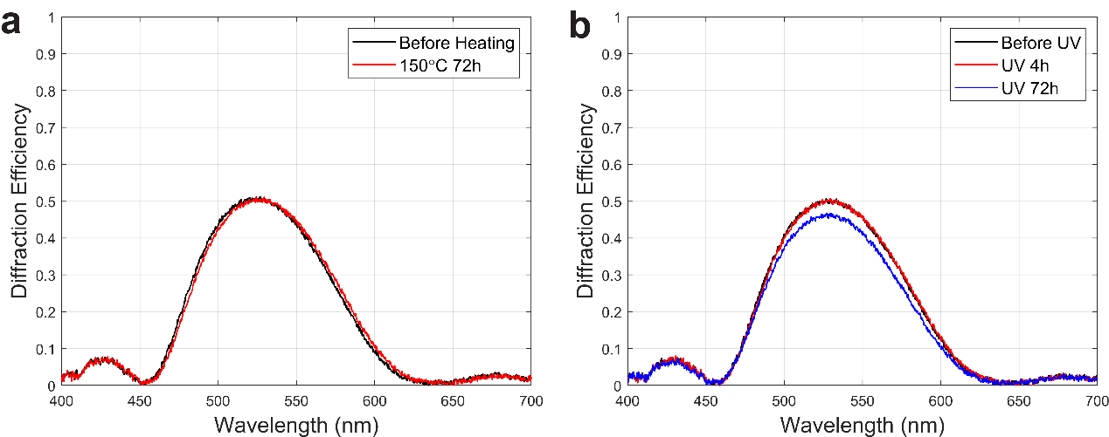
Fig. S10: Results of temperature and UV stability tests. a Temperature test with sample heated at 150°C for 72 hours. b UV test with sample exposed for 4 hours and 72 hours.

