Supporting Information
Ultrafast Laser One-Step Construction of 3D Micro-/Nanostructures Achieving High-Performance Zinc Metal Anodes
Yanan Liu^{1†}, Ye Ding^{2†}, Zeping Liu³, Xingchen Li⁴, Sichao Tian^{5*}, Lishuang Fan^{3*}, Jichang Xie⁶, Liangliang Xu⁷, Jinwoo Lee^{7*}, Jian Li⁸, Lijun Yang^{1*}
†These authors contributed equally to this work.
*Correspondence:
Sichao Tian
tiansichao@outlook.com
Lishuang Fan
fanlsh@hit.edu.cn
Jinwoo Lee
jwlee1@kaist.ac.kr
Lijun Yang
yljtj@hit.edu.cn
¹Zhengzhou Research Institute, Harbin Institute of Technology, Zhengzhou 450000, P. R. China
²Suzhou Research Institute, Harbin Institute of Technology, Suzhou 215104, P. R. China
³School of Chemistry and Chemical Engineering, Harbin Institute of Technology, Harbin 150001, P. R. China
⁴Defense Innovation Institute, Chinese Academy of Military Science, Beijing 100071, P. R. China
⁵Institute of Medicinal Plant Development, Chinese Academy of Medical Sciences and Peking Union Medical College, Beijing 100193, P. R. China
⁶Laboratoire Roberval, UTC, Sorbonne Universités, Université de Technologie de Compiègne, Centre de recherche Royallieu, CS60319, Compiègne Cedex 60203, France
⁷Department of Chemical and Biomolecular Engineering, Korea Advanced Institute of Science and Technology (KAIST), Daejeon 34141, Republic of Korea
⁸School of Mechanical Engineering, Beijing Institute of Technology, Beijing 100081, P. R. China

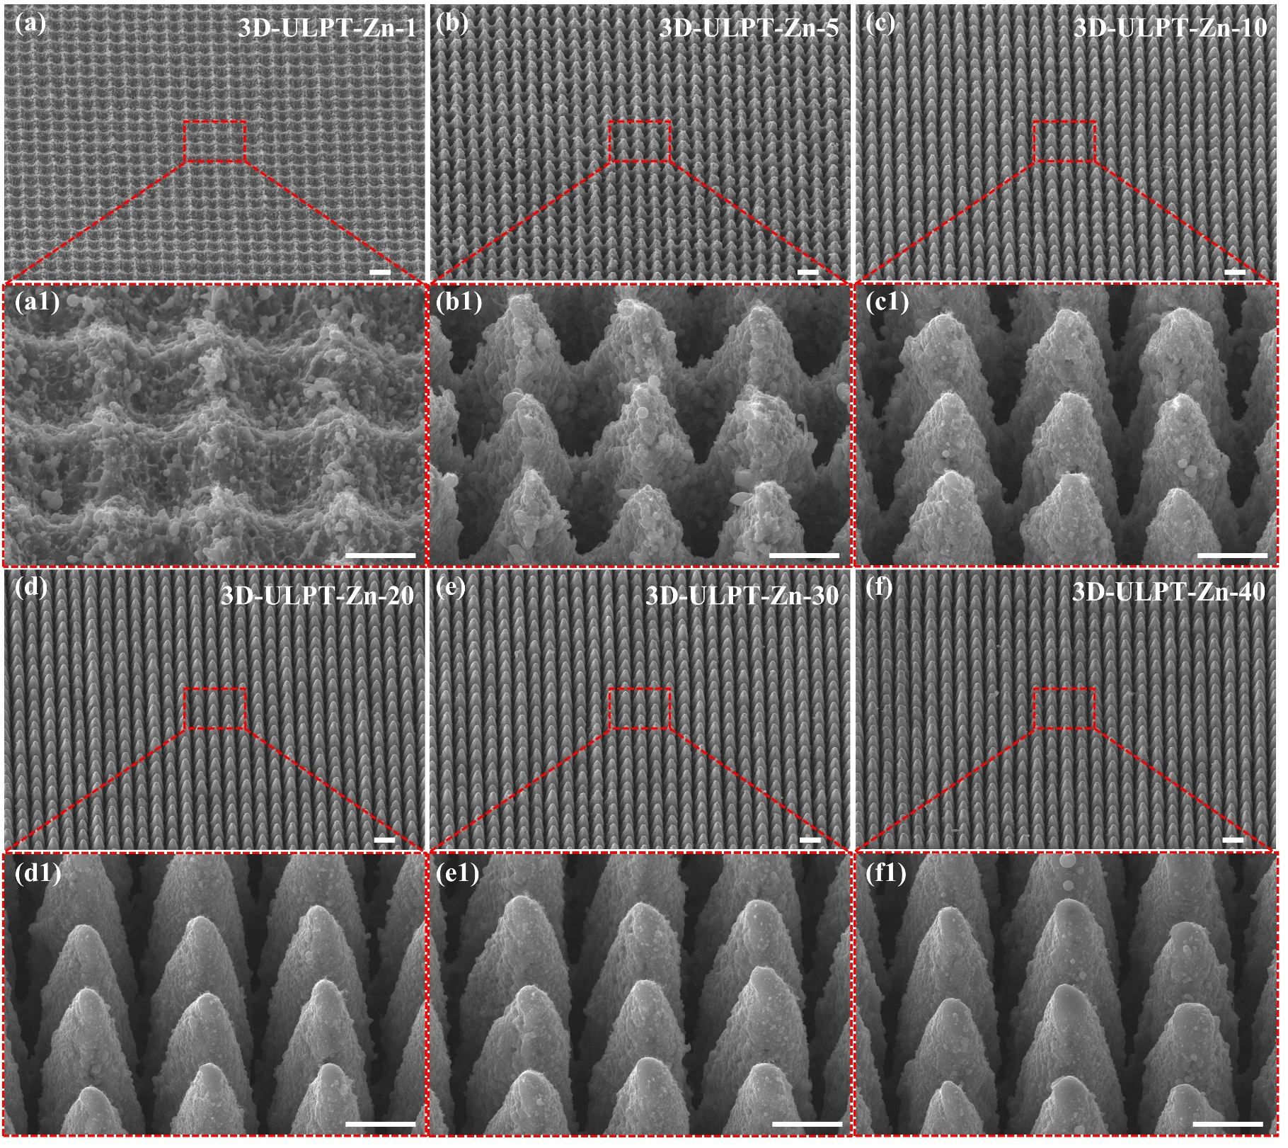
Fig. S1. 3DMNs evolution of the Zn anode irradiated by various laser processing parameters. Scale bar: 10 μm for (a-f) and 5 μm for (a1-f1).
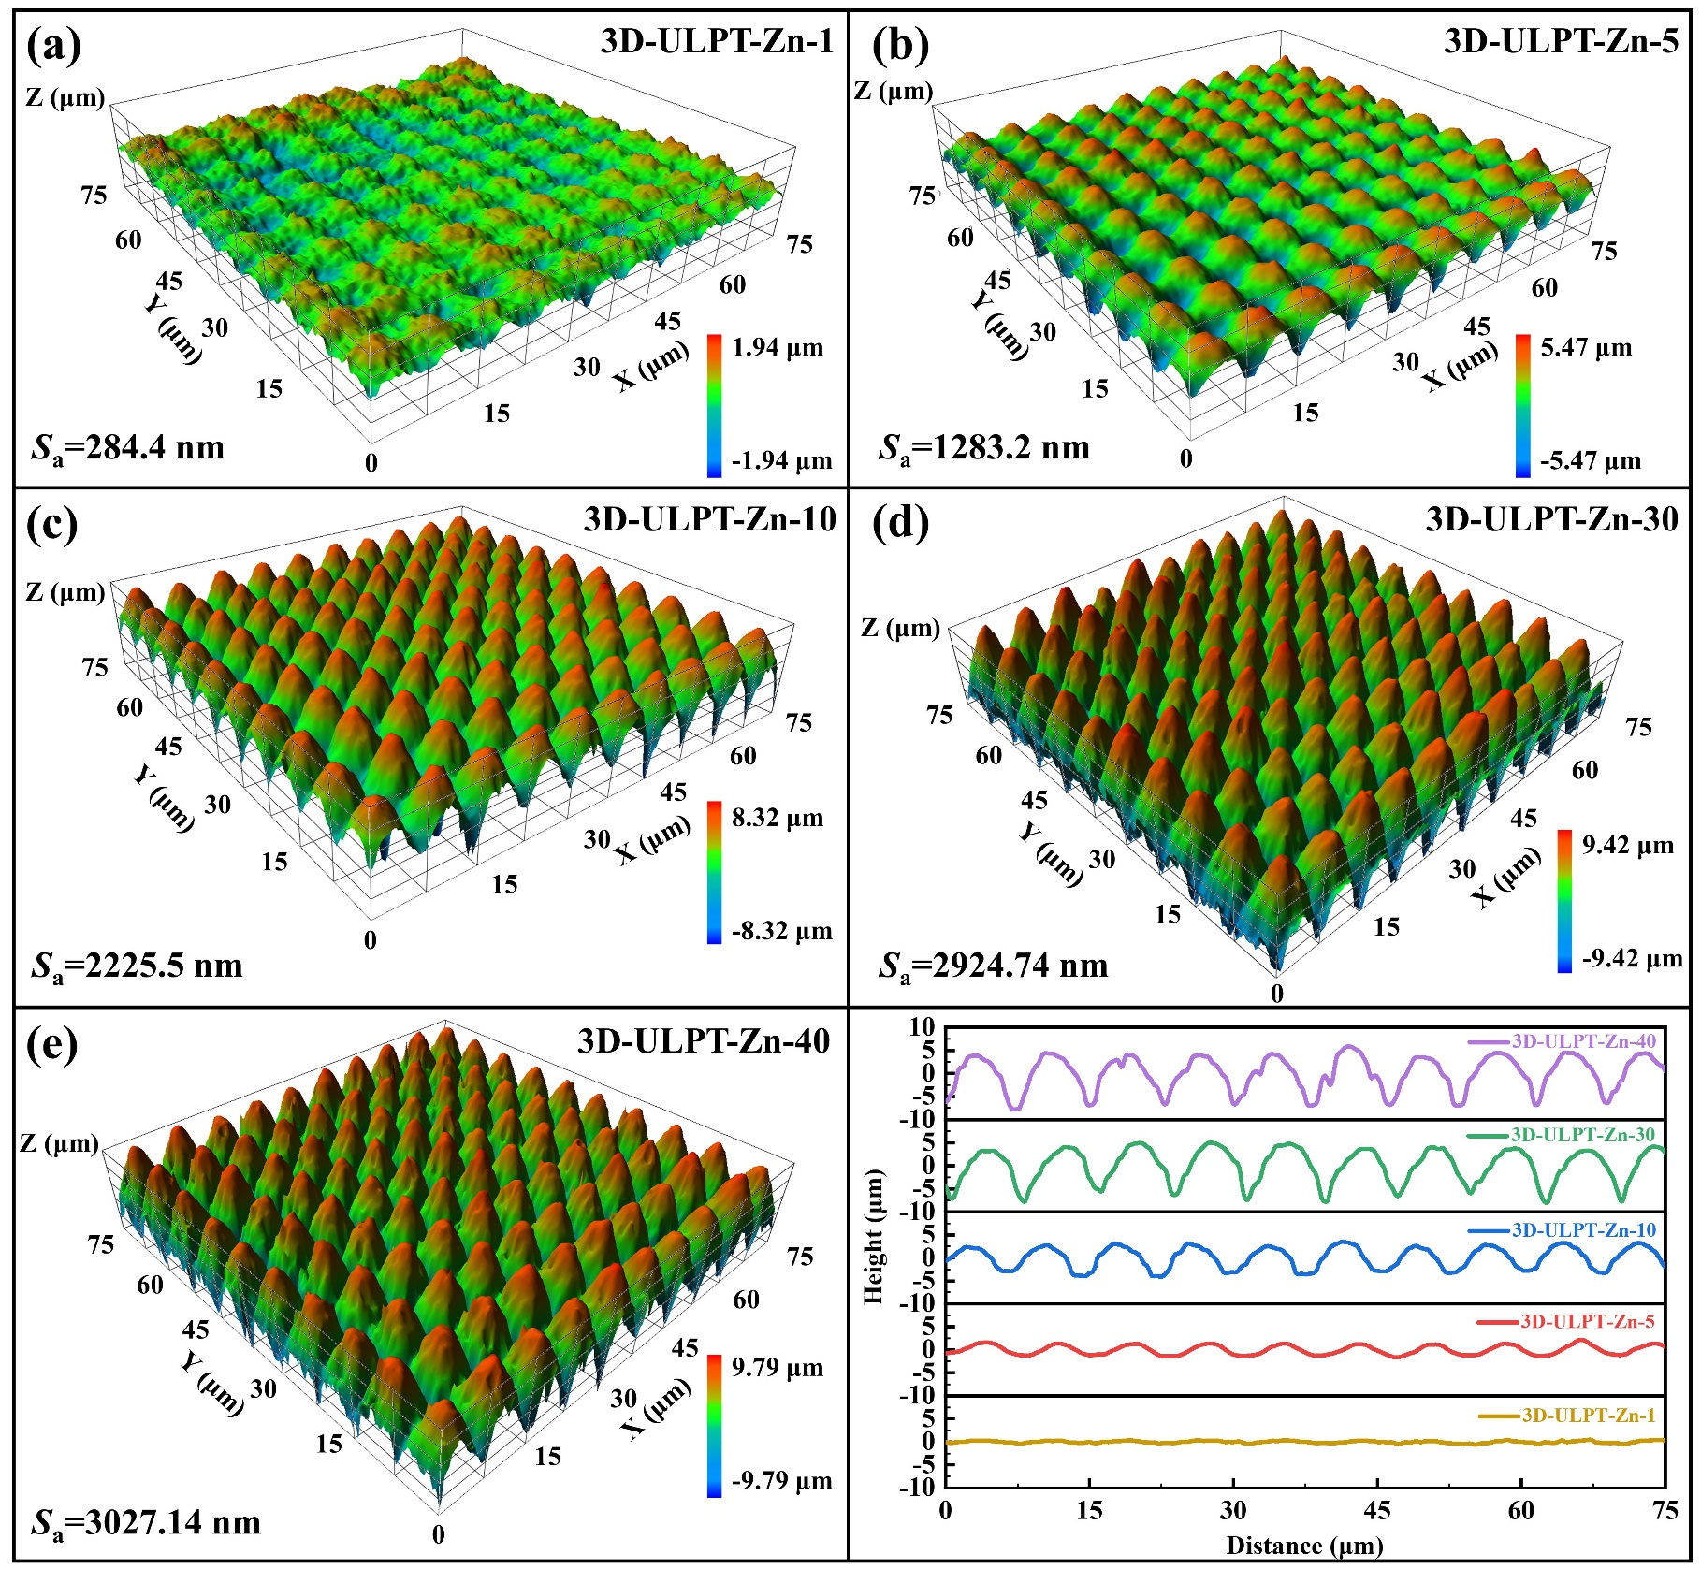
Fig. S2. 3D images of 3DMNs irradiated by various laser processing parameters.

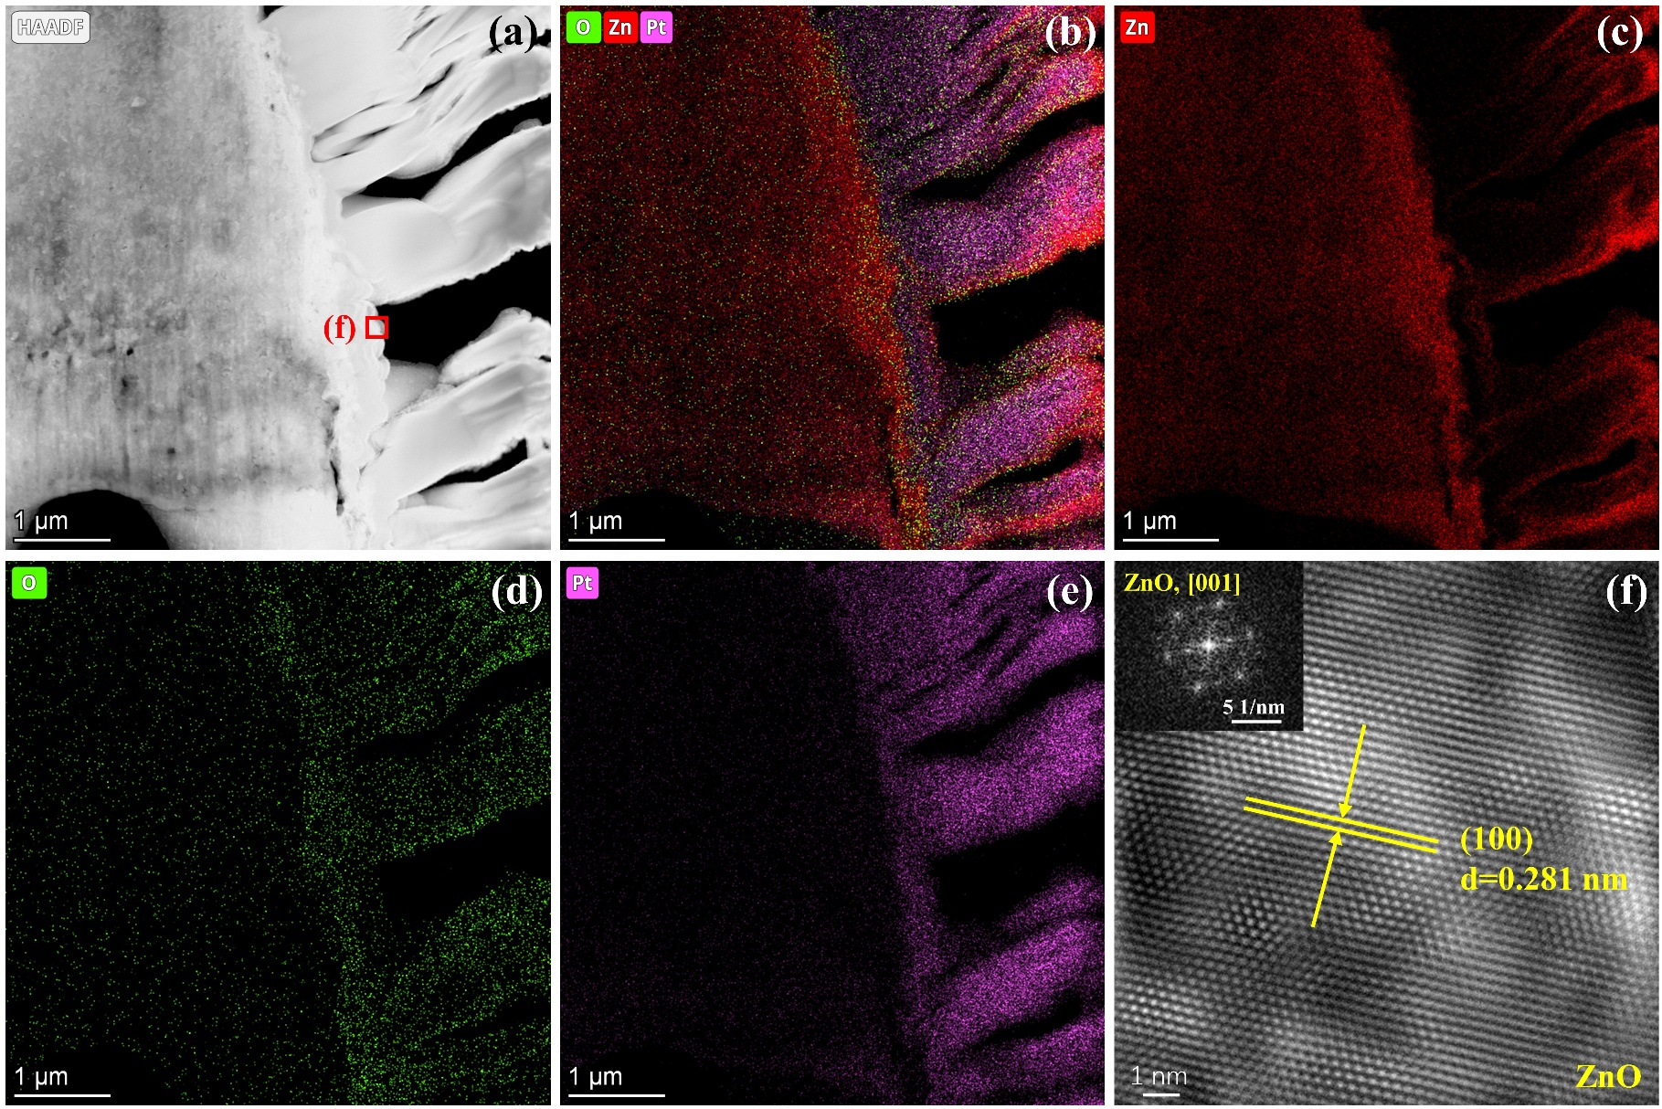
Fig. S3. TEM analysis of nanoparticles on 3DMNs surface. (a) HAADF image of 3DMNs. (b-e) EDS mapping images of 3DMNs. (f) HRTEM images of the region f in (a).
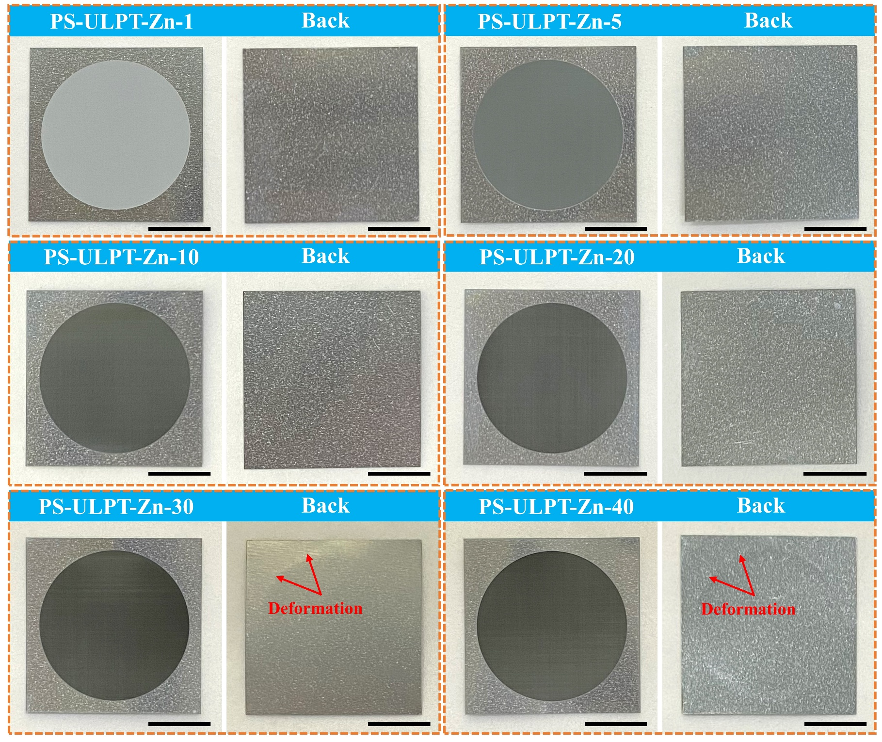
Fig. S4. Digital photos of Zn anodes irradiated by various laser processing parameters. Scale bar: 5 mm.
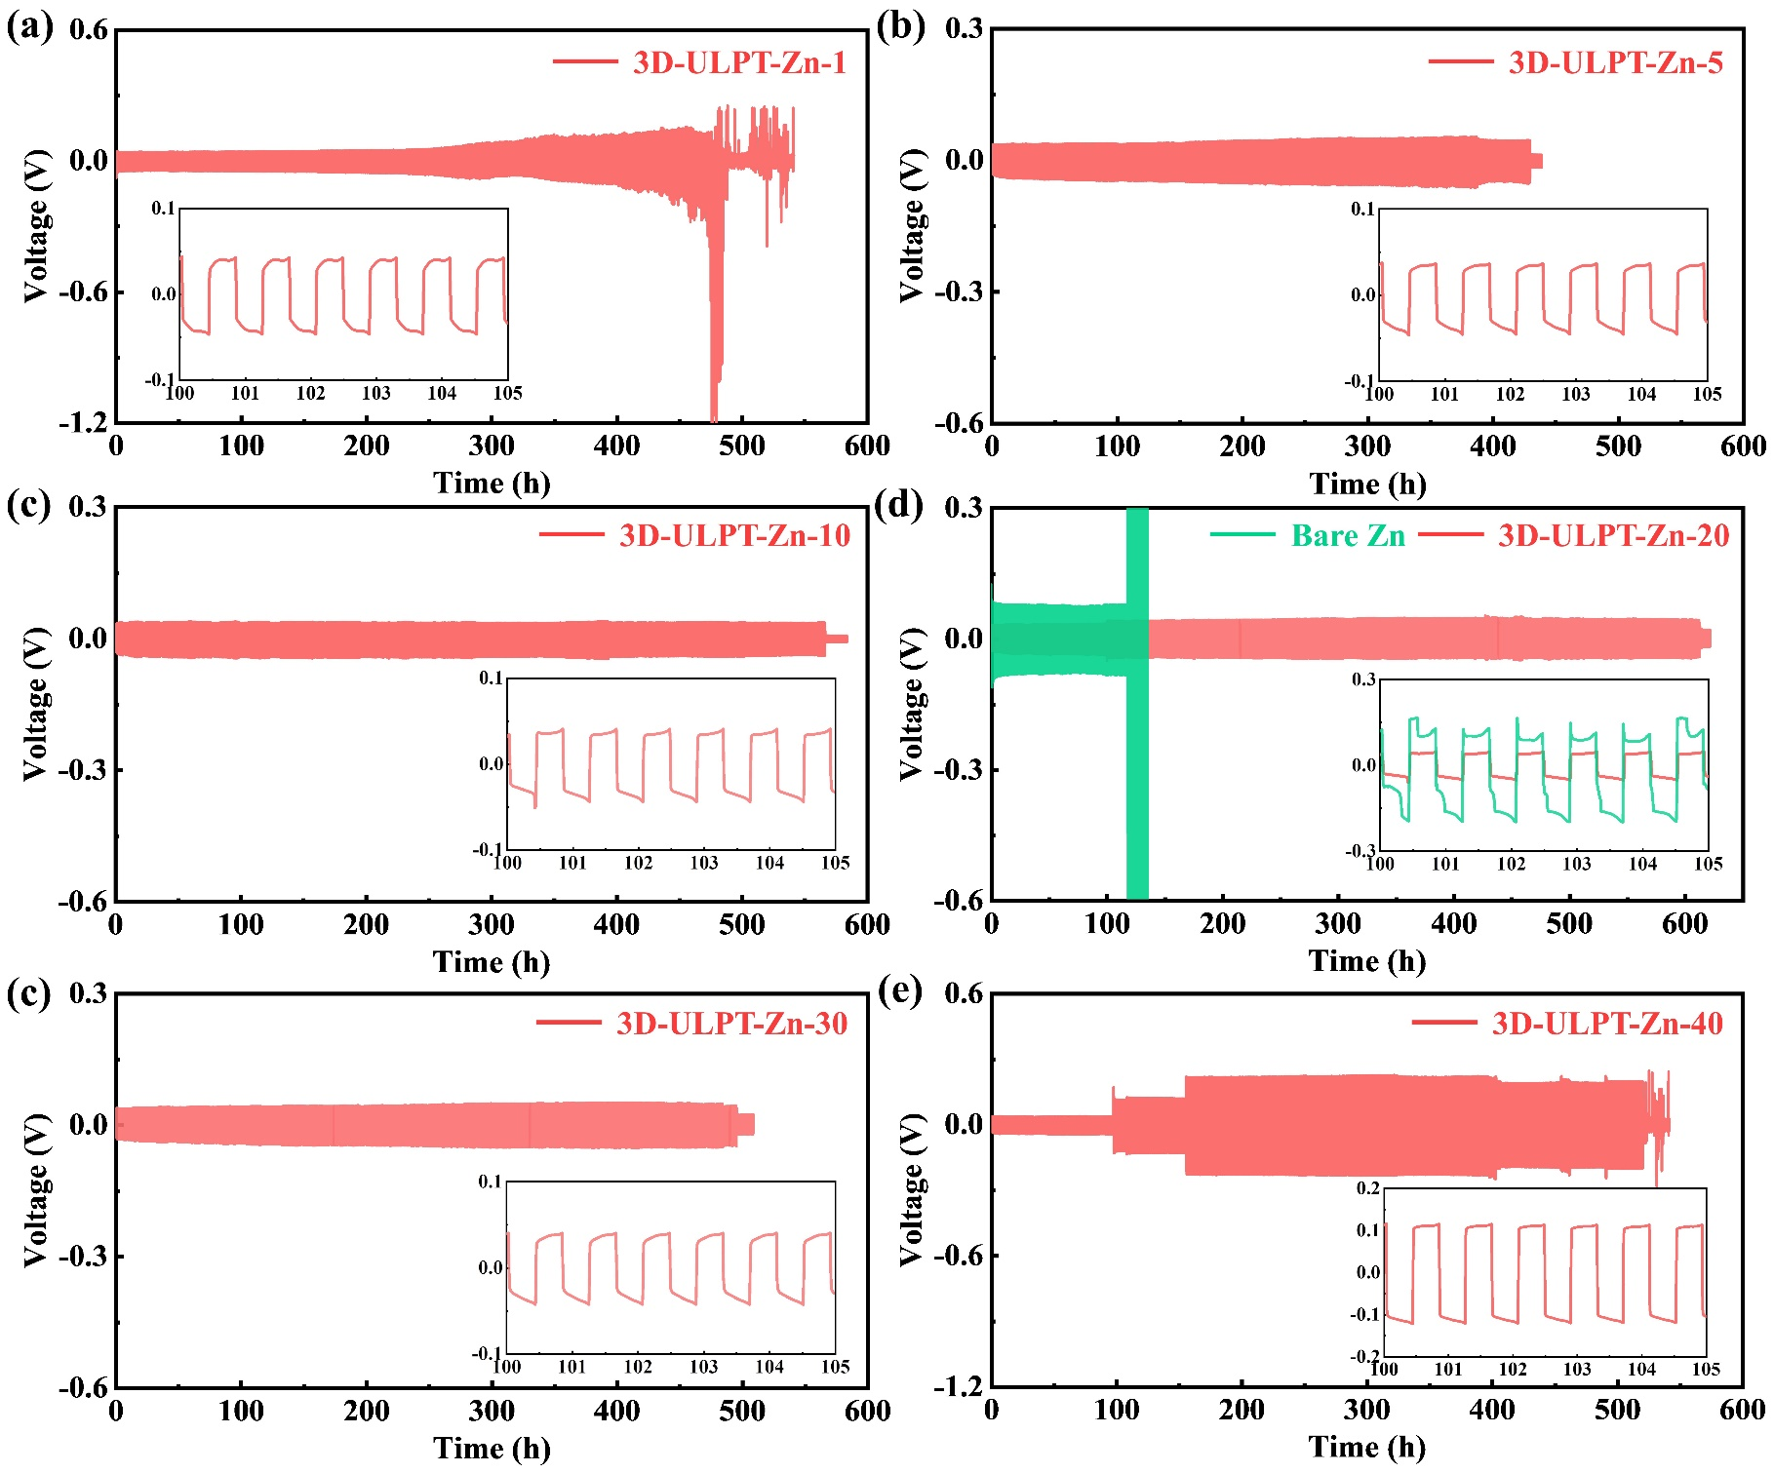
Fig. S5. GCD curves of 3D-ULPT-Zn//3D-ULPT-Zn symmetric cells composed of various 3DMNs on Zn anodes at the current density of 5 mA cm⁻² and areal capacity of 2 mAh cm⁻².
As illustrated in Fig. S1, the variation in laser scanning repetitions (R_{s}) leads to different 3DMNs on Zn anodes. Notably, a single laser scan (R_{s}=1) can remove the original rough surface of the commercial Zn foil and cause periodic concave-convex micro-/nanostructures (Fig. S1a and Fig. S2a). Due to the ultra-high energy density of laser processing, the microstructure gradually evolves from a concave-convex structure to a conical system within the range of 1 to 10 processing repetitions (Fig. S1b-c and Fig. S2b-c). When the scanning repetition is in the range of 20 to 40, the 3DMN remains stable. However, excessive processing repetitions (30 and 40) cause certain deformation at the bottom of the substrate (Fig. S4), which should be avoided. The galvanostatic charge-discharge (GCD) performance (Fig. S5) of 3D-ULPT-Zn//3D-ULPT-Zn symmetric cells indicates the optimized cycling performance (620 h) under R_{s}=20, guaranteeing the best cycling performance of the laser-modified Zn anode.
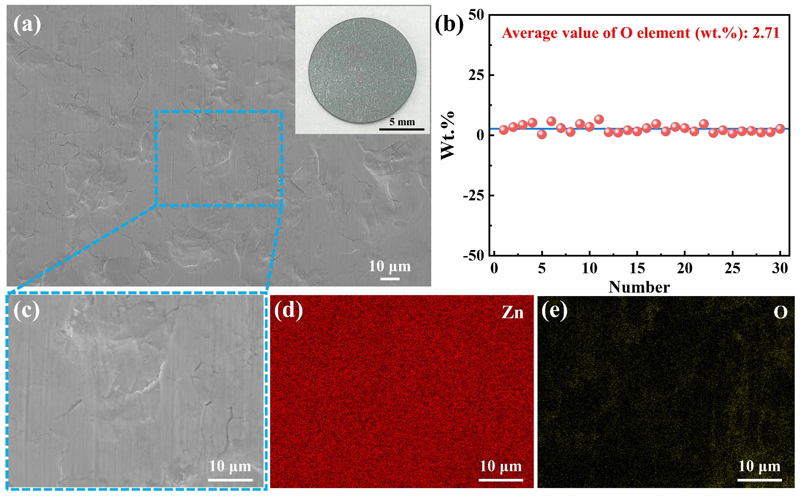
Fig. S6. (a) SEM image and digital photography (inset) of the bare Zn foil. (b) EDS result of randomly selected points on Zn foil indicates oxidation conditions. (c) Enlarged SEM image of dashed box in (a). (d-e) EDS-mapping results of the bare Zn foil.
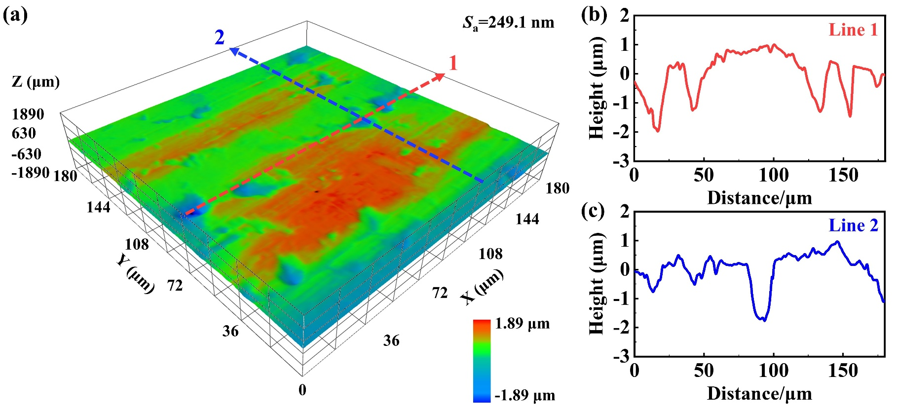
Fig. S7. (a) 3D image of the bare Zn foil. (b-c) Cross-sectional profiles of the bare Zn foil.
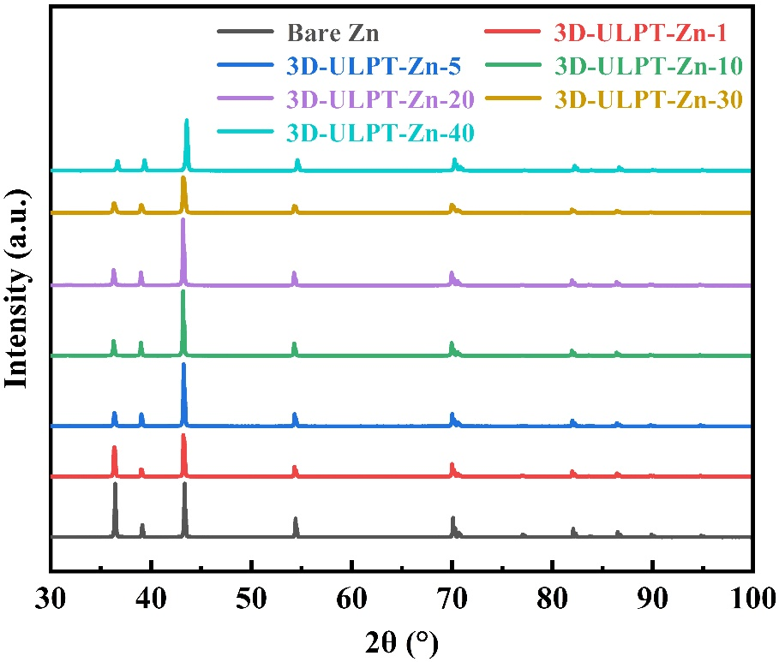
Fig. S8. XRD patterns of Zn anodes irradiated by various laser processing parameters.
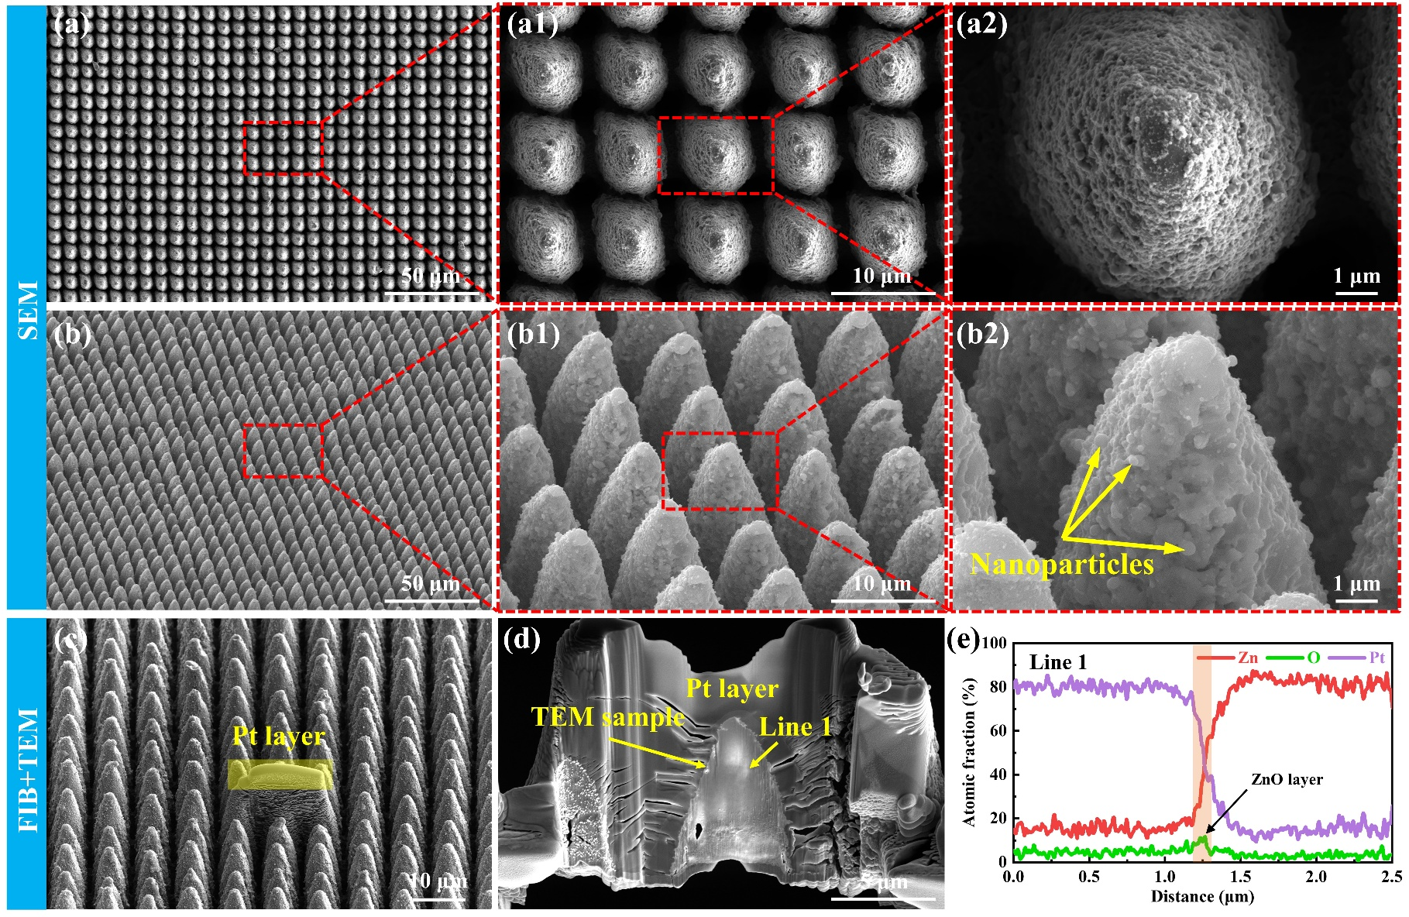
Fig. S9. (a-b) SEM images of 3DMNs irradiated by ultrafast laser (R_{s}=20). (c-d) Preparation of TEM sample by FIB. (e) EDS line scan result of Zn, O, and Pt elements.
Fig. S9(a-b) shows SEM images of the 3DMN on Zn metal produced by the laser processing parameter R_{s}=20. The FIB technology (Fig. S9c-d) was used to prepare the TEM sample to study the element distribution of the 3DMN. The EDS line scan result (Fig. S9e) illustrates that a relatively thin (~35 nm) oxide layer appeared on the surface of the 3DMN. Combined with the TEM analysis in Fig. 1(i), the generation of the ZnO layer was verified.
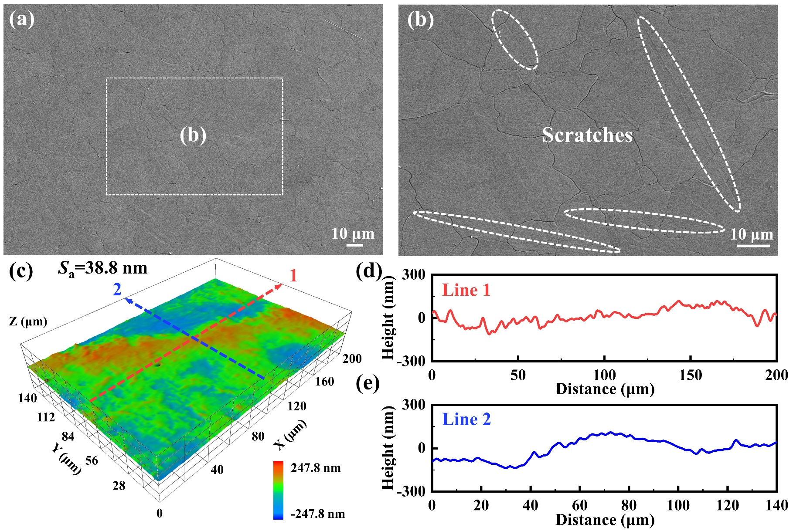
Fig. S10. (a-b) SEM images of the polished Zn. (c) 3D image of the polished Zn. (d-e) Cross-sectional profiles of the polished Zn.
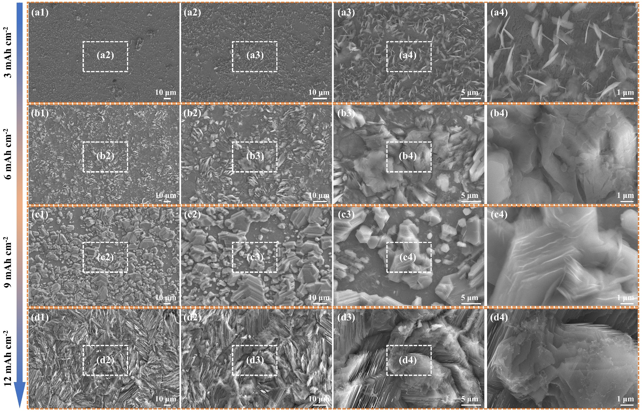
Fig. S11. SEM images of polished Zn anode deposited at various areal capacities with a fixed current density of 5 mA cm⁻².
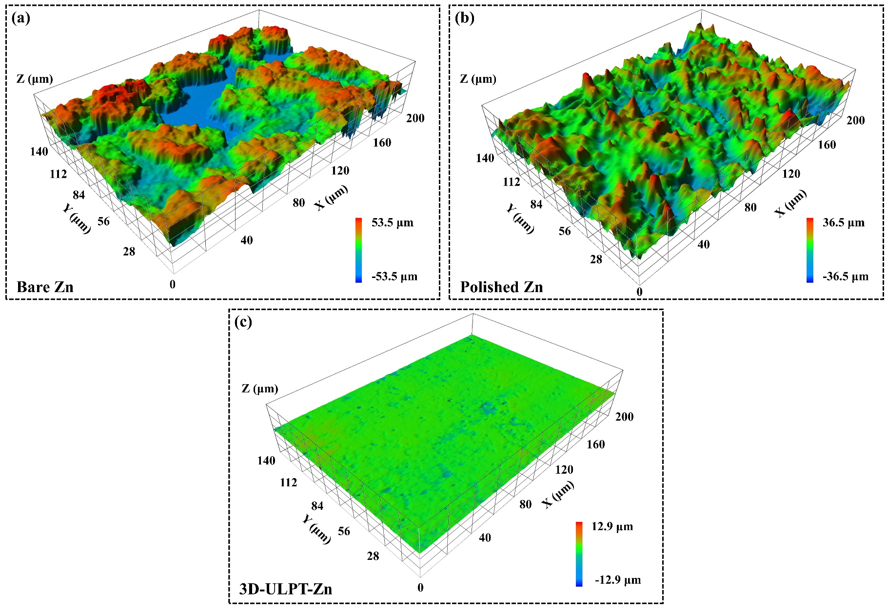
Fig. S12. 3D images of (a) bare Zn, (b) polished Zn, and (c) 3D-ULPT-Zn anodes deposited at the areal capacity of 12 mAh cm⁻² and a fixed current density of 5 mA cm⁻².

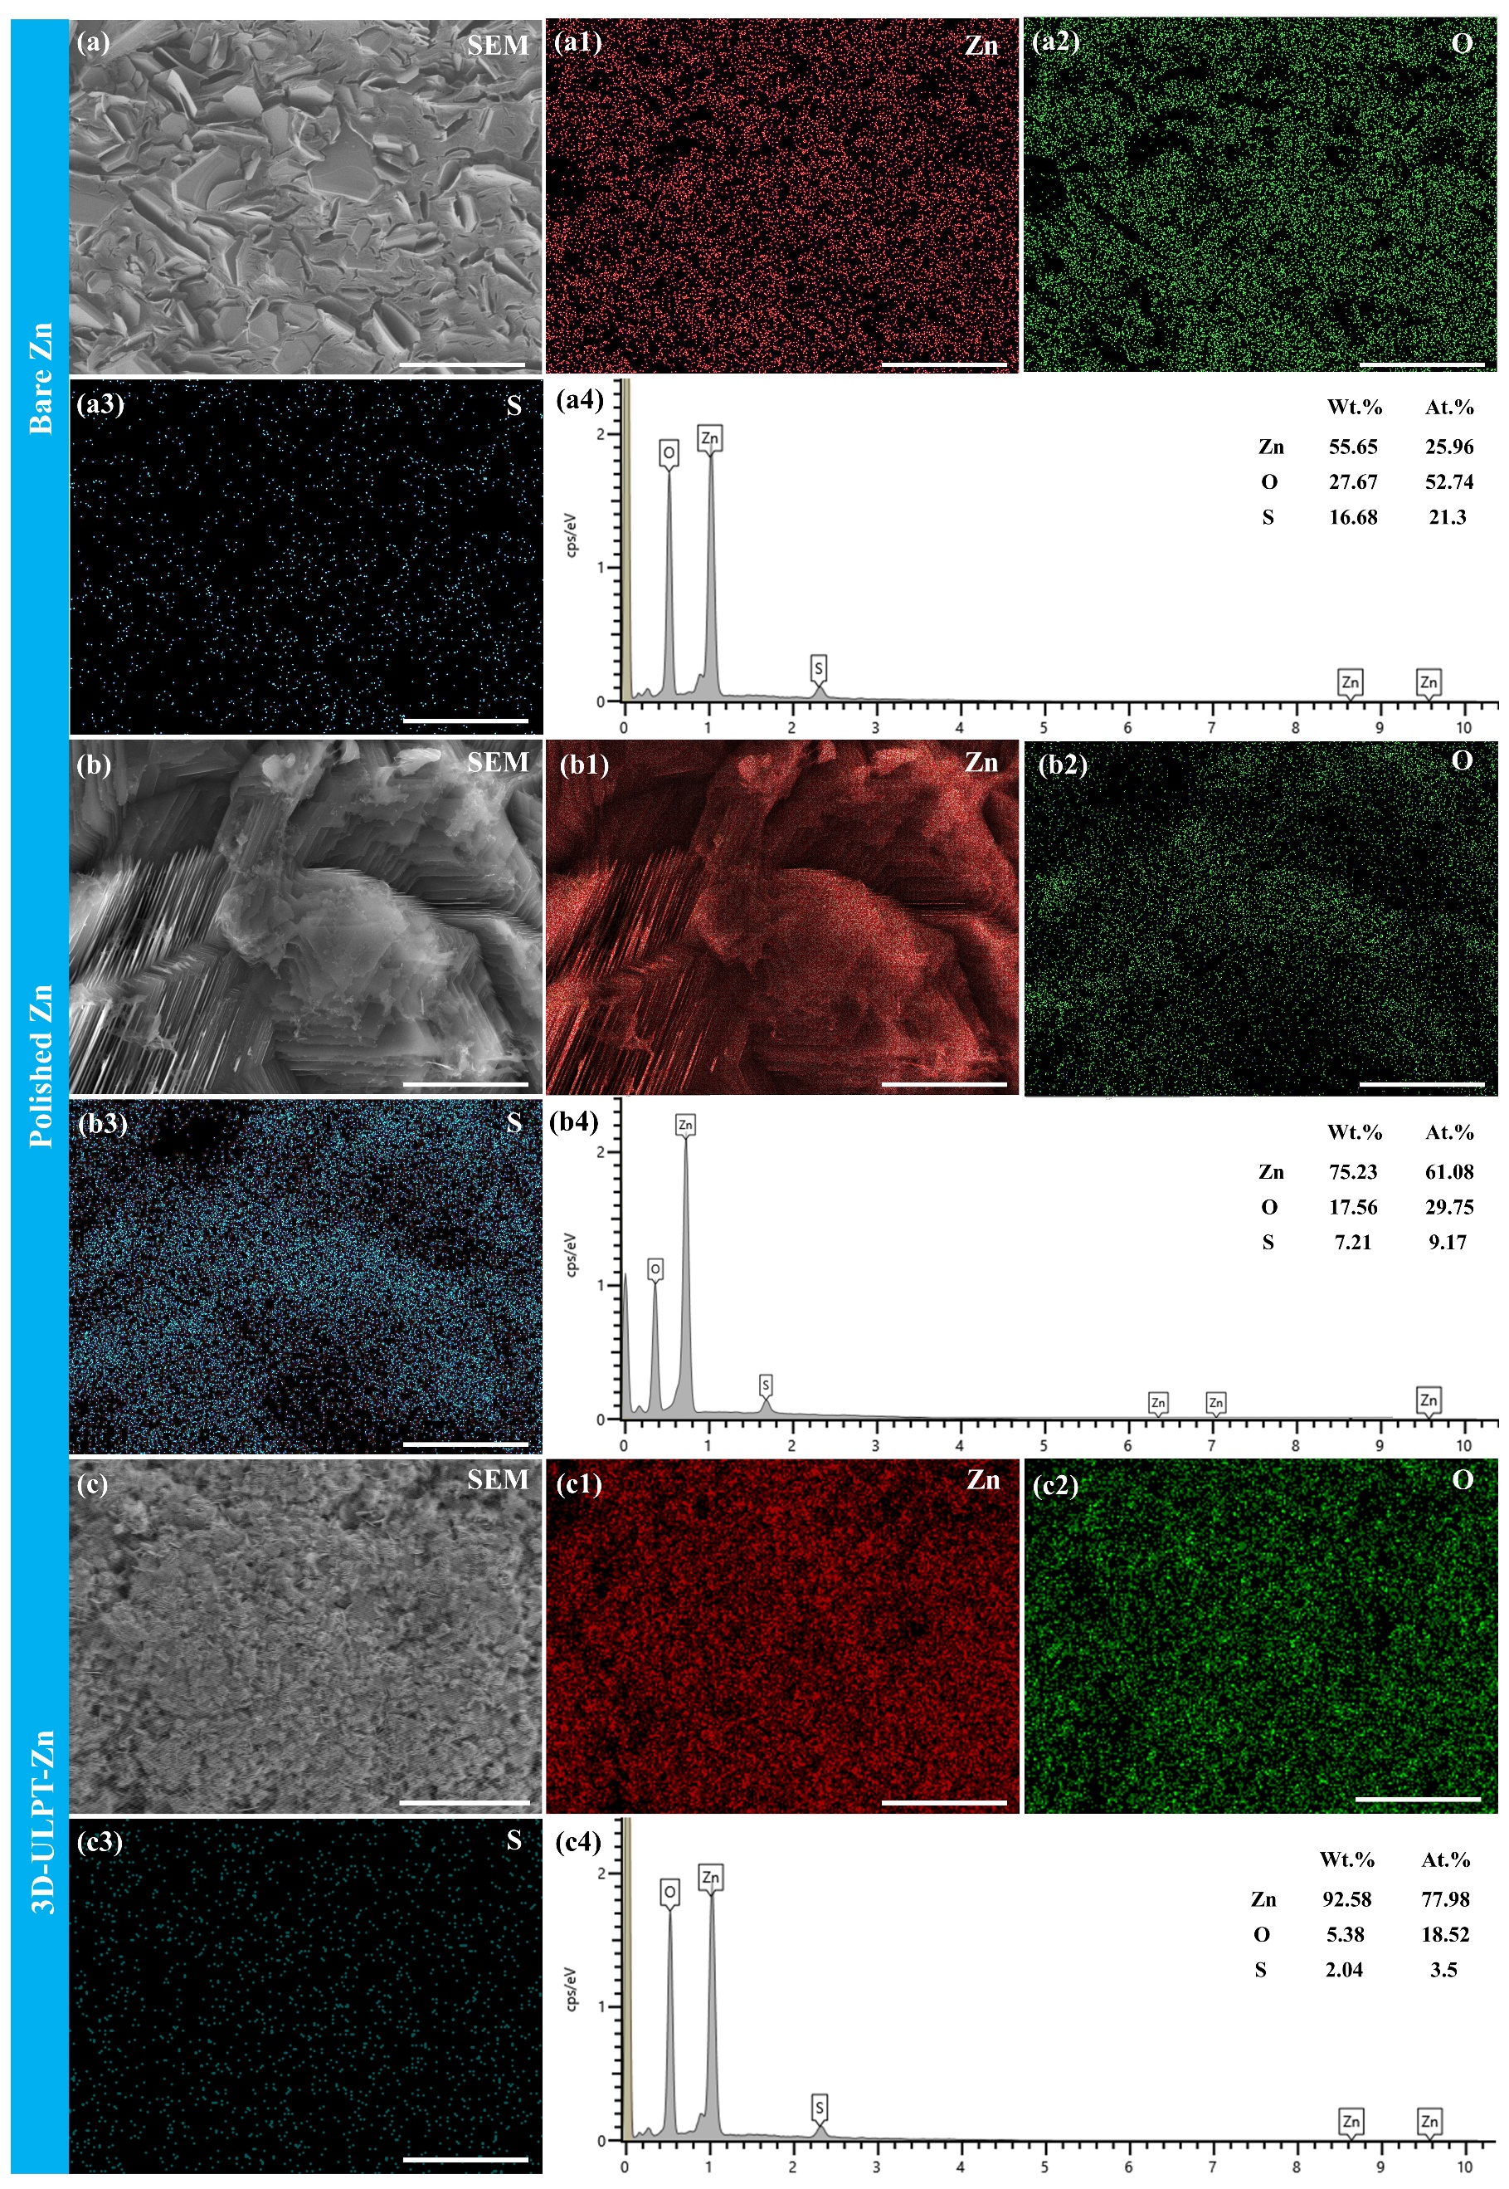
Fig. S13. EDS analysis of (a-a4) Bare Zn, (b-b4) Polished Zn, and (c-c4) 3D-ULPT-Zn anodes after deposited at the current density of 5 mA cm⁻² and the areal capacity of 12 mAh cm⁻². Scale bar: 10 μm.
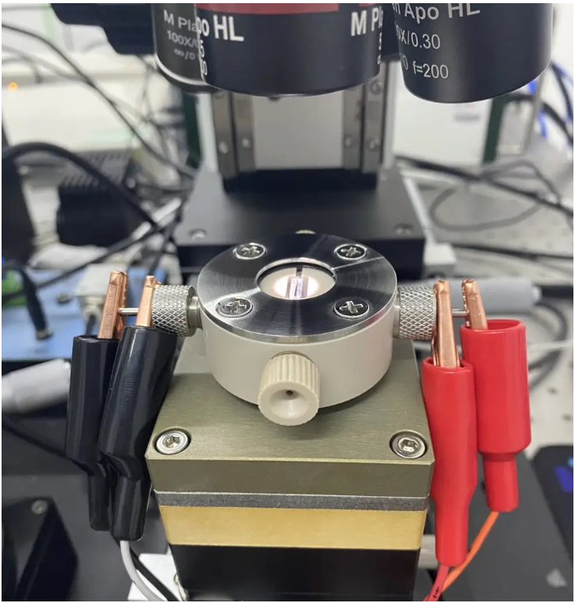
Fig. S14. Digital photo of Zn deposition visualization by in situ optical microscopy.
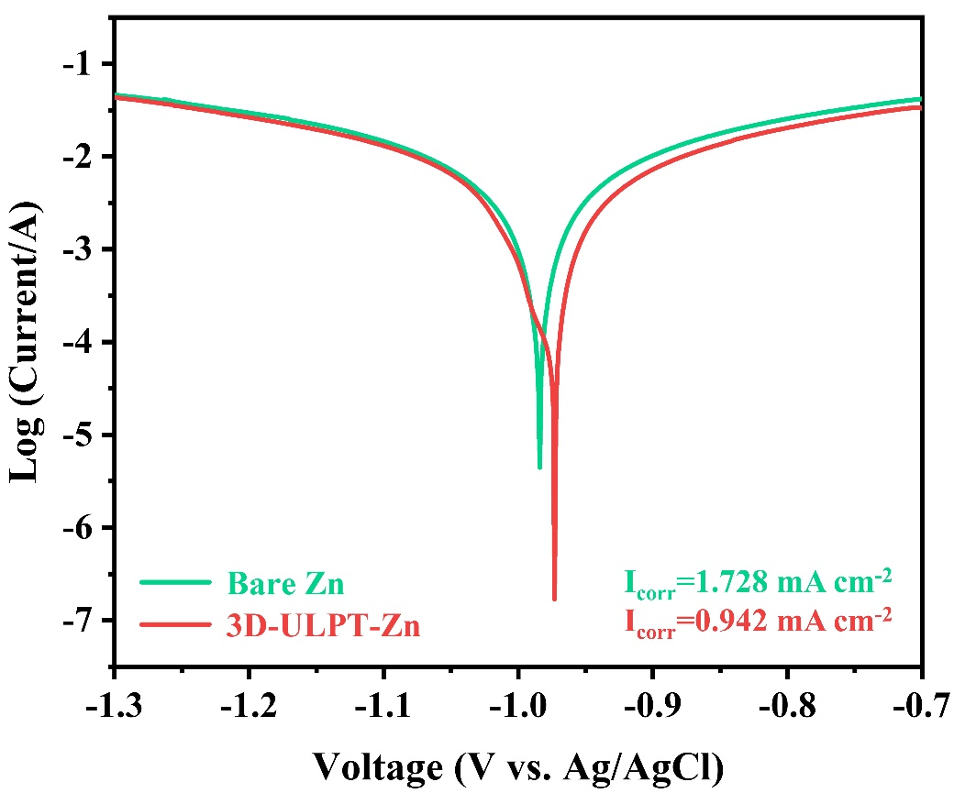
Fig. S15. Linear polarization curves displaying the corrosion on bare Zn and 3D-ULPT-Zn anodes.
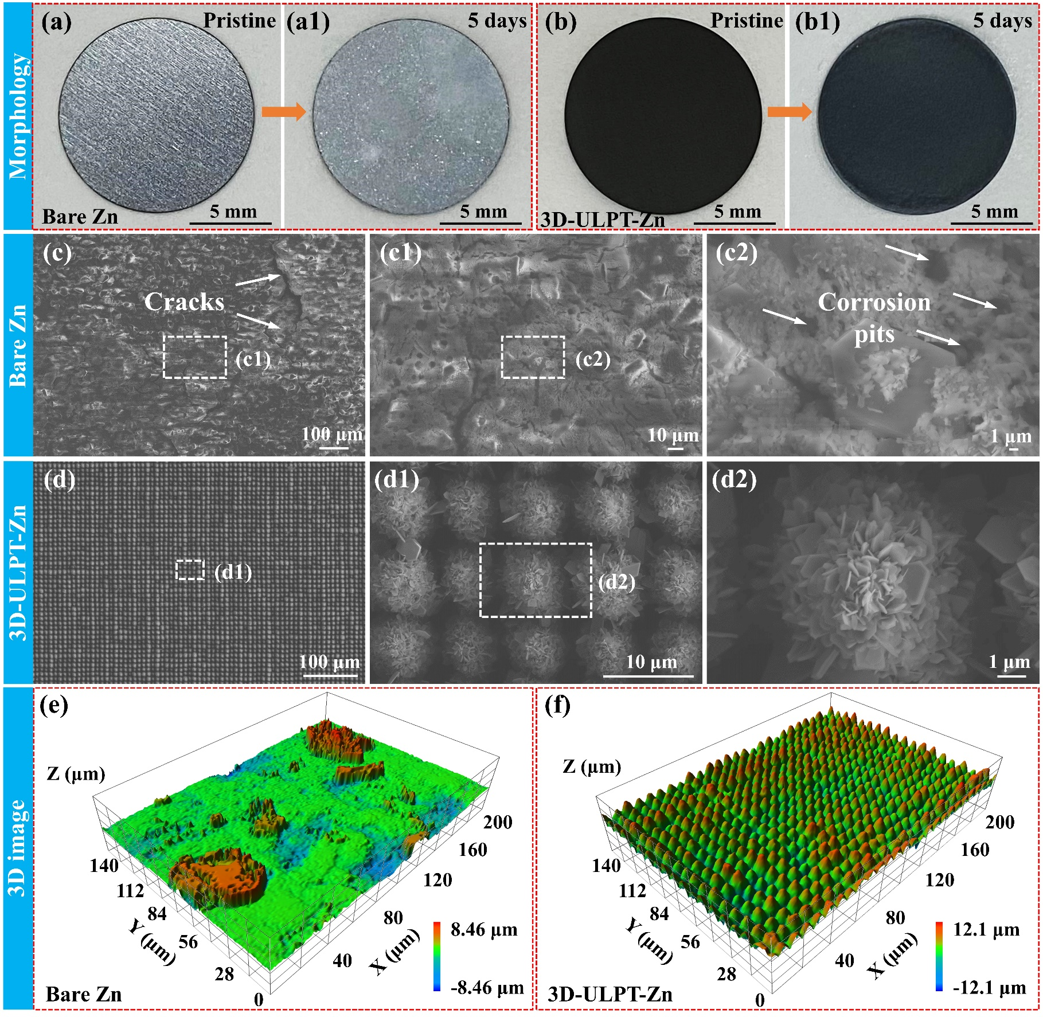
Fig. S16. Morphology of (a-a1) bare Zn and (b-b1) 3D-ULPT-Zn anodes before and after immersion in 2 M aqueous ZnSO₄ electrolyte for 5 days. SEM images of (c-c2) bare Zn and (d-d2) 3D-ULPT-Zn anodes immersed in 2 M aqueous ZnSO₄ electrolyte for 5 days. 3D images of (e) bare Zn and (f) 3D-ULPT-Zn anodes immersed in 2 M aqueous ZnSO₄ electrolyte for 5 days.
Fig. S16(a-b) shows the morphology of the bare Zn and 3D-ULPT-Zn anodes before and after immersion in 2 M ZnSO₄ aqueous electrolyte for 5 days, respectively. As shown in Fig. S16(a-a1), the surface of bare Zn loses its original metallic luster after being immersed in 2 M aqueous ZnSO₄ electrolyte for 5 days, indicating the formation of a passivation film caused by the reaction between Zn and the electrolyte. As a comparison, there was no significant change in the 3D-ULPT-Zn anode before and after immersion in the electrolyte (Fig. S16b1). Combining the SEM images in Fig. S16(c-d) and 3D images in Fig. S16(e-f), it can be concluded that the 3D-ULPT-Zn electrode exhibits better corrosion resistance, demonstrating its high stability in the electrolyte.

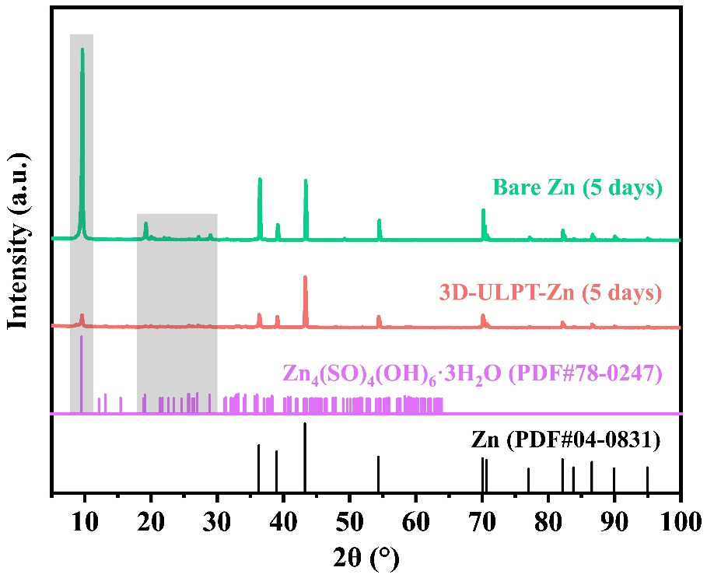
Fig. S17. XRD patterns of bare Zn and 3D-ULPT-Zn anodes immersed in 2 M ZnSO₄ aqueous electrolyte for 5 days.

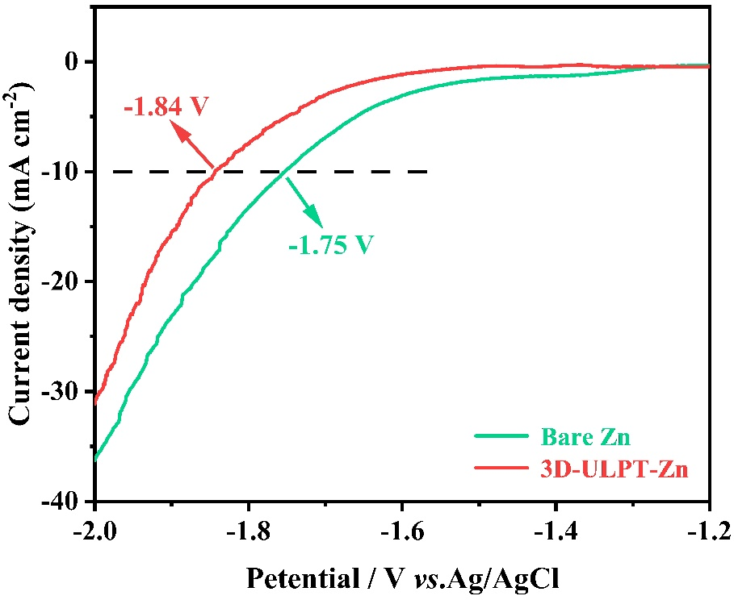
Fig. S18. LSV curves of bare Zn and 3D-ULPT-Zn anodes at 1 mV s⁻¹.
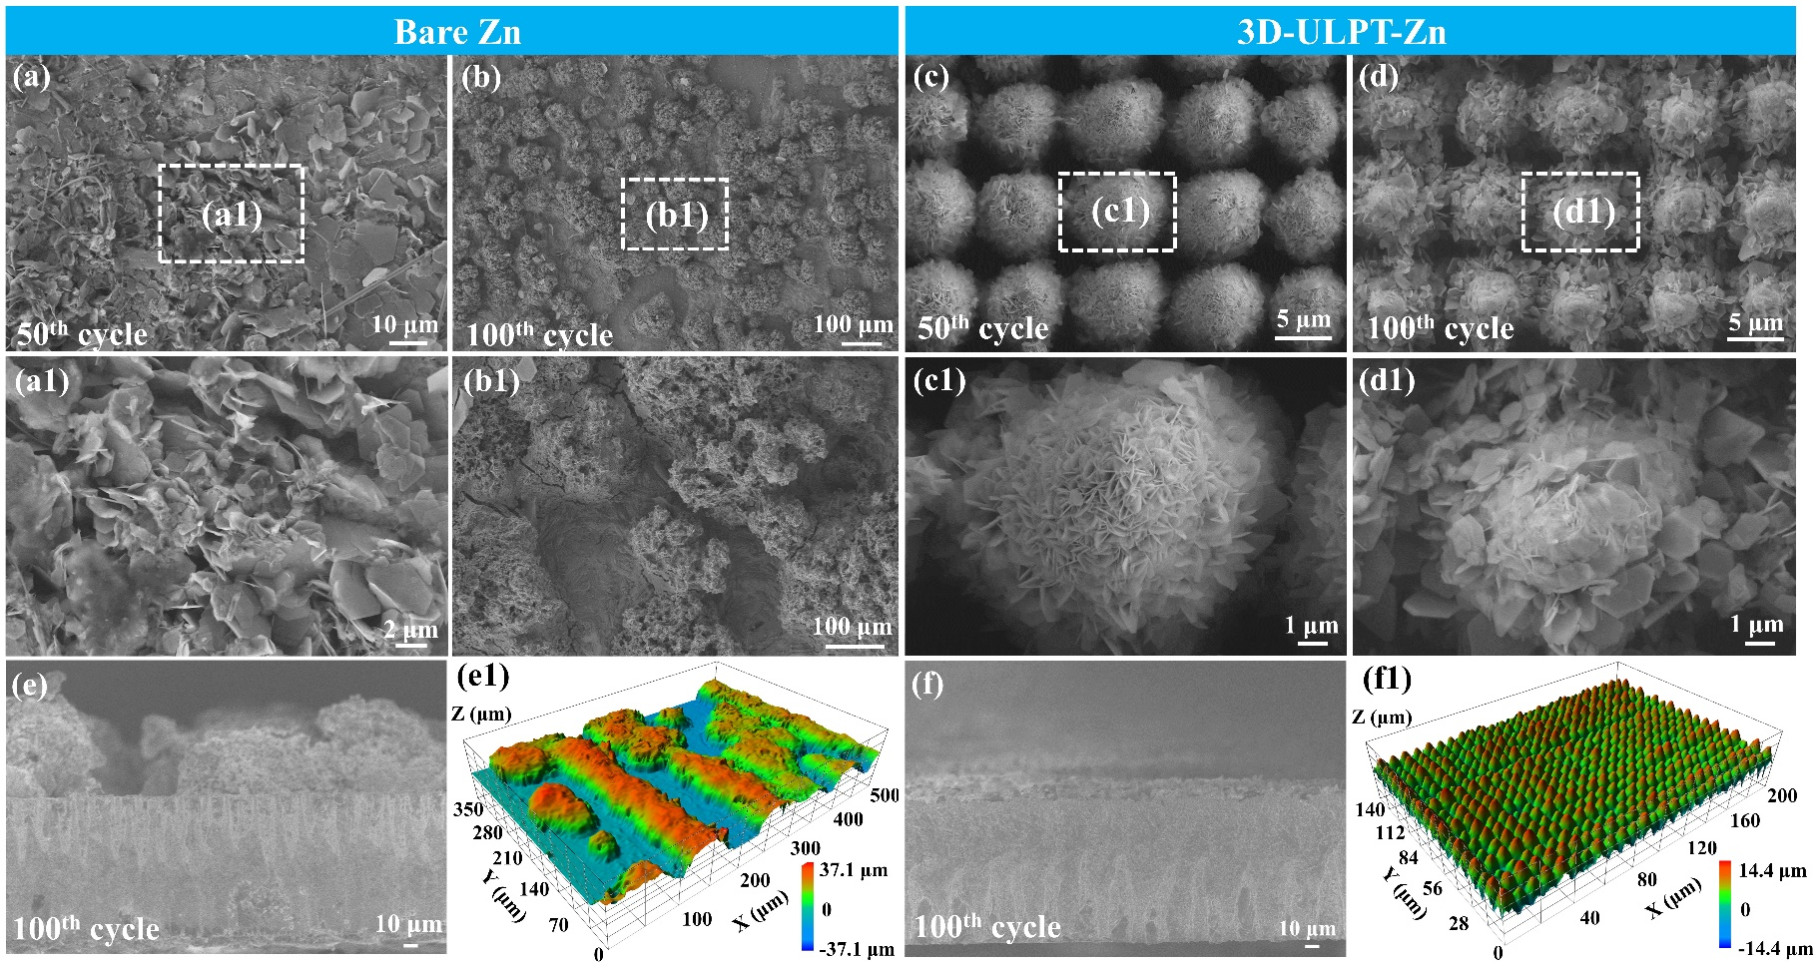
Fig. S19. SEM images of (a-b) bare Zn and (c-d) 3D-ULPT-Zn anodes after (a) 50 and (b) 100 cycles at the current density of 5 mA cm⁻² and areal capacity of 2 mAh cm⁻². Cross-section morphology of (e) bare Zn and (f) 3D-ULPT-Zn anodes after 100 cycles at the current density of 5 mA cm⁻² and areal capacity of 2 mAh cm⁻². 3D images of (e1) bare Zn and (f1) 3D-ULPT-Zn anodes after 100 cycles at the current density of 5 mA cm⁻² and areal capacity of 2 mAh cm⁻².
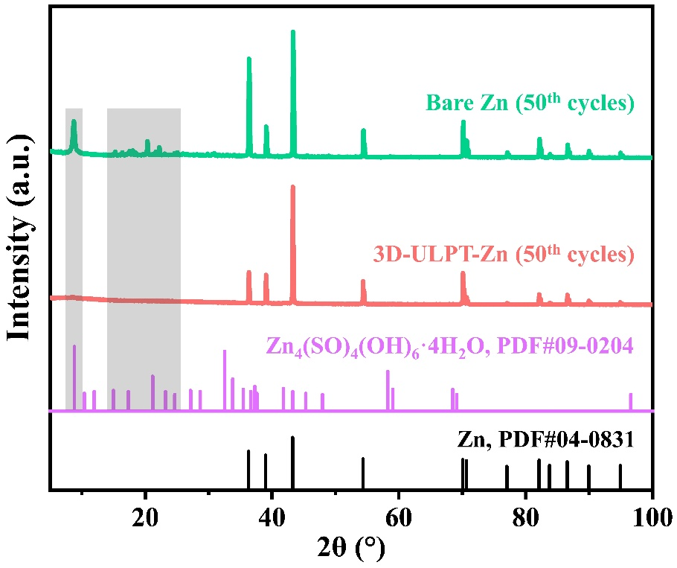
Fig. S20. XRD patterns of bare Zn and 3D-ULPT-Zn anodes after 50 cycles at the current density of 5 mA cm⁻² and areal capacity of 2 mAh cm⁻².
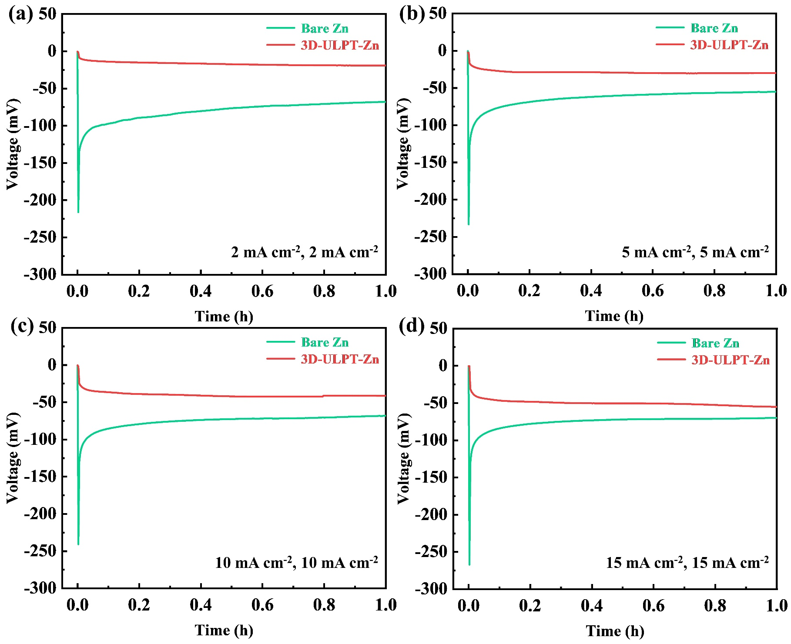
Fig. S21. Nucleation overpotential of bare Zn and 3D-ULPT-Zn anodes at different current densities and areal capacities. (a) 2 mA cm⁻², 2 mAh cm⁻². (b) 5 mA cm⁻², 5 mAh cm⁻². (c) 10 mA cm⁻², 10 mAh cm⁻². (d) 15 mA cm⁻², 15 mAh cm⁻².
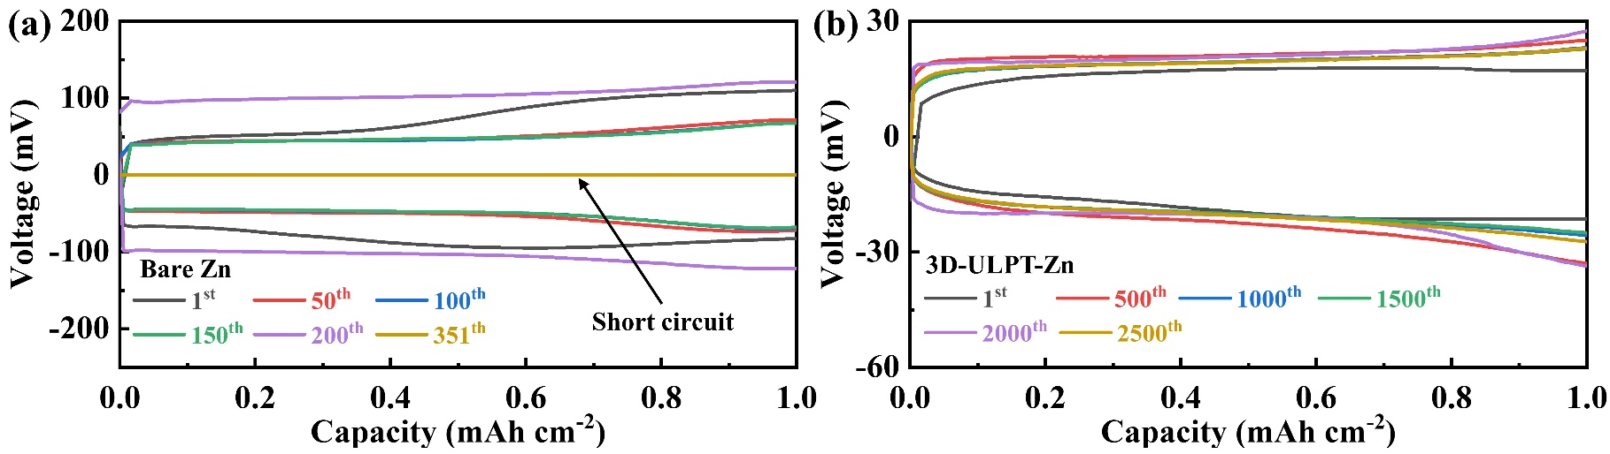
Fig. S22. Voltage-capacity curves of bare Zn and 3D-ULPT-Zn anodes after different cycles at the current density of 2 mA cm⁻² and areal capacity of 1 mAh cm⁻².
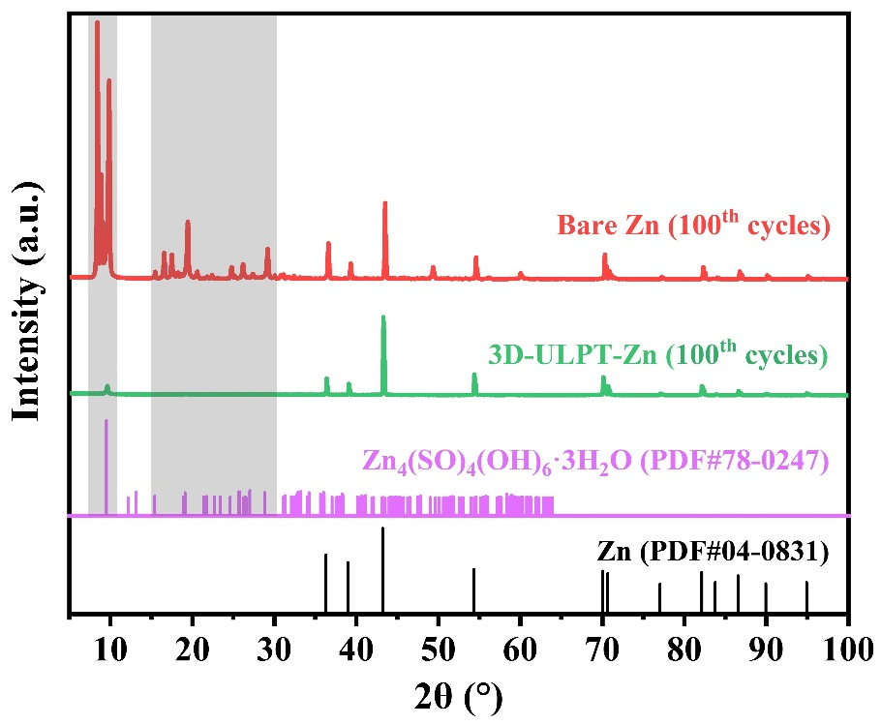
Fig. S23. XRD patterns of bare Zn and 3D-ULPT-Zn anodes after 100 cycles at the current density of 15 mA cm⁻² and the areal capacity of 15 mAh cm⁻².
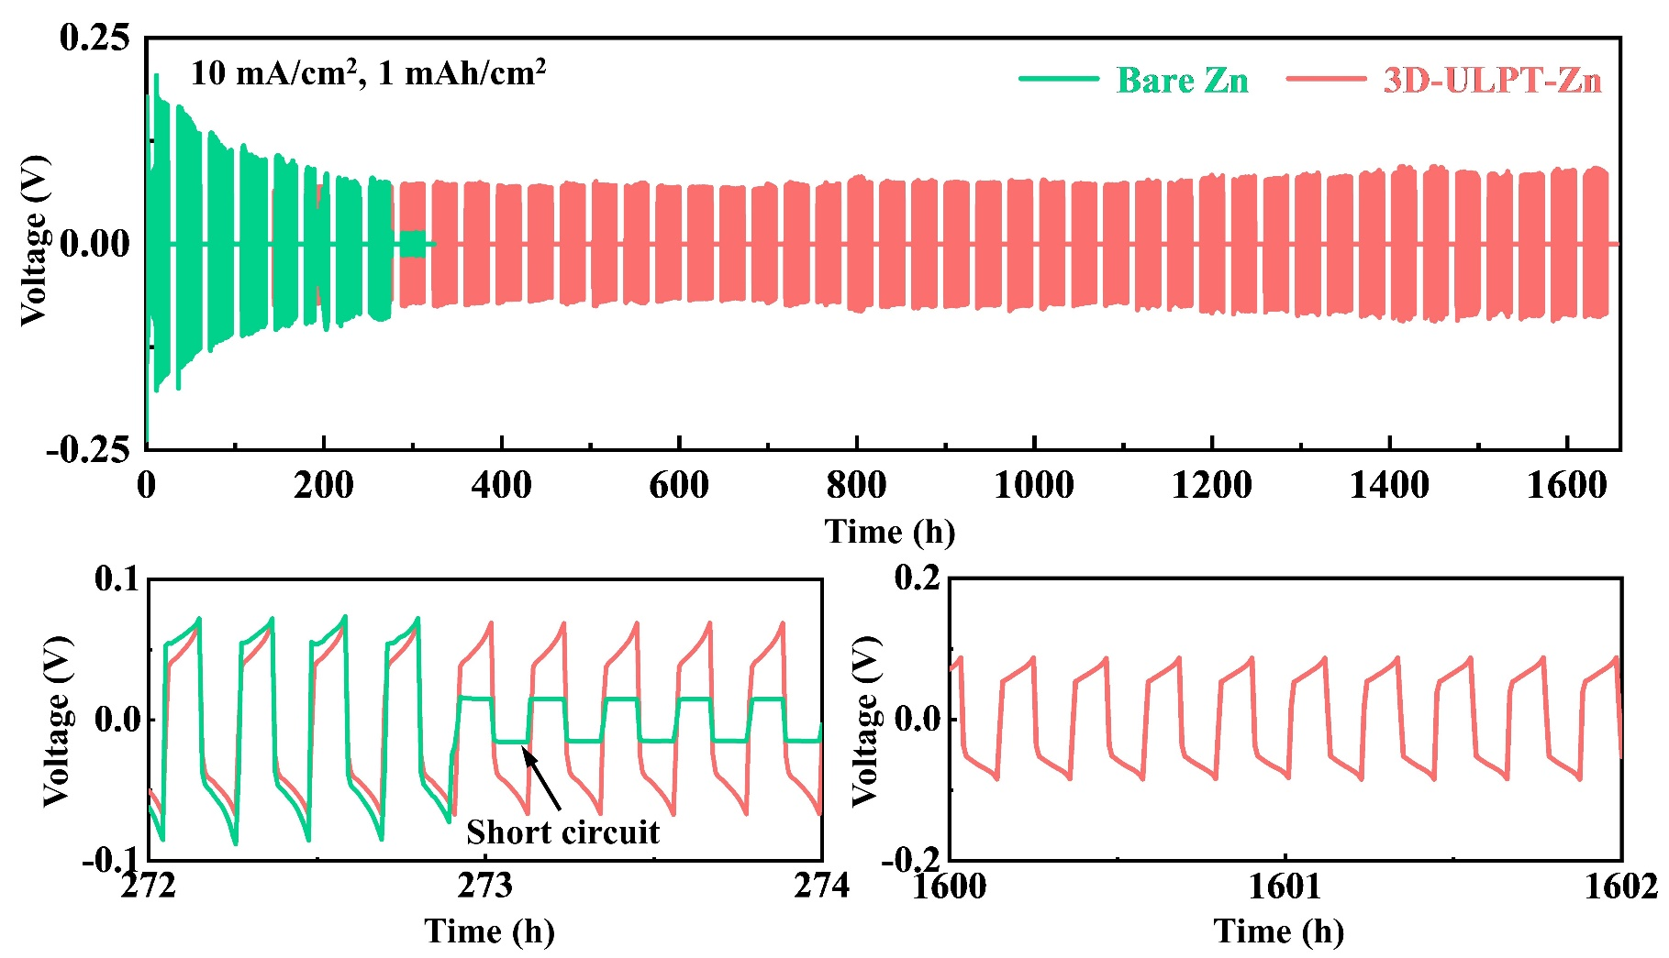
Fig. S24. GCD performance of Zn//Zn and 3D-ULPT-Zn//3D-ULPT-Zn symmetric cells under work-rest tests at the current density of 10 mA cm⁻² and the areal capacity of 1 mAh cm⁻².
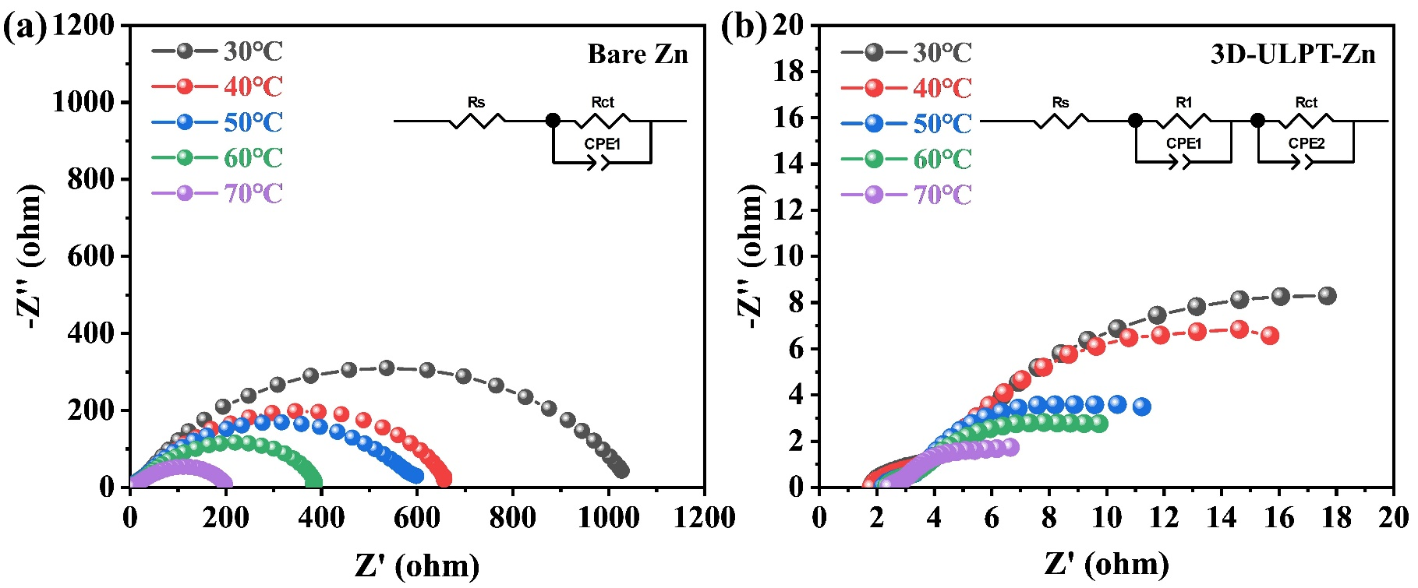
Fig. S25. Nyquist plots at different temperatures for (a) bare Zn and (b) 3D-ULPT-Zn anodes. The insets indicate the equivalent circuit fitting results.
The activation energy (E_{a}) can be obtained using the Arrhenius equation:
(S1)
where R_{ct}, A, R, and T represent the charge transfer resistance, pre-exponential factor, molar gas constant, and absolute temperature, respectively. The R_{ct} value is obtained by fitting the EIS curves of Zn//Zn and 3D-ULPT-Zn//3D-ULPT-Zn symmetric cells at different temperatures ranging from 30 to 70 ℃.
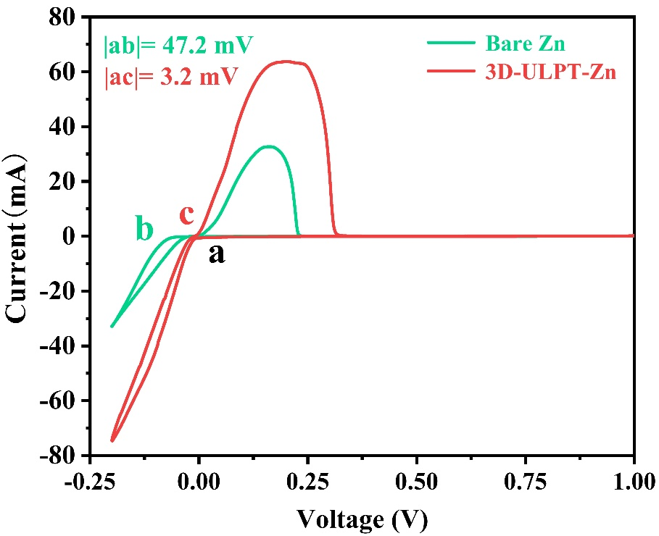
Fig. S26. CV curves of Zn//Cu and 3D-ULPT-Zn//Cu asymmetric cells at 0.1 mV s⁻¹.
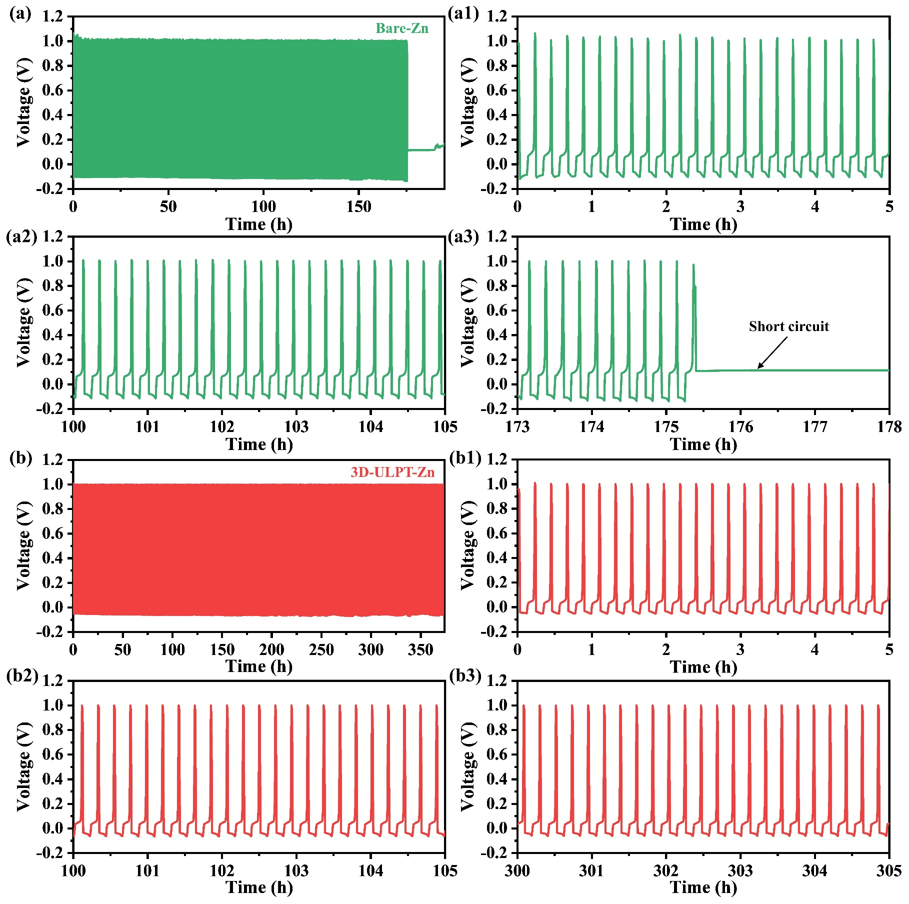
Fig. S27. Voltage-time curves of (a) bare Zn and (b) 3D-ULPT-Zn anodes during the CE measurement.
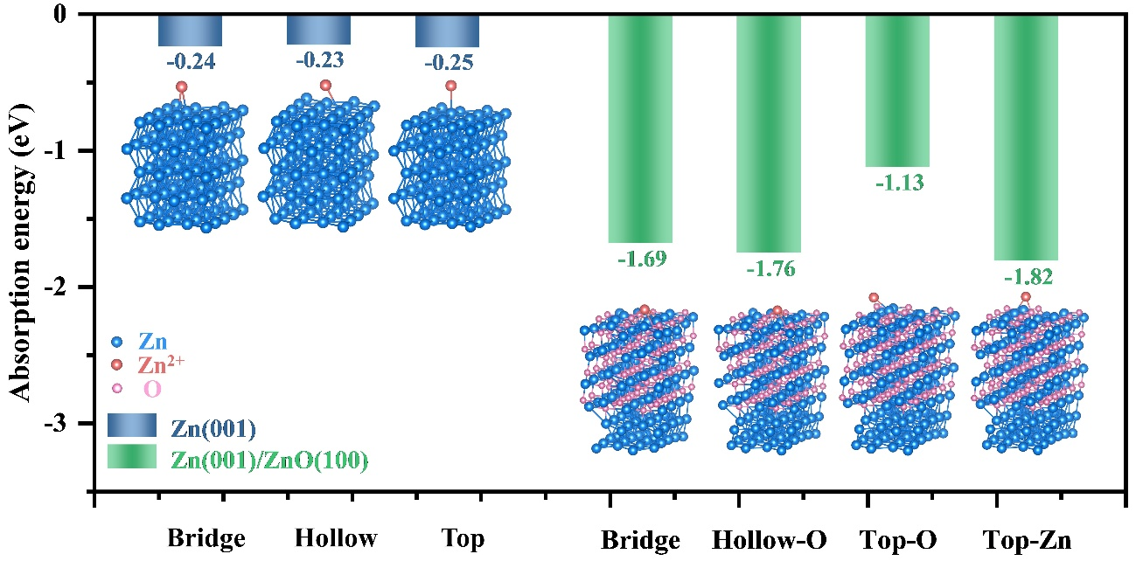
Fig. S28. Absorption energy comparison of Zn²⁺ on Zn(001) and Zn(001)/ZnO(100) surfaces. The insets indicate the constructed Zn²⁺ absorbed models for different sites.
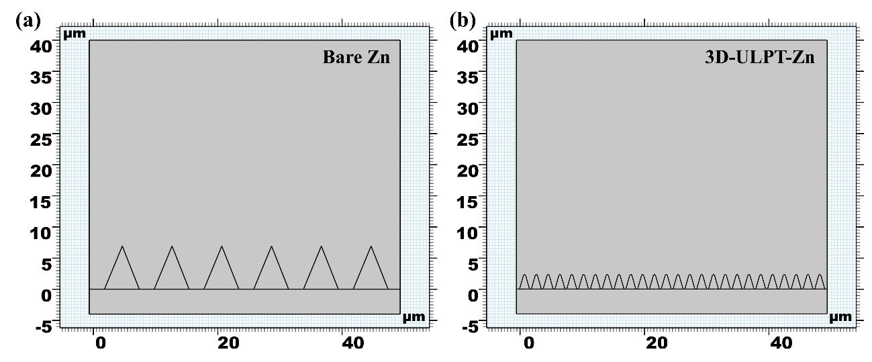
Fig. S29. Simulation geometric modeling of (a) bare Zn and (b) 3D-ULPT-Zn electrodes during the Zn deposition process.
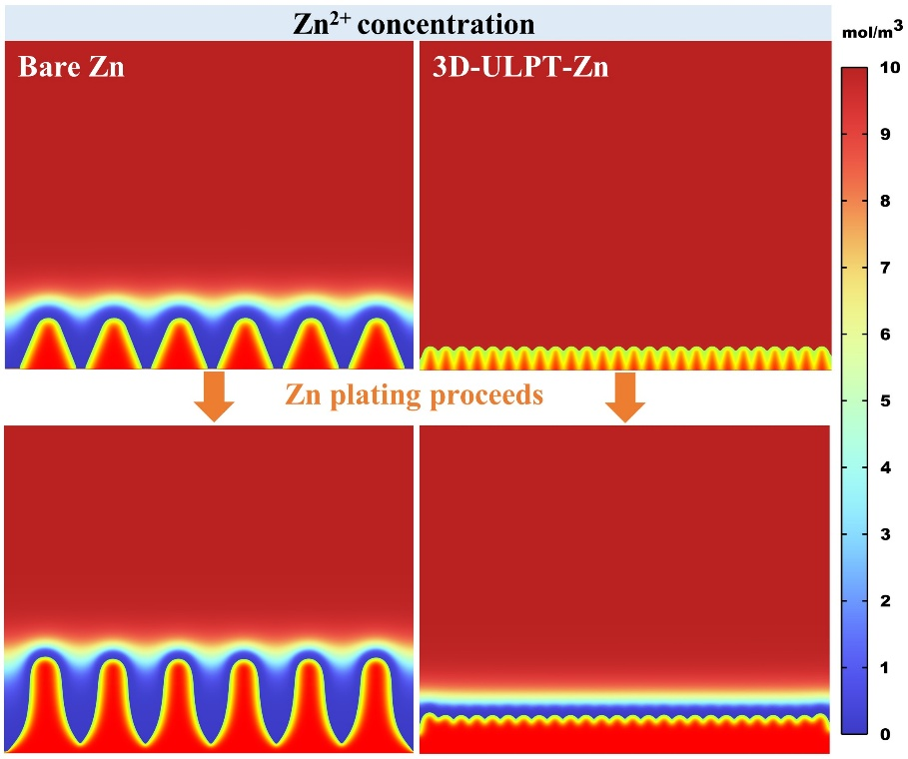
Fig. S30. Simulation results of Zn²⁺ concentration distribution of bare Zn and 3D-ULPT-Zn anodes during the plating process before and after 30 s.
.
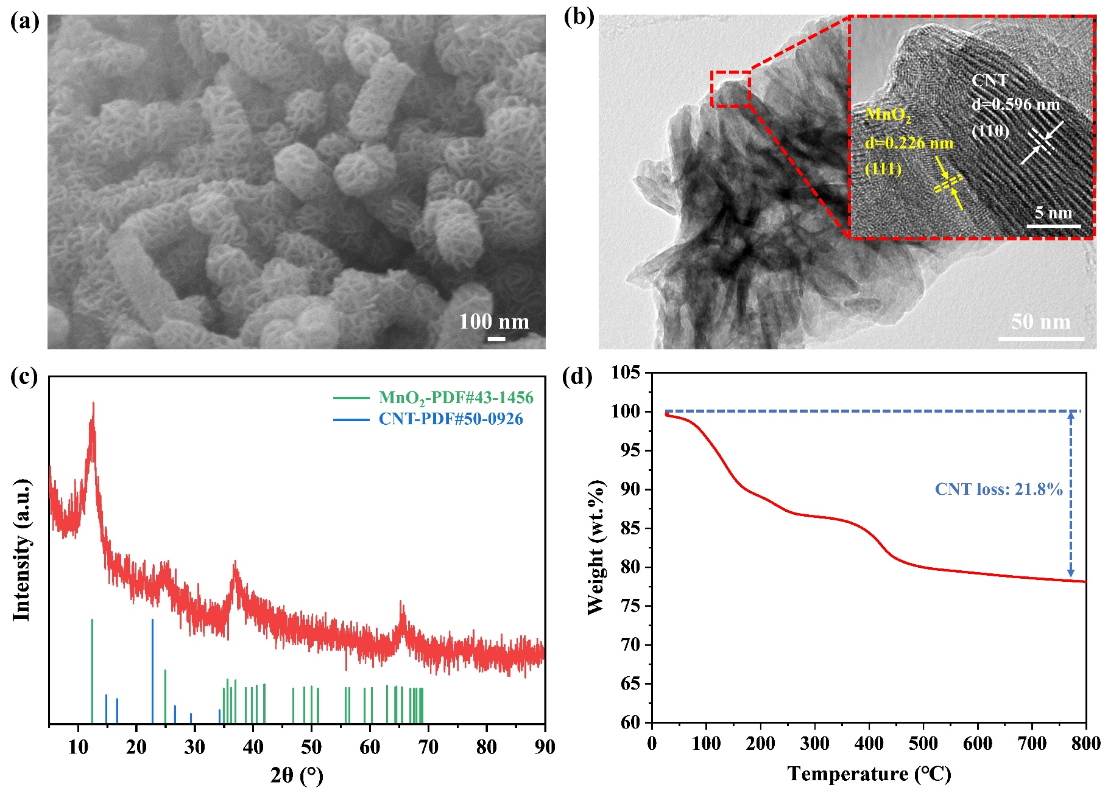
Fig. S31. (a) SEM image, (b) TEM image, (c) XRD pattern, and (d) TG curve of MnO₂@CNT materials.
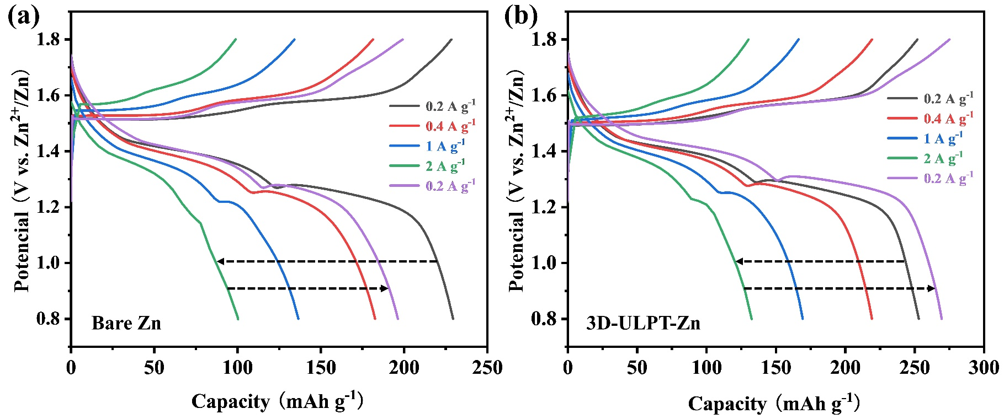
Fig. S32. Rate charge-discharge curves of (a) Zn//MnO₂@CNT and (b) 3D-ULPT-Zn//MnO₂@CNT full cells ranging from 0.2 to 2 A g⁻¹.
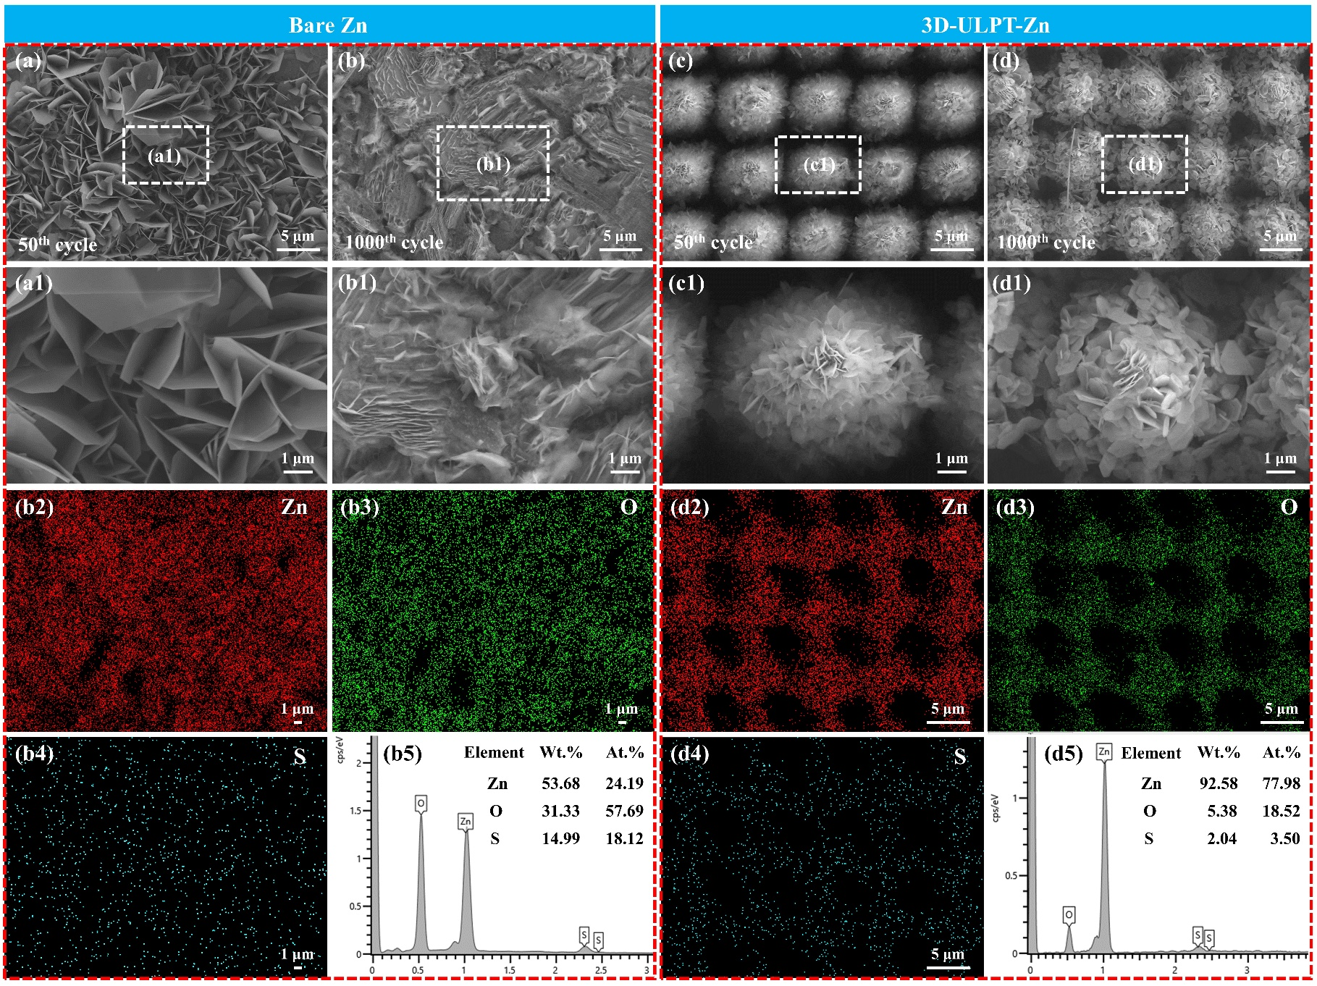
Fig. S33. SEM images of (a-b) Zn//MnO₂@CNT and (c-d) 3D-ULPT-Zn//MnO₂@CNT full cells after (a) and (c) 50 cycles, and (b) and (d) 1000 cycles at 1 A g⁻¹. EDS mapping elements of (b2) Zn, (b3) O, and (b4) S of (b). (b5) EDS element proportion of (b). EDS mapping elements of (d2) Zn, (d3) O, and (d4) S of (d). (d5) EDS element proportion of (d).

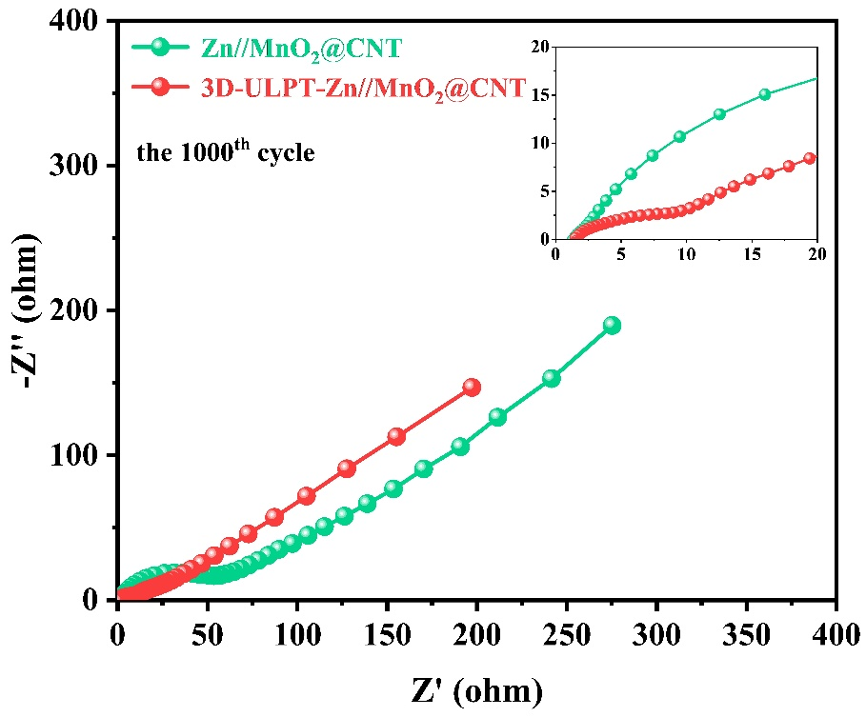
Fig. S34. EIS results of Zn//MnO₂@CNT and 3D-ULPT-Zn//MnO₂@CNT full cells after 1000 cycles at 1 A g⁻¹.
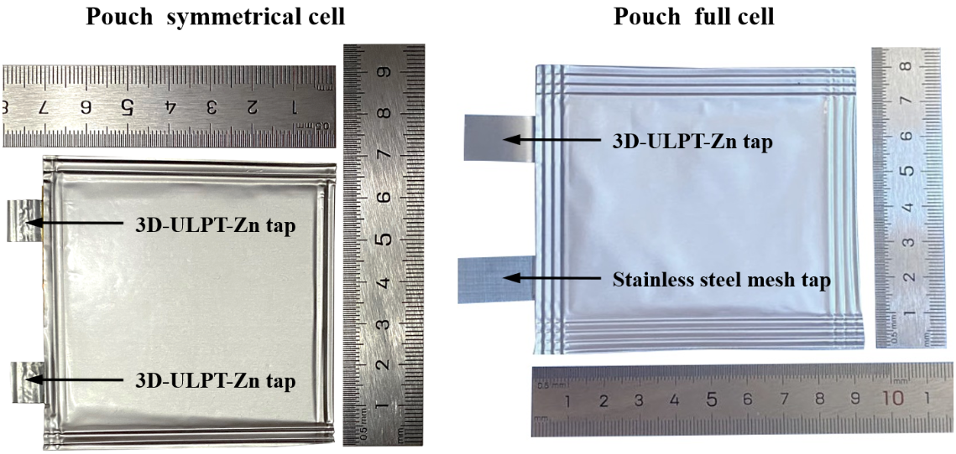
Fig. S35. Digital photograph of 3D-ULPT-Zn//3D-ULPT-Zn and 3D-ULPT-Zn//MnO₂@CNT pouch cells.
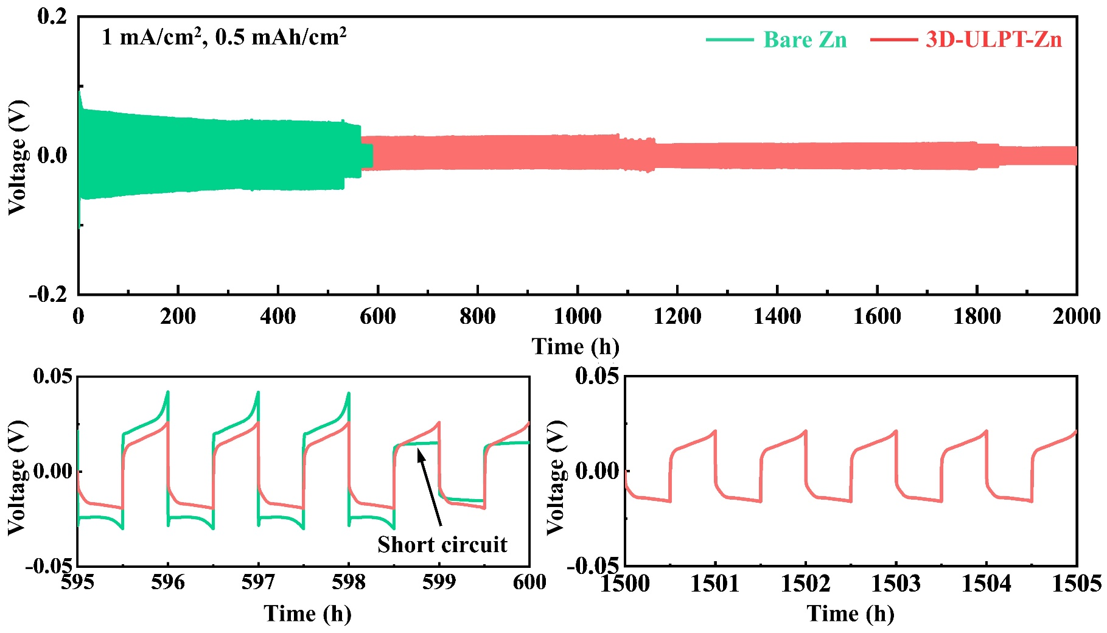
Fig. S36. GCD performance of Zn//Zn and 3D-ULPT-Zn//3D-ULPT-Zn pouch cells.
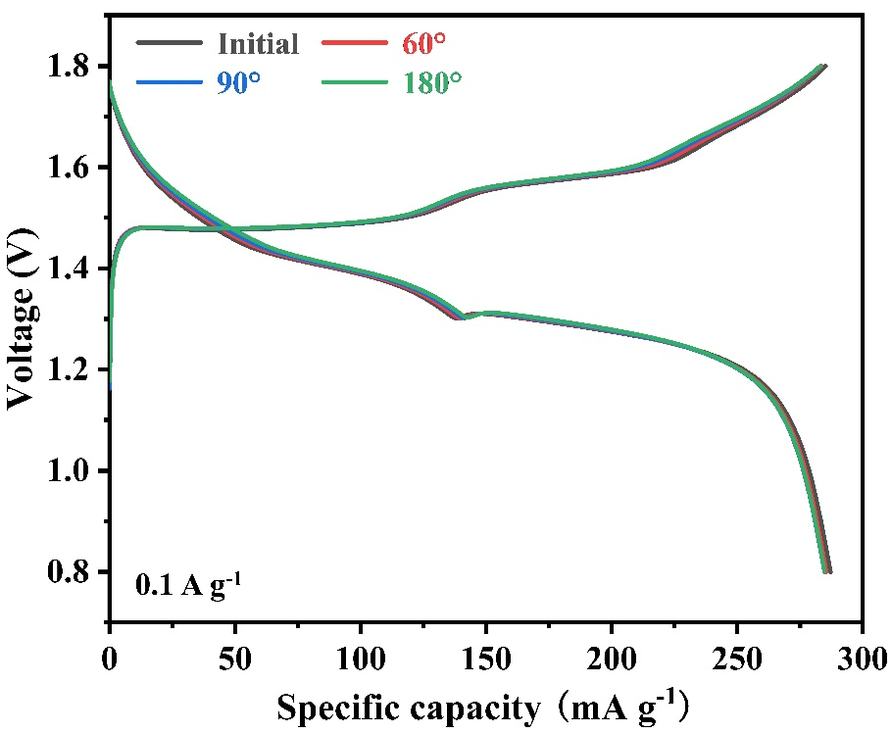
Fig. S37. Discharge-charge profiles of the 3D-ULPT-Zn//MnO₂@CNT pouch cell in different states.
Table S1. Fitting resistance results of Zn//Zn and 3D-ULPT-Zn//3D-ULPT-Zn symmetric cells at different temperatures ranging from 30 to 70 ℃.
Symmetrical cells | Resistance (Ω) | 30℃ | 40℃ | 50℃ | 60℃ | 70℃
Zn//Zn | R_{ct} | 1042.5 | 660.2 | 619.4 | 383.3 | 200.1
3D-ULPT-Zn//3D-ULPT-Zn | R_{ct} | 35.5 | 30.2 | 22.2 | 17.8 | 10.9

Table S2. Performance comparisons of the AZIBs developed in the present work and those of recently researched 3D structures via various methodologies.
Modification  Strategies | Areal density  (mA cm⁻²) | Areal capacity  (mAh cm⁻²) | Lifespan  (h) | Ref. | Published  Year
3D-ULPT-Zn | 2 | 1 | 2530 | This work
3D-ULPT-Zn | 5 | 2 | 620 | This work
3D-ULPT-Zn | 15 | 1 | 500 | This work
3D-ULPT-Zn | 15 | 15 | 240 | This work
3D Zn/CC | 5 | 2.5 | 110 | Adv. Mater.^{[1]} | 2019
Zn@ZnO HPA | 5 | 2.5 | 100 | Adv. Funct. Mater.^{[2]} | 2020
CNT foam | 3 | 0.5 | 168 | J. Mater. Chem. A^{[3]} | 2020
Cu mesh@CuO | 1 | 1 | 340 | Small ^{[4]} | 2020
3D CNT scaffolds | 1 | 1 | 400 | Chem. Eng. J.^{[5]} | 2020
3D Zn@N-VG@CC | 0.5 | 0.5 | 150 | Adv. Funct. Mater.^{[6]} | 2021
Zn micromesh | 5 | 2 | 250 | Adv. Funct. Mater.^{[7]} | 2021
3D Ni-Zn | 5 | 2 | 200 | Adv. Energy Mater.^{[8]} | 2021
3D-ZGC | 5 | 5 | 250 | Adv. Mater.^{[9]} | 2022
ZnO-3D coating | 5 | 1.25 | 500 | Energy Environ. Sci.^{[10]} | 2022
3D Cu networks | 5 | 2.5 | 280 | Nano-Micro Lett.^{[11]} | 2022
Triple-gradient Zn | 10 | 1 | 250 | Adv. Mater.^{[12]} | 2022
3D-ZGC | 5 | 5 | 250 | Adv. Mater.^{[13]} | 2022
3D ZnOHF | 2 | 1 | 400 | Energy Storage Mater.^{[14]} | 2022
Cu NBs@NCFs | 2 | 2 | 300 | Adv. Mater.^{[15]} | 2022
C_{flower} | 5 | 2.5 | 150 | Nano Lett.^{[16]} | 2022

References
[1] Zeng Y, Zhang X, Qin R, Liu X, Fang P, Zheng D, Tong Y, Lu X. Dendrite-Free Zinc Deposition Induced by Multifunctional CNT Frameworks for Stable Flexible Zn-Ion Batteries. Adv Mater. 2019;31:1903675.
[2] Kim J, Liu G, Shim G, Kim H, Lee J. Functionalized Zn@ZnO Hexagonal Pyramid Array for Dendrite-Free and Ultrastable Zinc Metal Anodes. Adv Funct Mater. 2020;30:2004210.
[3] Zhou Y, Wang X, Shen X, Shi Y, Zhu C, Zeng S, Xu H, Cao P, Wang Y, Di J, Li Q. 3D confined zinc plating/stripping with high discharge depth and excellent high-rate reversibility. J Mater Chem A. 2020;8:11719-27.
[4] Zhang Q, Luan J, Huang X, Zhu L, Tang Y, Ji X, Wang H. Simultaneously Regulating the Ion Distribution and Electric Field to Achieve Dendrite-Free Zn Anode. Small. 2020;16:2000929.
[5] Dong L, Yang W, Yang W, Tian H, Huang Y, Wang X, Xu C, Wang C, Kang F, Wang G. Flexible and conductive scaffold-stabilized zinc metal anodes for ultralong-life zinc-ion batteries and zinc-ion hybrid capacitors. Chem Eng J. 2020;384:123355.
[6] Cao Q, Gao H, Gao Y, Yang J, Li C, Pu J, Du J, Yang J, Cai D, Pan Z, Guan C, Huang W. Regulating Dendrite-Free Zinc Deposition by 3D Zincopilic Nitrogen-Doped Vertical Graphene for High-Performance Flexible Zn-Ion Batteries. Adv Funct Mater. 2021;31:2103922.
[7] Liu H, Li J, Zhang X, Liu X, Yan Y, Chen F, Zhang G. Ultrathin and Ultralight Zn Micromesh-Induced Spatial-Selection Deposition for Flexible High-Specific-Energy Zn-Ion Batteries. Adv Funct Mater. 2021;31:2106550.
[8] Zhang G, Zhang X, Liu H, Li J, Chen Y. 3D-Printed Multi-Channel Metal Lattices Enabling Localized Electric-Field Redistribution for Dendrite-Free Aqueous Zn Ion Batteries. Adv Energy Mater. 2021;11:2003927.
[9] Xue P, Guo C, Li L, Li H, Luo D, Tan L, Chen Z. A MOF-Derivative Decorated Hierarchical Porous Host Enabling Ultrahigh Rates and Superior Long-Term Cycling of Dendrite-Free Zn Metal Anodes Adv Mater. 2022;34:2110047.
[10] Xie X, Liang S, Gao J, Guo S, Guo J, Wang C, Xu G, Wu X, Chen G, Zhou J. Manipulating the Ion-Transference Kinetics and Interface Stability for High-Performance Zinc Metal Anode. Energy Environ Sci. 2020;13:503-10.
[11] Xie S, Li Y, Li X, Zhou Y, Dang Z, Rong J, Dong L. Stable Zinc Anodes Enabled by Zincophilic Cu Nanowire Networks. Nano-Micro Lett. 2022;14:39.
[12] Gao Y, Cao Q, Pu J, Zhao X, Fu G, Chen J, Wang Y, Guan C. Stable Zn Anodes with Triple Gradients. Adv Mater. 2022;35:2207573.
[13] Xue P, Guo C, Li L, Li H, Luo D, Tan L, Chen Z. A MOF-Derivative Decorated Hierarchical Porous Host Enabling Ultrahigh Rates and Superior Long-Term Cycling of Dendrite-Free Zn Metal Anodes. Adv Mater. 2022;34:2270109.
[14] Pan Z, Cao Q, Gong W, Yang J, Gao Y, Gao Y, Pu J, Sun J, Loh X, Liu Z, Guan C, Wang J. Zincophilic 3D ZnOHF nanowire arrays with ordered and continuous Zn²⁺ Ion modulation layer enable long-term stable Zn metal anodes. Energy Storage Mater. 2022;50:435-43.
[15] Zeng Y, Sun P, Pei Z, Jin Q, Zhang X, Yu L, Lou X. Nitrogen-Doped Carbon Fibers Embedded with Zincophilic Cu Nanoboxes for Stable Zn-Metal Anodes. Adv Mater. 2022;34:2200342.
[16] Xu Z, Jin S, Zhang N, Deng W, Seo M, Wang X. Efficient Zn Metal Anode Enabled by O,N-Codoped Carbon Microflowers. Nano Lett. 2022;22:1350-57.

