Supplementary Information
Large-scale optical switches
by thermo-optic waveguide lens

Tao Chen^{1,†}, Zhangqi Dang^{1,†}, Zeyu Deng^{1,†}, Shijie Ke¹, Zhenming Ding¹ and Ziyang Zhang^{1,}*
¹Laboratory of Photonic Integration, School of Engineering, Westlake University, 18 Shilongshan Road, Hangzhou, China
†These authors contributed equally to this work.
*zhangziyang@westlake.edu.cn

1. The on-axis and off-axis imaging in TOWL
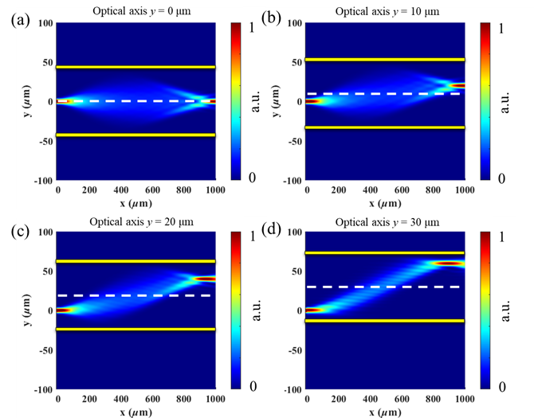
Fig. S1. The simulated field distribution for the on-axis and off-axis 1×1 imaging (D = 90 μm, P = 45 mW/mm, symmetrical heating) with different optical axes: (a) y = 0 μm, (b) y = 10 μm, (c) y = 20 μm and (d) y = 30 μm.

2. Step index MMI vs. TOWL
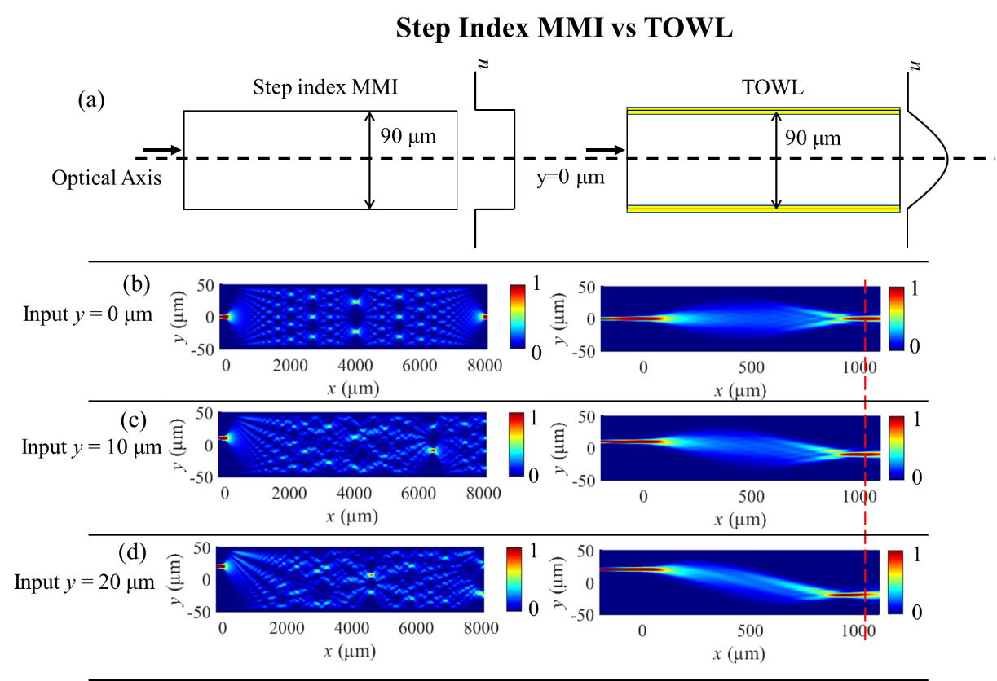
Fig. S2. (a) The schematic of the step index MMI and TOWL. The simulated field of the input axis at (b) y = 0 μm, (c) y = 10 μm, and (d) y = 20 μm. The imaging point deteriorates abruptly in MMI: as the input moves away from the central axis, the 1×1 imaging point gets distorted and moves quickly in both x and y. In contrast, TOWL can maintain a good imaging behavior for off-axis input and the images stay at the same x location.

3. 1×24 MZI switch vs. 1×24 TOWL switch
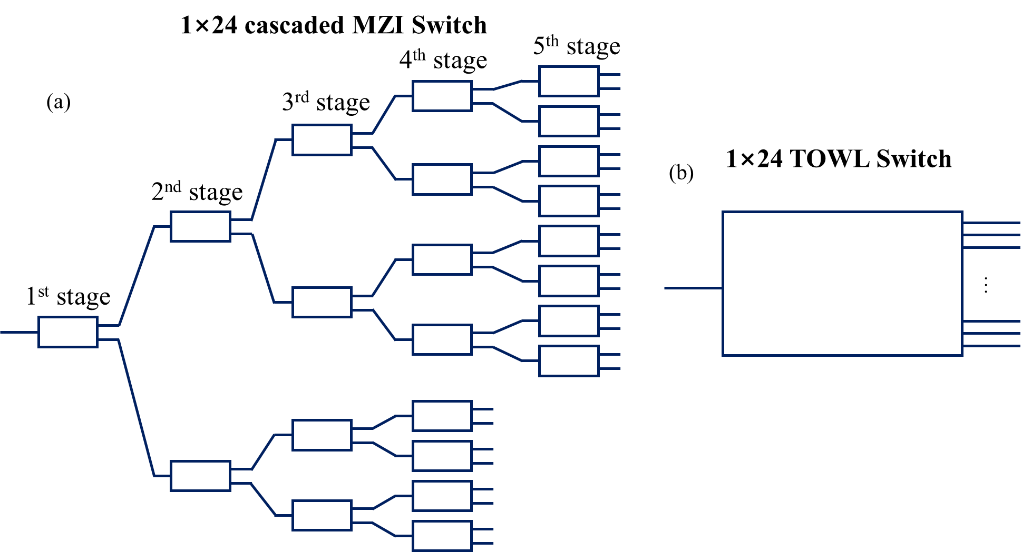
Fig. S3. The schematic of the 1×24 switch based on (a) MZI and (b) TOWL. The MZIs need to be cascaded in 5 stages while the TOWL is a single device.

Table S1. Comparison of MZI and TOWL in constructing large-scale switches
Port Count | Switch Mechanics | Num. of Basic Units | Cascade Stages | Num. of Total Electrodes | Num. of Applied Electrodes
1×24 | MZI | 23 | 5 | 23×2=46 | 10
1×24 | TOWL | 1 | None | 32 | 2
1×576 | MZI | 25×23=575 | 10 | 25×23×2=1150 | 20
1×576 | TOWL | 1+24=25 | 2 | 25×32=800 | 4
1×1024 | MZI | 1023 | 10 | 2046 | 20
1×1152 | TOWL | 51 | 3 | 50×32+2=1602 | 6
1×2^{N} | MZI | 2^{N}-1 | N | 2(2^{N}-1) | 2N
1×24^{M} | TOWL | (24^{M}-1)/23 | M | 32(24^{N}-1)/23 | 2M
Note: An MZI switch unit has 2 electrodes and a 1×24 TOWL switch unit has 32. Here, only the contributing electrodes for the phase shift (MZI) and the interference modulation (TOWL) are counted, leaving out the interconnect and pads as their designs depend on the specific bonding / integration technology.

4. Topology for constructing a N×N TOWL switching network
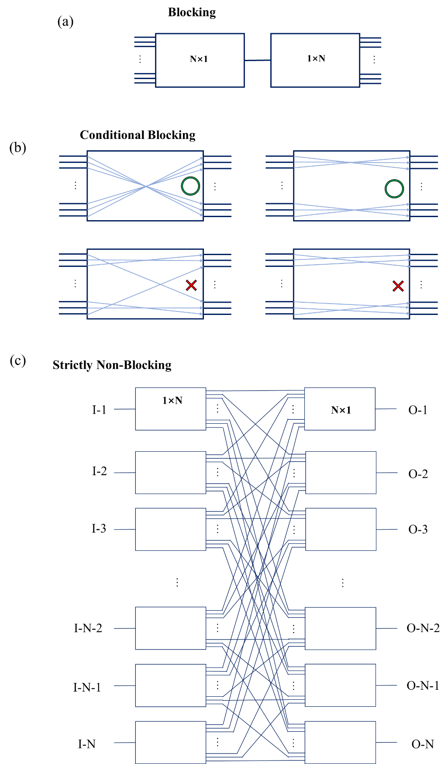
Fig. S4. The schematic of the N×N TOWL switch design with (a) strictly blocking: only one input-output pair is allowed at the same time; (b) conditional blocking: some input-output pairs can operate at the same time; (c) strict non-blocking: any input can be routed to any output at the same time (without beam combining or splitting).

