Supplementary Information

A planar compound eye based microsystem for high precision 3D perception

Li Zhang^{1,2,3}, Haiyang Zhan^{1,2,3}, Xinyuan Liu^{1,2,3}, Hongjing Cao^{1,2,3}, Fei Xing^{1,2,3,*}, Zheng You^{1,2,3}

¹ Department of Precision Instrument, Tsinghua University, Beijing 100084, China.
² State Key Laboratory of Precision Measurement Technology and Instrument, Tsinghua University, Beijing 100084, China
³ Beijing Advanced Innovation Center for Integrated Circuits, Tsinghua University, Beijing, 100084, China.
* Contacting e-mail: Fei Xing (xingfei@mail.tsinghua.edu.cn)

Supplementary Table 1 A summary of the performance of compound eye 3D measurement systems in the references
Reference | Year | Name of system | Baseline/Size of system | Measure/experiment distance | Positioning accuracy | FOV | Focal length | Number of sub-eyes
[1] | 2022 | the stereo compound eye system | ~70mm | 160mm | Horizontal angle: 0.33°;  Pitch angle: 0.32°;  Depth: 1.84mm | 74.2° | \ | 282
[2] | 2021 | 3×3-channel BCEIS | ~20mm | 470mm~670mm | 9 channel: 0.025；  6 channel: 0.06mm；  4 channel: 0.23mm | 30° | 6.2mm | 9
[3] | 2021 | BAC-eye | Ф5mm | 9mm | ~0.1mm | 170° | \ | 522
[4] | 2019 | CurvACE on ACEbot | 12.8mm | 700~900mm | 1.5mm | 96.6° | 0.55um | 630
[5] | 2019 | \ | 12.36mm | 500mm | 3.1%（~6mm） | 90° | 5.48mm | ~200
[6] | 2018 | \ | 8.66mm | 85mm | 10%(~8.5mm) | 24° | 2mm~2.5mm | 61
[7] | 2017 | \ | 4.43mm | 100mm~200mm | 6mm | 40° | 6mm | 7
[8] | 2017 | \ | 25.86mm | 1050mm | 4mm | 110°×90° | \ | 169
[9] | 2016 | \ | 12mm | 150mm | 0.376mm | ~40° | 12mm | 7
[10] | 2015 | active CurvACE | 12.8mm | 1000mm | Horizontal movement: 78mm  Hove: 25mm | 180°×60° | 0.55um | 630
[11] | 2014 | \ | x:31.92mm  y:13.65mm | 106mm  300mm | 106mm: 1.85mm  300mm: 10mm | ~16° | 5.89mm | 247
[12] | 2012 | \ | 6.35mm | 155mm~355mm | 2.41%(~5mm) | \ | 0.083mm | \

Reference：
- Chen, J., Chen, Y., Zhao, H. & Ma, T. Development of neural-network-based stereo bionic compound eyes with fiber bundles. Concurr. Comput.-Pract. Exp. 35, 13, doi:10.1002/cpe.7464 (2023).
- Xian, D., Su, Q., Fengwen, M. & Weiqi, J. Development of a 3x3-channel bionic compound eyes imaging system for target positioning. Proc. SPIE (USA) 11885, 118850V (118810 pp.)-118850V (118810 pp.), doi:10.1117/12.2602394 (2021).
- Dai, B. et al. Biomimetic apposition compound eye fabricated using microfluidic-assisted 3D printing. Nature Communications 12, 11, doi:10.1038/s41467-021-26606-z (2021).
- Colonnier, F., Ramirez-Martinez, S., Viollet, S. & Ruffier, F. A bio-inspired sighted robot chases like a hoverfly. Bioinspir. Biomim. 14, 15,
- Zheng, Y. L., Song, L., Huang, J. X., Zhang, H. Y. & Fang, F. Z. Detection of the three-dimensional trajectory of an object based on a curved bionic compound eye. Opt. Lett. 44, 4143-4146, doi:10.1364/ol.44.004143 (2019).
- Li, L., Hao, Y. P., Xu, J. L., Liu, F. L. & Lu, J. The Design and Positioning Method of a Flexible Zoom Artificial Compound Eye. Micromachines 9, 14, doi:10.3390/mi9070319 (2018).
- Pang, K., Fang, F. Z., Song, L., Zhang, Y. & Zhang, H. Y. Bionic compound eye for 3D motion detection using an optical freeform surface. J. Opt. Soc. Am. B-Opt. Phys. 34, B28-B35, doi:10.1364/josab.34.000b28 (2017).
- Jian, H. J., He, J. Z., Jin, X. Y., Chen, X. C. & Wang, K. Y. Automatic geometric calibration and three-dimensional detecting with an artificial compound eye. Applied Optics 56, 1296-1301, doi:10.1364/ao.56.001296 (2017).
- Frost, S. A., Gorospe, G. E. & Teubert, C. Compound eye sensor for real-time aircraft wing deflection measurement. AIAA Guidance, Navigation and Control Conference, 9 pp.-9 pp. (2016).
- Colonnier, F. et al. A small-scale hyperacute compound eye featuring active eye tremor: application to visual stabilization, target tracking, and short-range odometry. Bioinspir. Biomim. 10, 18, doi:10.1088/1748-3190/10/2/026002 (2015).
- Chen, A. H., He, B. W. & Gao, C. H. in 3rd International Conference on Mechatronics and Control Engineering (ICMCE). 290-294 (Trans Tech Publications Ltd, 2014).
- Chung-You, L., Jun-Fu, C., Ting-Chieh, Y. & Wang, K. Use bionic microlens array and CMOS image sensor for three-dimensional motion detection. 2012 7th IEEE International Conference on Nano/Micro Engineered and Molecular Systems (NEMS), 388-391, doi:10.1109/nems.2012.6196800 (2012).

Supplementary Note 1 Derivation of compound eye 3D perception principle

In compound eye 3D perception, coordinate system and target P(x_{p}, y_{p}, z_{p}) are represented as Figure S1. With the center of the image sensor as the origin, the row and column directions of the image sensor are y and x directions respectively, and the z axis is perpendicular to the image sensor plane. The compound eye optical system is located in front of the sensing unit of the image sensor, and the distance from the sensing unit is focal length f.

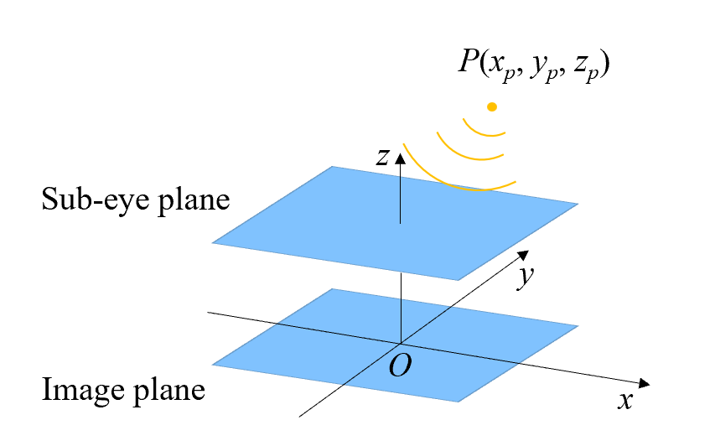
Figure S1 3D perception of compound eye
Suppose that the target images formed by n sub-eye apertures are collected by the image sensor, the horizontal and vertical coordinate information of any pair target images (i, j=1, 2, ..., n) can be calculated according to the parallax principle as a target coordinate P, denoted as P_{(i, j)}=(x_{p(i, j)}, y_{p(i, j)}, z_{p(i, j)}). Take the xOz plane as an example, as shown in Figure S2.
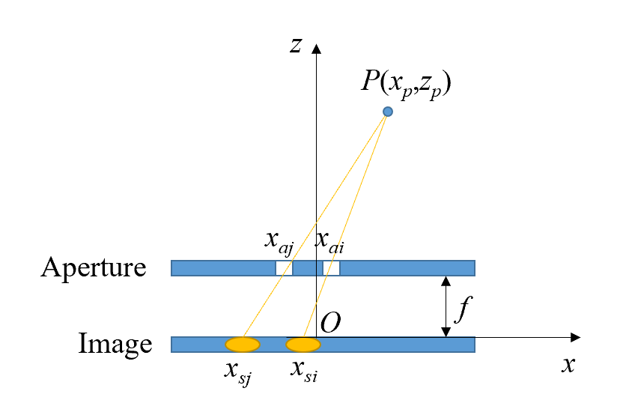
Figure S2 Diagram of target calculation
Based on similar triangles, the formula is as follows:
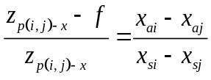 (S1)
Simplify to:
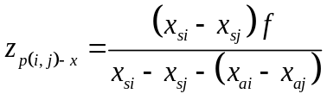 (S2)
For the same reason:
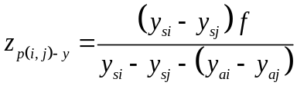 (S3)
For x_{p}, according to similar triangles:
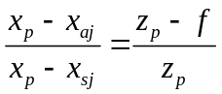 (S4)
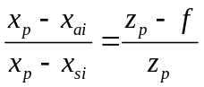 (S5)
Simplify to:
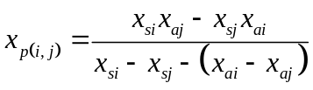 (S6)
For y_{p}, the same can be obtained:
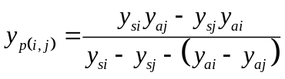 (S7)
There are several pairs of target images in the collected image, and each pair of target images can calculate the 3D information of the target. The final solution results x_{p}, y_{p}, z_{p} are the average or weighted average of the calculated results of the selected point pairs. If k pair of target images in the x direction and l pair of target images in the y direction are selected, then:
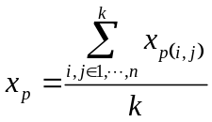 (S8)
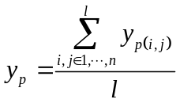 (S9)
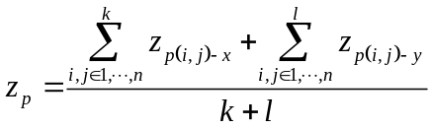 (S10)
Thus, the mathematical model of target position P with aperture center coordinates and image centroid coordinates as independent variables is established:
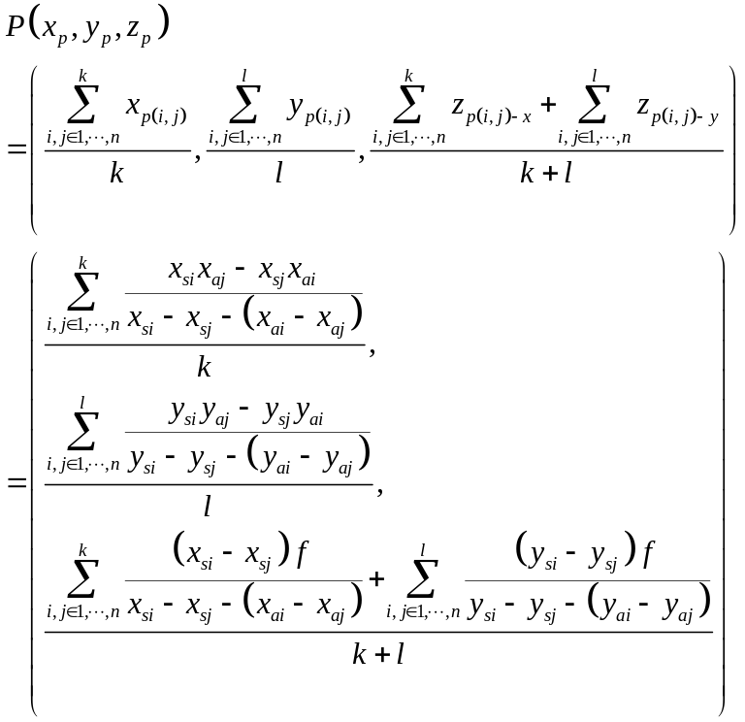 (S11)
Where, x_{p}, y_{p} and z_{p} respectively represent the x, y and z coordinates of target P in the microsystem coordinate system; f is the focal length of the microsystem; n is the number of target images collected in a single measure; x_{si}, y_{si}, i∈1,…,n is the x and y coordinates of the collected target image centroid, x_{ai}, y_{ai}, i∈1,... ,n is the x and y coordinates of the sub-eye aperture center corresponding to the collected target image; and k and l are the number of pairs in the x and y directions selected in different determination algorithms.

Supplementary Note 2 Simulation of whole-FOV with different sizes of sub-eyes at different positions

The sub-eyes at different positions on the compound eye optical system have different FOV, as shown in Supplementary Table 2. The image morphology formed by the same angle of incident light in different size of the sub-eye is different. In this section, the imaging of different sizes of sub-eyes in the whole-FOV is simulated, so as to obtain the optimal aperture size of sub-eyes at different positions.
Supplementary Table 2 The FOV of sub-eye
The distance between the center of the sub-eye and the origin /mm | Starting angle of FOV /° | The main incident light corresponding to the angle of FOV /° | Ending angle of FOV /° | FOV/°
0 | -26.7973 | 0 | 26.7973 | 53.5945
2 | -12.3725 | 15.9454 | 38.3366 | 50.7092
4 | 3.7961 | 29.7449 | 47.1100 | 43.3139
6 | 19.3955 | 40.6013 | 53.7177 | 34.3223
8 | 32.5290 | 48.8141 | 58.7498 | 26.2208
10 | 42.7223 | 55.0080 | 62.6539 | 19.9316
12 | 50.4097 | 59.7436 | 65.7446 | 15.3349
14 | 56.2202 | 63.4349 | 68.2386 | 12.0184
15 | 58.5925 | 64.9831 | 69.3108 | 10.7183
Note: The focal length is 7mm, and the sensor area size is 5mm×$\sqrt{\text{2}}$≈7mm.
According to the analysis in the Microsystem design of article, it is simplified that only the influence of the incident light angle in the l_{p} direction and the size of the aperture in the l_{p} direction on the sub-eye imaging is considered. The focal length of the microsystem is 7mm and the sensing unit of the image sensor is 5mm×5mm. The FOV of the sub-eyes at different positions can be calculated according to the Equation (5) and Equation (6) in the article. The aperture imaging is simulated by Equation (4). The wavelength of the simulation parameters is selected at 532nm, the incidence angle in the y direction remains unchanged at 0°, and the aperture size in the y direction remains unchanged at 0.063mm (the optimal size of the vertical incidence of light).
When the distance between the center of the sub-eye and the center of the image sensor is 0mm, the FOV in the l_{p} direction is -27°~27°. 0°~27° is selected as the simulation FOV range of the l_{p} direction, and the simulation aperture size in the l_{p} direction is 0.050mm~0.090mm. The simulation results are shown in Figure S3.
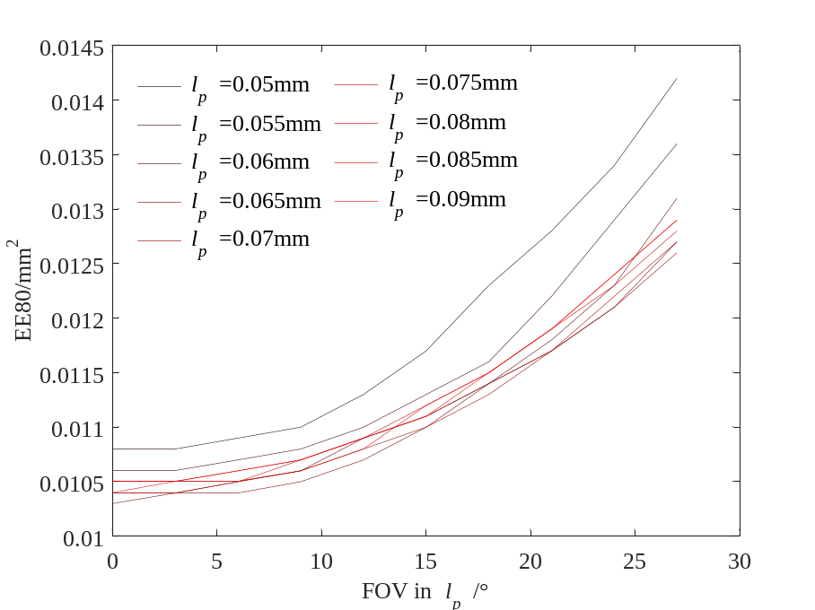
Figure S3 Simulation results of sub-eye at 0mm position
When the distance between the center of the sub-eye and the center of the image sensor is 2mm, the FOV in the l_{p} direction is -12°~39°. 0°~39° is selected as the simulation FOV range of the l_{p} direction, and the simulation aperture size in the l_{p} direction is 0.055mm~0.090mm. The simulation results are shown in Figure S4.

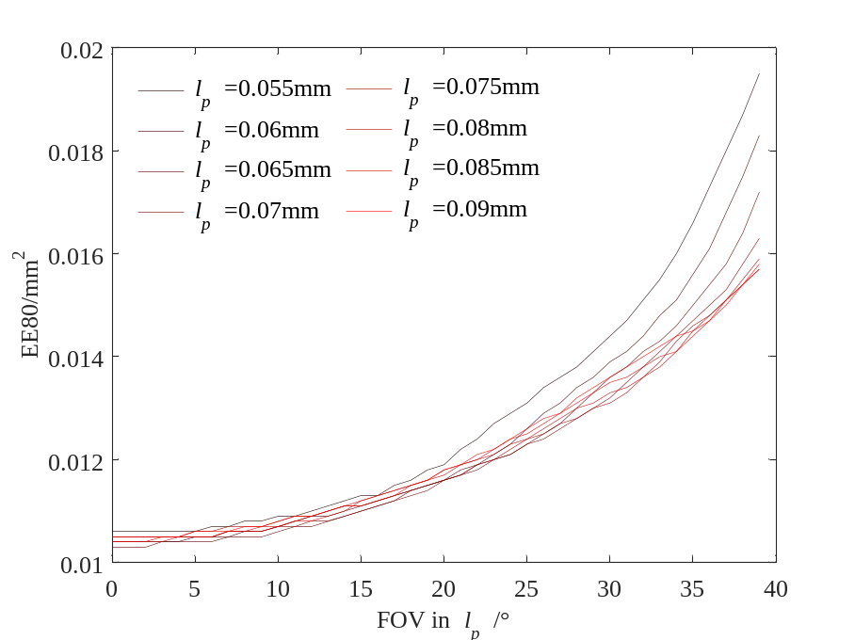
Figure S4 Simulation results of sub-eye at 2mm position
When the distance between the center of the sub-eye and the center of the image sensor is 4mm, the FOV in the l_{p} direction is 3°~47°. 3°~47° is selected as the simulation FOV range of the l_{p} direction, and the simulation aperture size in the l_{p} direction is 0.055mm~0.115mm. The simulation results are shown in Figure S5.
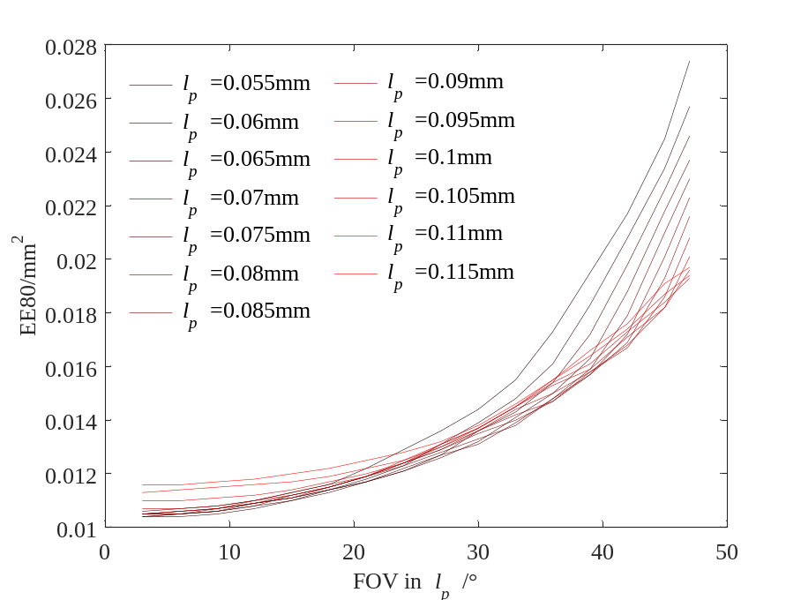
Figure S5 Simulation results of sub-eye at 4mm position
When the distance between the center of the sub-eye and the center of the image sensor is 6mm, the FOV in the l_{p} direction is 19°~54°. 19°~54° is selected as the simulation FOV range of the l_{p} direction, and the simulation aperture size in the l_{p} direction is 0.065mm~0.160mm. The simulation results are shown in Figure S6.
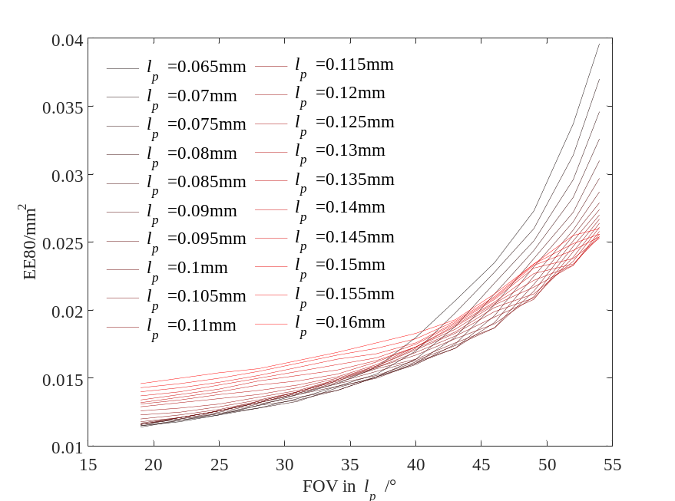
Figure S6 Simulation results of sub-eye at 6mm position
When the distance between the center of the sub-eye and the center of the image sensor is 8mm, the FOV in the l_{p} direction is 32°~59°. 32°~59° is selected as the simulation FOV range of the l_{p} direction, and the simulation aperture size in the l_{p} direction is 0.070mm~0.200mm. The simulation results are shown in Figure S7.
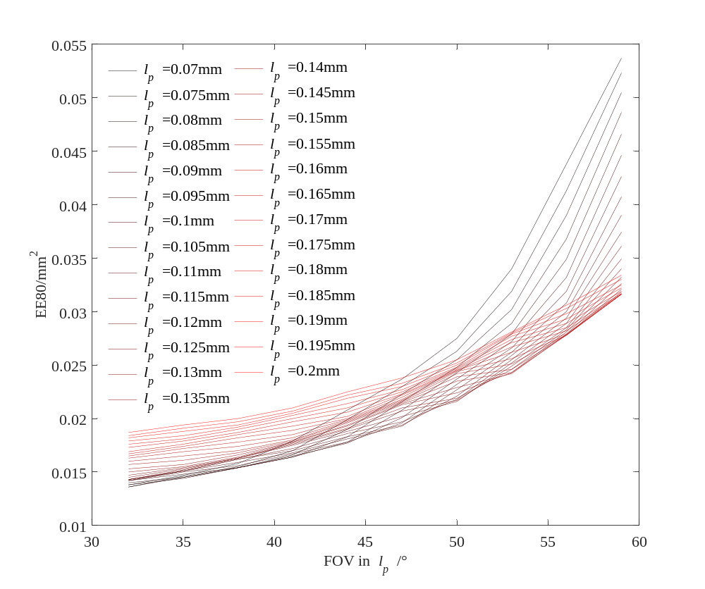
Figure S7 Simulation results of sub-eye at 8mm position
When the distance between the center of the sub-eye and the center of the image sensor is 10mm, the FOV in the l_{p} direction is 42°~63°. 42°~60° is selected as the simulation FOV range of the l_{p} direction, and the simulation aperture size in the l_{p} direction is 0.080mm~0.200mm. The simulation results are shown in Figure S8.
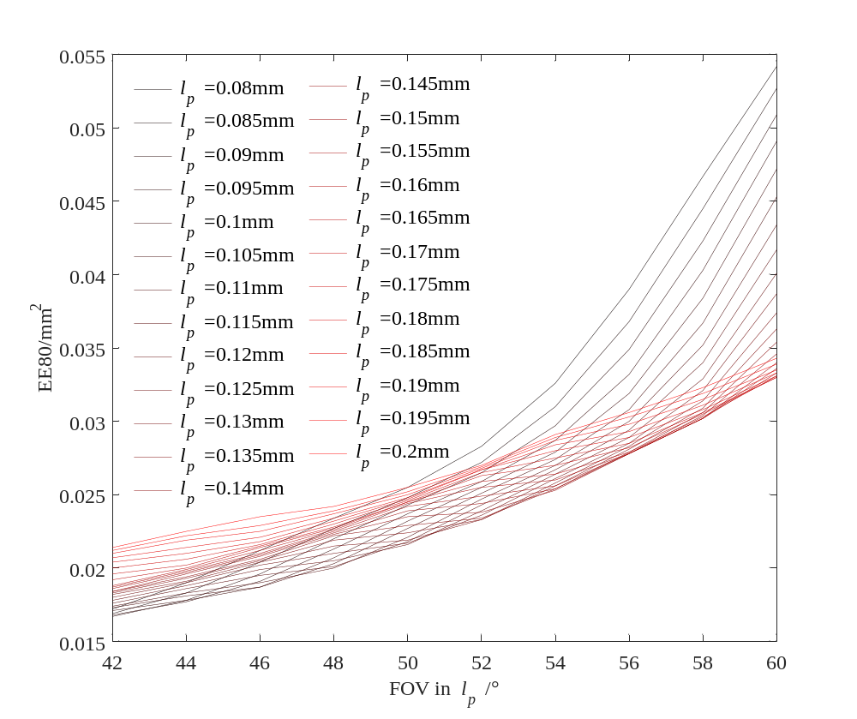
Figure S8 Simulation results of sub-eye at 10mm position
When the distance between the center of the sub-eye and the center of the image sensor is 12mm, the FOV in the l_{p} direction is 50°~66°. 50°~60° is selected as the simulation FOV range of the l_{p} direction, and the simulation aperture size in the l_{p} direction is 0.110mm~0.200mm. The simulation results are shown in Figure S9.
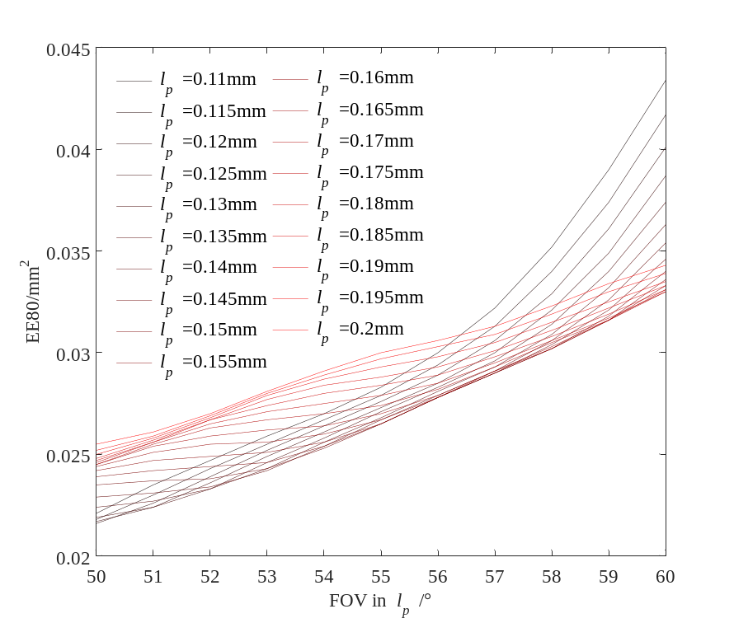
Figure S9 Simulation results of sub-eye at 12mm position
When the distance between the center of the sub-eye and the center of the image sensor is 14mm, the FOV in the l_{p} direction is 56°~68°. 56°~60° is selected as the simulation FOV range of the l_{p} direction, and the simulation aperture size in the l_{p} direction is 0.140mm~0.200mm. The simulation results are shown in Figure S10.
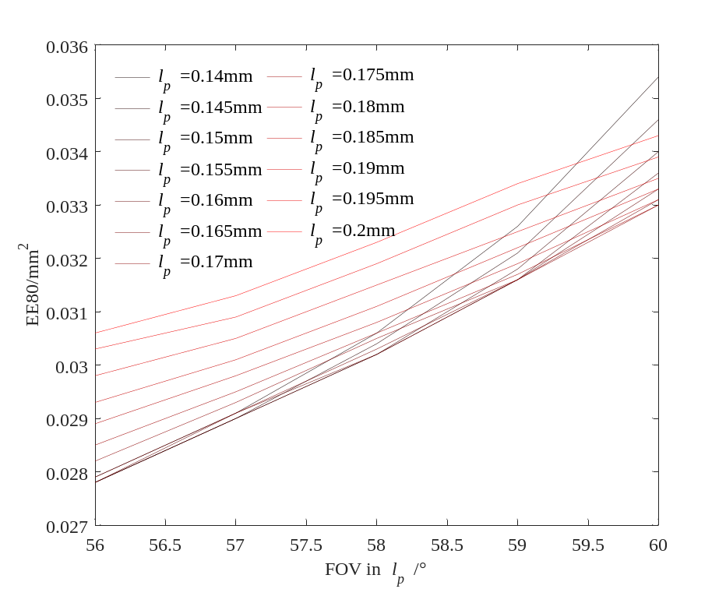
Figure S10 Simulation results of sub-eye at 14mm position
When the distance between the center of the sub-eye and the center of the image sensor is 15mm, the FOV in the l_{p} direction is 59°~69°. 59°~60° is selected as the simulation FOV range of the l_{p} direction, and the simulation aperture size in the l_{p} direction is 0.150mm~0.200mm. The simulation results are shown in Figure S11.
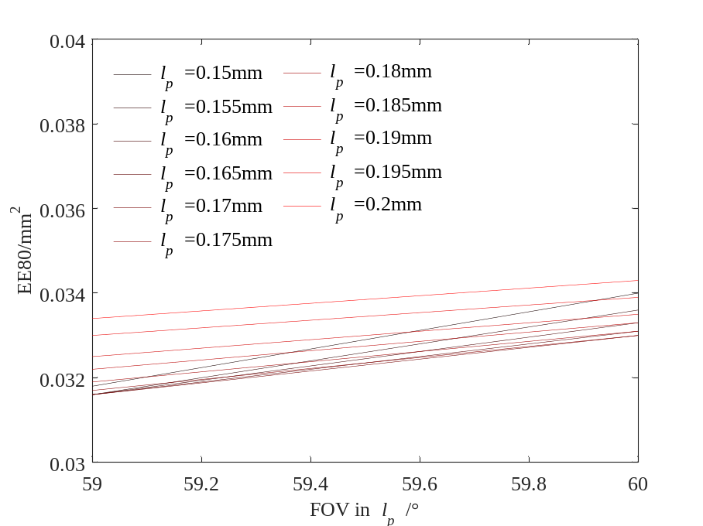
Figure S11 Simulation results of sub-eye at 15mm position
According to the above results, the average diffraction area of the image in the whole-FOV under different sizes is selected as the weighted value, and the standard deviation is modified by weighting. Specifically, n different l_{p} and m different field angles are selected for simulation, and the area of the simulated diffraction spot of the l_{pi} under the j field angle is denoted as EE80_{(i,j)}. For the aperture size l_{pi}, the average and standard deviation of EE80_{(i,1)} ~ EE80_{(i,m)} corresponding to FOV₁~FOV_{m} are as follows:
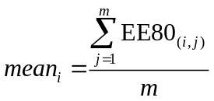 (S12)
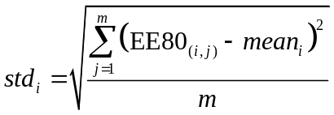 (S13)
The evaluation standard is as follows:
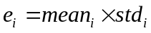 (S14)
Using this as the evaluation standard, the l_{pi} corresponding to the smallest e_{i} is selected as the optimal size value in the imaging range of the sub-eye. This evaluation standard comprehensively considers the area size and fluctuation of the diffraction spot. The specific optimization results are shown in Supplementary Table 3.

Supplementary Table 3 The optimal size of the apertures at different distances to the optical axis
The distance from the aperture center to the optical axis /mm | Optimal aperture size /mm
0 | 0.070
2 | 0.080
4 | 0.110
6 | 0.140
8 | 0.175
10 | 0.175
12 | 0.175
14 | 0.190
15 | 0.195

When specifically designing the compound eye optical system, the distance from the center of the sub-eye to the z axis of the microsystem can be calculated, and the corresponding optimal size l_{p} can be obtained by interpolating the distance in Supplementary Table 3.

Supplementary Note 3 Influence of focal length and wavelength on sub-eye imaging spot

Due to the installation error, the distance between the compound eye optical system and the image sensor is not necessarily the set focal length value, but fluctuates around the set value. The incidence angle of the incident light in the l_{v} direction is set to 0°, and several representative values (0°, 20°, 40°, 50°, 60°) are selected for that in the l_{p} direction. The aperture size in the l_{p} direction is optimized for the corresponding incidence angle. In simulation, the focal length f changes from 6mm to 8mm, and the area of the aperture imaging spot is observed, as shown in Figure S12. The comparison between the simulation results with the focal length of 6mm ,7mm and 8mm is shown in Supplementary Table 4.
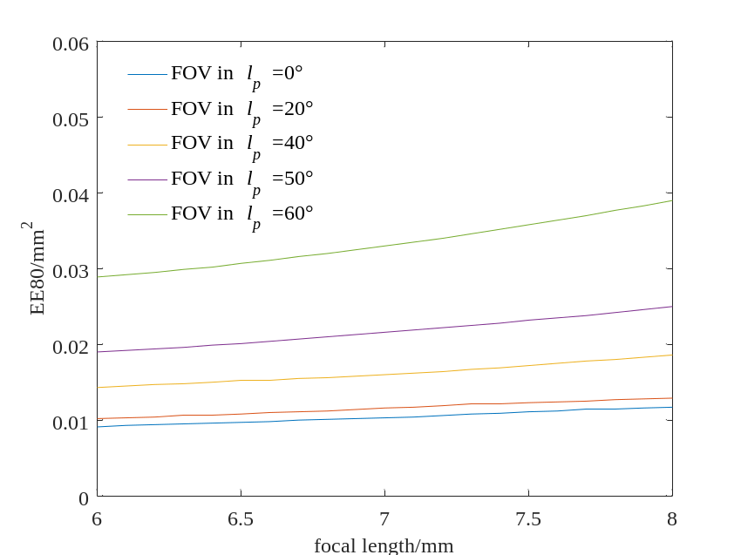
Figure S12 Simulation results of sub-eye under different focal lengths

Supplementary Table 4 The comparison between the simulation results with the focal length of 6mm ,7mm and 8mm
Incident angle /° | The percentage of the area decreased at a focal length of 6mm compared to a focal length of 7mm | The percentage of the area increased at a focal length of 8mm compared to a focal length of 7mm
0 | 11.65% | 13.59%
20 | 12.07% | 11.21%
40 | 10.63% | 16.25%
50 | 12.04% | 15.74%
60 | 12.42% | 18.18%

The diffraction spot area of sub-eye imaging increases with the increase of focal length, which is approximately linear. In practical application, it can be considered that there is a definite ratio between the actual focal length and the set focal length. The actual focal length is a definite value, and the size of the diffraction spot is scaled by this ratio. When the focal length changes in the range of 1mm, the spot size is scaled in the range of 10% to 15%. However, the actual focal length error is in the range of 0.1~0.5mm, and the change of diffraction spot area is smaller (~5%), which has little impact on the result.

Wavelength is also an important factor affecting the spot area. The above parameter settings are selected for simulation, and the focal length is 7mm. For incident light of different wavelengths, the area of sub-eye diffraction spot is shown in Figure S13. With the increase of the wavelength of the incident light, the diffraction spot area increases approximately linearly. Therefore, it will be best that the compound eye microsystem is a single-wavelength system. The optimization effect of the sub-eye is the most obvious at this time. It will be best to design according to the desired wavelength when designing the sub-eye’s aperture size. In practical application, narrow-band filter can be used to select the frequency band of incident light.
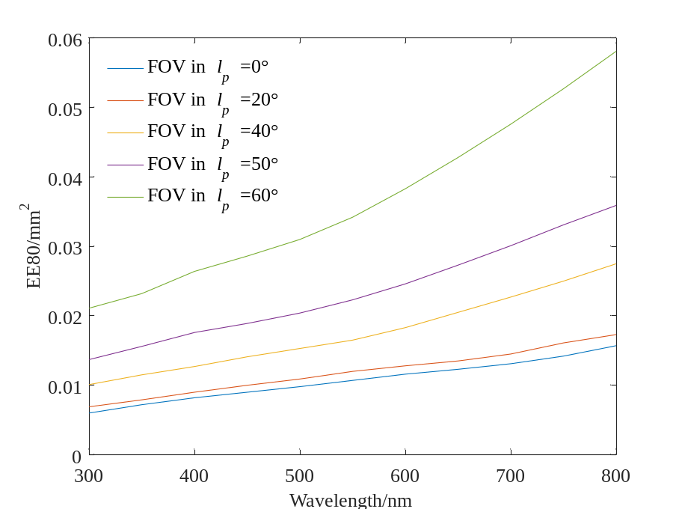
Figure S13 Simulation results of sub-eye under different wavelengths

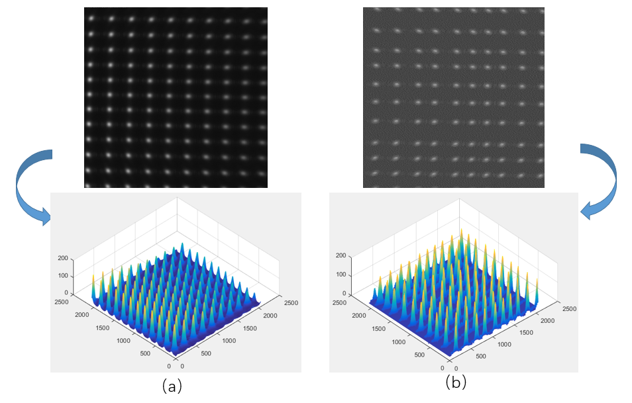

Figure S14 (a) The actual diffraction spot morphology of the aperture optimized for the main incident angle in the previous article[1]. (b) The actual diffraction spot morphology of the aperture optimized for the sub-eye whole-FOV in this paper. The light incident angle of both is about 60°.

Reference：
- Zhang, L., Zhan, H. Y., Liu, X. Y., Xing, F. & You, Z. A wide-field and high-resolution lensless compound eye microsystem for real-time target motion perception. Microsyst. Nanoeng. 8, 9, doi:10.1038/s41378-022-00388-w (2022).

Supplementary Note 4 Detailed experimental test results

For the case that the x direction FOV select 0°, 20°, 40°, and 60° respectively (the y direction FOV is maintained at 0°), the specific calculation results of different collection points are shown in Supplementary Table 5~Supplementary Table 8.

Supplementary Table 5 Solution results of different collection points at 0°
Set Euclidean distance /mm | The average value of the x-coordinate calculated value /mm | The standard deviation of the x-coordinate calculated value /mm | The average value of the y-coordinate calculated value /mm | The standard deviation of the y-coordinate calculated value /mm | The average value of the z-coordinate calculated value /mm | The standard deviation of the z-coordinate calculated value /mm | The average value of the Euclidean distance calculated value /mm | The standard deviation of the Euclidean distance calculated value /mm
500 | -8.6508 | 0.0151 | -47.4232 | 0.0781 | 547.3619 | 0.9033 | 549.4805 | 0.9068
1000 | -8.0200 | 0.0334 | -44.2487 | 0.1390 | 1066.6717 | 3.3166 | 1067.6192 | 3.3195
1500 | -7.6428 | 0.0268 | -41.0663 | 0.1480 | 1588.5958 | 5.7539 | 1589.1449 | 5.7559
2000 | -7.0456 | 0.0332 | -37.9726 | 0.1773 | 2117.4889 | 9.8061 | 2117.8410 | 9.8077
2500 | -6.4960 | 0.0389 | -35.0585 | 0.2090 | 2650.9288 | 15.7197 | 2651.1685 | 15.7211
3000 | -6.2501 | 0.0591 | -31.5557 | 0.3211 | 3155.4341 | 27.2153 | 3155.5981 | 27.2159
3500 | -6.2027 | 0.0532 | -28.6524 | 0.2376 | 3696.8042 | 30.6421 | 3696.9204 | 30.6430
4000 | -5.9040 | 0.0742 | -25.6101 | 0.3860 | 4271.1039 | 55.6293 | 4271.1848 | 55.6297
4500 | -5.0450 | 0.0877 | -21.6787 | 0.4161 | 4711.1543 | 76.9391 | 4711.2069 | 76.9393
5000 | -4.2808 | 0.0653 | -19.2294 | 0.2907 | 5442.4168 | 81.9851 | 5442.4525 | 81.9857
5500 | -3.5784 | 0.0669 | -16.2728 | 0.2949 | 6181.6108 | 112.1383 | 6181.6333 | 112.1387
6000 | -2.3090 | 0.0589 | -12.3950 | 0.5095 | 6787.5411 | 114.8846 | 6787.5528 | 114.8846
6500 | -1.8998 | 0.0267 | -8.8959 | 0.0965 | 7226.9424 | 74.8973 | 7226.9482 | 74.8974
7000 | -1.6271 | 0.0362 | -5.2549 | 0.1933 | 7611.3550 | 146.8524 | 7611.3570 | 146.8525
7500 | -1.1481 | 0.0248 | -1.7969 | 0.0315 | 8302.8906 | 110.2080 | 8302.8909 | 110.2080
8000 | -0.7127 | 0.0372 | 1.6115 | 0.3065 | 8687.8614 | 185.9177 | 8687.8616 | 185.9177
8500 | 0.4836 | 0.0248 | 4.6386 | 0.0840 | 8857.5737 | 151.6143 | 8857.5749 | 151.6143
9000 | 1.2533 | 0.0256 | 8.2412 | 0.1032 | 9328.4040 | 114.4845 | 9328.4077 | 114.4845
9500 | 2.0477 | 0.0379 | 11.1281 | 0.1888 | 9818.0849 | 169.2559 | 9818.0915 | 169.2560
10000 | 2.2901 | 0.0488 | 13.9760 | 0.2663 | 10192.9896 | 192.6823 | 10192.9995 | 192.6825

Supplementary Table 6 Solution results of different collection points at 20°
Set Euclidean distance /mm | The average value of the x-coordinate calculated value /mm | The standard deviation of the x-coordinate calculated value /mm | The average value of the y-coordinate calculated value /mm | The standard deviation of the y-coordinate calculated value /mm | The average value of the z-coordinate calculated value /mm | The standard deviation of the z-coordinate calculated value /mm | The average value of the Euclidean distance calculated value /mm | The standard deviation of the Euclidean distance calculated value /mm
500 | 168.7464 | 0.7516 | -49.9267 | 0.2219 | 511.1544 | 2.2743 | 540.5986 | 2.4056
1000 | 333.1836 | 1.7634 | -49.0990 | 0.2593 | 975.4799 | 5.1633 | 1031.9801 | 5.4623
1500 | 498.2239 | 3.5984 | -48.8797 | 0.3571 | 1442.9069 | 10.4215 | 1527.2840 | 11.0309
2000 | 640.3018 | 5.7684 | -47.0938 | 0.4236 | 1844.1124 | 16.6128 | 1952.6789 | 17.5908
2500 | 806.3585 | 9.4935 | -47.5134 | 0.5884 | 2314.6464 | 27.2654 | 2451.5423 | 28.8767
3000 | 956.5669 | 18.4295 | -47.0822 | 0.9074 | 2740.6940 | 52.8017 | 2903.2121 | 55.9329
3500 | 1089.1064 | 22.6346 | -45.9344 | 0.9564 | 3116.5995 | 64.7717 | 3301.7351 | 68.6193
4000 | 1219.6849 | 22.1272 | -44.9584 | 0.8515 | 3486.3151 | 63.2528 | 3693.7847 | 67.0167
4500 | 1393.9340 | 32.4634 | -45.6056 | 1.0644 | 3979.9224 | 92.6723 | 4217.2164 | 98.1996
5000 | 1824.6445 | 24.3425 | -53.7530 | 0.7188 | 5203.8485 | 69.4171 | 5514.7308 | 73.5650
5500 | 1990.8031 | 33.0272 | -53.3147 | 0.8869 | 5673.1975 | 94.1159 | 6012.5959 | 99.7467
6000 | 1909.8530 | 36.6744 | -46.4387 | 0.8936 | 5437.9405 | 104.4192 | 5763.7568 | 110.6760
6500 | 2084.1127 | 47.5882 | -46.6145 | 1.0662 | 5931.8657 | 135.4408 | 6287.5058 | 143.5618
7000 | 2028.1199 | 40.6853 | -42.1186 | 0.8442 | 5771.2173 | 115.7692 | 6117.3519 | 122.7132
7500 | 2366.6789 | 69.0955 | -45.6888 | 1.3369 | 6732.6142 | 196.5661 | 7136.6203 | 208.3608
8000 | 2357.6819 | 60.9424 | -42.6998 | 1.1087 | 6705.6045 | 173.3267 | 7108.1375 | 183.7317
8500 | 2244.4218 | 61.9887 | -38.1142 | 1.0553 | 6380.9313 | 176.2239 | 6764.2565 | 186.8117
9000 | 2522.1417 | 63.0057 | -40.3377 | 1.0095 | 7168.0769 | 179.0619 | 7598.9573 | 189.8260
9500 | 2442.1348 | 69.9144 | -36.7946 | 1.0430 | 6938.8608 | 198.6264 | 7356.1652 | 210.5737
10000 | 2524.3695 | 100.8530 | -36.2136 | 1.6093 | 7171.4099 | 286.5252 | 7602.8201 | 303.7604

Supplementary Table 7 Solution results of different collection points at 40°
Set Euclidean distance /mm | The average value of the x-coordinate calculated value /mm | The standard deviation of the x-coordinate calculated value /mm | The average value of the y-coordinate calculated value /mm | The standard deviation of the y-coordinate calculated value /mm | The average value of the z-coordinate calculated value /mm | The standard deviation of the z-coordinate calculated value /mm | The average value of the Euclidean distance calculated value /mm | The standard deviation of the Euclidean distance calculated value /mm
500 | 328.0560 | 1.7239 | -55.1574 | 0.2950 | 424.9381 | 2.2353 | 539.6624 | 2.8377
1000 | 639.4013 | 3.9673 | -59.1521 | 0.3656 | 809.8701 | 5.0252 | 1033.5485 | 6.4130
1500 | 934.2227 | 11.4919 | -62.5383 | 0.7678 | 1174.5615 | 14.4466 | 1502.0911 | 18.4758
2000 | 1212.4739 | 20.1984 | -65.5749 | 1.0895 | 1518.6943 | 25.2955 | 1944.4345 | 32.3887
2500 | 1468.3818 | 19.3284 | -68.1444 | 0.8942 | 1835.0039 | 24.1518 | 2351.1759 | 30.9467
3000 | 1815.0437 | 24.3683 | -74.9265 | 1.0027 | 2265.4097 | 30.4114 | 2903.8042 | 38.9830
3500 | 2074.3769 | 24.8316 | -77.9047 | 0.9322 | 2586.6506 | 30.9605 | 3316.6052 | 39.6993
4000 | 2384.8940 | 40.1970 | -83.0075 | 1.3990 | 2971.6325 | 50.0811 | 3811.1953 | 64.2329
4500 | 2549.4209 | 34.2012 | -83.0697 | 1.1147 | 3174.1740 | 42.5788 | 4072.0791 | 54.6253
5000 | 2941.2560 | 42.3749 | -90.6490 | 1.3739 | 3659.5214 | 52.7238 | 4695.8812 | 67.6556
5500 | 3336.7921 | 64.3447 | -98.0221 | 1.9875 | 4149.2768 | 80.0189 | 5325.4379 | 102.6991
6000 | 3217.8085 | 80.1782 | -90.5689 | 2.2630 | 3999.4955 | 99.6450 | 5134.0490 | 127.9171
6500 | 3369.5607 | 74.6688 | -91.3900 | 2.0268 | 4186.9414 | 92.7773 | 5375.1996 | 119.1098
7000 | 3765.9421 | 145.7896 | -98.9591 | 3.8302 | 4678.7512 | 181.1097 | 6006.8982 | 232.5296
7500 | 3879.7810 | 90.6243 | -98.9567 | 2.3153 | 4819.0331 | 112.5551 | 6187.5337 | 144.5226
8000 | 4099.9444 | 113.7842 | -101.9698 | 2.8341 | 5091.7680 | 141.3051 | 6538.0458 | 181.4443
8500 | 4350.1241 | 105.4030 | -105.6145 | 2.5590 | 5400.9297 | 130.8651 | 6935.7606 | 168.0536
9000 | 4544.8297 | 119.3187 | -108.0224 | 2.8368 | 5641.4603 | 148.1033 | 7245.2205 | 190.2094
9500 | 4821.7316 | 152.1195 | -112.3876 | 3.5521 | 5984.0841 | 188.7796 | 7685.7653 | 242.4679
10000 | 5397.9148 | 235.5372 | -123.6884 | 5.4007 | 6698.2987 | 292.2705 | 8603.4870 | 375.4051

Supplementary Table 8 Solution results of different collection points at 60°
Set Euclidean distance /mm | The average value of the x-coordinate calculated value /mm | The standard deviation of the x-coordinate calculated value /mm | The average value of the y-coordinate calculated value /mm | The standard deviation of the y-coordinate calculated value /mm | The average value of the z-coordinate calculated value /mm | The standard deviation of the z-coordinate calculated value /mm | The average value of the Euclidean distance calculated value /mm | The standard deviation of the Euclidean distance calculated value /mm
500 | 459.8976 | 0.3522 | -63.2211 | 0.0482 | 295.6827 | 0.2266 | 550.3916 | 0.4216
1000 | 887.6633 | 4.8260 | -73.0721 | 0.4218 | 558.2406 | 3.0429 | 1051.1509 | 5.7206
1500 | 1333.5246 | 9.3020 | -84.6967 | 0.5907 | 832.5976 | 5.8073 | 1574.3825 | 10.9818
2000 | 1674.7480 | 26.9430 | -90.4305 | 1.4563 | 1041.6964 | 16.7572 | 1974.3581 | 31.7624
2500 | 2080.2827 | 42.7733 | -100.5485 | 2.0696 | 1291.0201 | 26.5404 | 2450.3916 | 50.3809
3000 | 2511.9664 | 52.2310 | -111.8378 | 2.3259 | 1557.0363 | 32.3724 | 2957.5065 | 61.4936
3500 | 2922.8781 | 76.1590 | -122.0884 | 3.1813 | 1810.2010 | 47.1643 | 3440.1961 | 89.6369
4000 | 3392.9408 | 84.3191 | -134.7291 | 3.3471 | 2099.7812 | 52.1797 | 3992.4028 | 99.2151
4500 | 3811.8148 | 110.8733 | -145.0719 | 4.2168 | 2357.3224 | 68.5626 | 4484.1885 | 130.4282
5000 | 4343.6652 | 131.6305 | -159.6126 | 4.8355 | 2684.3551 | 81.3436 | 5108.6853 | 154.8119
5500 | 4762.9216 | 157.6649 | -169.8781 | 5.6225 | 2941.7471 | 97.3758 | 5600.7282 | 185.3966
6000 | 5099.7842 | 171.9780 | -177.2247 | 5.9949 | 3148.1203 | 106.1612 | 5995.8209 | 202.1942
6500 | 5465.1834 | 223.3776 | -185.7478 | 7.5831 | 3372.6872 | 137.8501 | 6424.7764 | 262.5980
7000 | 6024.5116 | 321.4611 | -200.9417 | 10.7158 | 3717.2991 | 198.3539 | 7081.9087 | 377.8840
7500 | 6162.3586 | 345.0279 | -202.0169 | 11.3022 | 3801.6074 | 212.8523 | 7243.4586 | 405.5590
8000 | 6829.7724 | 412.8206 | -220.6578 | 13.3332 | 4212.6605 | 254.6295 | 8027.5145 | 485.2162
8500 | 6743.8735 | 771.9480 | -214.8688 | 24.5648 | 4158.3408 | 475.9974 | 7925.7678 | 907.2379
9000 | 7608.4291 | 556.5491 | -239.4947 | 17.5044 | 4690.4317 | 343.1050 | 8941.2360 | 654.0447
9500 | 7795.6459 | 669.1597 | -242.7585 | 20.8254 | 4804.9944 | 412.4539 | 9160.7313 | 786.3374
10000 | 7567.9734 | 627.8488 | -233.4677 | 19.3501 | 4664.1329 | 386.9456 | 8892.8547 | 737.7638

Notes:
1, The above solution results are retained to fourth decimal places, but it does not mean that the resolution of the microsystem is 0.0001mm, but only the numerical calculation results.
2, According to the accuracy of the guide rail (less than 0.1mm) and the number of frames (collected 100 frames), it is reasonable to take first or second decimal places for observation.

Supplementary Note 5 Calibration experiment
Because there are many systematic errors in the microsystem, such as the processing errors, installation errors of the compound eye optical system, and the non-uniform response of image sensor pixels, it is necessary to calibrate the microsystem to achieve more accurate perception. It can be seen from Equation (2) and Equation (3) that the perceived result of the microsystem is closely related to the ratio R. And for targets in different positions, the ratio R is a quantity related only to depth information z and focal length f. Therefore, the target perception result can be corrected by correcting the ratio R of different points.
According to the experimental data in Experiment for 3D perception, taking the data collected at 40° angle as an example, choose the Euclidean distance of 500mm, 1500mm, ... , 8500mm, 9500mm point as the calibration points, and choose the Euclidean distance of 1000mm, 2000mm, ... , 9000mm, 10000mm as the test points.
The difference between the calculated ratio R and the true ratio R value (calculated according to the set value coordinates and Equation (2)) of different positions is shown in the blue curve in the Figure S15. Select a polynomial function of 6th order:
$y\left(x\right)=a_{6}x^{6}+a_{5}x^{5}+a_{4}x^{4}+a_{3}x^{3}+a_{2}x^{2}+a_{1}x+a_{0}$ (S15)
Fit the data of calibration points (500mm, 1500mm, ... , 8500mm, 9500mm), and the fitting results are shown in the orange curve in the Figure S15.
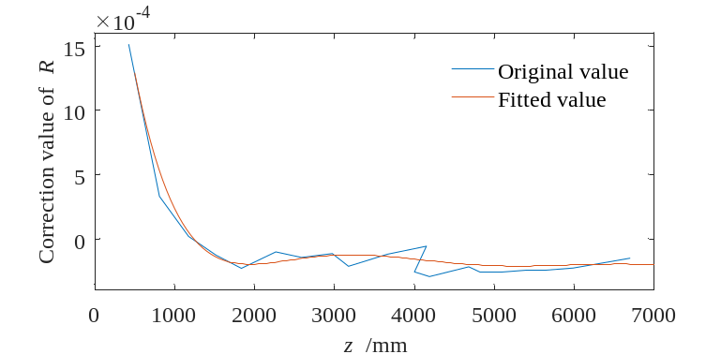
Figure S15 The original value and the fitted value of the ratio R correction
Take the fitted correction curve as the correction value and substitute it into the test points (1000mm, 2000mm, ... , 9000mm, 10000mm), the comparison of the calculated value after and before the correction is shown in the Figure S16. The calculation error of different test points is shown in the Figure S17.
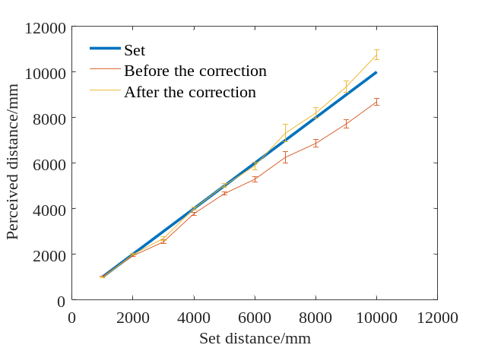
Figure S16 Comparison of measurement results before and after correction
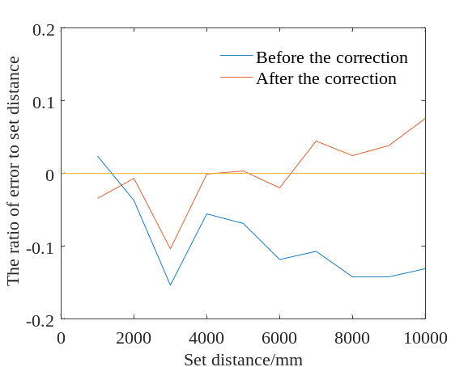
Figure S17 Comparison of measurement errors before and after correction
It can be seen that the average absolute value of the measurement error of all test points under the 40° angle is 9.80% before correction, and 3.08% after correction. For test points beyond 5000mm, the average absolute value of the perceived error is 11.83% before correction, and 2.34% after correction. After calibration, the measurement results of the microsystem are more accurate.
It should be noted that the calibration is only carried out for data under a certain FOV angle. If the whole FOV is calibrated, the amount of data collected is huge. Therefore, the following strategies can be used. Calibrate several angles in the FOV. After finding the target, the target can be adjusted to the calibrated angle through controlling an external rotating device, and the 3D position of the target can be more accurately perceived under the calibrated angle.

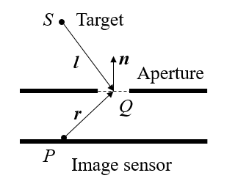

Figure S18 Definition of variables in Fresnel-Kirchhoff diffraction formula (see Equation (4))

