Supplementary Information for
Spectral period doubling and encoding of dissipative optical solitons via gain control
Kangwen Yang^{1,2,3&}, Yi Zhou^{2,3,&*}, Yuqing Ling¹, Kevin K. Tsia^{2,3}, Heping Zeng^{4,*}, and Kenneth K. Y. Wong^{2,3,*}
¹Shanghai Key Laboratory of Modern Optical System, and Engineering Research Center of Optical Instrument and System, Ministry of Education, School of Optical Electrical and Computer Engineering, University of Shanghai for Science and Technology, Shanghai 200093, China
²Department of Electrical and Electronic Engineering, The University of Hong Kong, Pokfulam Road, Hong Kong, China
³Advanced Biomedical Instrumentation Centre, Hong Kong Science Park, Shatin, New Territories, Hong Kong, China
⁴State Key Laboratory of Precision Spectroscopy, East China Normal University, Shanghai 200062, China
(&These authors contributed equally to this work)
* Corresponding author
Email: yizhou1508@gmail.com, hpzeng@phy.ecnu.edu.cn, kywong@eee.hku.hk

Contents
1. Period-doubled spectral evolution of the dissipative soliton molecule 2
2. Numerical simulation of intracavity light field evolution and chirp characteristic in period doubling operation 2
3. Period-doubled soliton pairs before three solitons collision 4
4. DFT spectra evolution of period-doubled three and four solitons 5
5. Key components in the mode-locked fiber laser 7

Section 1. Period-doubled spectral evolution of the dissipative soliton molecule
As the pulse in the laser is formed from background noise, the periodic-doubled soliton molecule can also be observed in the experiment at a particular pump power and initial seed condition. Specifically, we first generate the double pulse period doubling state by setting the pump power at 160 mW. Then, we turn off and on the pump power to the set value several times; subsequently, the soliton molecule with period doubling characteristics can be generated at suitable seed conditions. The DFT spectral evolution of period-doubled soliton molecule is shown in Fig. S1a. The enlargement spectral evolution (Fig. S1b) and two single-shot optical spectra (Fig. S1d) clearly indicate the characteristic of period-doubling with obvious spectral intensity variation in two consecutive roundtrips. Simultaneously, the temporal separation between two solitons in the soliton molecule also slightly changes periodically during evolution (0.086 ps), which is verified by the corresponding field autocorrelation trace (Fig. S1c).
Fig. S1. Period-doubled spectral evolution of the dissipative soliton molecule. a DFT spectral evolution of period-doubled soliton molecule. b Zoom-in plot corresponds to the dashed line in a. c Field autocorrelation trace over roundtrips obtained by Fourier transform the DFT spectra in b. d Two consecutive optical spectra.

Section 2. Numerical simulation of intracavity light field evolution and chirp characteristic in period doubling operation
To obtain more insights into the period-doubling mechanism, the corresponding soliton intracavity evolution is displayed in Fig. S2. The evolution of pulse spectral and temporal intensity is shown in Figs. S2a and S2b, along with the intracavity position over two consecutive roundtrips. The corresponding evolution of the pulse peak power, temporal width, and energy is displayed in Fig. S2c. We note that the pulse energy in RT N is clearly larger than the RT N+1, representing a visible pulsation (red curve in Fig. S2c). In this net-normal dispersion laser cavity with a linear structure, the signal will propagate two times within the fiber section in one roundtrip. The significant increase in the pulse peak power mainly occurs during the YDF propagation process, owing to the rapid improvement in pulse energy. Due to the normal dispersion of SMF and positive chirp of the pulse, the pulse peak power always decreases during propagation in SMF with gradually increased pulse temporal width. The pulse experiences a stronger nonlinear amplification process and higher peak power in RT N compared to RT N+1, further demonstrating that the Kerr nonlinearity plays a vital role in this period-doubling evolution. The major spectral width variation and spectral lobes oscillation dynamics are attributed to the self-phase modulation (SPM) effect (Fig. S2a). The spectral peak-to-dip flip corresponds to a mitigated excessive nonlinearity of the pulse experienced during the roundtrip N. The composite effects of SA modulation and nonlinearity induced in gain fiber shape the pulse with obviously different output spectral characteristics in two consecutive roundtrips.
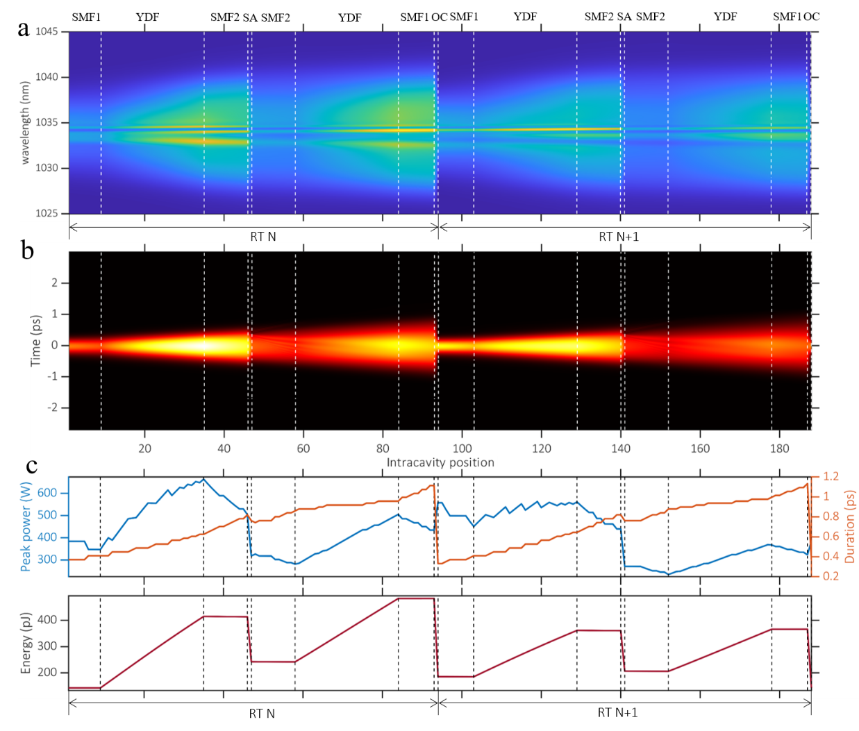
Fig. S2. Simulation of the intracavity light field evolution over two consecutive roundtrips during period doubling operation. Roundtrip N is from slice 1 to 94. Roundtrip N+1 is from slice 95 to 188. a Spectral intensity profile evolution. b Pulse temporal intensity evolution. c Evolution of the pulse peak power (blue curve), pulse duration (orange curve), and energy (red curve).

For the period doubling soliton operation, the simulated chirp characteristic of the pulse over two consecutive roundtrips is shown in Fig. S3. The chirp of the central part of pulse during RT N and N+1 is shown in Figs. S3a and S3e, respectively. We can find that the pulse always has a positive chirp during evolution, demonstrating that the period doubling operation can also be achieved in a net-normal dispersion laser cavity even without sign flipping of the chirp. The temporal intensity profile and chirp of pulse are quite different in YDF, SMF, and output position in two consecutive roundtrips (Figs. S3b-d and S3f-h), which verify that this period doubling operation mainly originate from the pulse experiencing varying degrees of Kerr nonlinearity within two adjacent RTs.
Fig. S3. Chirp characteristic of the pulse at different positions over two consecutive roundtrips in simulated period doubling operation. Chirp evolution of the central part of the pulse, pulse temporal intensity (blue curve), and chirp (orange curve) at different positions during the roundtrip N (a-d) and N+1 (e-h).

Section 3. Period-doubled soliton pairs before three solitons collision
For pulses period-doubling involving two solitons, either synchronous or asynchronous period doubled evolution can be generated depending on the specific initial state and pump strength. Besides the synchronous and asynchronous period-doubled soliton pairs that have been observed in the main text, we also observed more cases of period-doubled soliton pairs before solitons collision, as shown in Fig. S4. The DFT spectra evolution of synchronous period-doubled soliton pairs is shown in Fig. S4a. The local enlargement of the spectra in Fig. S4a (Fig. S4b) and two consecutive single-shot optical spectra (Fig. S4c) further demonstrates the synchronous period doubling characteristic of leading and trailing solitons. While the middle soliton corresponds to a long period oscillating (570 RTs), the two consecutive optical spectra of the middle soliton are almost unchanged (Fig. S4c). Similarly, asynchronous period-doubled soliton pairs can also be observed experimentally under a different initial state, and the corresponding DFT spectral evolution is shown in Figs. S4d and S4e. Here, the trailing soliton corresponding to a long period oscillating (576 RTs), the leading and middle solitons exhibit an asynchronous period-doubling evolution and further verified by the two consecutive single shot optical spectra shown in Fig. S4f.
Fig. S4. Period-doubled soliton pairs before three solitons collision. a DFT spectra evolution of synchronous soliton pair. b Zoom-in plot corresponds to the dashed line in a. c Two consecutive optical spectra correspond to dashed lines in b. d DFT spectra evolution of asynchronous soliton pair. e Zoom-in plot corresponds to the dashed line in d. f Two consecutive optical spectra correspond to dashed lines in e.

Section 4. DFT spectra evolution of period-doubled three and four solitons
Moreover, the period-doubling of three and four solitons was also observed experimentally under a higher pump power. The DFT spectral evolution and two consecutive single shot optical spectra of three solitons period doubling are shown in Figs. S5a and S5b, respectively. Here, three solitons maintain a fixed temporal separation during evolution without collision. The leading and middle soliton correspond to synchronous period-doubling evolution, while the trailing soliton exhibits asynchronous period-doubling compared to the leading and middle solitons. Further, the DFT spectral evolution and two consecutive single shot optical spectra of four solitons period doubling are shown in Figs. S6b and S6c, respectively. The stable pulse evolution involving four solitons is verified by the temporal intensity evolution (Fig. S6a). As the first two and last two solitons have relatively small temporal intervals (337.5 ps and 400 ps), the recorded stretched waveform of each soliton pair will overlap, as shown in Fig. S6b. The synchronous period-doubling of two soliton pairs can be resolved in the DFT spectral evolution and two consecutive optical spectra.
Fig. S5. Period-doubled three solitons evolution. a DFT spectra evolution of period-doubled three solitons; b Two consecutive optical spectra.
Fig. S6. Period-doubled four solitons evolution. a Temporal intensity evolution of period-doubled four solitons. b DFT spectral evolution. c Two consecutive optical spectra.

Section 5. Key components in the mode-locked fiber laser
For the convenience of other groups in the field to build a fiber laser with the same or similar structure of our work, we list the model number of key components in Table S1.

Table S1 Key components in the mode-locked fiber laser
Symbol | Description | Model number
SESAM | Semiconductor saturable absorber mirror | Batop  SAM-1030-55-500 fs
Multi-functional element | SESAM is packaged by Advanced Fiber Resources, also integrated with wavelength division multiplex  Fiber type:  Signal (Connecting gain fiber), PM 980;  Pump (Connecting pump laser), HI 1060 | Advanced Fiber Resources  PMSESAMWDM-98-N-B
YDF | Ytterbium-doped fiber | Nufern  PM-YSF-HI-HP
CFBG | Chirped fiber Bragg grating  Fiber type: PM 980 | TeraXion  DMR-1030-20-25-P1
Pump diode | 976 nm single-mode continuous laser diode | Thorlabs  BL976-PAG500
Pump driver | Compact LD and temperature controller with mount | Thorlabs  CLD1015
AWG | Arbitrary waveform generator | Tektronix  AFG31000

