[Supplementary Information]
Cascaded compressed-sensing single-pixel camera for high-dimensional imaging
Jongchan Park¹ and Liang Gao^{1,*}
¹Department of Bioengineering, University of California, Los Angeles, CA 90095, USA
*Correspondence: Prof. Liang Gao, Email: gaol@ucla.edu

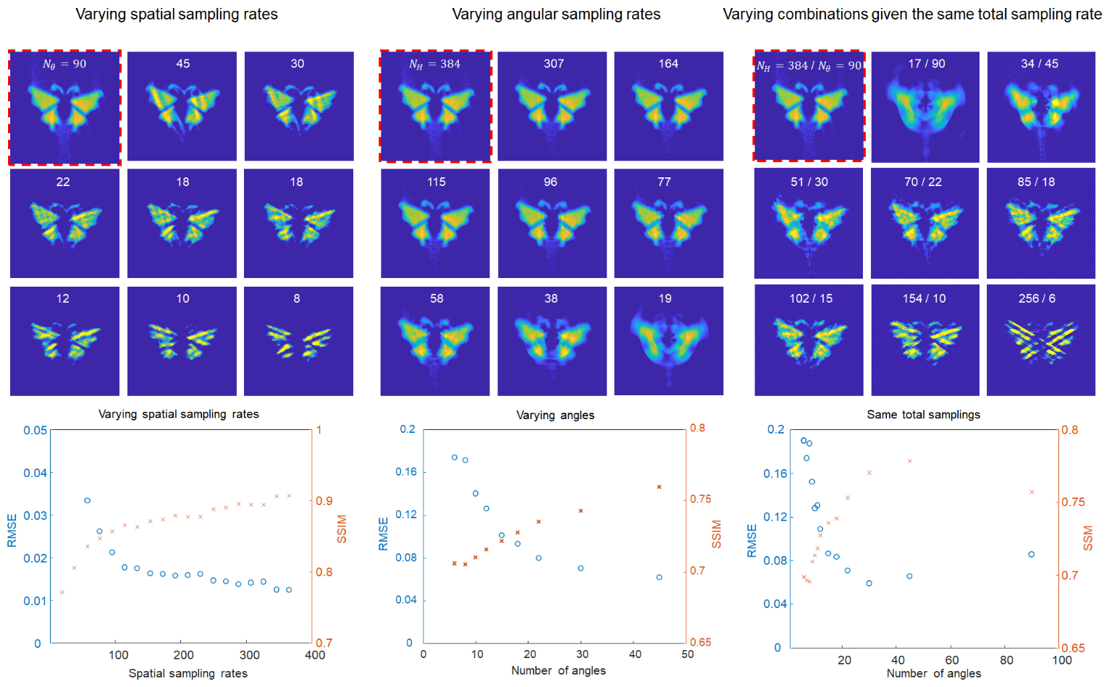
Fig. S1. Experimental demonstrations of cascaded compressed measurements at varying sampling rate. A butterfly image was captured and reconstructed at varying sapling rate. The reconstructed image is shown in the figure. Root mean squared error (RMSE) and structural similarity (SSIM) of the image are shown in the graph. The pixel resolution of the scene is 384×384. N_{H} and N_{θ} are numbers of Hadmadard patterns and projection angles, respectively.
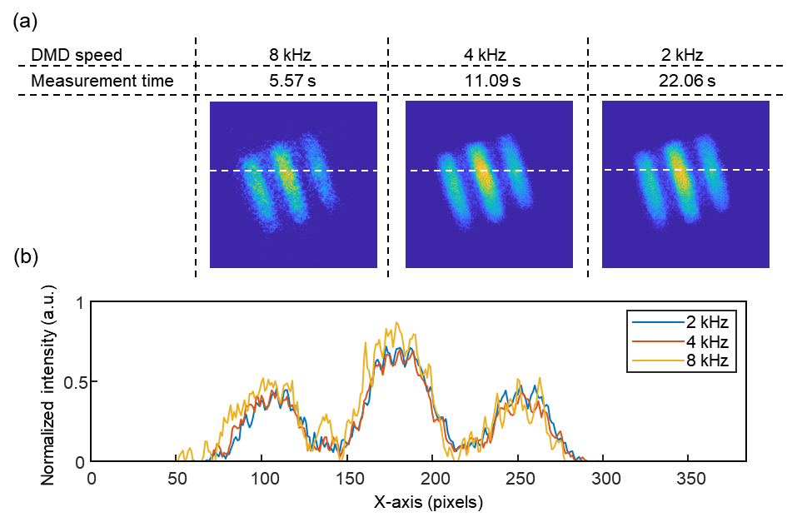
Fig. S2. Single-pixel imaging at various DMD refresh rates. a A three-bar object was captured at various DMD refresh rates. The number of Hadamard patterns, projection angles, and spectral bands were 192, 45, and 5, respectively. At a higher DMD frequency (8 kHz), the reconstructed image tends to exhibit more grainy noise. This is attributed to the reduced effective exposure time at the higher DMD refresh rate, where we did not modify the brightness of the object or gain of the single-pixel detector. b Intensity profiles along the white-dashed lines in a.

Number of spectral bands | Number of Hadamard patterns | Number of rotating angles | Total sampling rate | DMD frequency | DMD picture time | Actual measurement time
3 | 192 | 45 | 25,920 | 8 kHz | 3.24 s | 3.390 ± 0.032 s
5 | 192 | 45 | 43,200 | 8 kHz | 5.4 s | 5.582 ± 0.017 s
10 | 192 | 45 | 86,400 | 8 kHz | 10.8 s | 11.125 ± 0.014 s
20 | 192 | 45 | 172,800 | 8 kHz | 21.6 s | 22.229 ± 0.027 s
Table. S1. Measurement time of the cascaded single-pixel imaging system at various numbers of spectral sampling rates. The total measurement time is primarily determined by the picture time of the DMD, rather than the speed of the rotating dove prism. During each measurement, the dove prism rotates 90 degrees, resulting in a 180-degree rotation of the image. The rotary stage (ACR32UT, IntelLiDrivers) used in the experiment has the maximum speed of 1,400 RPM, which is significantly faster than the rotating speed required for the measurement. The actual measurement time was slightly longer than the DMD picture time (of approximately 4%), mainly due to the communication time between the DMD, digitizer, and rotary stage.

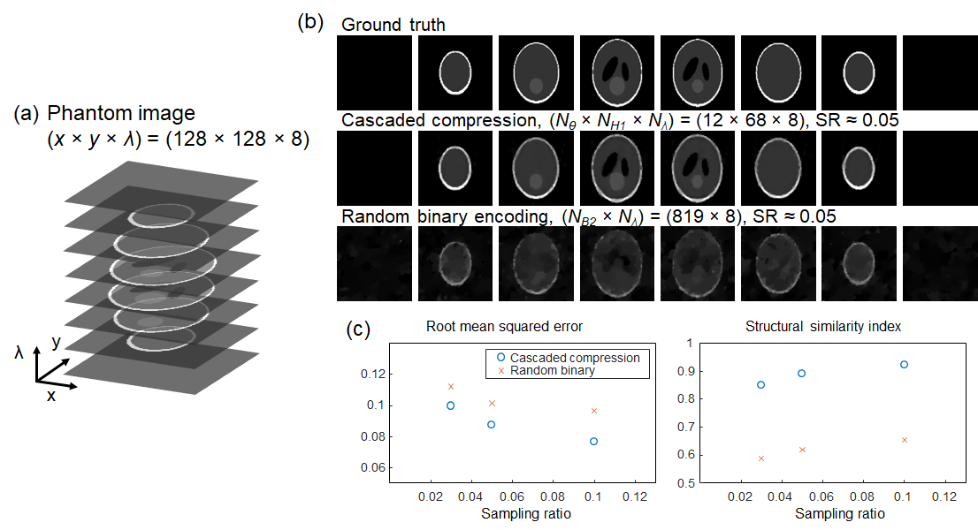
Fig. S3. Cascaded compressed sensing for hyperspectral imaging versus random binary encoding for spatially and spectrally multiplexed single-pixel imaging. a Numerical simulations comparing our method to single-pixel compressed multispectral imaging based on random binary pattern encoding¹. A standard 3D Shepp-Logan phantom of size (128×128×8) was used as the hyperspectral scene, with varying sampling rates and white random Gaussian noise added to achieve a signal-to-noise ratio of 20 dB. Iterative reconstruction was performed using the FISTA algorithm² with a 2D total variation regularizer for cascaded compression and a weighted 3D total variation regularizer for random binary encoding. b Reconstructed images at a sampling ratio of 0.05, where N_{θ}, N_{H1}, N_{λ} represent the numbers of dove prism angles, 1D Hadamard patterns, and spectral samplings, respectively, while N_{B2} denotes the number of random binary patterns. c Root-mean-squared error and structural similarity index of the images. The results demonstrate the high efficiency of the cascaded compressed sensing method in sampling the scene at a high sub-Nyquist rate compared to the binary random encoding method. It is worth noting that our method can reconstruct the scene with high fidelity using a simple soft-thresholding operator (MATLAB code in Supplementary Information), while the random binary encoding method requires a computationally heavy total variation regularizer with a heuristic choice of regularization parameters.

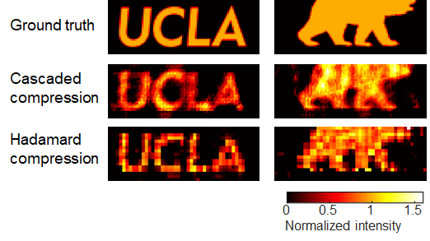
Fig. S4. Enlarged view of Fig 5c. In Hadamard compression method with a very sparse sampling, the reconstructed image tends to exhibit pixelation artifact along x and y direction. This occurs because the impinging Hadamard patterns lack high spatial frequency information; we used total variation ordering when choosing the subset of the Hadamard basis because it typically yields a high-quality image at a low sampling rate. On the other hand, the cascaded compression method tends to exhibit smoother boundary and provides higher structural similarity and low root mean squared error given the same sampling rate (Fig. 5).

. a Numerical simulations comparing our method to single-pixel compressed multispectral
Reference
1. Li, Z. et al. Efficient single-pixel multispectral imaging via non-mechanical spatio-spectral modulation. Sci. Rep. 7, 41435 (2017).
2. Beck, A. & Teboulle, M. A fast iterative shrinkage-thresholding algorithm for linear inverse problems. SIAM J. Imaging Sci. 2, 183–202 (2009).

MATLAB code for cascaded compressed-sensing single-pixel imaging
% README
% Simulation code for 'Cascaded compressed-sensing single-pixel camera for high-dimensional optical imaging' by Jongchan Park and Liang Gao
% Codes are modified from https://github.com/Computational-Imaging-Hub/LIFT
% Requirements: MATLAB (Tested in MATLAB R2023a), Optional: CUDA-capable GPU device for acceleration
% Instructions: Copy all the codes into a single MATLAB file and run
% In this demo, an image of size (384x384x10) is reconstructed. Expected run time is within 10 seconds.

Initialization
% 3D image to be measured
imgSize = 384; % image size
lambdaNo = 10; % number of spectrum
phantomImg = repmat(phantom('Modified Shepp-Logan',imgSize),[1, 1, lambdaNo]); % 3D image example

% Sampling
anglesCounter = 45; % number of dove prism angles
hCounter = 192; % number of DMD patterns
snrVal = 20; % signal to noise ratio in dB

Compressed measurement
% 1. en-face parallel projection
rotAngles = linspace(0,180*(anglesCounter-1)/anglesCounter,anglesCounter); % projection angles
liftImg = zeros(imgSize,anglesCounter,lambdaNo);
for k = 1:lambdaNo
projImg = radon(phantomImg(:,:,k),rotAngles); % radon transform
liftImg(:,:,k) = projImg(round(size(projImg,1)/2-imgSize/2)+1:round(size(projImg,1)/2+imgSize/2),:); % crop
end

% 2. DMD pattern encoding
% Hadamard pattern with a total variation order
hPattern = hadamard(imgSize,'single');
maskTVIndex = zeros(1,imgSize);
for k = 1:imgSize
Gy = gradient(hPattern(:,k));
maskTVIndex(k) = sum(sqrt(Gy.^2)); % 1D total variation
end
[B sortIndex] = sort(maskTVIndex); % sorting the patterns
% Encode the pattern
ySize = round(hCounter); xSize = imgSize;
sensingMatrix = zeros(ySize,xSize);
for k = 1:ySize
sensingMatrix(k,:) = hPattern(:,sortIndex(k))';
end
sensingMatrix = 1/2*(sensingMatrix+1); % DMD display pattern
invSensingMatrix = pinv(sensingMatrix);
totalMeasurement = zeros(ySize,anglesCounter,lambdaNo);
for k = 1:anglesCounter
for l = 1:lambdaNo
totalMeasurement(:,k,l) = sensingMatrix*liftImg(:,k,l);
end
end
% Add noise
totalMeasurement = awgn(totalMeasurement,snrVal);

Reconstruction
% Parameters for the image reconstruction algorithm
options = [];
options.lambda_reg = 5e-1; % regularization parameter
options.maxIter = 50; % number of iterations
options.useGPU = 1; % GPU usage
options.vis = 0; % display objective
options.positivity = 1; % non-negative intensity
options.rotAngles = rotAngles;
forwardFunction = @(x) forwardComp(x,rotAngles,sensingMatrix,options.useGPU); % forward
backwardFunction = @(x) backwardComp(x,rotAngles,invSensingMatrix,imgSize,lambdaNo,options.useGPU); % backward
options.step = power_iter_cube(forwardFunction,backwardFunction,zeros(imgSize,imgSize,lambdaNo)); % step size

% Image reconstruction
img_recon= fx_rotLIFT(totalMeasurement,options,forwardFunction,backwardFunction,sensingMatrix);

% Visualization
f = figure(2);
subplot(1,2,1); imagesc(phantomImg(:,:,1)); axis('image'); axis off; title('ground truth');
subplot(1,2,2); imagesc(img_recon(:,:,1)); axis('image'); axis off; title('reconstruction');

Functions
function im_recon = fx_rotLIFT(image_t, options,forwardFunction, backwardFunction,sensingMatrix)
% Initialize parameters
angle = options.rotAngles;
angle = 90 - angle;
N_angle = length(angle);
N_img_comp = size(sensingMatrix,1);
N_img = size(sensingMatrix,2);
Nt = size(image_t,3);
opt.maxiter = options.maxIter;
opt.lambda = options.lambda_reg;
opt.vis = options.vis;
opt.step = options.step;
opt.POScond = options.positivity;

% Setup solver
A = forwardFunction;
AT = backwardFunction;

% Input image
image_meas = zeros(Nt,N_img_comp,N_angle);
for l = 1:Nt
for k = 1:N_angle
image_meas(l,:,k) = image_t(:,k,l);
end
end
image_meas = permute(image_meas,[2,3,1]);
b = reshape(image_meas,[N_img_comp*N_angle*Nt,1]);
b = (single(b)); x0 = zeros(N_img,N_img,Nt);

% Reconstruction
x = Solver_PlugPlay_FISTA(A,AT,b,x0,opt);
im_recon = circshift(flipud(x(:,:,:)),[-1 -1]);
end

% Forward mapping function
function image_F = forwardComp(image_cube,angle,sensingMatrix,useGPU)
N_angle = length(angle);
[m,n,Nt] = size(image_cube);
n_comp = size(sensingMatrix,1);
x = ((1:n)-n/2)/n;
y = x;
[x,y] = meshgrid(x,y);
mask = (x.^2+y.^2)>=0.25;
mask = repmat(mask,[1,1,Nt]);
if(useGPU==1)
line_image_t = single(zeros(N_angle,n,Nt,'gpuArray'));
line_image_t_comp = single(zeros(n_comp,N_angle,Nt,'gpuArray'));
else
line_image_t = single(zeros(N_angle,n,Nt));
line_image_t_comp = single(zeros(n_comp,N_angle,Nt));
end
image_cube(mask) = 0;
for K = 1:N_angle
im = imrotate(image_cube,angle(K),'bilinear', 'crop');
line_image_t(K,:,:) = sum(im,1);
end
line_image_t = permute(line_image_t,[2,1,3]);
for ii = 1:N_angle
for jj = 1:Nt
line_image_t_comp(:,ii,jj) = sensingMatrix*line_image_t(:,ii,jj);
end
end
line_image_t_comp = reshape(line_image_t_comp,[n_comp*N_angle*Nt,1]);
image_F = line_image_t_comp;
end

% Backward mapping function
function img_sum = backwardComp(image_F,angle,invSensingMatrix,n,Nt,useGPU)
if(useGPU==1)
img_sum = single(zeros(n,n,Nt,'gpuArray'));
else
img_sum = single(zeros(n,n,Nt));
end
n_comp = size(invSensingMatrix,2);
N_angle = length(angle);
line_image = image_F(1:n_comp*N_angle*Nt);
line_image = reshape(line_image,[n_comp,N_angle,Nt]);
x = ((1:n)-n/2)/n; y = x;
[x,y] = meshgrid(x,y);
mask = (x.^2+y.^2)>=0.25;
mask = repmat(mask,[1,1,Nt]);
line = permute(line_image,[2,1,3]);
for k = 1:N_angle
tempLine = invSensingMatrix*squeeze(line(k,:,:));
image_y = permute(reshape(repmat(tempLine,[n,1,1]),[n,n,Nt]),[2 1 3]);
img_sum(:,:,:) = img_sum(:,:,:) + imrotate(image_y, -angle(k),'bilinear', 'crop');
end
img_sum(mask) = 0.;
end

% Optimization step size
function max_egival = power_iter_cube(A,At,image)
max_iter=100;
b0= single(rand(size(image)));
b0=b0./(sum(b0.^2,'all')^(1/2));
iter=0; cond=1;
while(cond)
iter=iter+1;
if(iter==1)
b_old=b0;
end
b_new=At(A(b_old));
b_old_temp=b_old(:);
u_new=b_old_temp.'*b_new(:);
b_new=b_new./(sum(b_new.^2,'all')^(1/2));
if(iter>1)
if((u_new-u_old)/u_new<1e-3)||(iter>=max_iter)
cond=0;
end
end
b_old=b_new;
u_old=u_new;
end
max_egival=u_new;
end

% Solver : Fast Iterative Shrinkage-Thresholding Algorithm
function [x] = Solver_PlugPlay_FISTA(A,At,b,x0,opt)
fprintf(' - Running FISTA with fixed step size method\n'); tic;
lambda = opt.lambda;
maxiter = opt.maxiter;
L0 = opt.step;
POSCOND= opt.POScond;
vis = opt.vis;
xk = x0; yk = xk; tk = 1;
objk = 0.5*(sum((b - A(xk)).^2,'all')^(1/2));
fprintf('%6s %9s %9s\n','iter','objective','sparsity');
fprintf('%6i %9.2e %9.2e\n',0,objk,nnz(xk)/numel(xk));
for i = 1:maxiter
x_old = xk; y_old = yk; t_old = tk;
yg = y_old - 1/L0*(At(A(y_old)-b));
zk = wthresh(yg,'s',lambda/L0);
xk = zk;
if(POSCOND)
xk(xk<0)=0;
end
tk = (1+sqrt(1+4*t_old*t_old))/2;
yk = xk + (t_old-1)/tk*(xk-x_old);
if(POSCOND)
yk(yk<0)=0;
end
if vis > 0
fprintf('%6i %9.2e %9.2e\n',i,0.5*(sum((b - A(xk)).^2,'all')^(1/2)),nnz(xk)/numel(xk));
end
if (i==1||i==maxiter)
fprintf('%6i %9.2e %9.2e\n',i,0.5*(sum((b - A(xk)).^2,'all')^(1/2)),nnz(xk)/numel(xk));
end
end
x = xk; toc;
end

